English: Writing task – Revision.
Dear parents,
This the revision for the writing task. The task will cover all the aspects done in class.
Question 1: Use of a and an.
Remember the vowel sounds; (a/e/i/o/u)
Eg:- an apple / a book
- ___________ elephant.
- ___________ umbrella.
- ___________ bicycle
- ___________ car.
- ___________ onion.
********************************************************************************
Question 2: Verbs. Choose the correct verb.
climbing | running | hanging | eating | Crying.

- Tom is 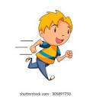 _________________________.

- Maitha is 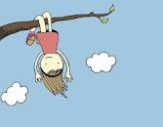 - _______________________.

- Baby is  _________________________.

- Hamad is  ___________________________.

- The children are 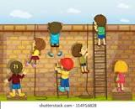 _____________________.

Question 3: Pronouns - Identify the pronouns.
he | they | she | it




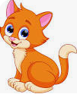

Question 4: Use of Can and Can’t
Write 2 sentences on what you can do and what you can’t do.

Question 5: Correct the sentence.
at / zebras. / the / Look
a monkey / is / in the / There / tree.
frog / The / into / the water. / jumps

