We Can! Book 3 Unit 4: Beautiful Nature

1. Listen and circle c or g. Then match with the pictures and write

___ ap ___ at ___ irl ___ ake ___ oat

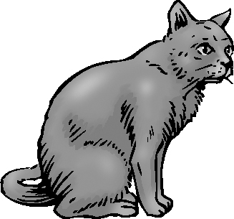 | c g | _________________
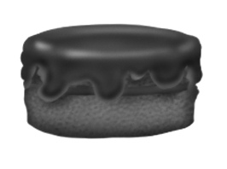 | c g | _________________
 | c g | _________________
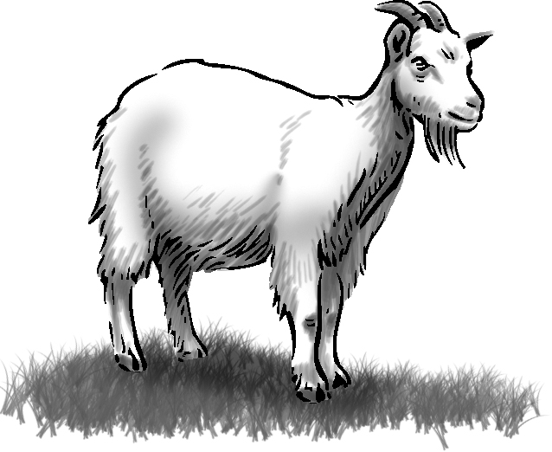 | c g | _________________
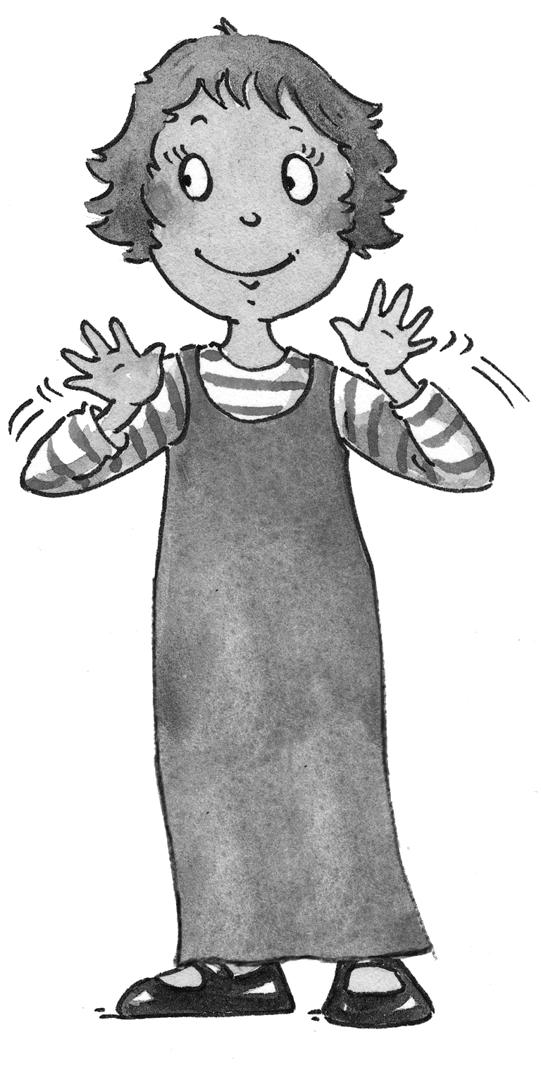 | c g | _________________

2. Listen, number, and write.

___I love the flowers ___ to be under this sky
___ all the stars are out. ___ I love the rolling hills

I love the mountains, (1)_______________,
(2)__________________, I love the daffodils,
I love the campfire when (3) ______________,
I sit and look, I look and smile,
I’m happy (4)________________.
3. Listen and match with the opposites. Write the number.
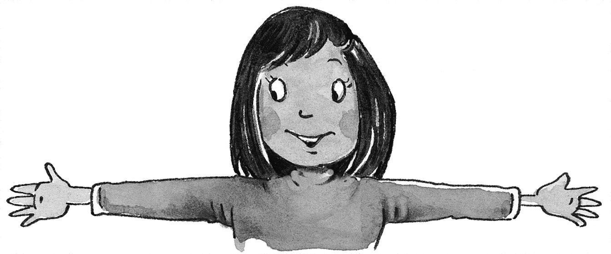  1. long | 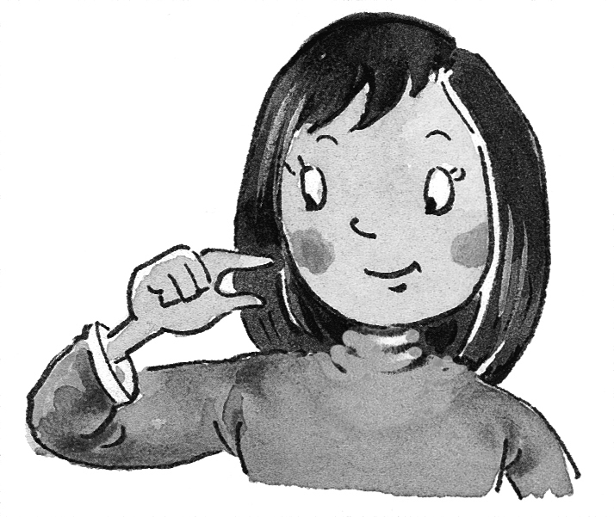  ___small
2. big | ___strong
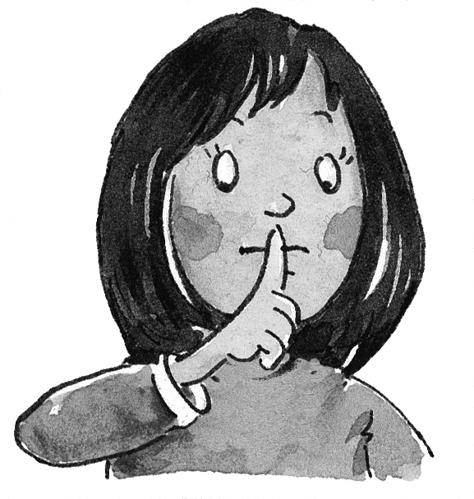  3. quiet | 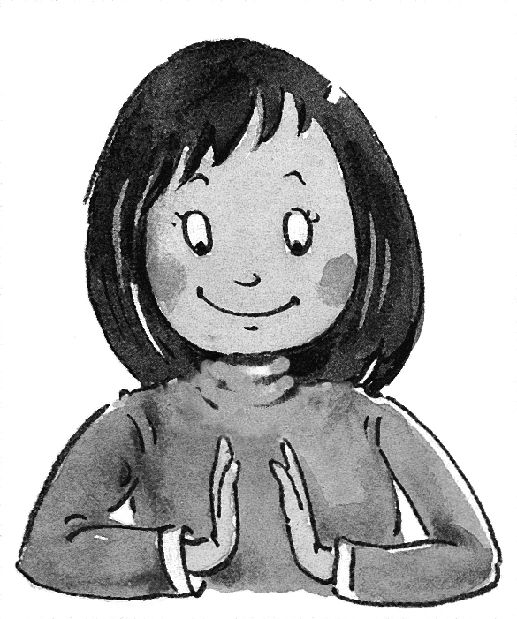  ___ short
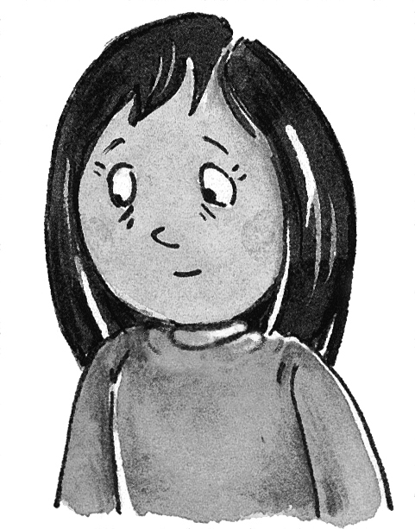  4. weak | 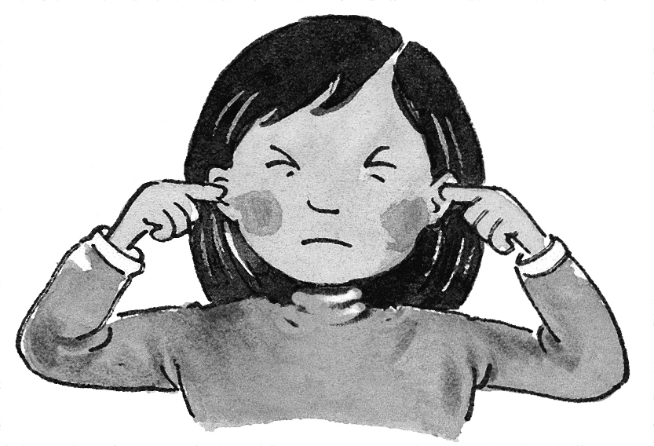  ___noisy

4. Listen and match pictures and months with seasons. Write.

fall spring summer winter

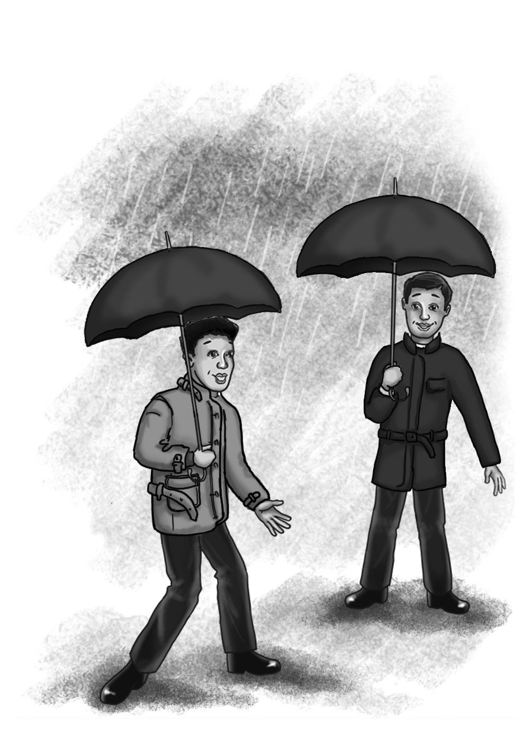 | September October November  ______ | 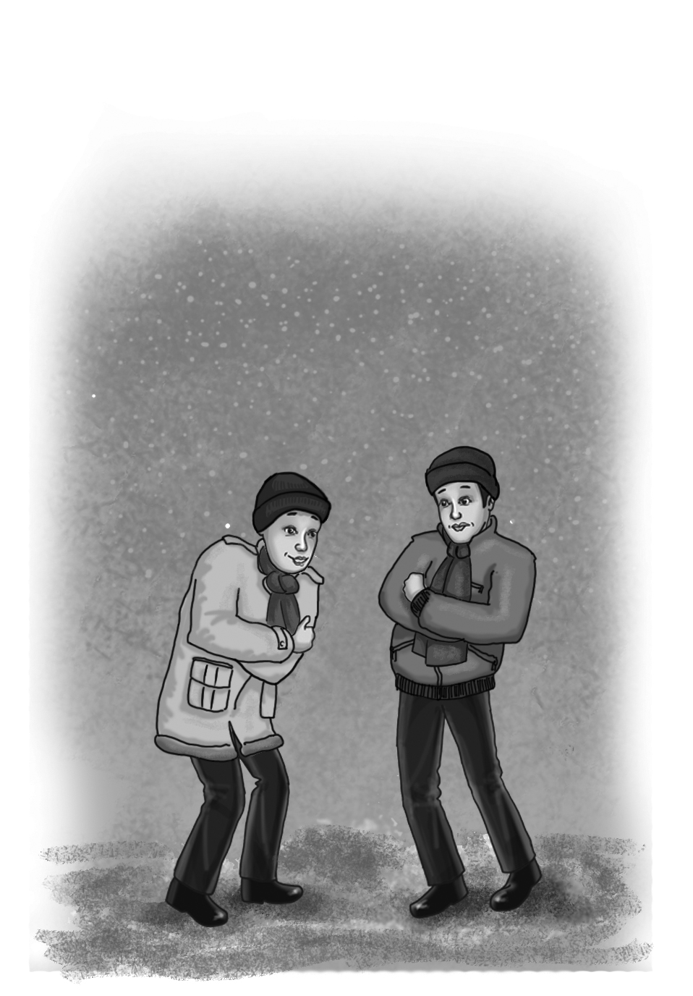 | December January February  ______
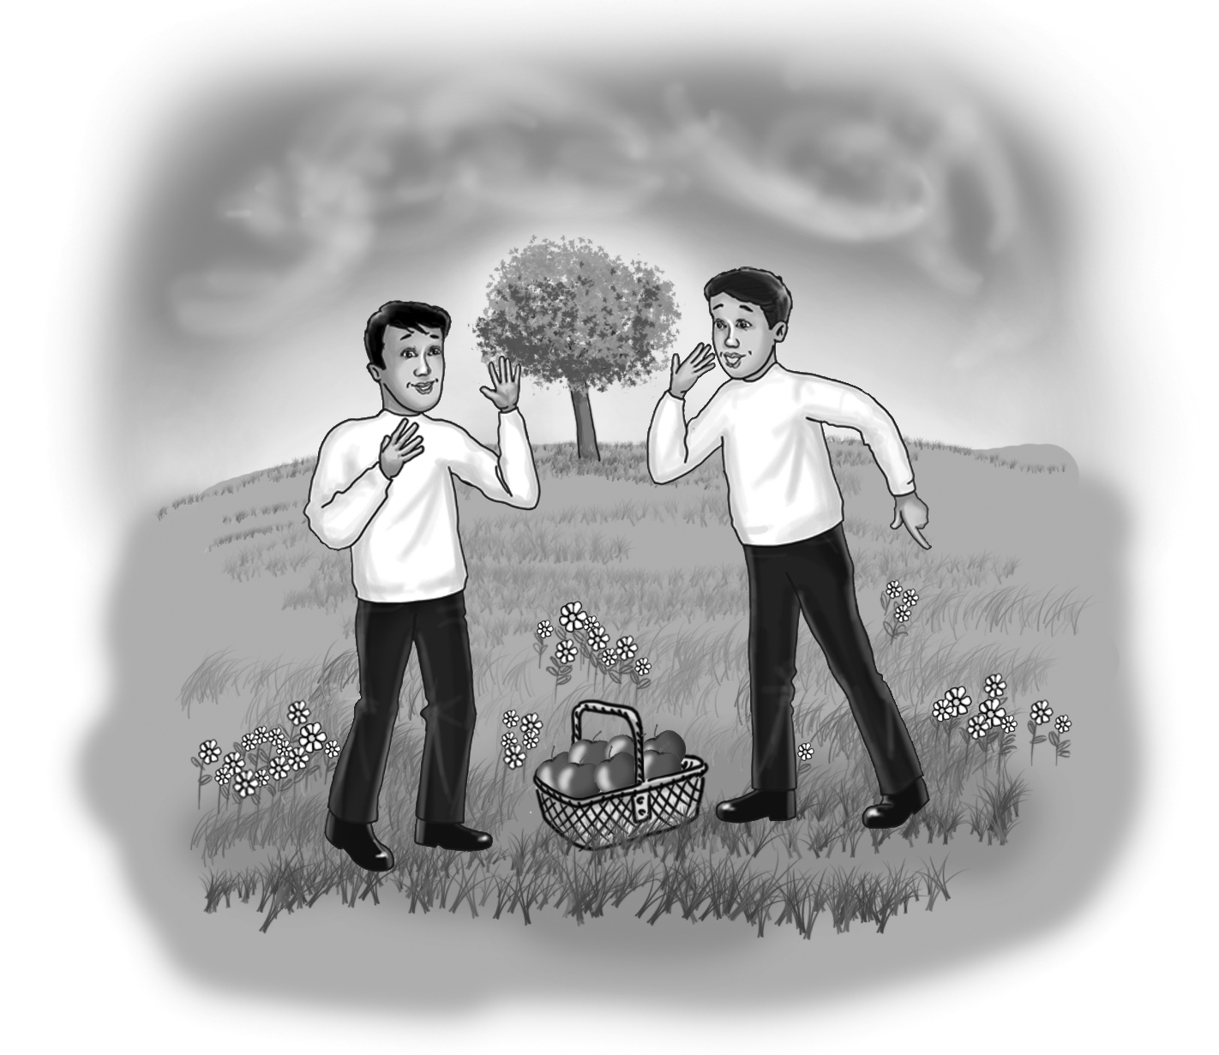 | March  April  May  ______ | 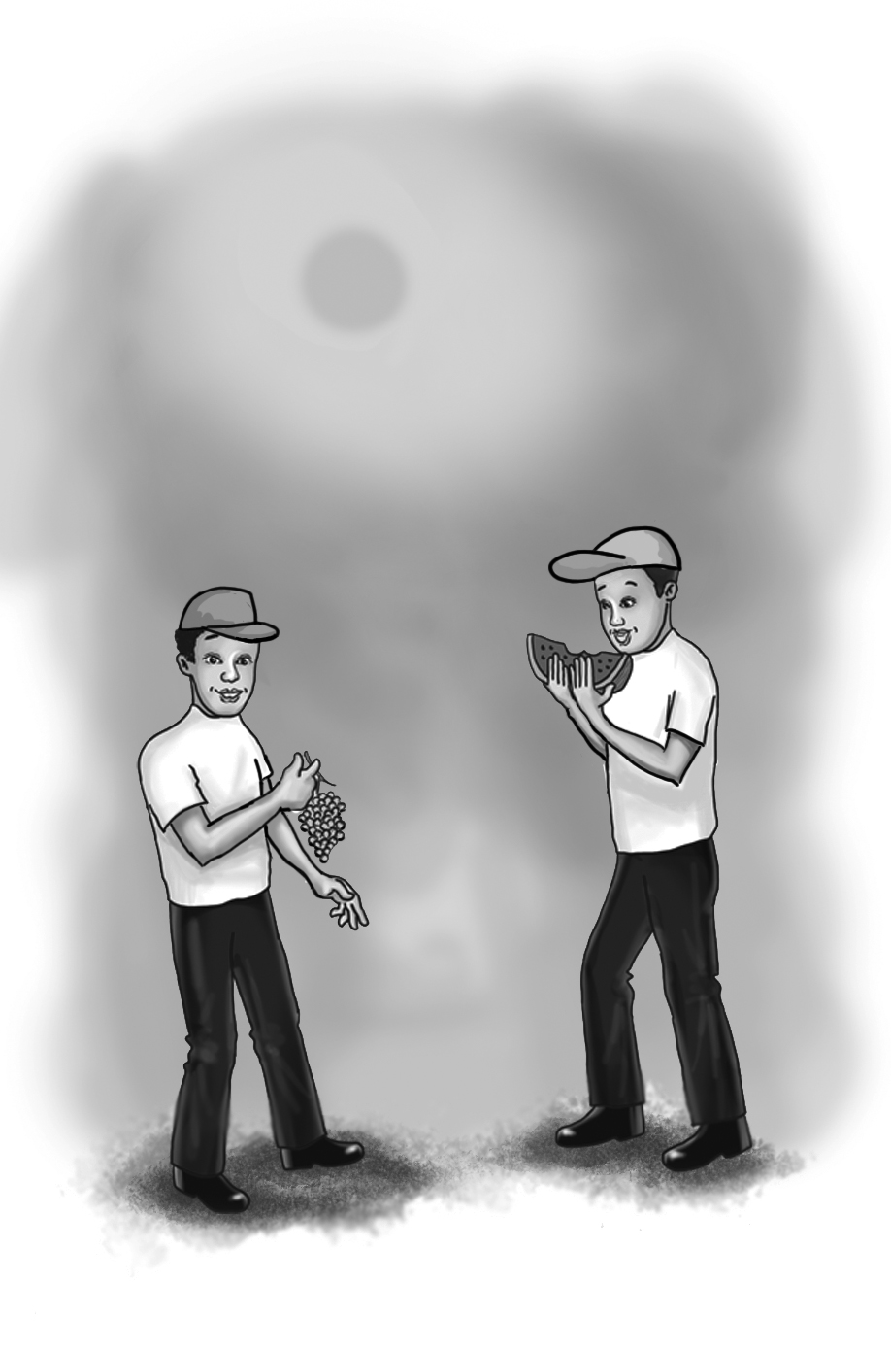 | June  July  August  ______

