We Can! Book 5 Unit 1: It’s Nice to Meet You!

1. Listen and match questions and answers. Number the questions. Then write.

___ How old are you ___ Where do you live ___ Nice to meet you ___ What’s your name

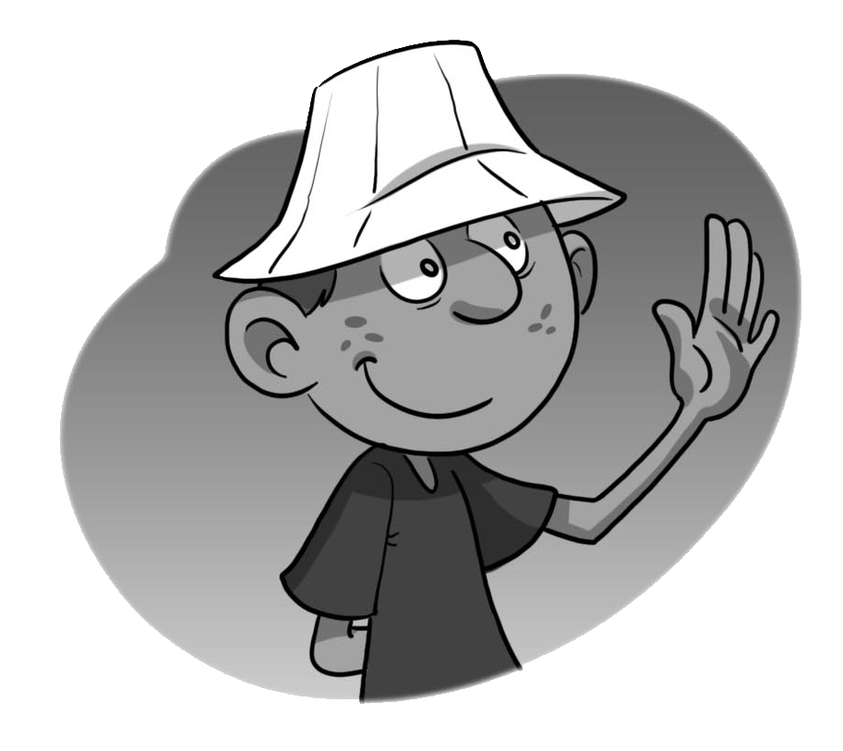  Jack | Hi, I’m Jack. (1) ___________? My name’s Samir.  (2) ______________________? I’m eleven years old.  (3) ______________________? I live in Jeddah.  (4) ______________________? Nice to meet you, too. | 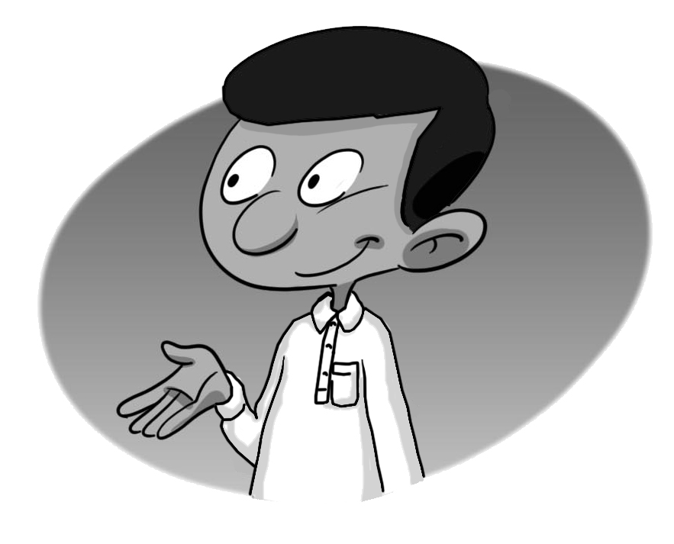  Samir

2. Read the questions and write your own answers.

What’s your name? _______________________.
How old are you? _______________________.
Where do you live? _______________________..
Do you have any brothers? ___________________.
How many? _______________________.
Do you have any sisters? ____________________.
How many? _______________________.
Can you read English words? __________________.
Can you ride a bicycle? __________________.

3. Whose … is this? Whose …are these? They’re his / hers / theirs. Listen and check the right column.
 | 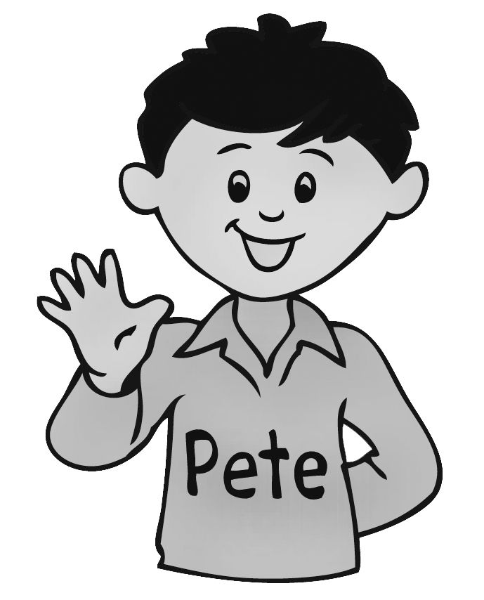Pete | Steve 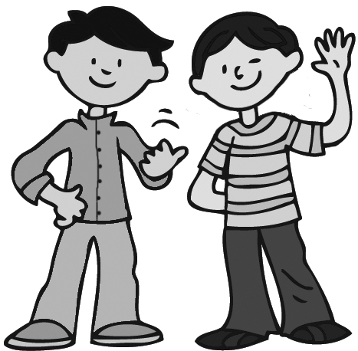 Ken |  | 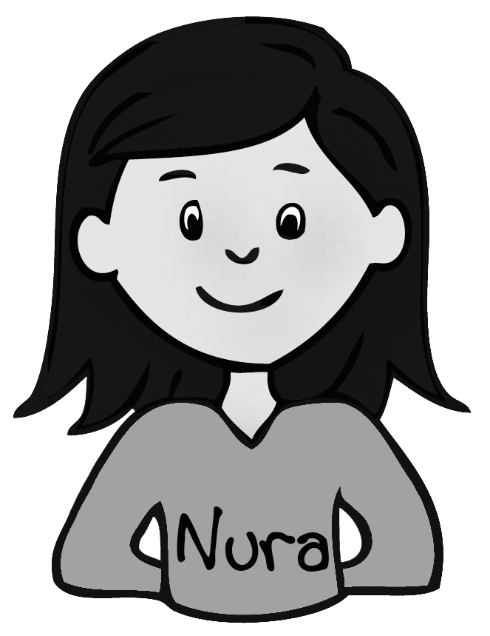Nura
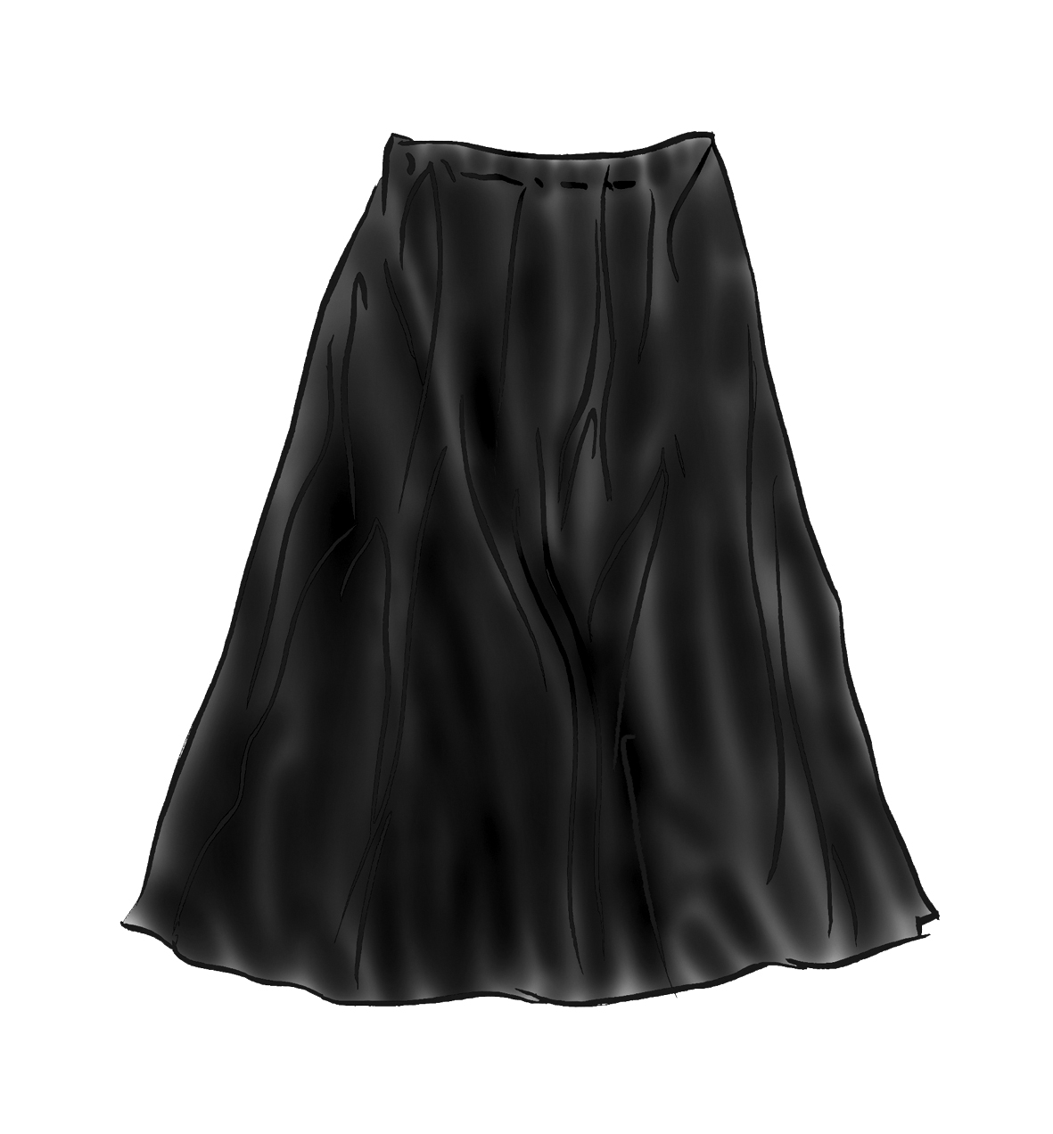
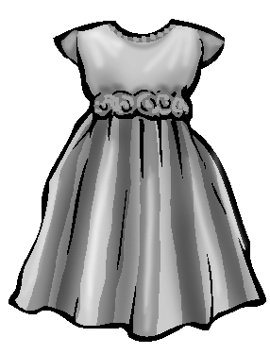
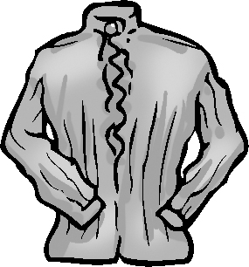
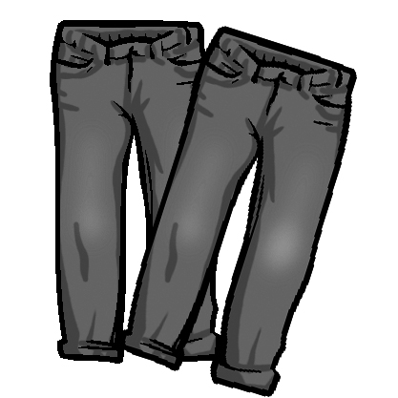
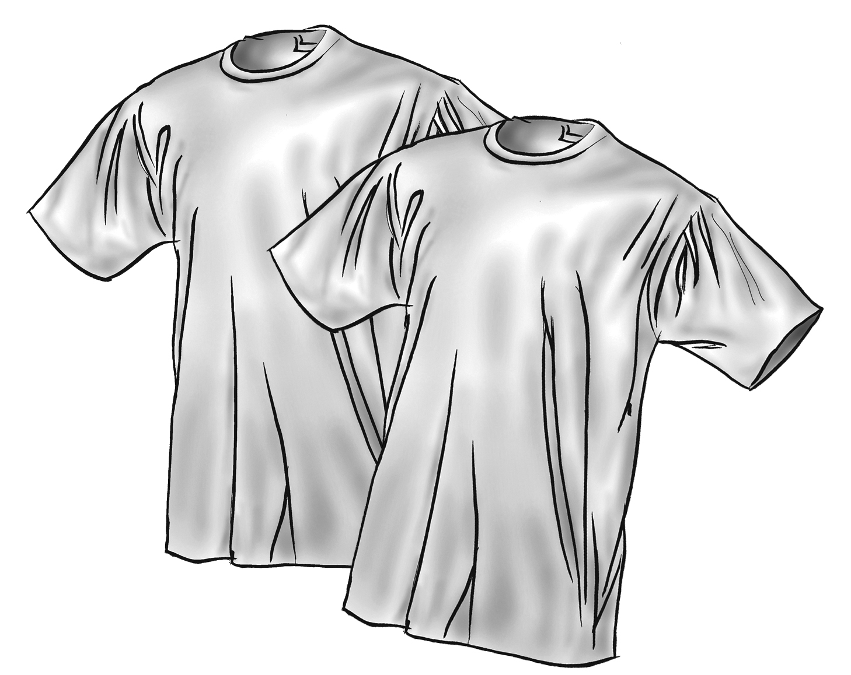
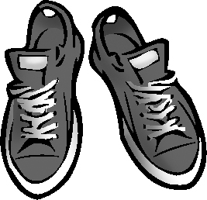
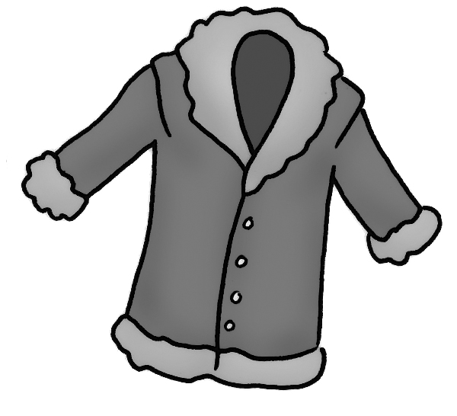
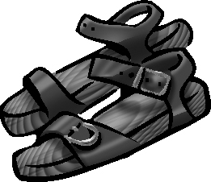
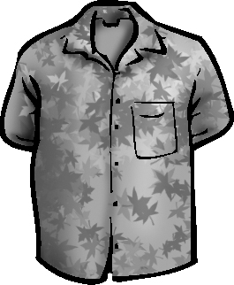
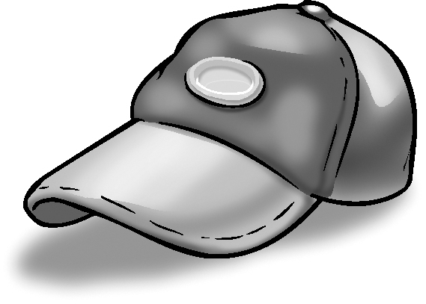

Now write questions and answers.

1. skirt
Whose skirt is this? It’s Nura’s. / It’s hers. 2. trousers
Whose trousers are these? They’re Steve and Ken’s.
/They’re theirs.
3. shoes
___________________ ? ________________________.
4. dress
___________________ ? ________________________.
5. coat
___________________ ? ________________________.
6. T-shirts
___________________ ? They’re Steve and Ken’s./
They’re theirs
7. sandals
___________________ ? ________________________.
8. blouse
___________________ ? ________________________.

