We Can! Book 1 Unit 4: How Old Are You?

1. Listen and number the words. Then copy.

__three | __ six | __ one | __ nine | __two
__ four | __ five | __ eight | __seven | __ ten

1.__ one ___  2. __________  3. __________  4. __________  5. __________ | 6. __ six ___  7. __________  8. __________  9. __________  10. __________

2. Listen, choose, and write.

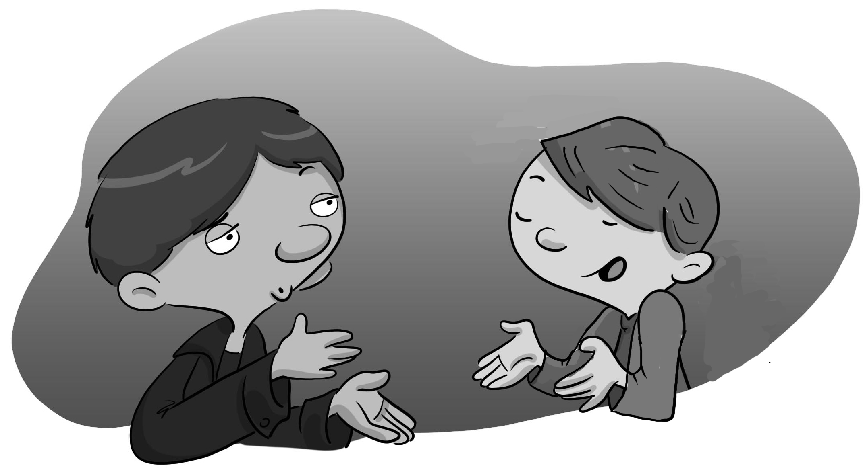
How ten you

_____ old are ____?

I’m _______ years old.
3. Listen, number, and trace.

__ diamond | __ star | __ square
__rectangle | __ circle | __triangle

4. Listen and circle the right letter. Then write.

1. | E F G H I J  __ ISH
2. 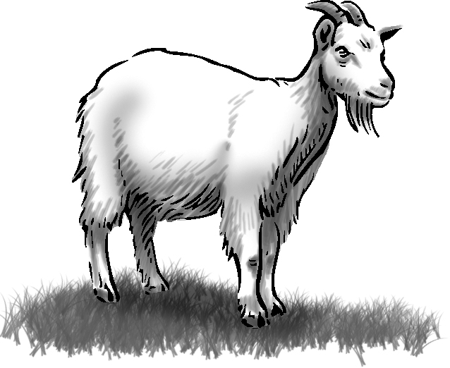 | E F G H I J  __ OAT
3. 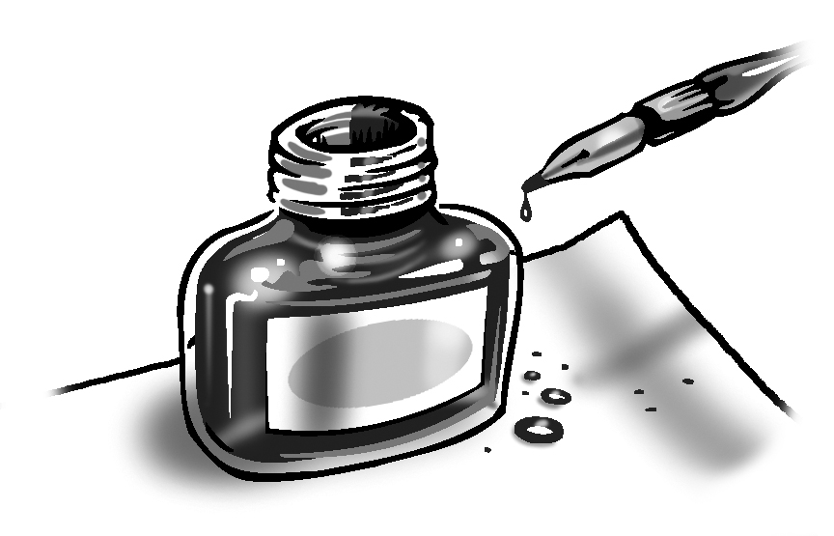 | E F G H I J  __ AT
4. | E F G H I J  __ NK
5. | E F G H I J  __ ET

