We Can! Book 3 Unit 1: Feelings

1. Listen and number. Then write.

Clap your hands ___ If you’re happy_1_
Then your face ___ and you know it ___
If you’re happy and you know it ___

If you’re happy and you know it, | 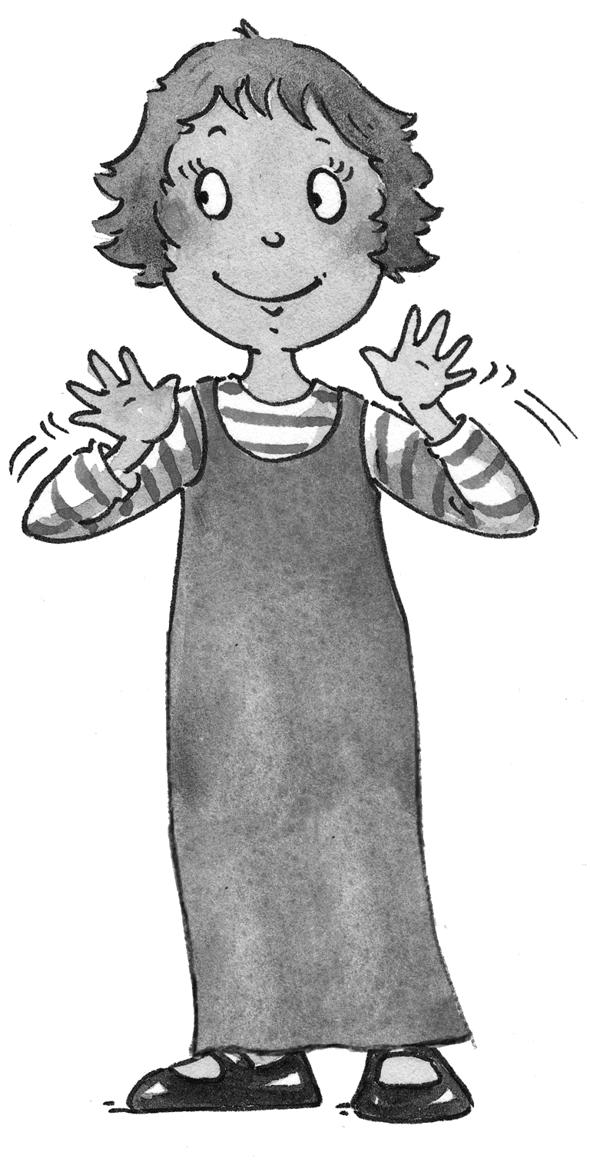
Clap your hands.
(1)________________ and you know it,
(2) ________________.
If you’re happy, (3) ________________,
(4) _______________will surely show it,
(5) __________________,
Clap your hands.
2. Read and write the letter.

A B C D E F G H I J

It’s the seventh letter of the alphabet. ___

It’s the second letter of the alphabet. ___

It’s the fifth letter of the alphabet. ___

It’s the ninth letter of the alphabet. ___
It’s the third letter of the alphabet. ___
3. Listen and number.

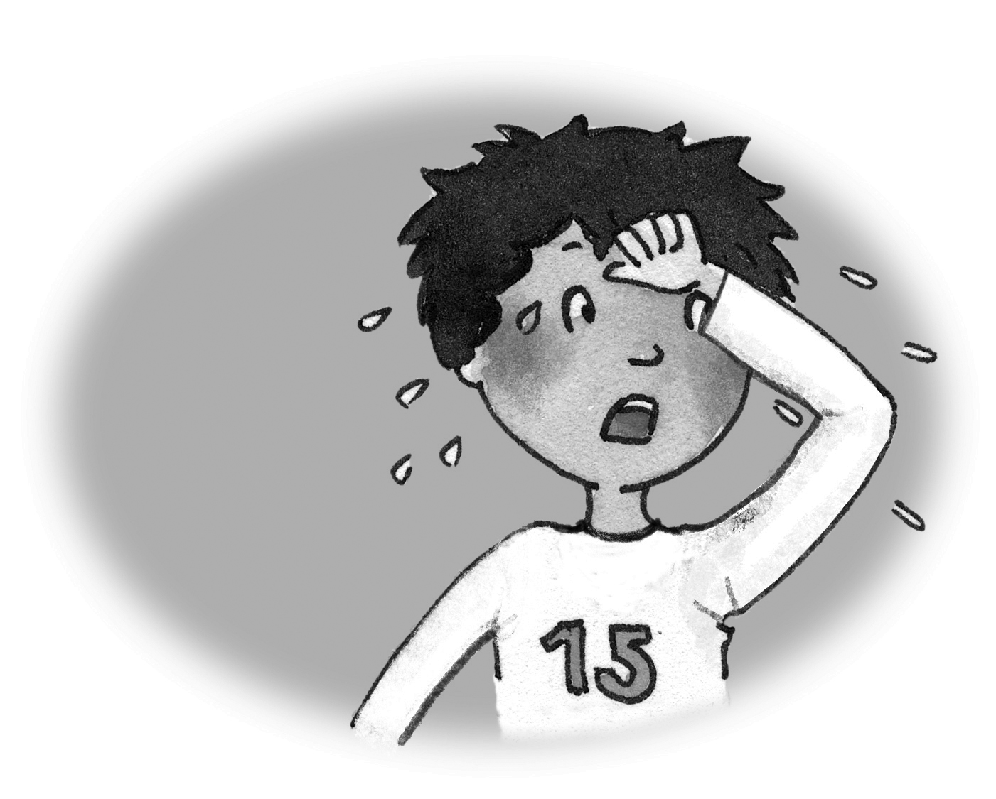  3. hot | 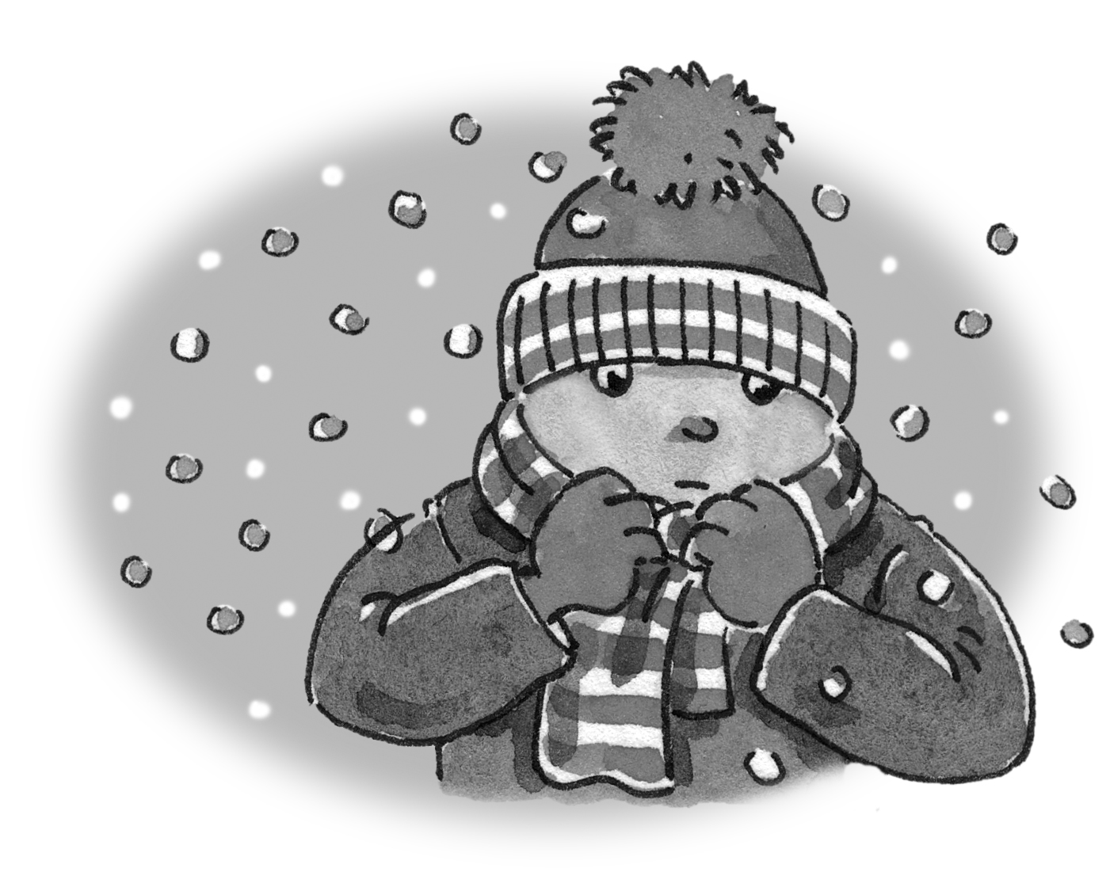  ___ cold | 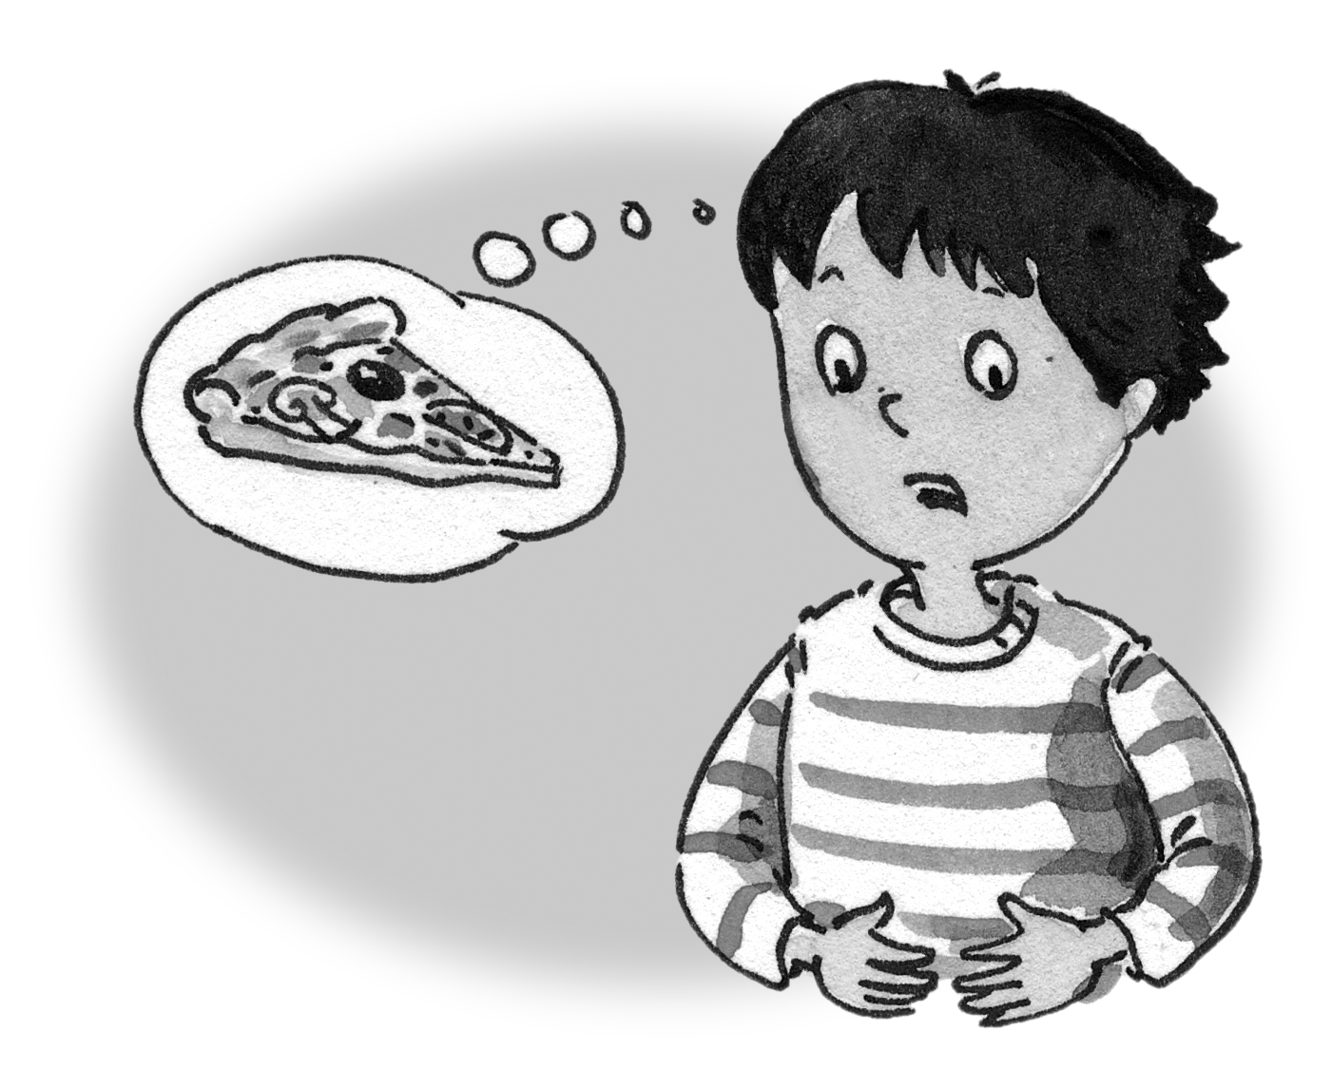  ____ hungry
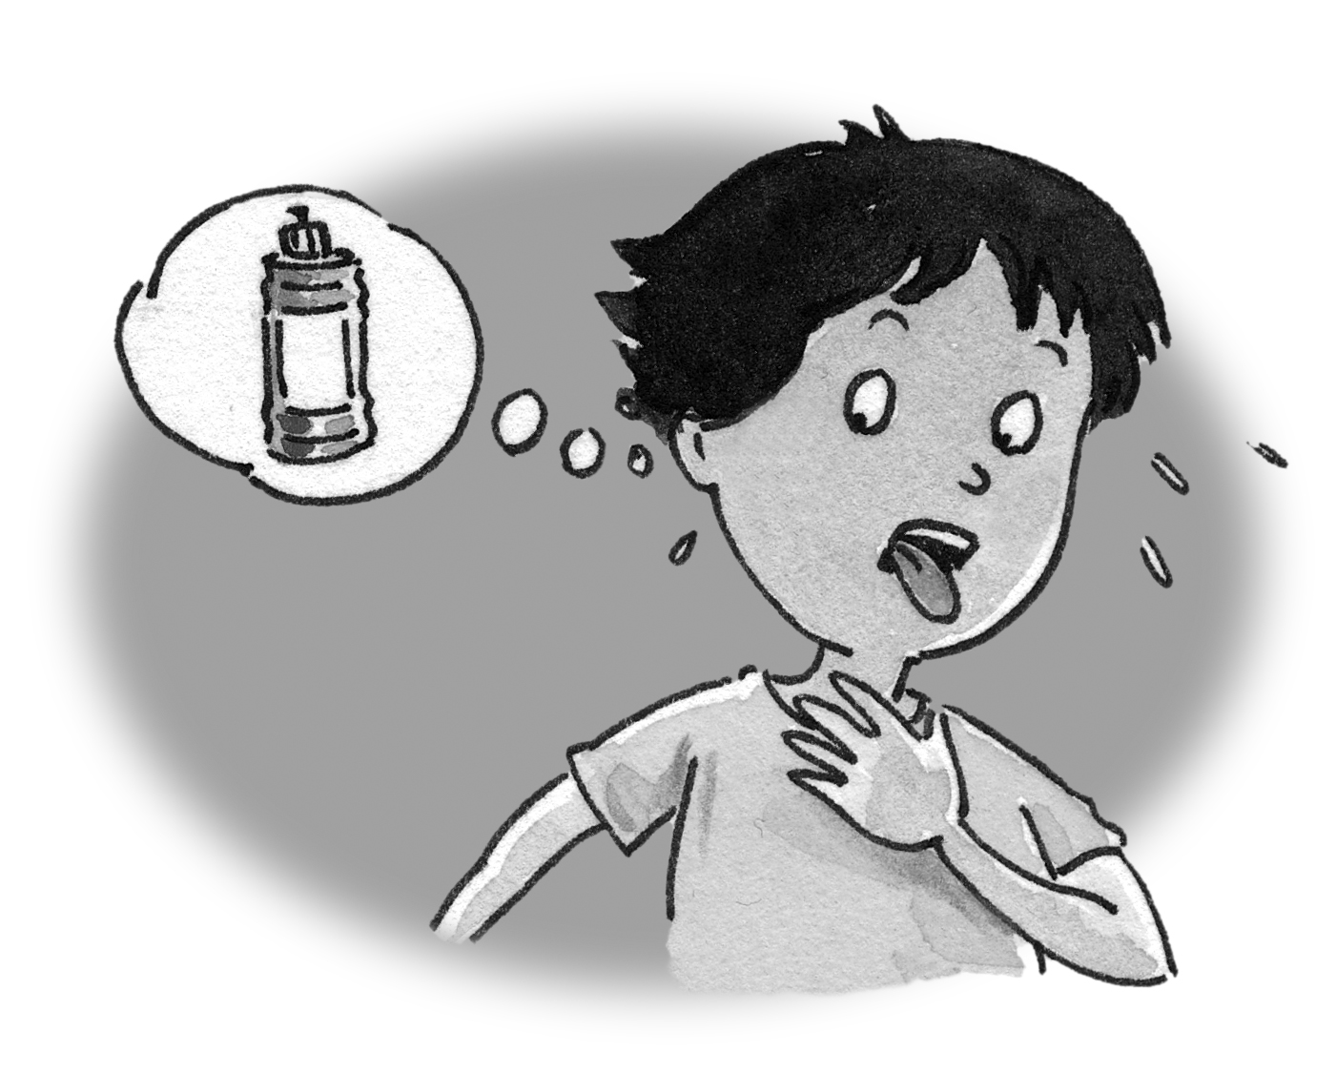  ____ thirsty | 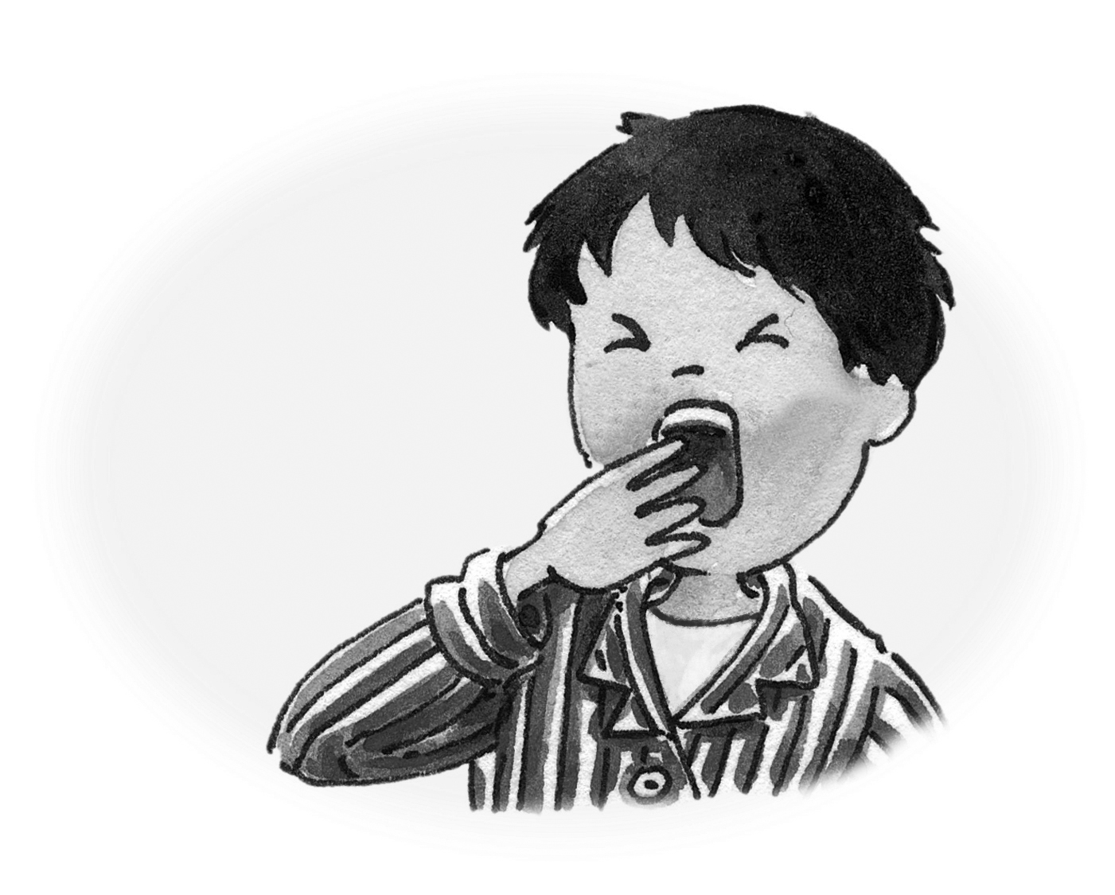  ____ sleepy | 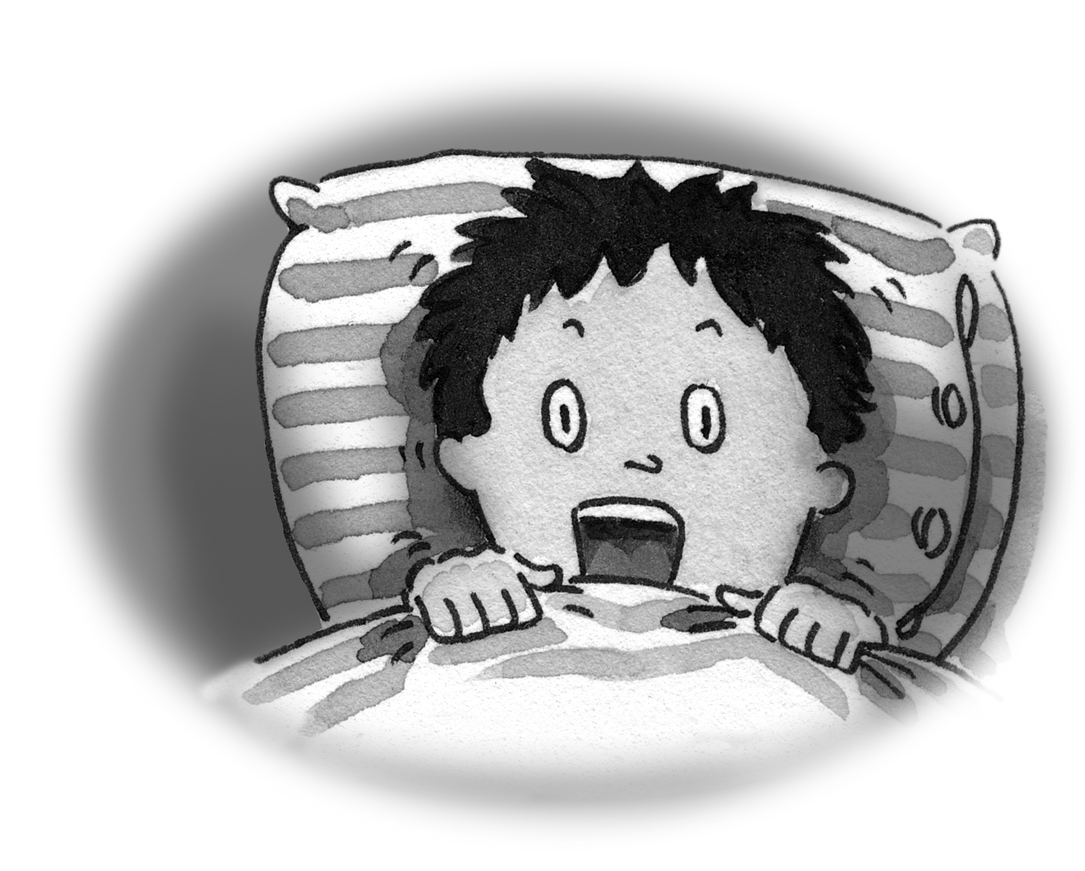  ___ scared

4. Unscramble the letters and write the words.

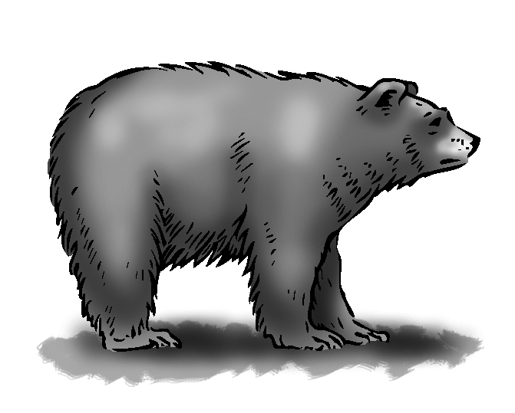 rbea _________
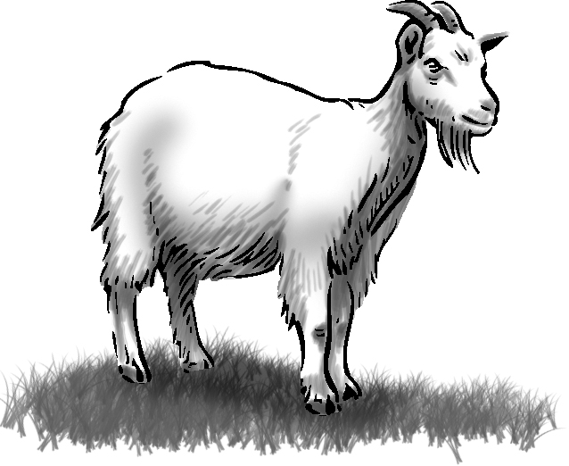 otag _________
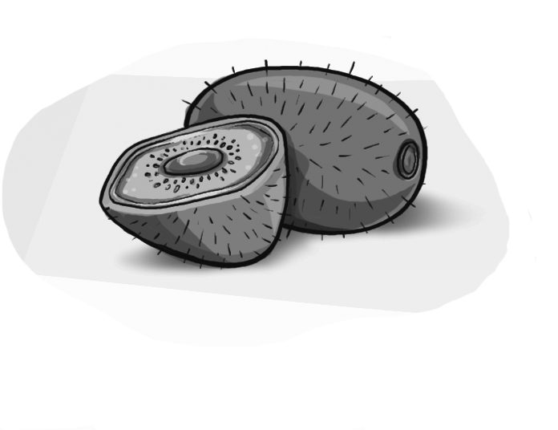 iwki _________
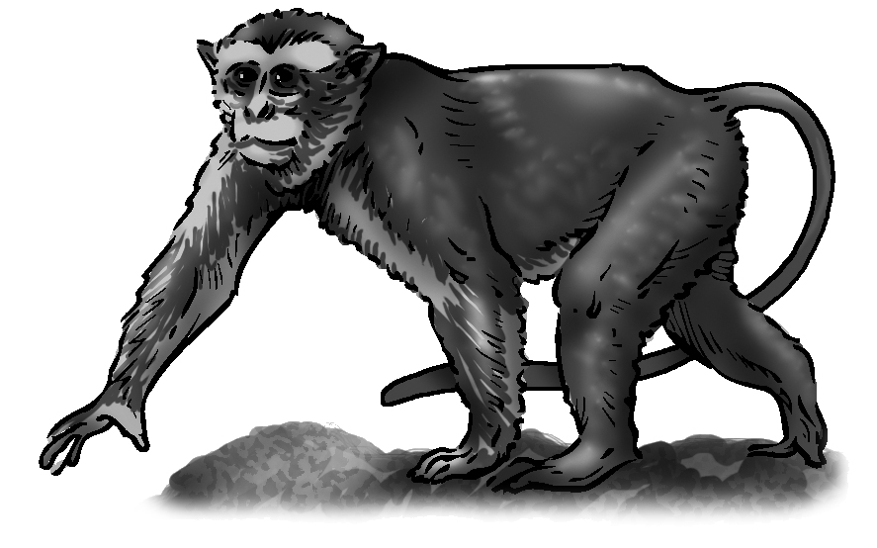 ykemno _________
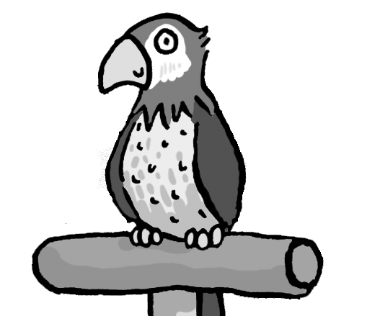 rtapro _________
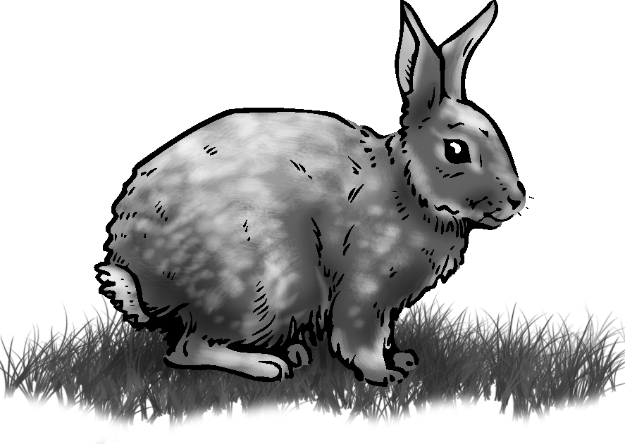 itrbab _________
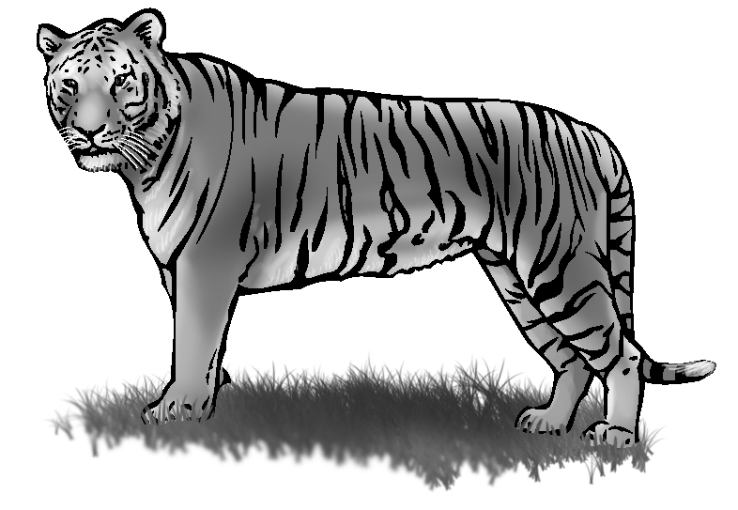 greti _________
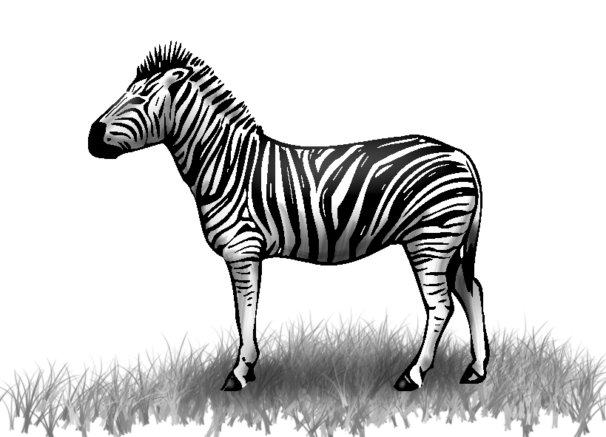 bazre _________

