We Can! Book 1 Unit 1: My Friends

1. Listen and number.

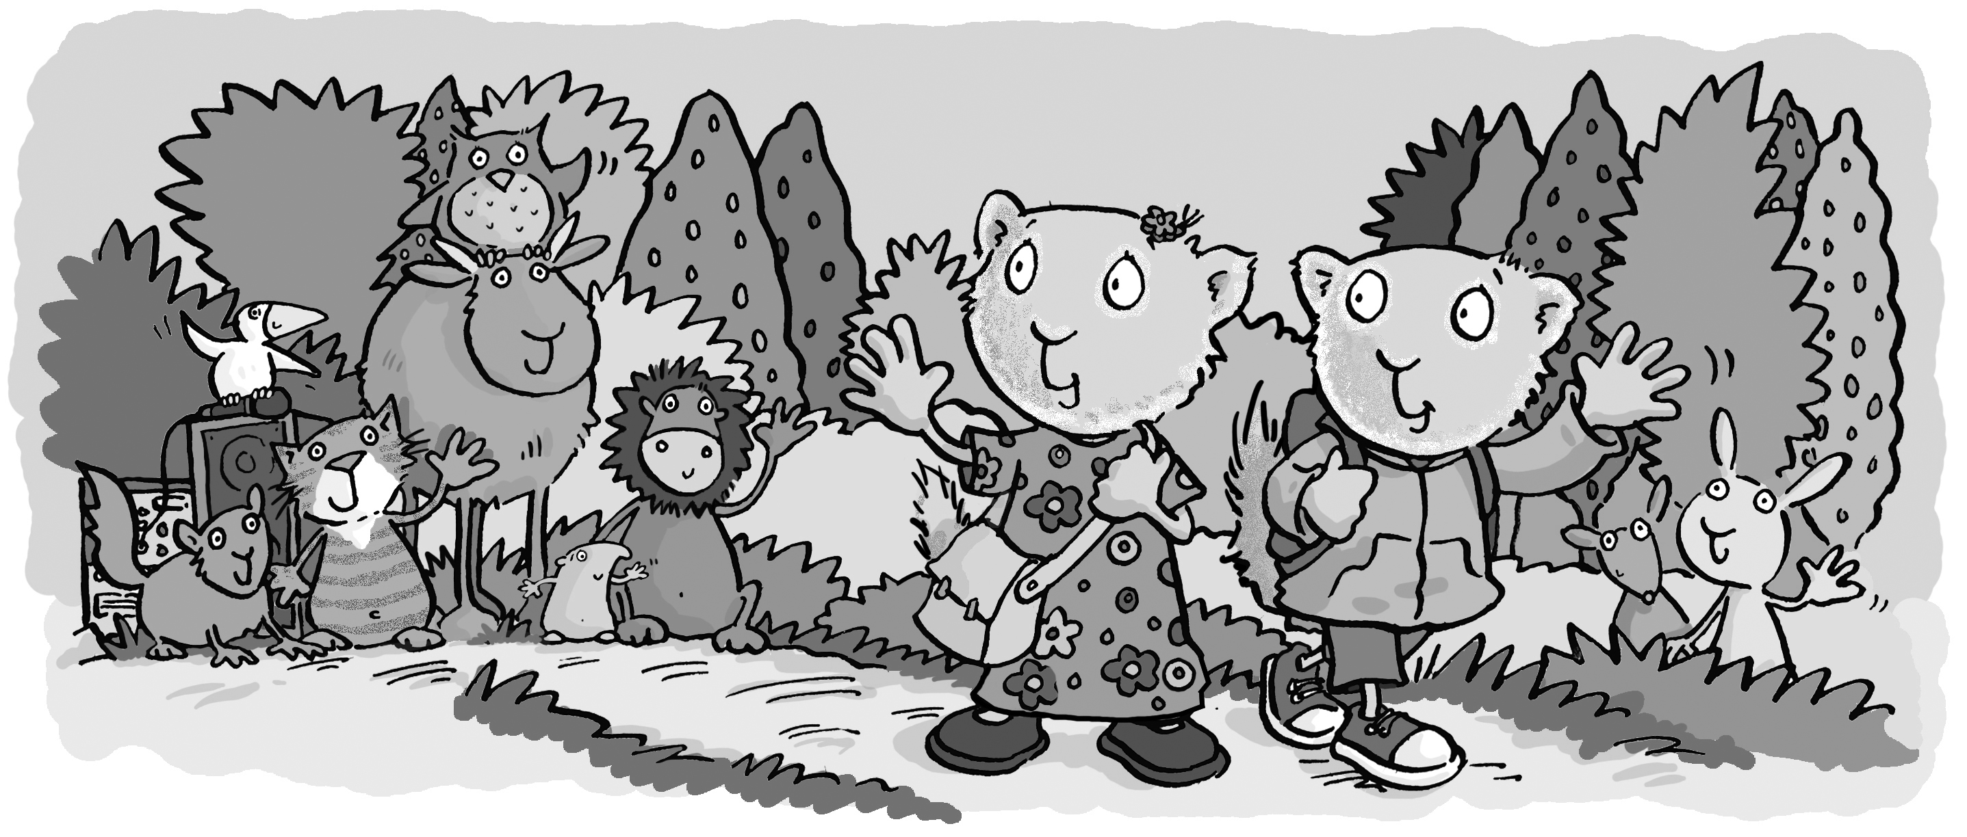
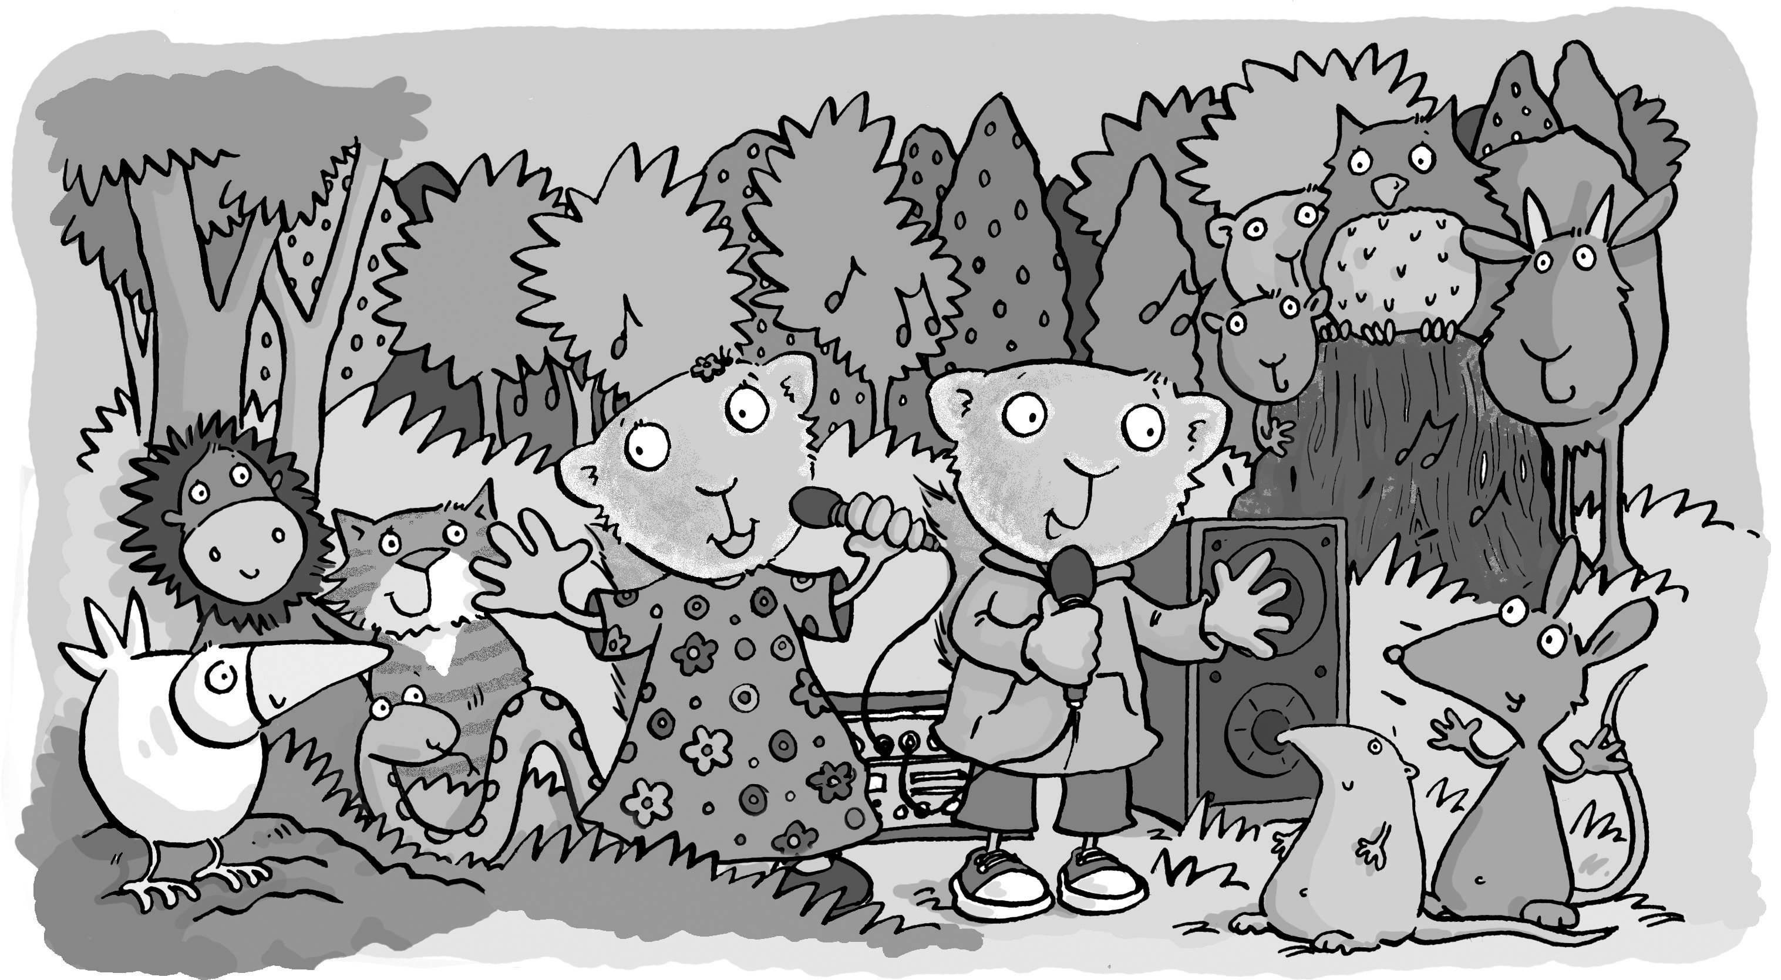

2. Make a name card. Write your name and draw.

My name’s

____________________________

This is my name card.

3. Listen and color. Then trace.

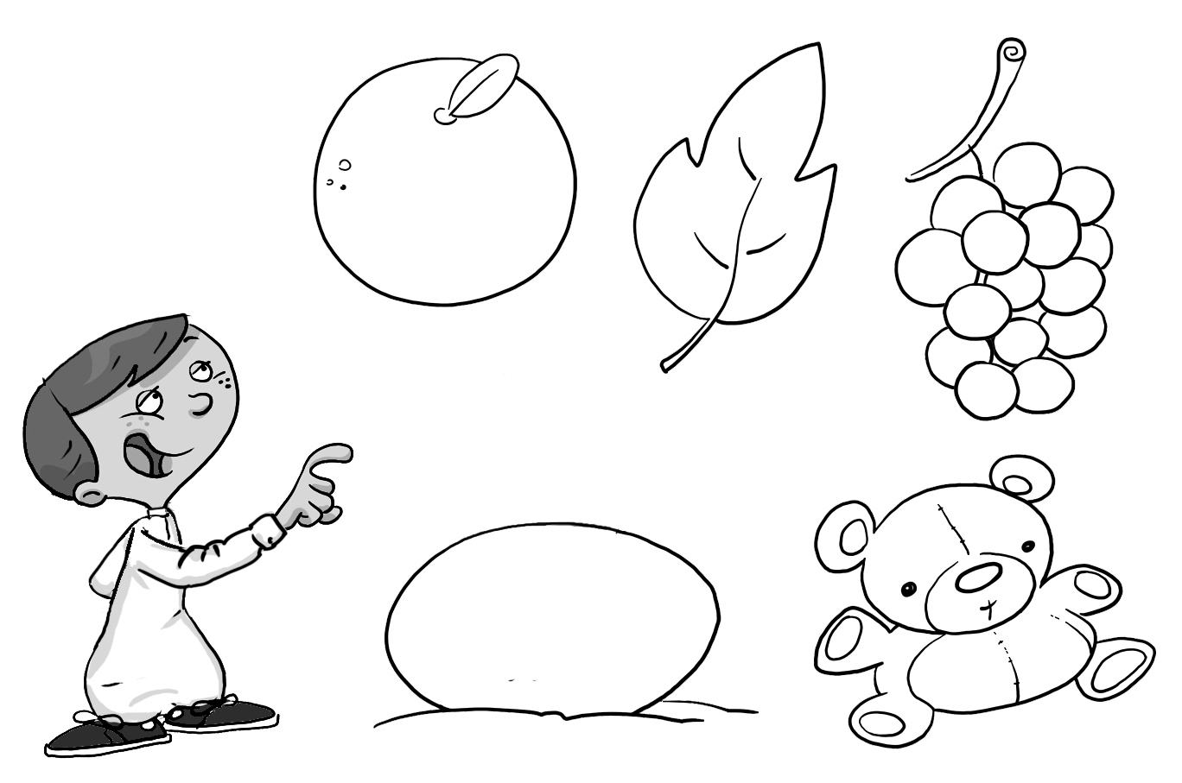

orange green purple

white brown

