We Can! Book 3 Unit 2: Things We Wear

1. Listen and check √ Boy and/ or Girl.

 | Boy - Safroot  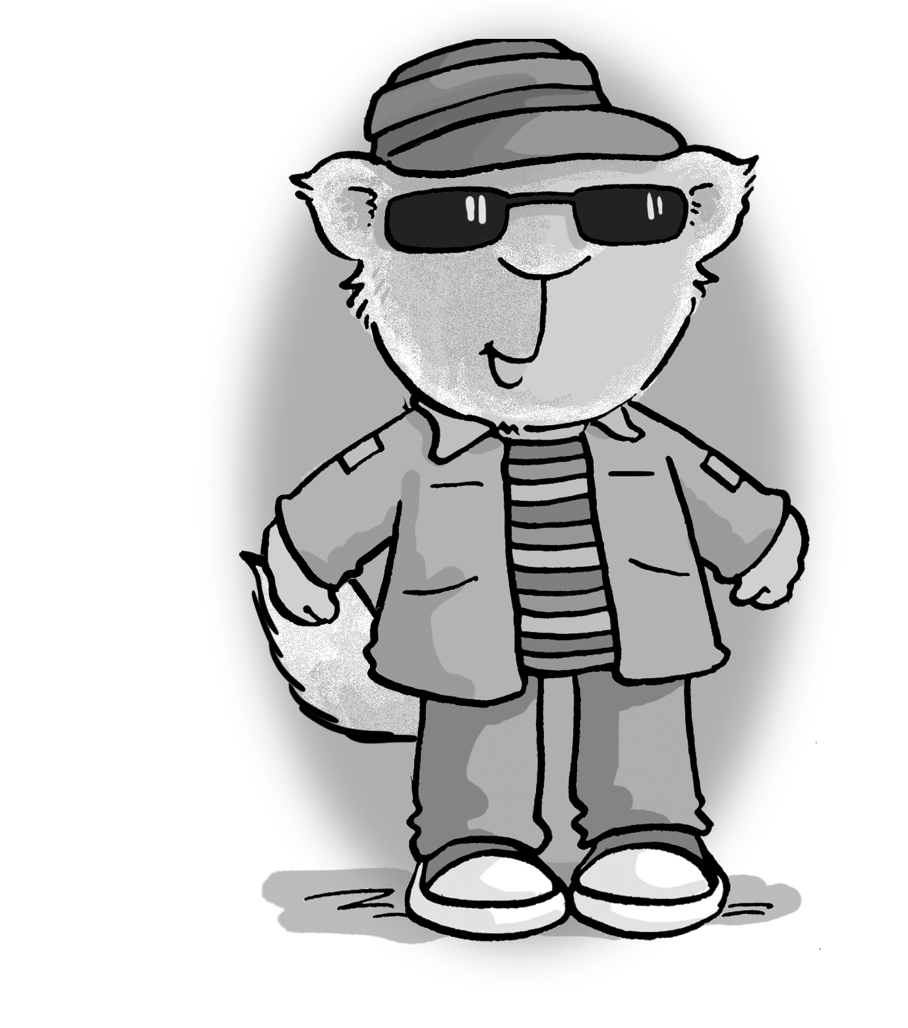 | Girl - Safroota  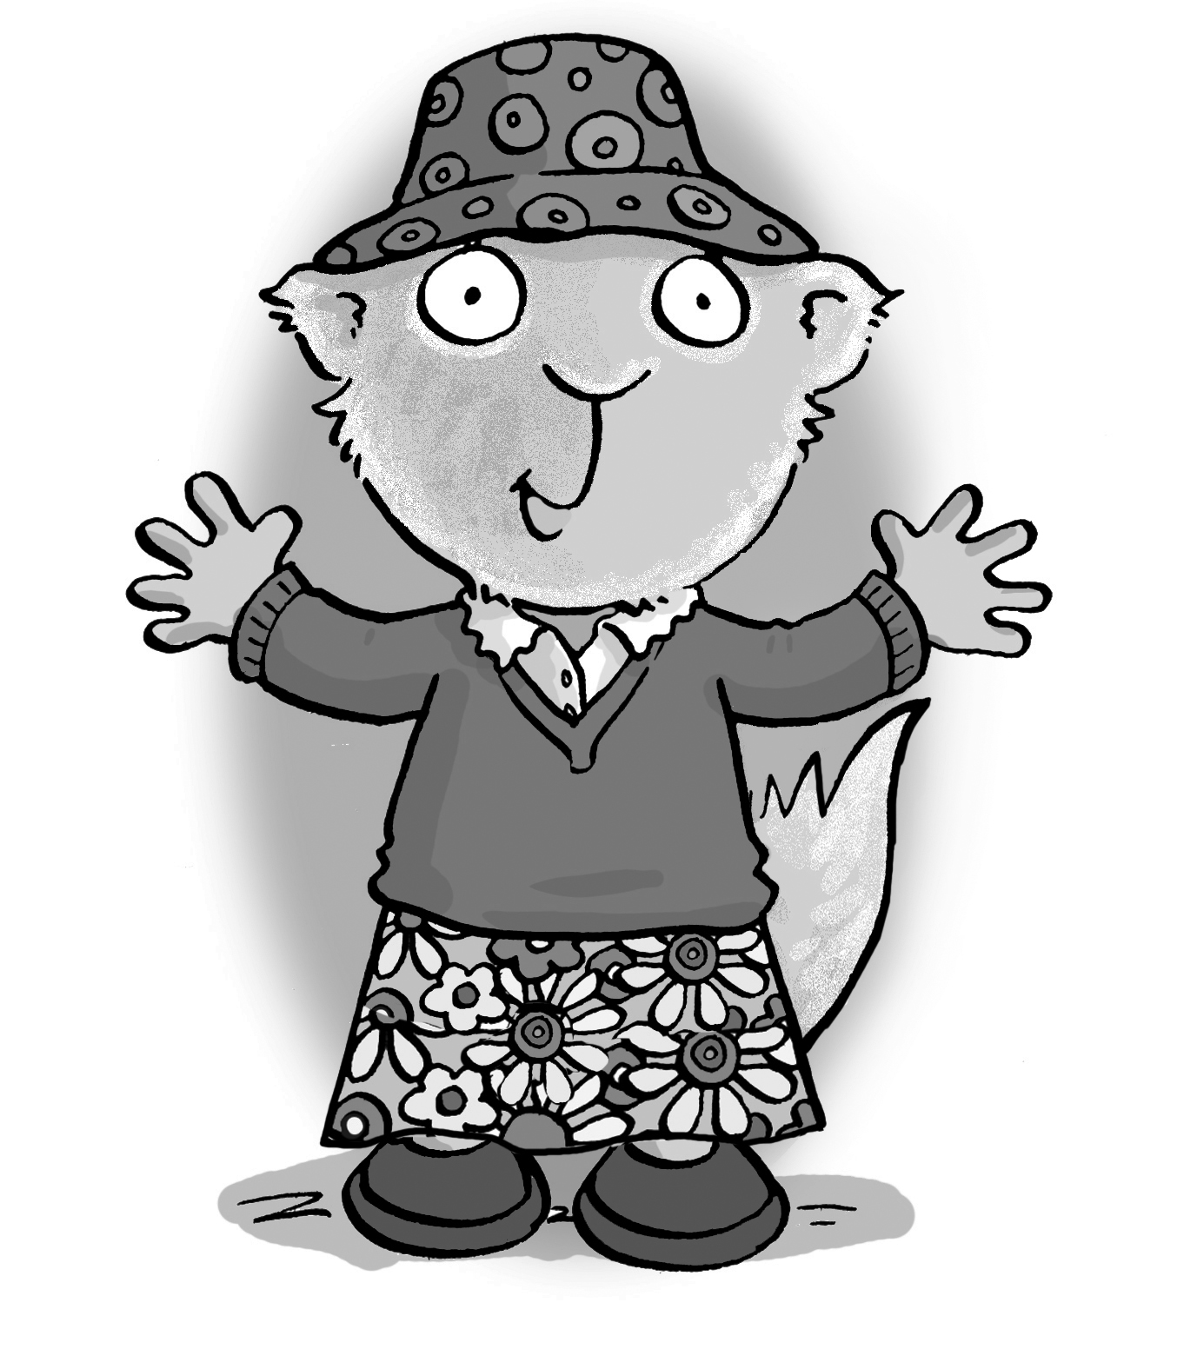
a hat
sunglasses
a blouse
a cap
a T-shirt
a jacket
jeans
a skirt
shoes
a sweater

2. Write about Safroot and Safroota. Look at the pictures in exercise 1.
Safroot is wearing a cap, sunglasses, a _________, a __________, a __________, and __________.
Safroota is wearing a _________, a __________, a __________, a __________, and __________.
I’m wearing ______(students’ own answers)___________
________________________________________.
3. Write b or p.

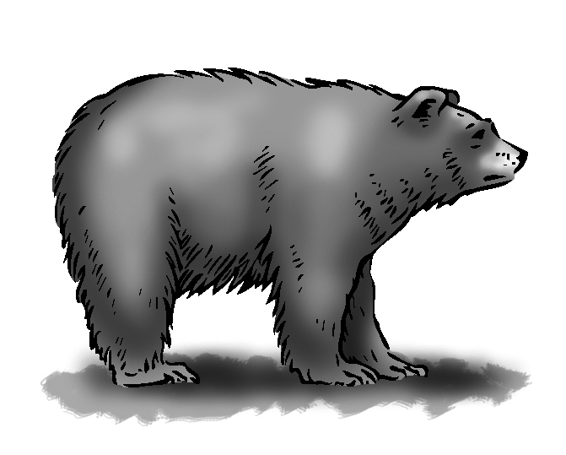 | __ ear | 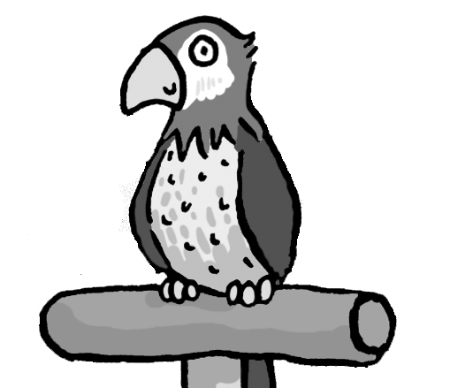 | __ arrot
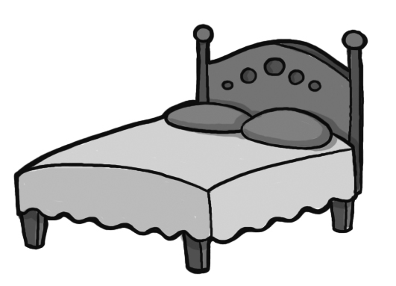 | __ ed | 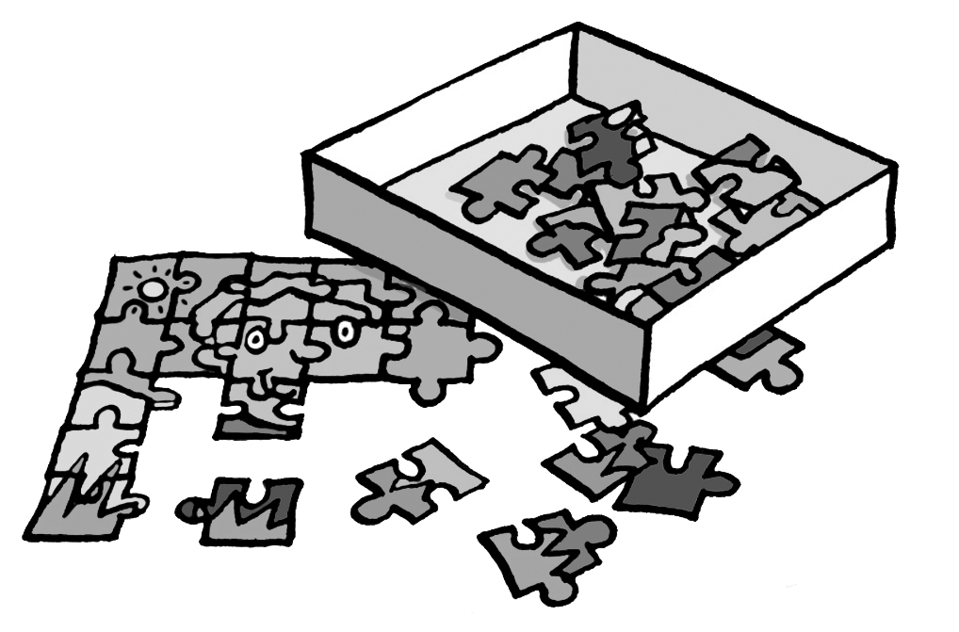 | __ uzzle
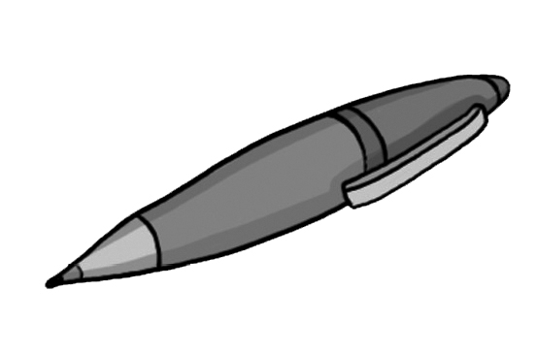 | __ en |  | __ all
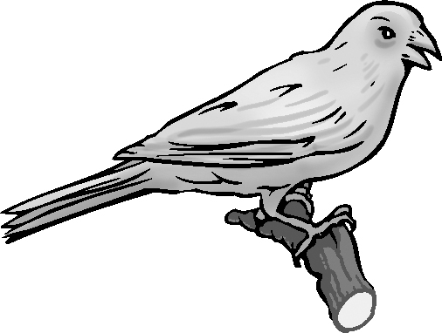 | __ ird | 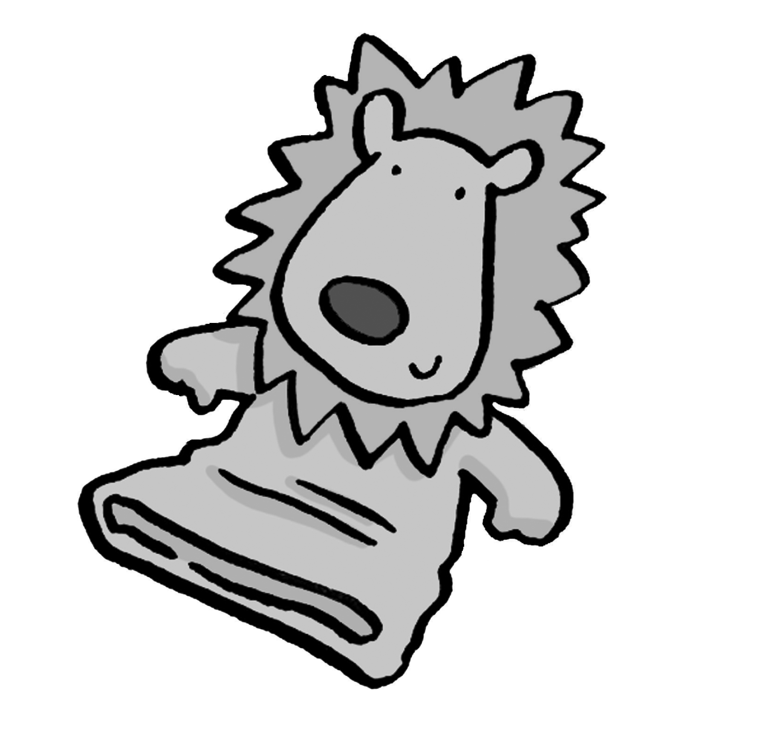 | __ uppet

4. Listen and circle. Then write the missing letters.

sh th | tr dr | br bl | c cl
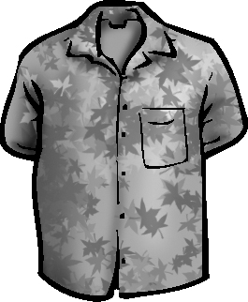  ___ irt | 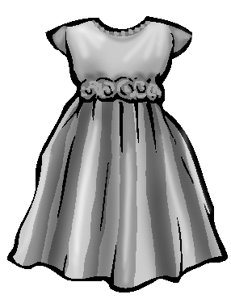  ___ ess | 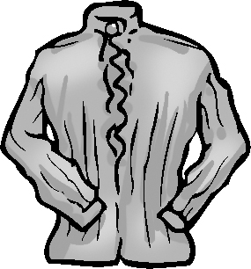  __ ouse | 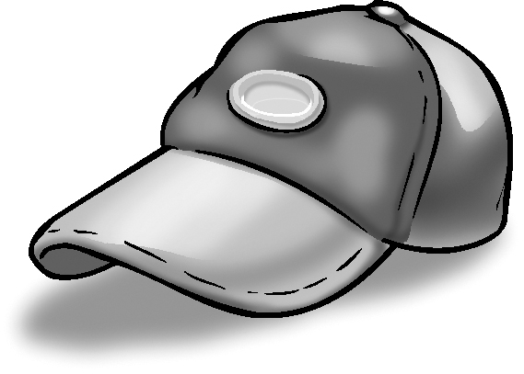  ___ ap
sh th | z s | p b | cl gl
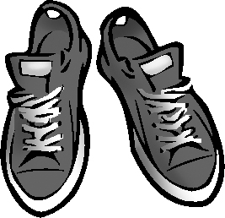  ___ oes | 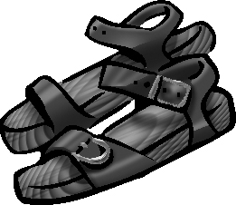  ___ andals | 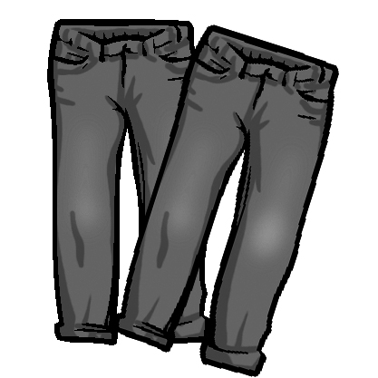  ___ ants | 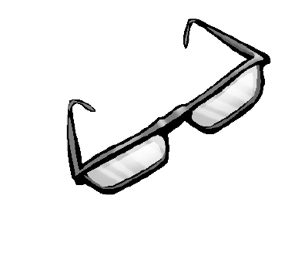  ___ asses

