We Can! Book 5: Revision

1. Listen and read. Then complete with the words.

snake cat house cow mouse cheese

This is Jack‘s _______.  This is the _______ that is in Jack‘s house.  This is the _______ that eats the _______  that is in Jack‘s _______.  This is the ______ that chases the ______  that eats the _____that is in Jack‘s _____.  This is the ______ that scares the ______  that chases the ______  that eats the _____that is in Jack‘s _____  This is the ______with the pointed horns  that tosses the _____that scares the ____  that chases the _____that eats the _____  that is in Jack‘s house. | 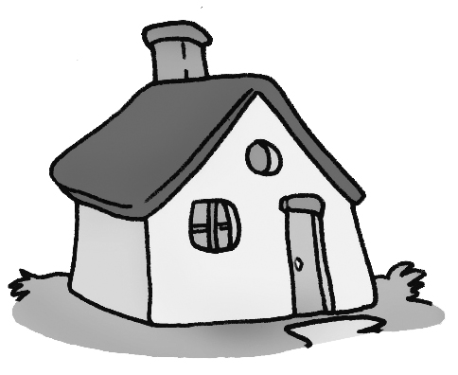  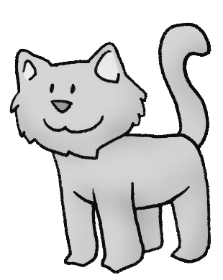  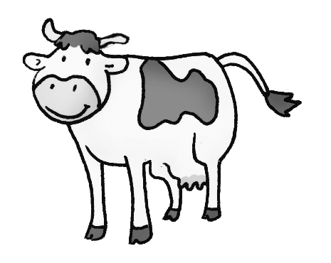
2. Read and underline the right word.

1. My friend likes to play/ do volleyball.
2. My brothers play/ do computer games every evening.
3. Asma’s sister plays/ does pottery.
4. They don’t play/ do words game very often.

3. Listen and put each phrase in the right place.
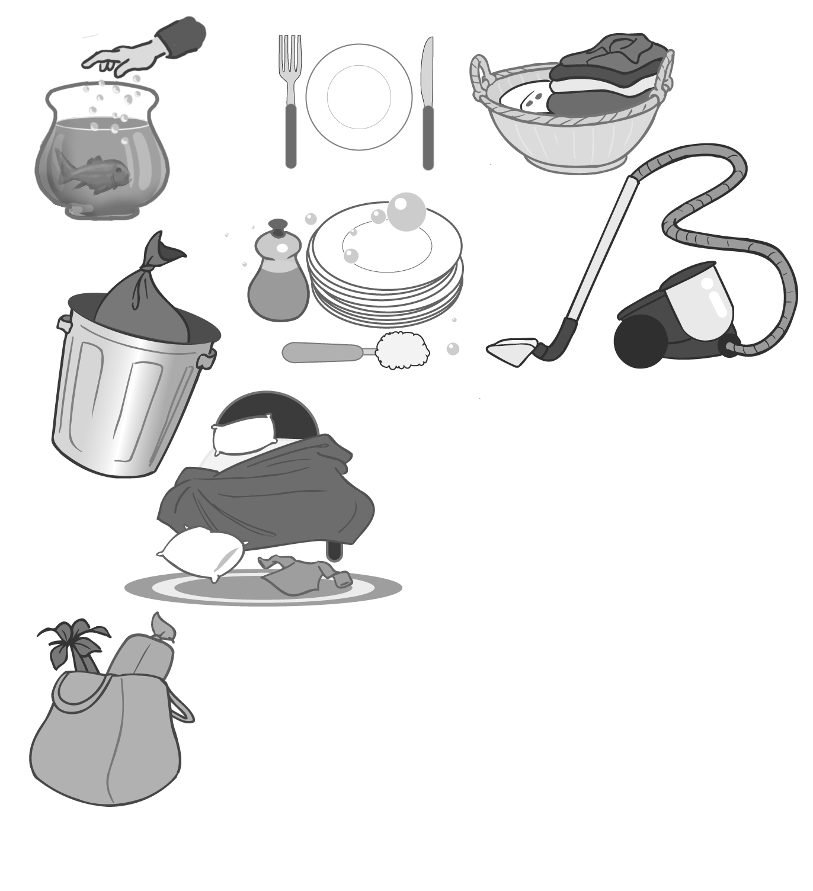
A. vacuums and cleans up
B. feeds the fish and goes
C. playing games and sitting
D. watching TV and eating

What is the good helper doing now?
She usually ________________ her room
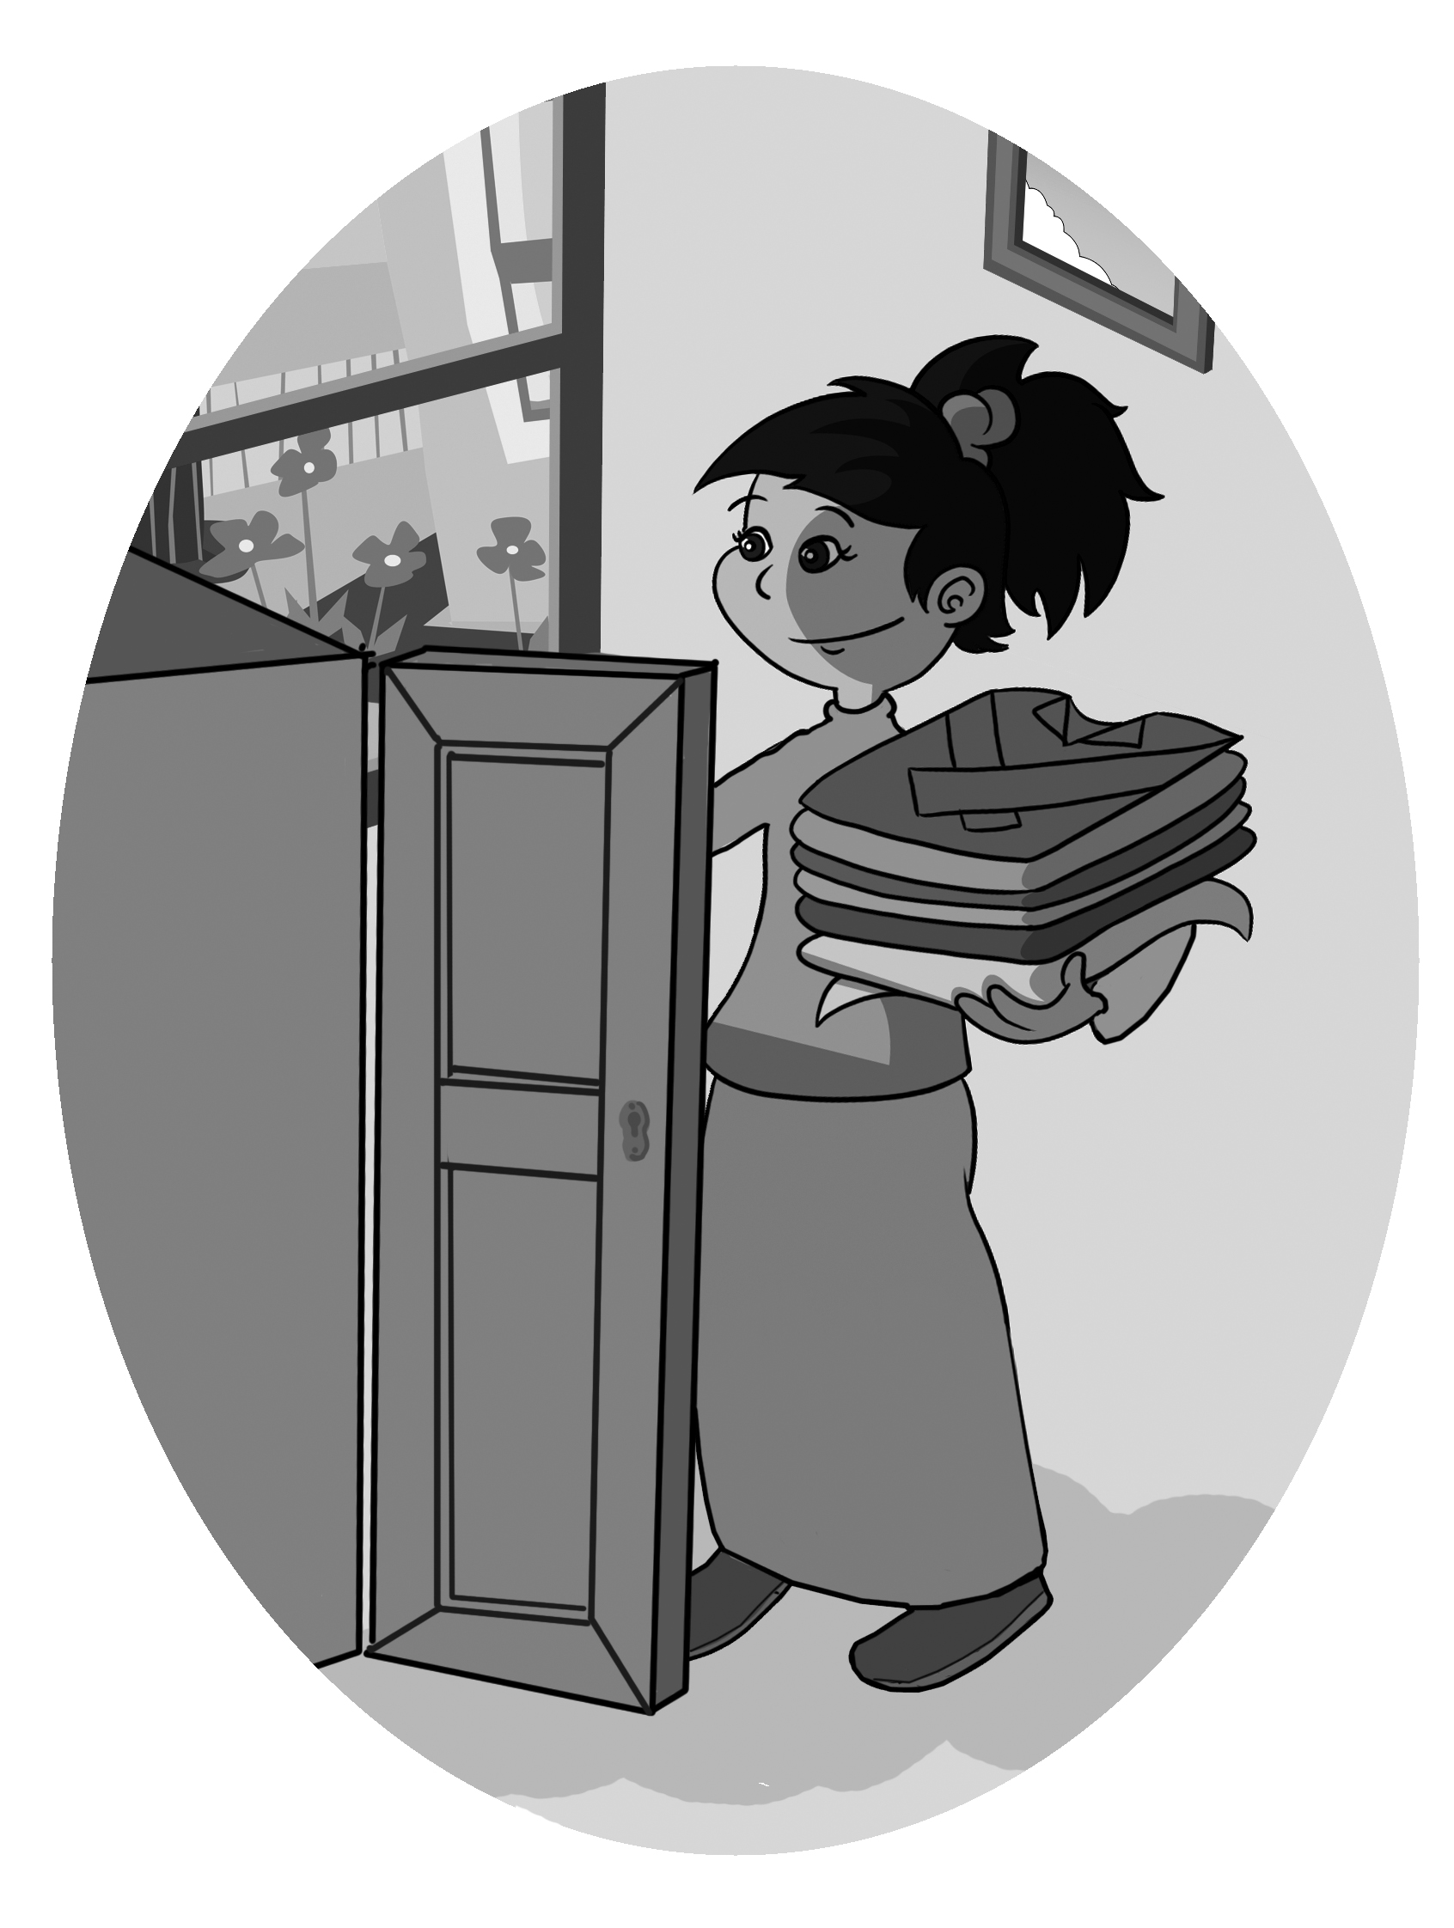
Early in the morning or in the afternoon!
What is she doing now?
She’s ________________ a snack.
Her room is clean, her chores all done!
What is the good helper doing now?
He usually ________________ shopping
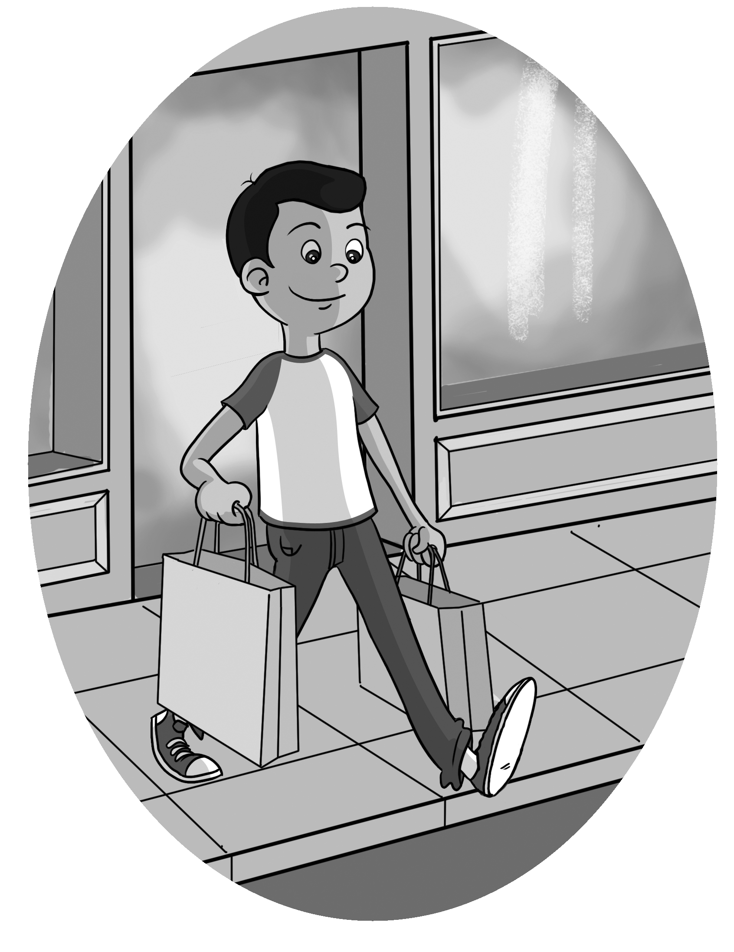
Early in the morning or in the afternoon!
What is he doing now?
He’s ________________ back.
The fish is full, his chores all done!
What are you doing now? _____________________

_________________________________________
4. Read about Nura 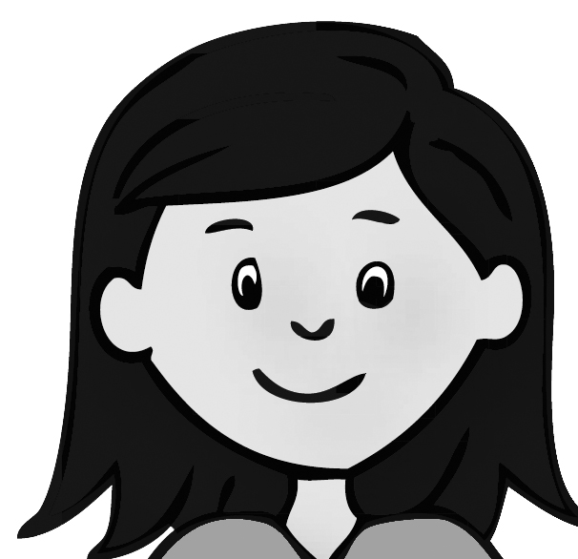 and her family, and underline the right words.
Nura and (1) his / her family live in Abha. (2) Their / Your apartment is near the center of town.
Nura‘s father is a doctor. (3) Your / Her mother is a teacher. She has two sisters. (4) Her / Their names are Fatima and Amal. They like to play in (5) her / their room and speak with (6) their / your friends.
5. Read about Hashim’s day . Write about his day yesterday.
Saeed gets up at 6:00 every morning. He eats breakfast and goes to school at 7:00. He comes home at 1:30 and eats lunch. Then he does his homework. In the evening he takes a bath and goes to bed early.
Yesterday, Saeed _______ at 6:30. He didn’t eat breakfast because he was late.
He _____ to school at 7:10. He ______ home at 2:00 because the school bus was late. He was very hungry. He ____ his lunch and ______ his homework. Then, he ______ a bath and _____ to bed early.
Answer the questions.
What time does Saeed usually go to school?
He usually goes ___________________________.
What time did he go to school yesterday?
Yesterday, he ___________________________.
What time do you usually come home?
I ___________________________
What time did you come home yesterday?
Yesterday, I ___________________________
What time do you usually eat lunch?
I ___________________________
What time did you eat lunch yesterday?
Yesterday, I ___________________________

