We Can! Book 5 Unit 4: Chores
1. Read and match with the pictures.
6  1  7  2 | 1 I feed the fish.  __ I set the table.  __ I wash the dishes.  __ I vacuum the floor.  __ I clean up my room.  __ I go shopping.  __ I take out the trash.  __ I fold the laundry | 4  8  5 3
2. Read and answer. Check the right column. Then write 3 sentences.
 | Always | Sometimes | Never
1. Do you set the table?
2. Do you wash the dishes?
3. Do you vacuum the floor?
4. Do you clean up your room?
5. Do you go shopping?
6. Do you take out the trash?
Example: I sometimes set the table.
________________________________________
_________________________________________
_________________________________________

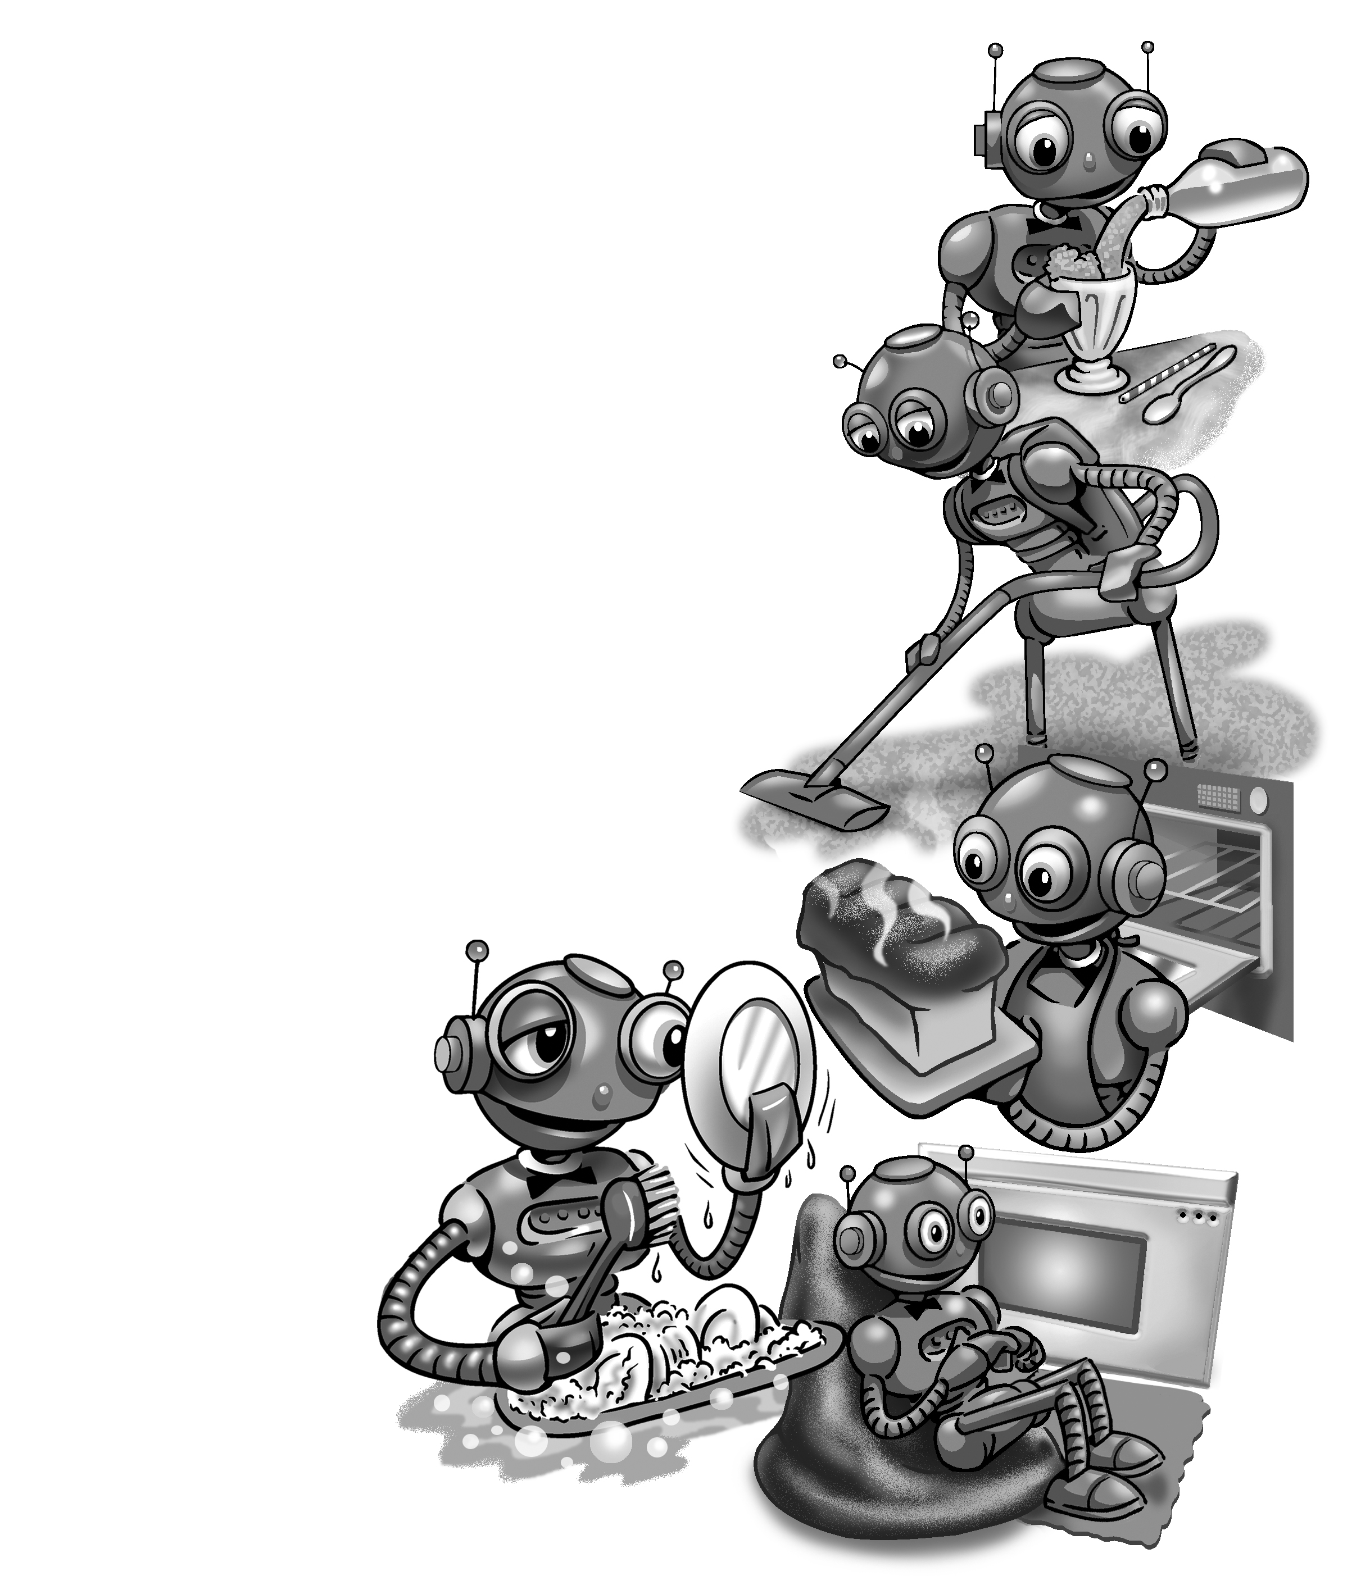
3. Listen and fill in the words.

robot gives have makes washes
bakes sits smartest keeps clean

I _____ a little _____,
The ________ ever seen,
He _____ my dishes,
And _____ the house _____.
He _____ my bread,
And _____ me a drink.
He _____ by the fire,
And _____ me a smile.

4. Read and answer the questions.
1. What chores do you do? ____________________
_________________________________________
2. What chores does your sister do? _____________
_________________________________________
3. What chores does your brother do? ____________
_________________________________________

