We Can! Book 5 Unit 3: Sports and Activities

1. Match the words with the pictures.

4 | 3 | 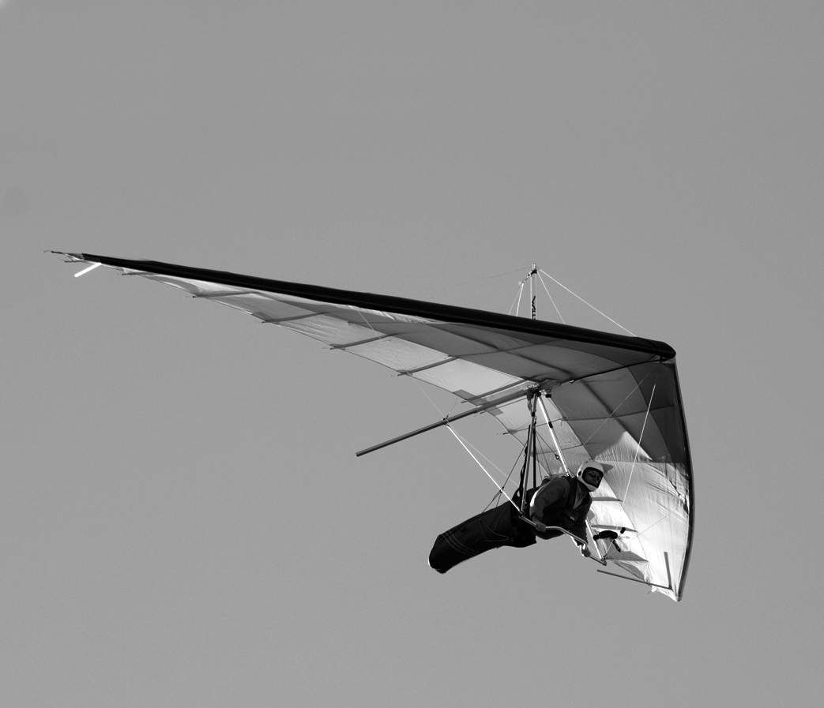 2 | 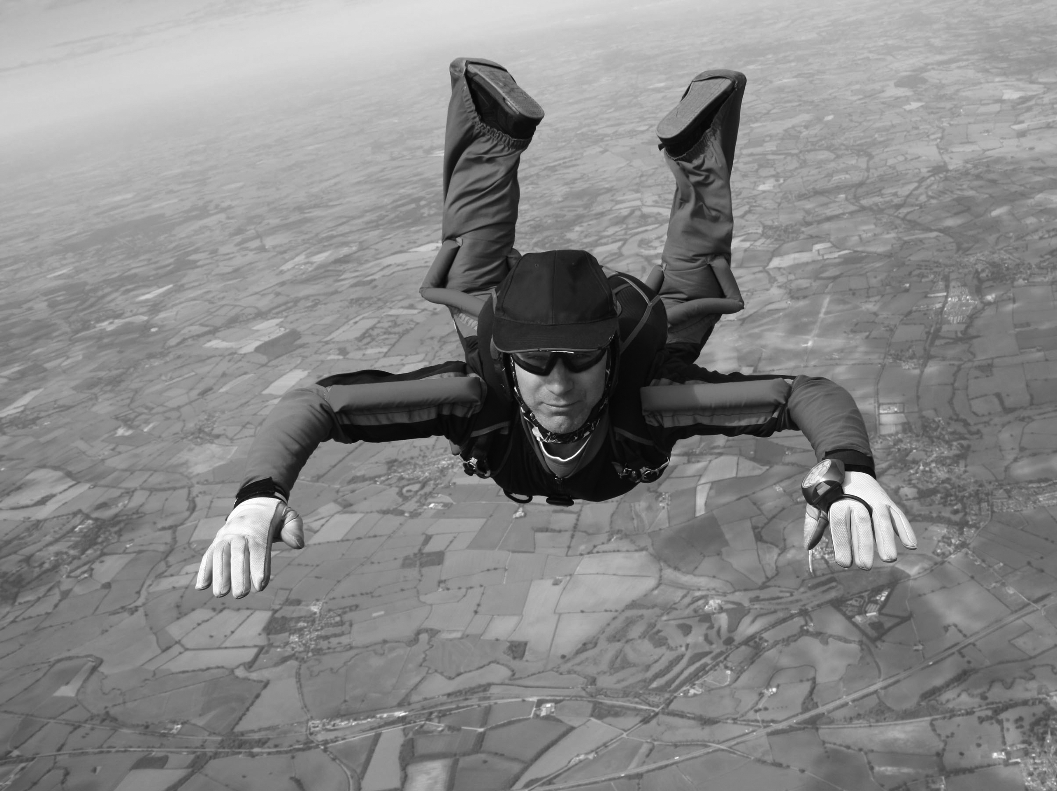 1
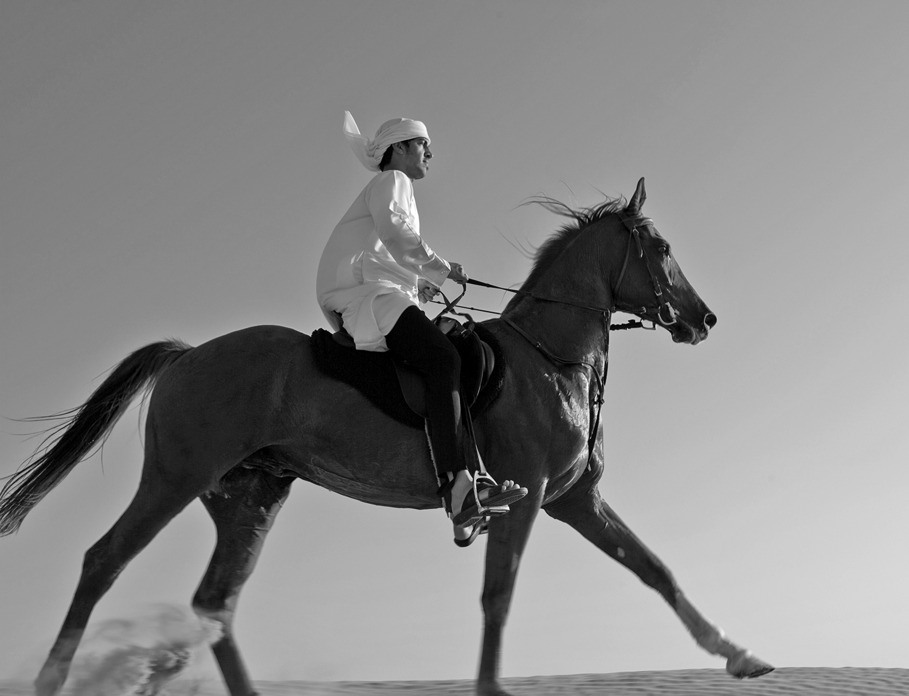 5 | __ scuba diving __ sky diving  __ football __ volleyball __ jogging  __ tennis __ basketball __ golf  __ hang gliding __ horse riding
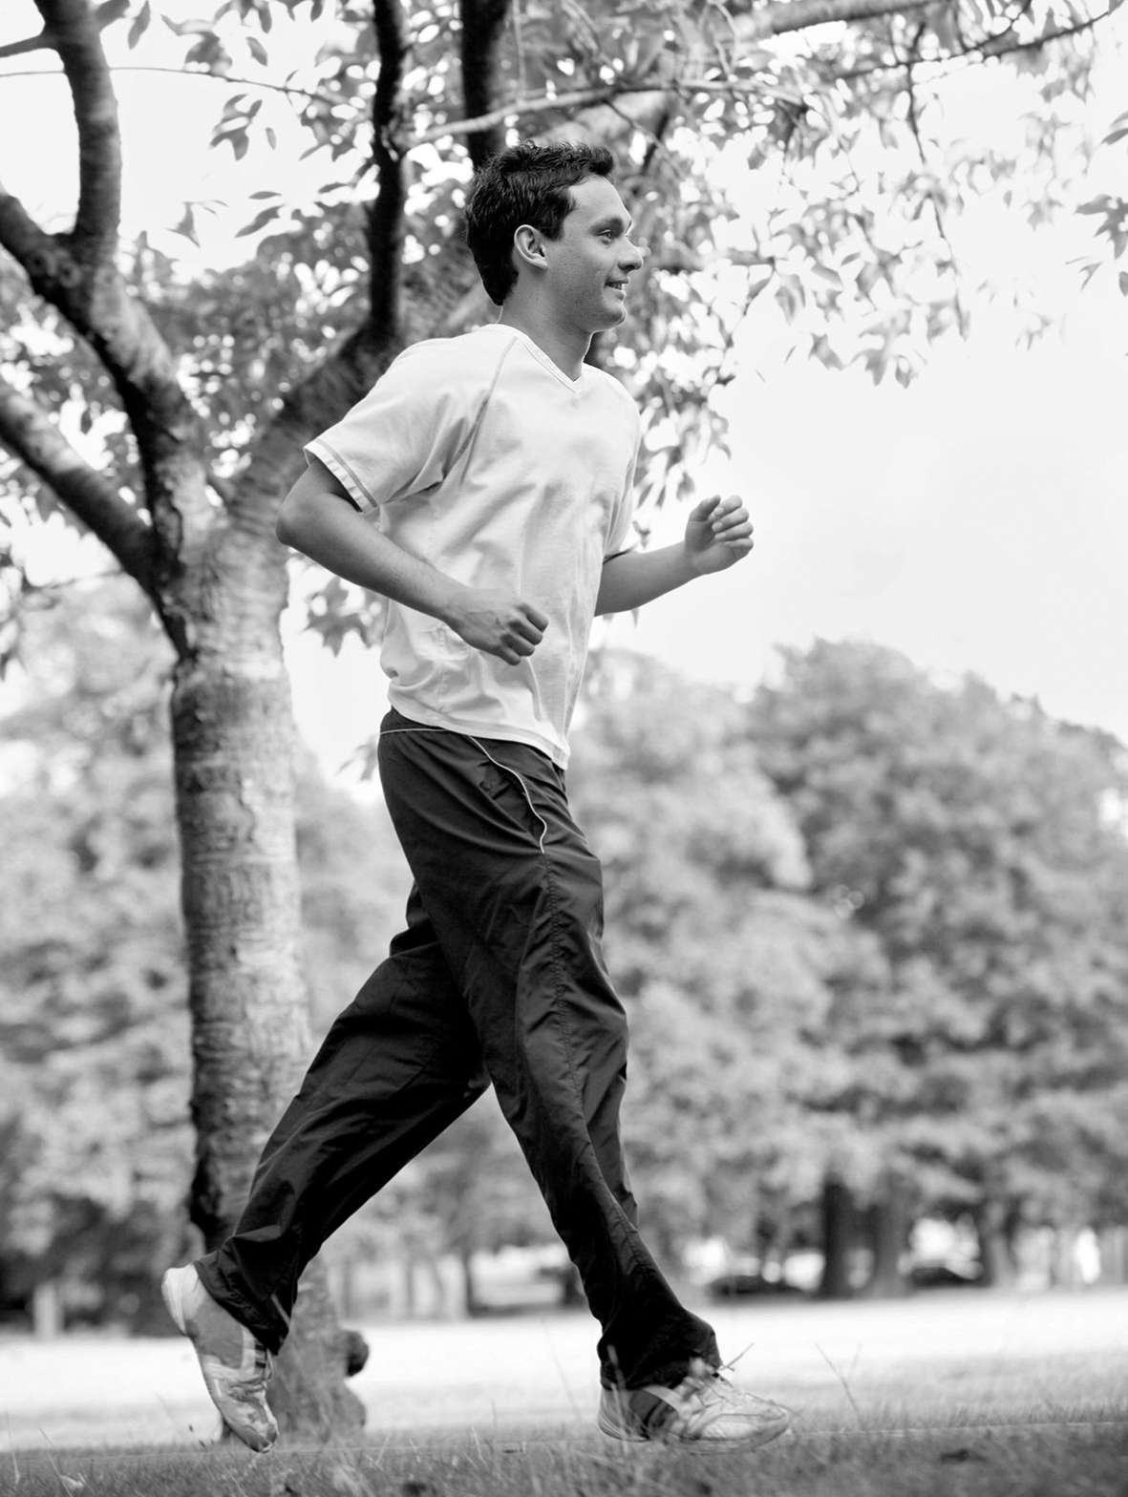 6
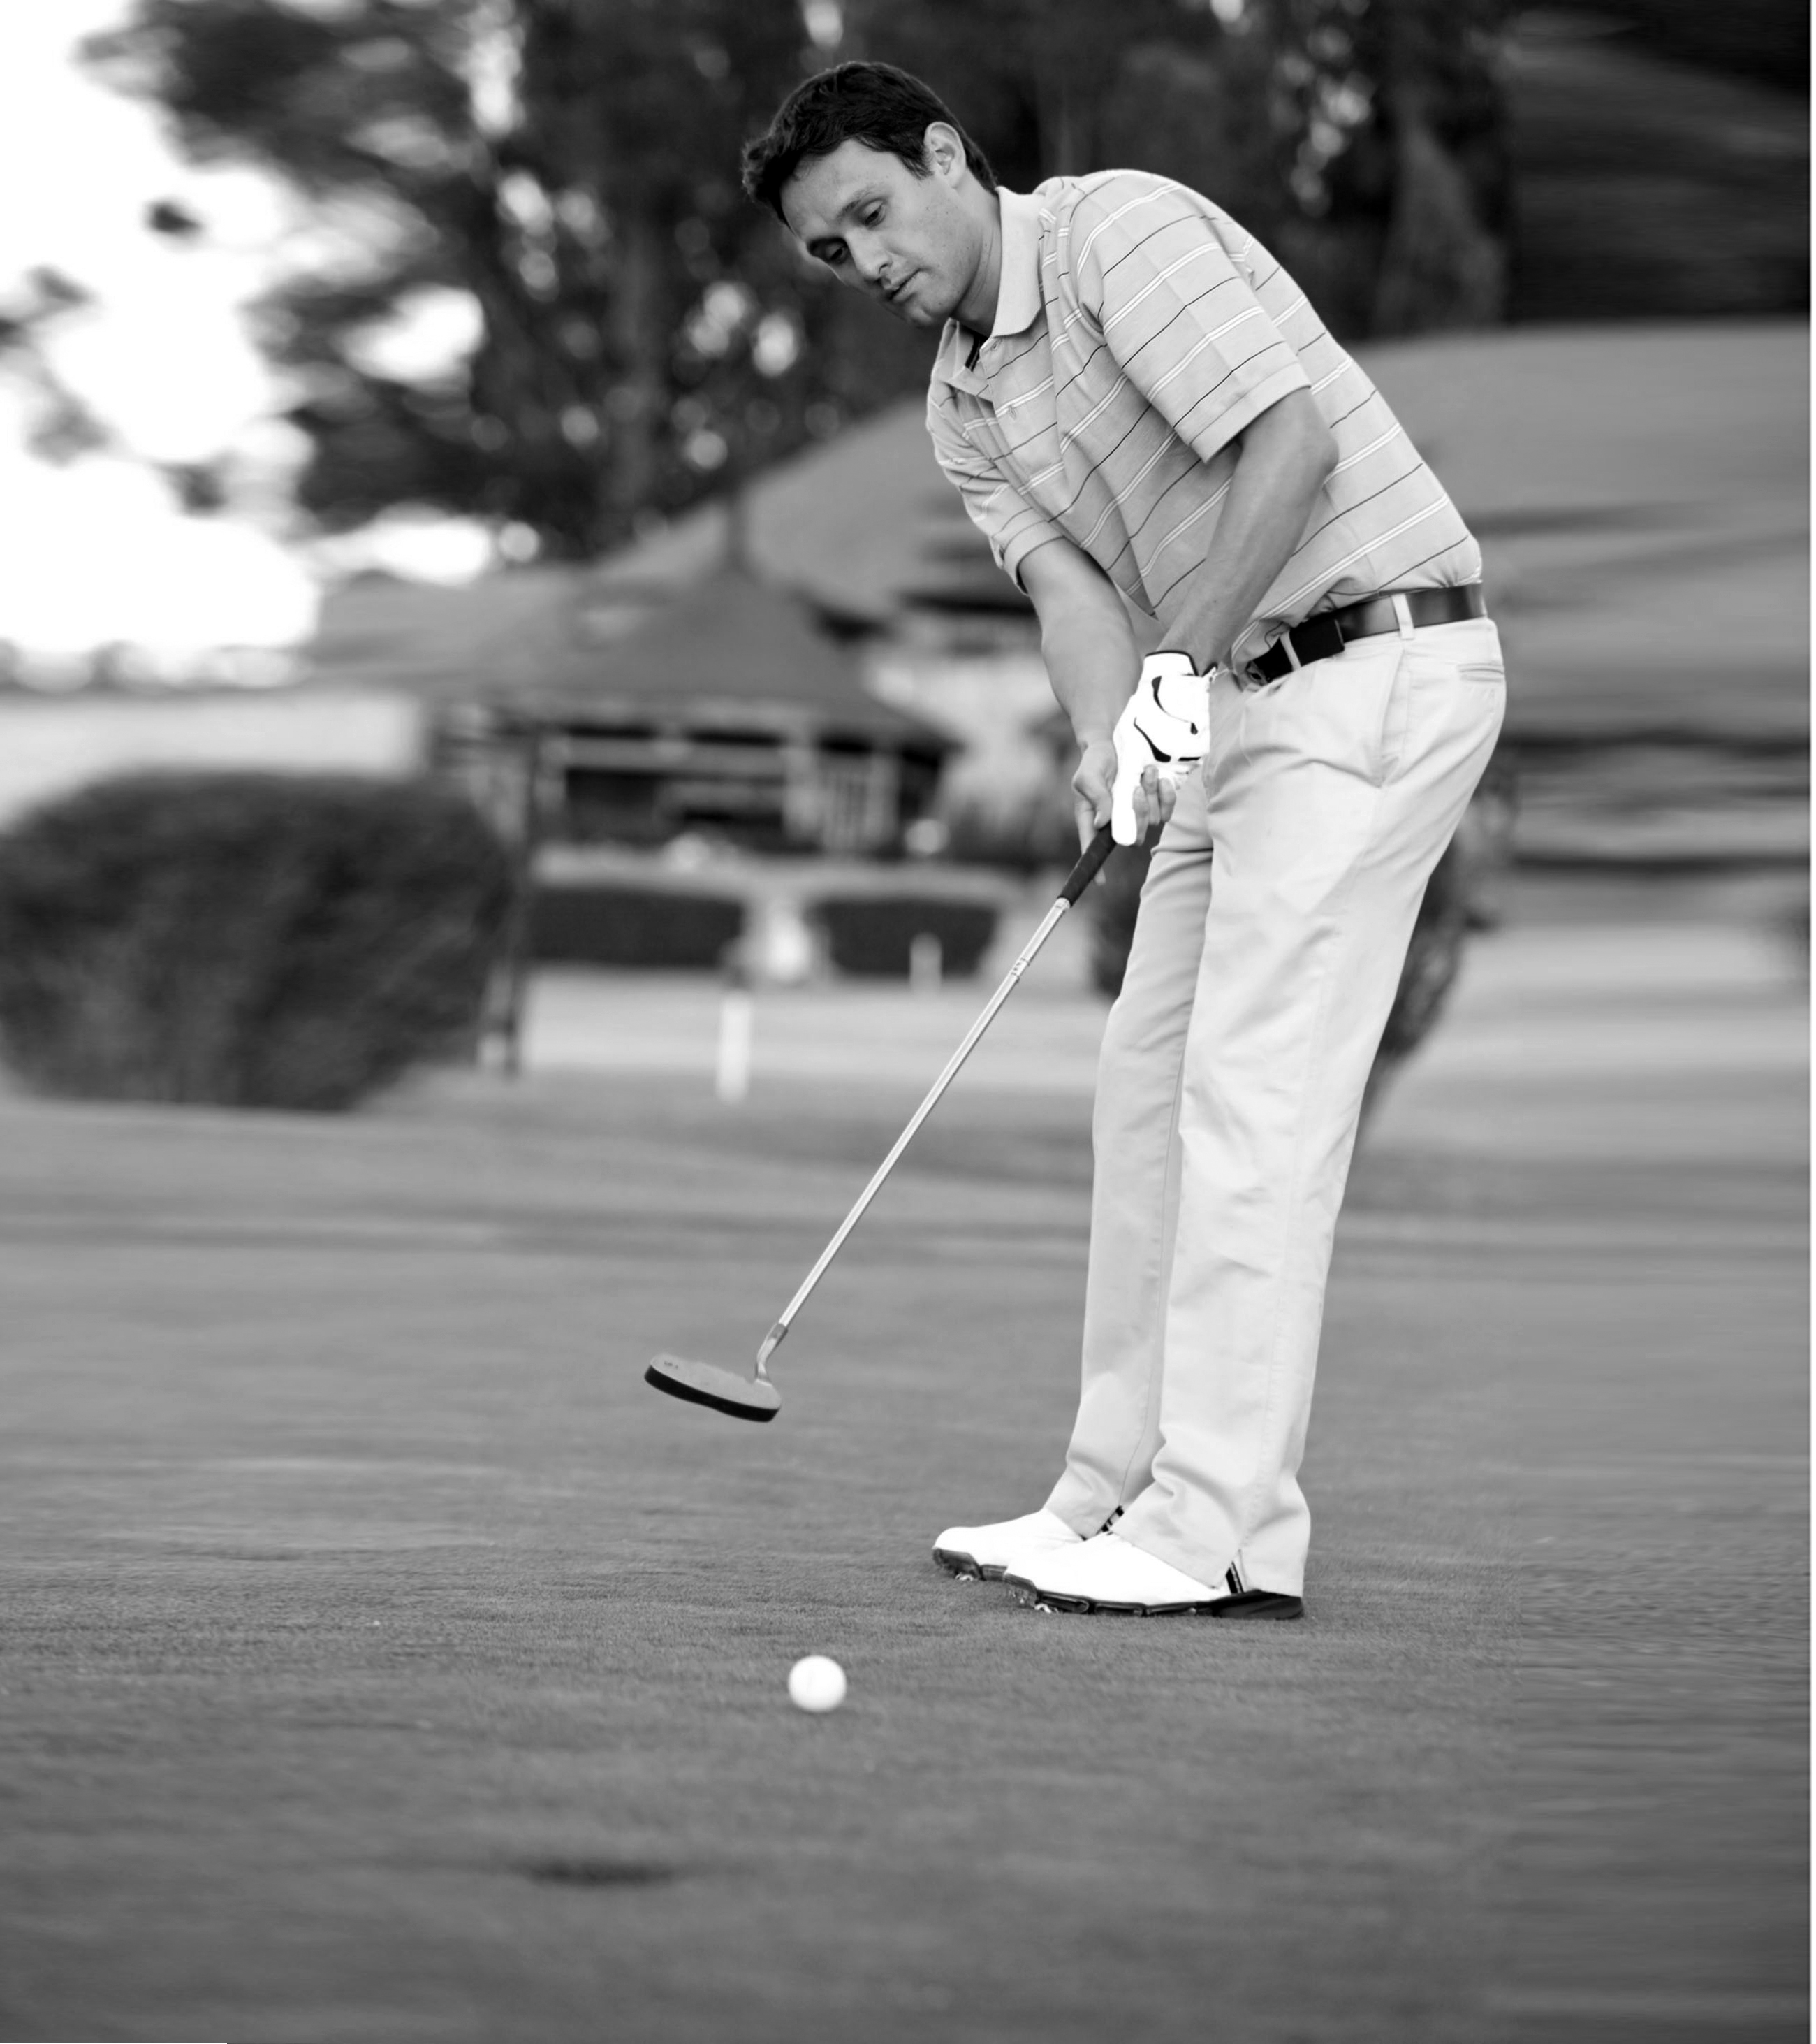 7 | 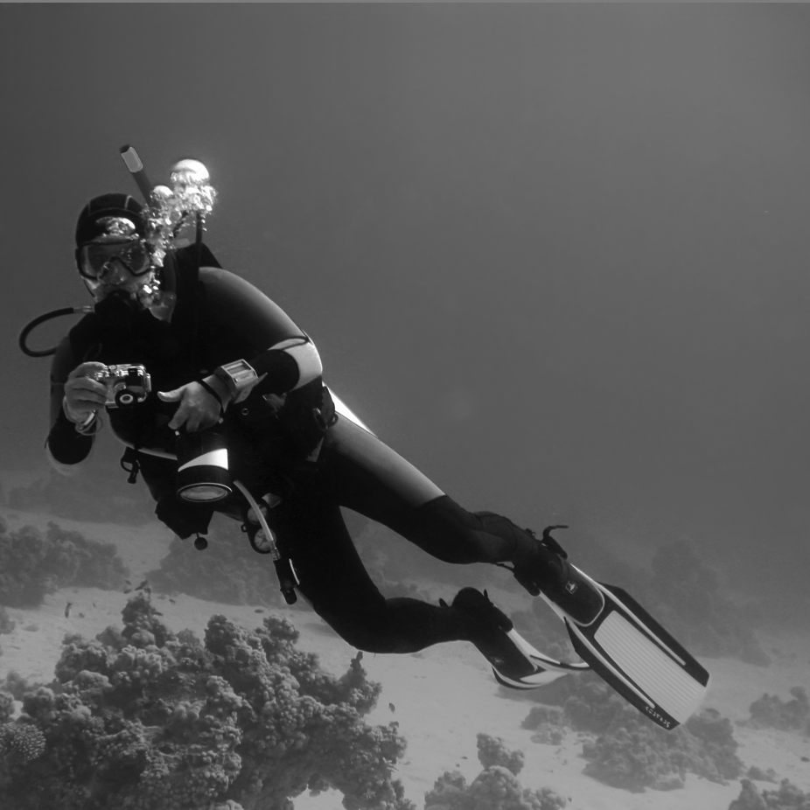 8 | 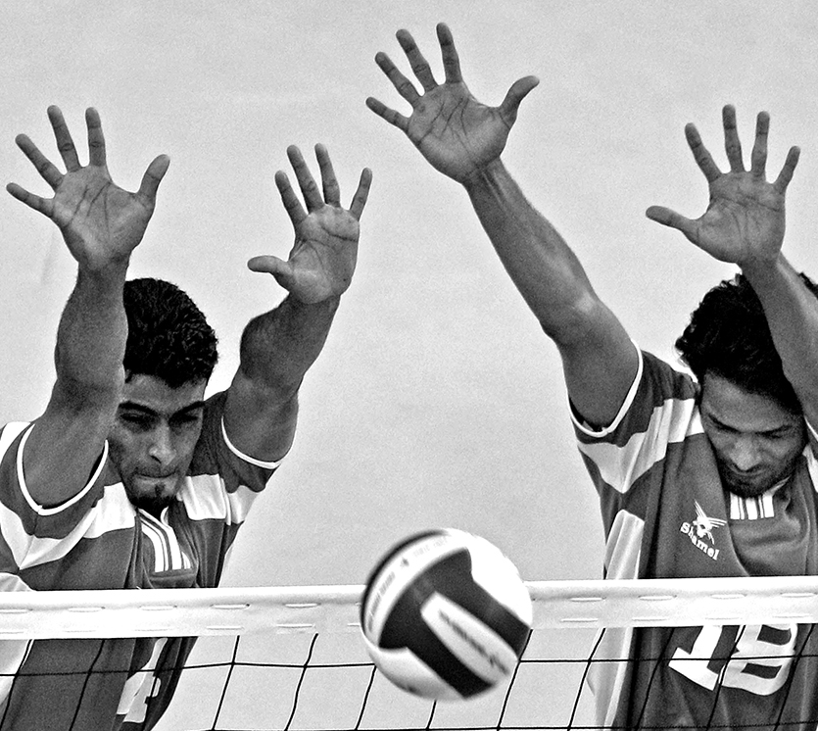 9 |  | 10

2. Read the sentences and circle T or F.
1. Roller skating is more dangerous than sky diving.  2. Skateboarding is more exciting than running.  3. Roller skating is more difficult than rock climbing.  4. Bungee jumping is more boring than tennis.  5. Basketball is the most dangerous sport.  6. Skiing is more exciting than running. | T F  T F  T F  T F  T F  T F

3. Listen, read, and complete the chant with the right words. Choose only 8 words or phrases.

tennis falconing riding scuba diving rock climbing cooking painting sky diving skiing skateboarding

I’d like to play ________ but I have no racket.  I’d like to try ________ but I have no falcon.  I’d like to try ________ but I have no horse.  I’d like to try ________ but there is no sea.  I’d like to try ________ but there is no rock.  I’d like to try ________ but there is no plane,  I’d like to try ________ but I don’t know how.  I’d like to try ________ but I don’t know how.  Try photography!  I have no camera and don’t know how! | 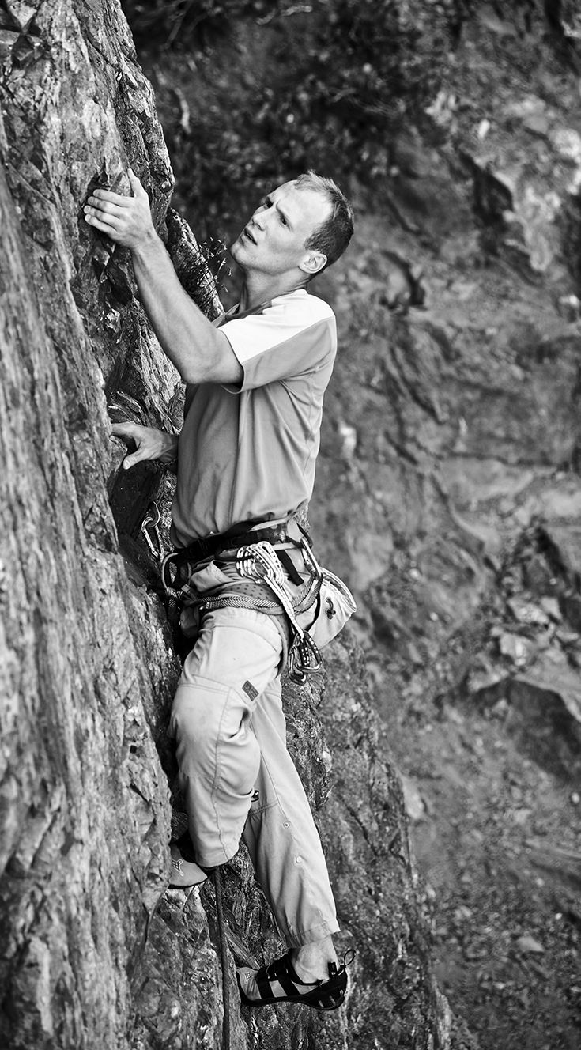  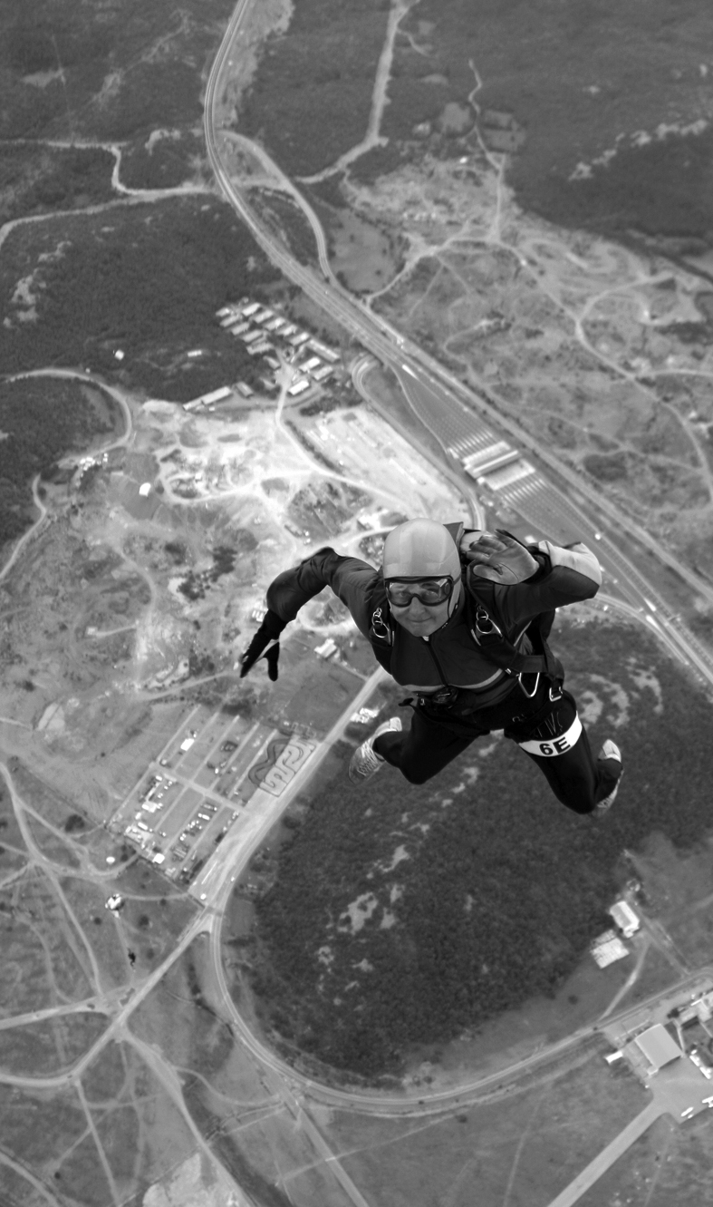
4. Read the questions and write your own answers.
1. Do you play tennis? _______________
2. Does your father play golf? _______________
3. Do you play board games? _______________
4. Does your friend do rock climbing? ______________ 5. Do you watch football games? _______________
6. Do your friends ride horses? _______________
7. Do you and your friend play basketball? __________
8. Does your friend play computer games? __________

