We Can! Book 3 Revision

1. Listen and circle number the missing words. Then write.
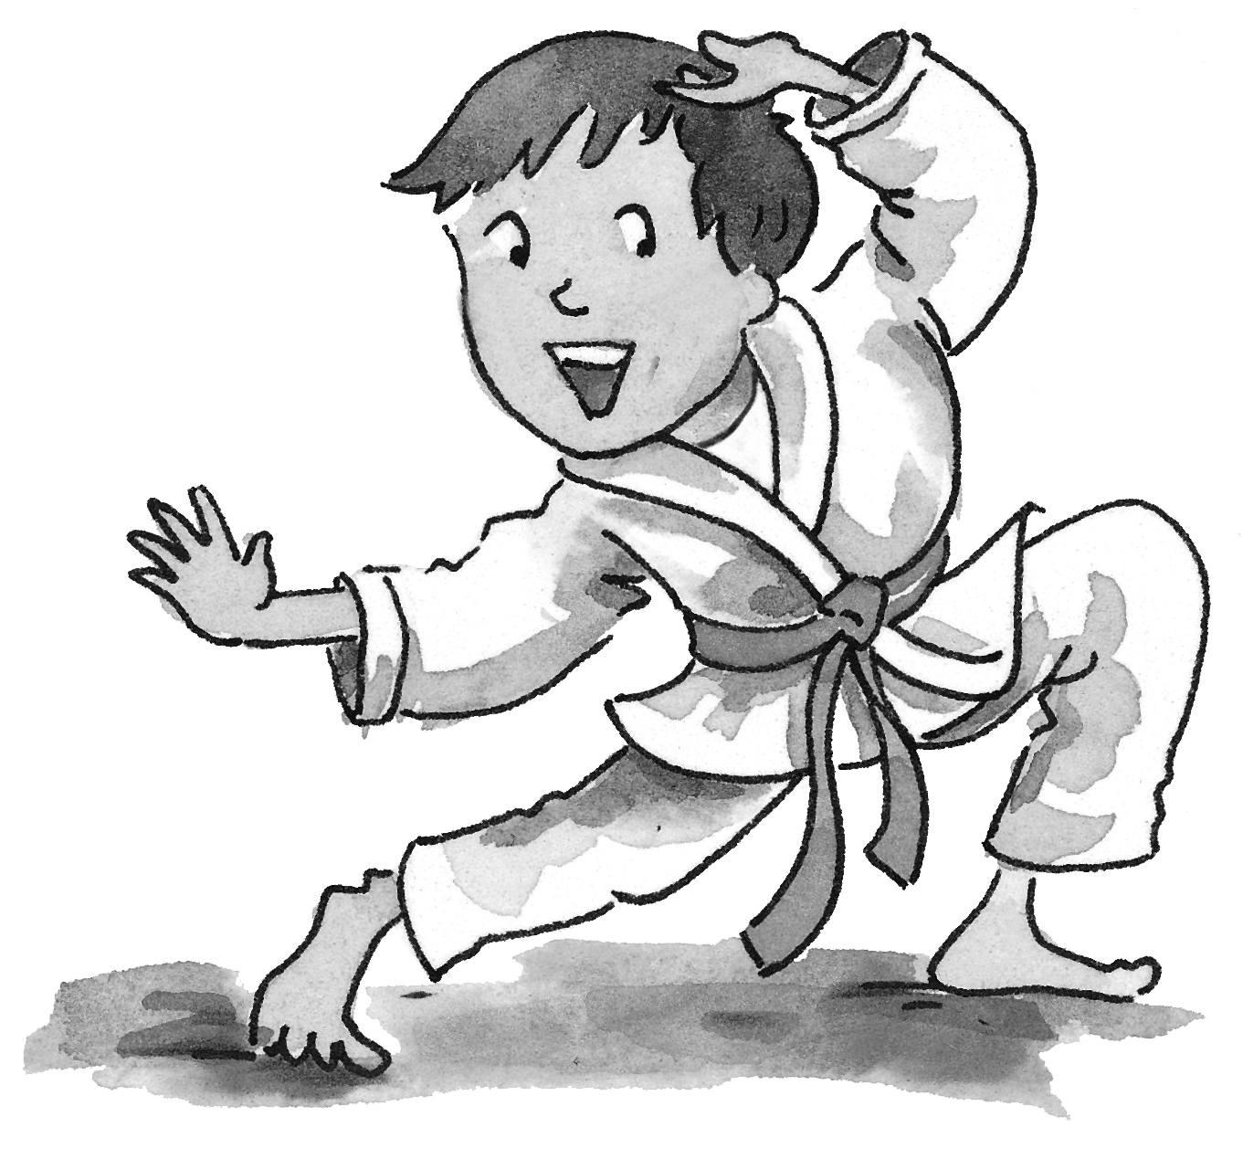
_______ are you _______?
I’m __________, doing karate,
doing karate.
______________ doing?
I’m _______ karate,
and _______ about _______?

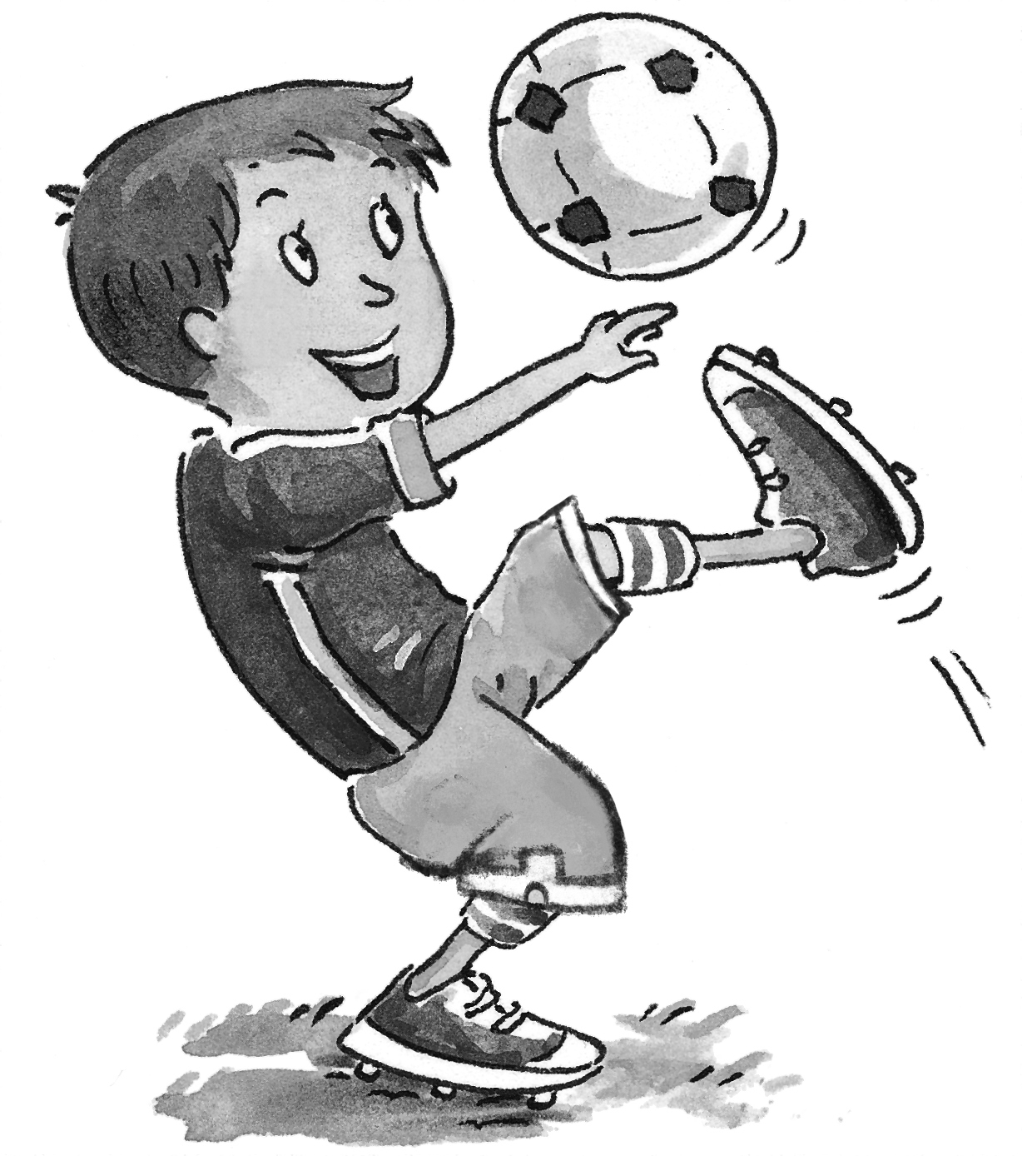
What _______ doing?
I’m ___________, ___________,
___________,.
What ___________,?
________playing football,
and __________________?

2. Now choose an activity and write your own chant.
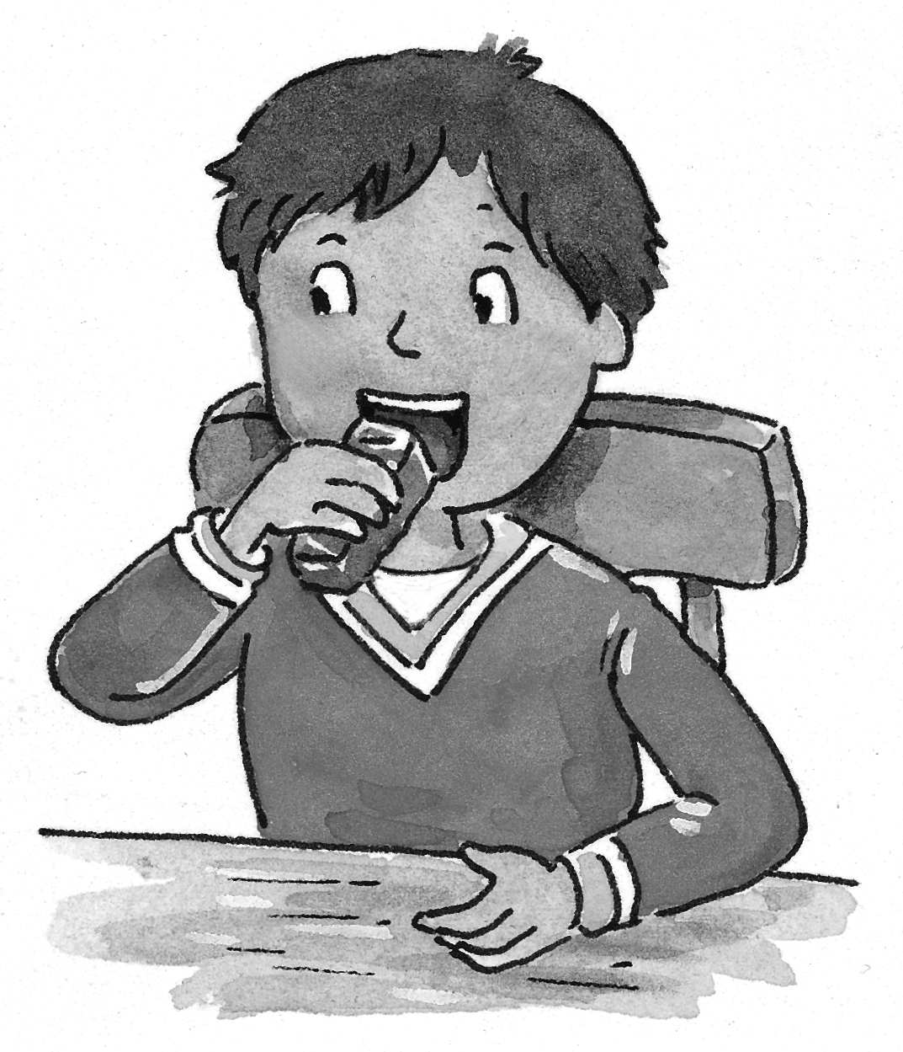 | What ______________?  I’m ________________, ___________________,  ______________.  What ______________?  I’m________________, ___________________,  ______________.  and ______________? | 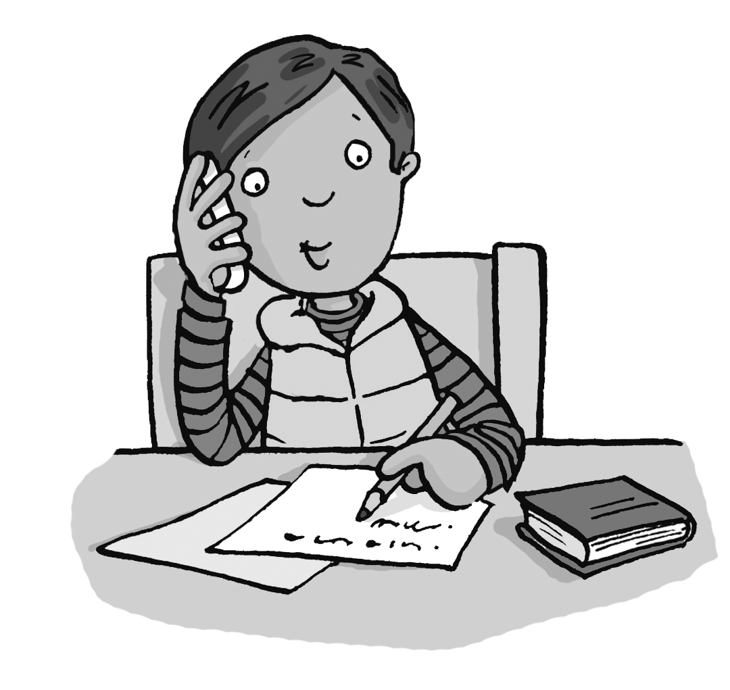
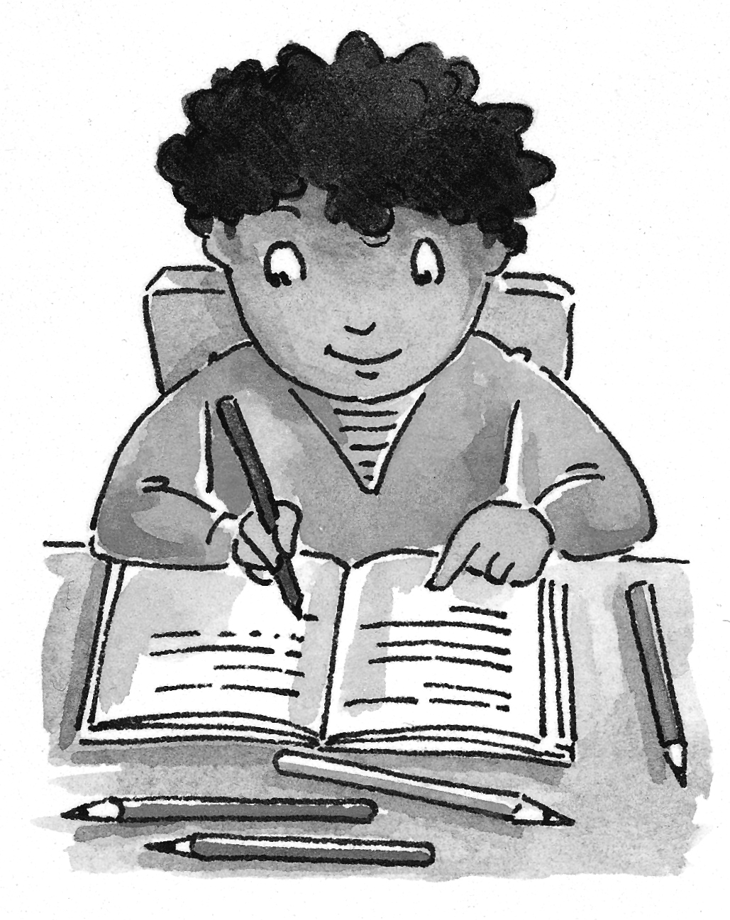 |  | 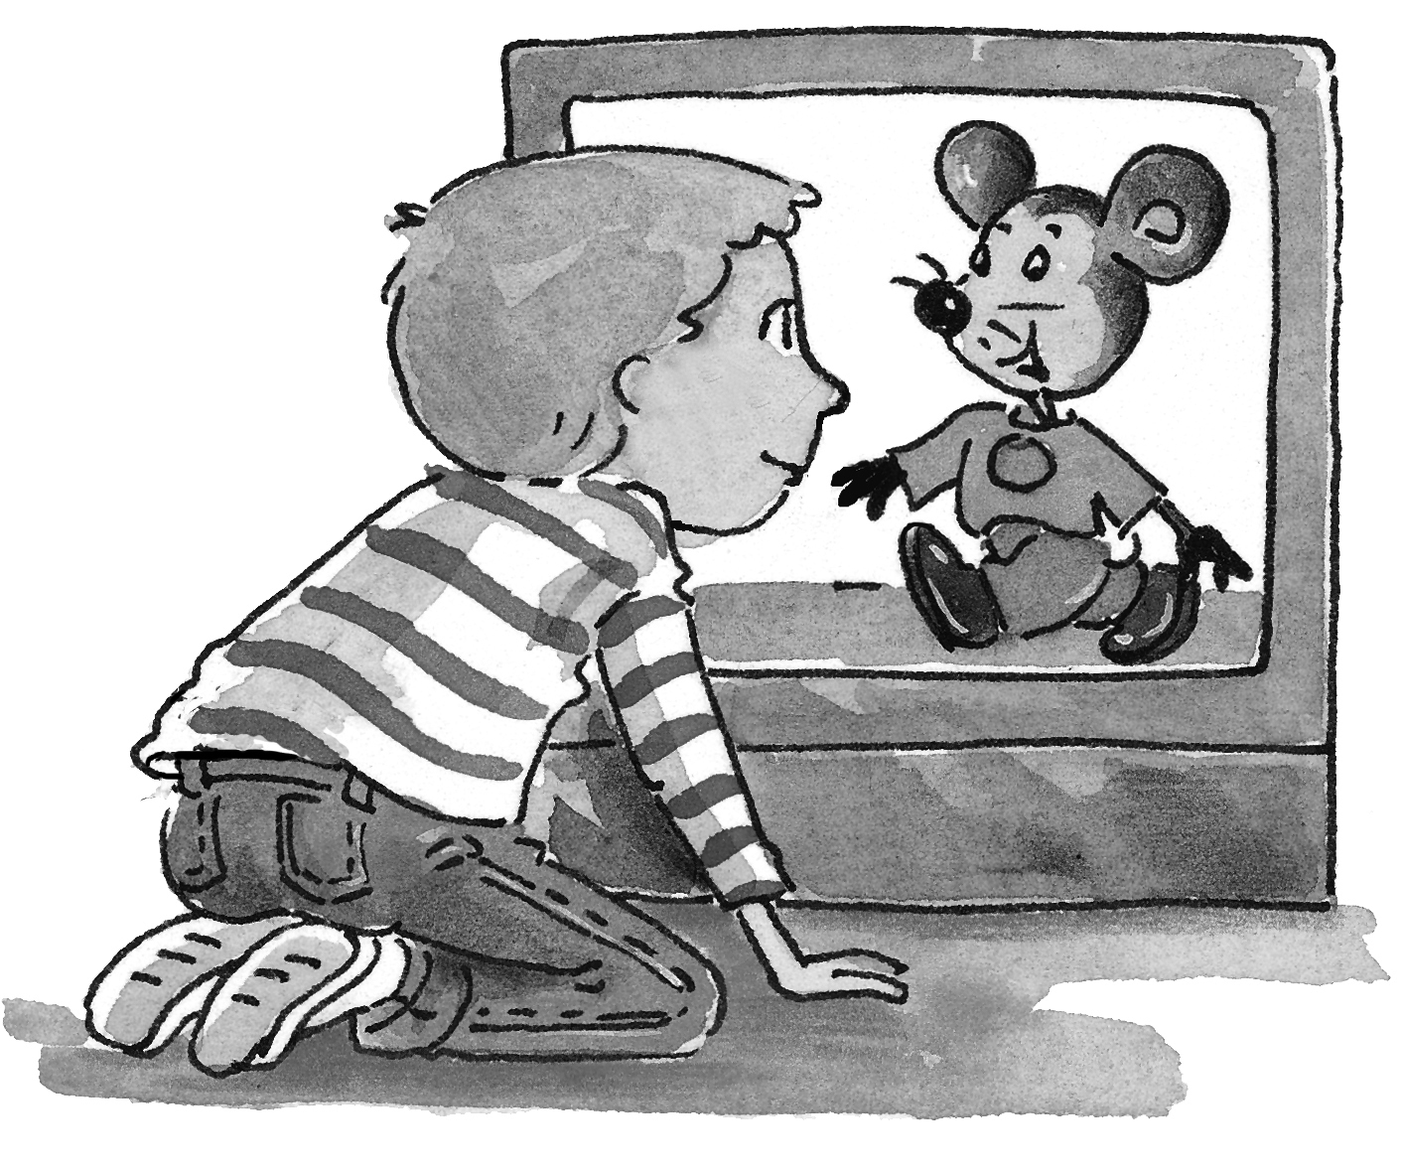
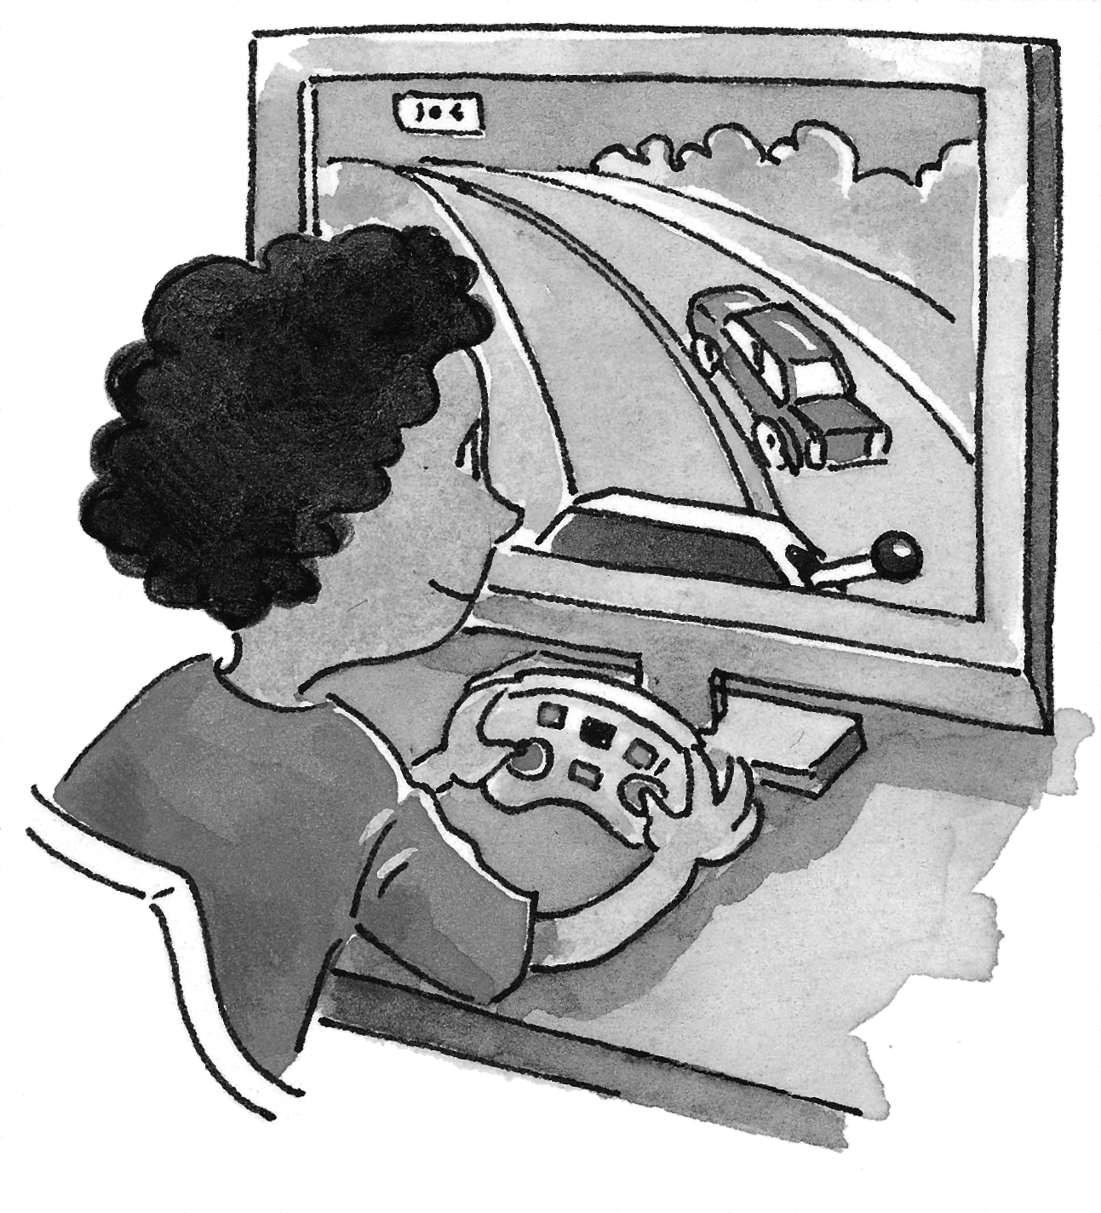 |  | 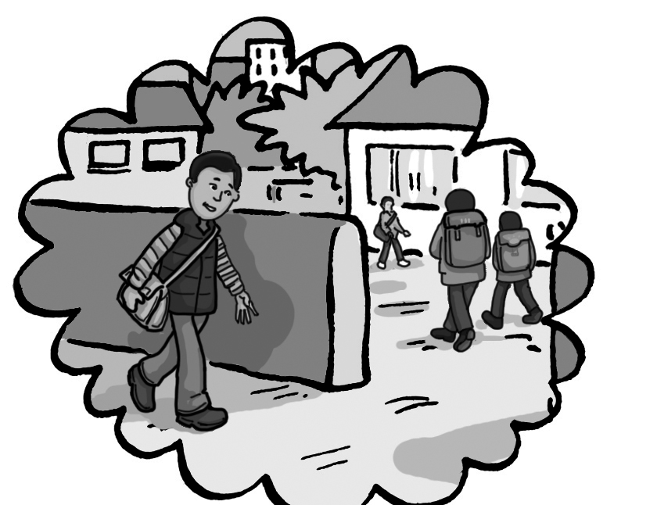
3. Read and circle YES or NO.

About animals
1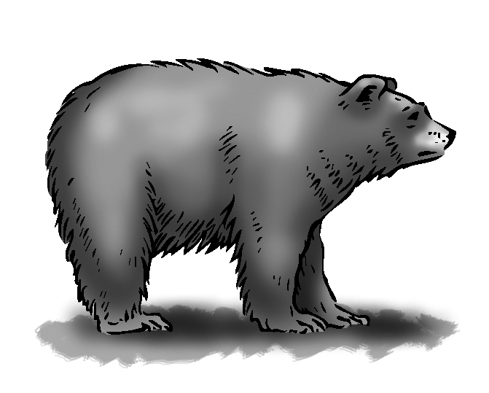 | The bear is small.  It’s strong. |  | YES NO  YES NO
2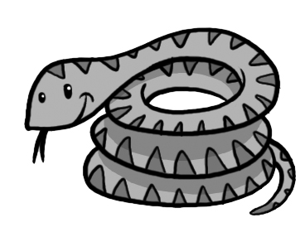 | The snake is short.  It’s quiet. |  | YES NO  YES NO
3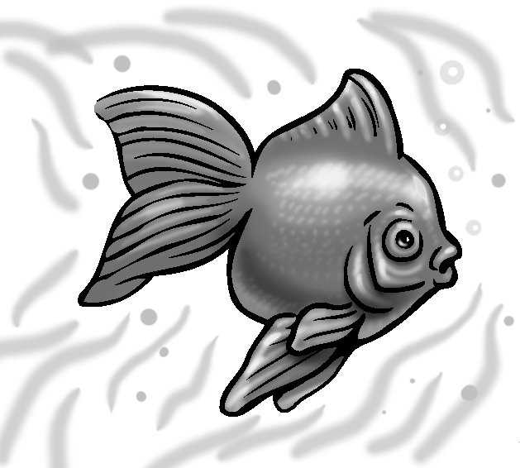 | The fish is long.  It’s noisy. |  | YES NO  YES NO
About food
4  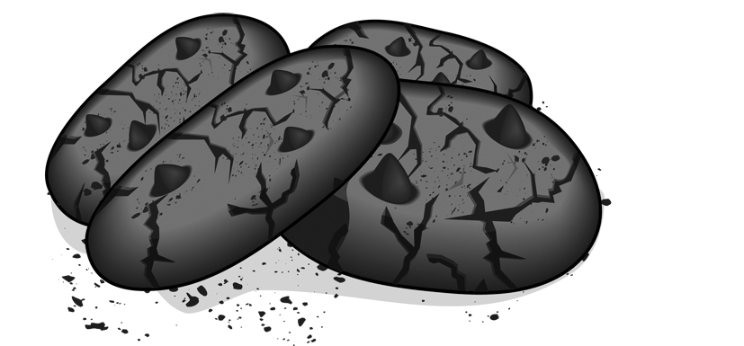 |  | Cookies are round and sweet! | YES NO
5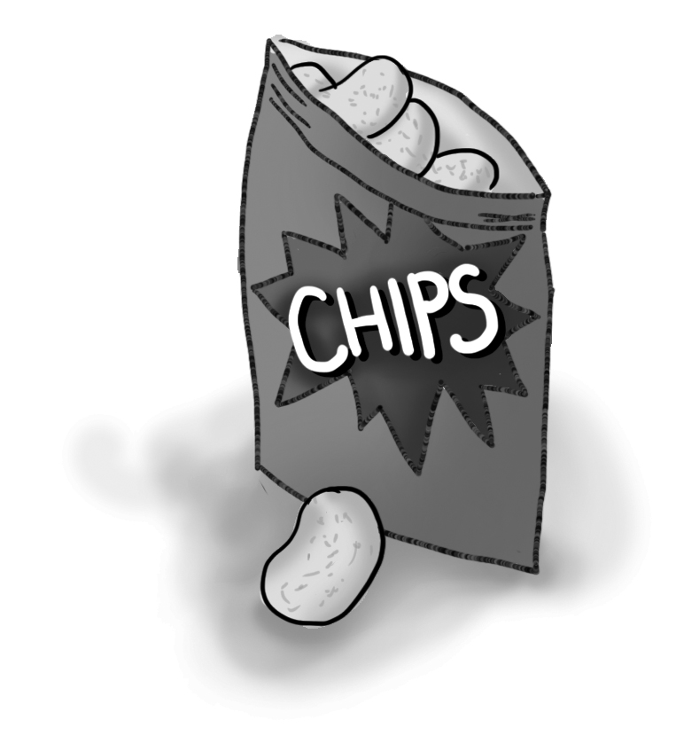 |  | Chips are thin and yellow.  They’re sweet. | YES NO  YES NO
6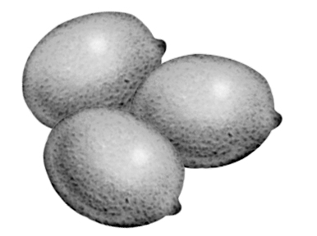 |  | Lemons are white.  They’re sour. | YES NO  YES NO
7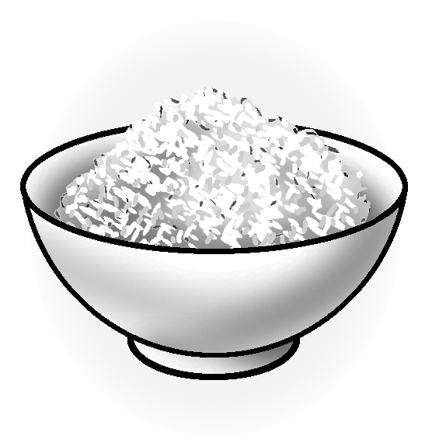 |  | Rice is white or brown.  It’s cold. | YES NO  YES NO
8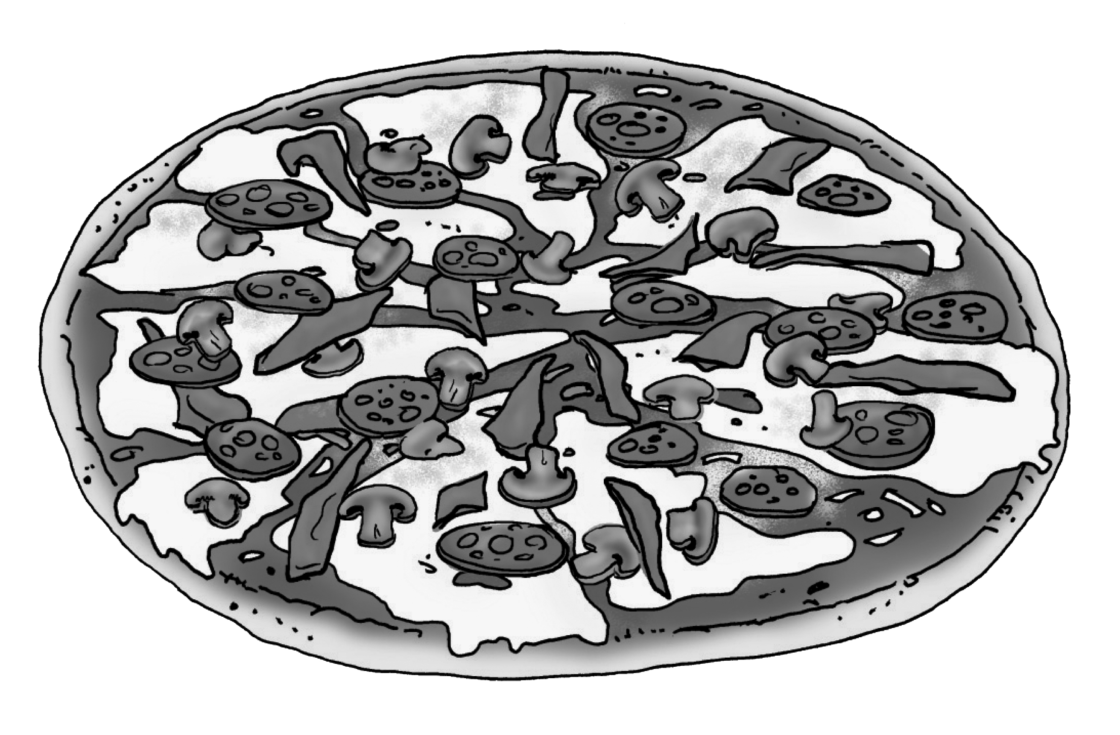 |  | It’s square.  It’s tasty. | YES NO  YES NO
9 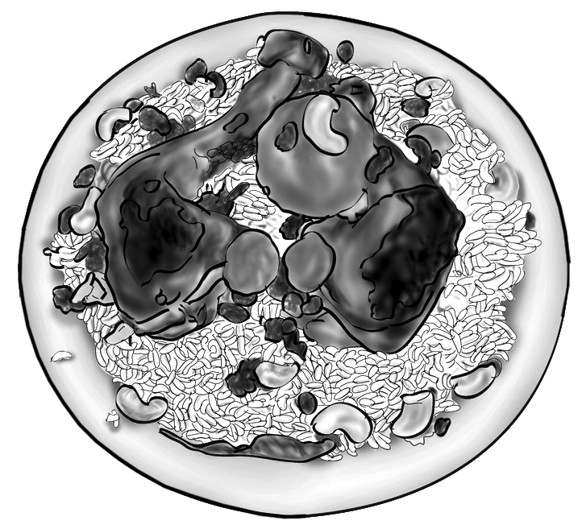 |  | Kabsa is a Saudi dish.  It’s a dish with rice and potatoes. | YES NO  YES NO
10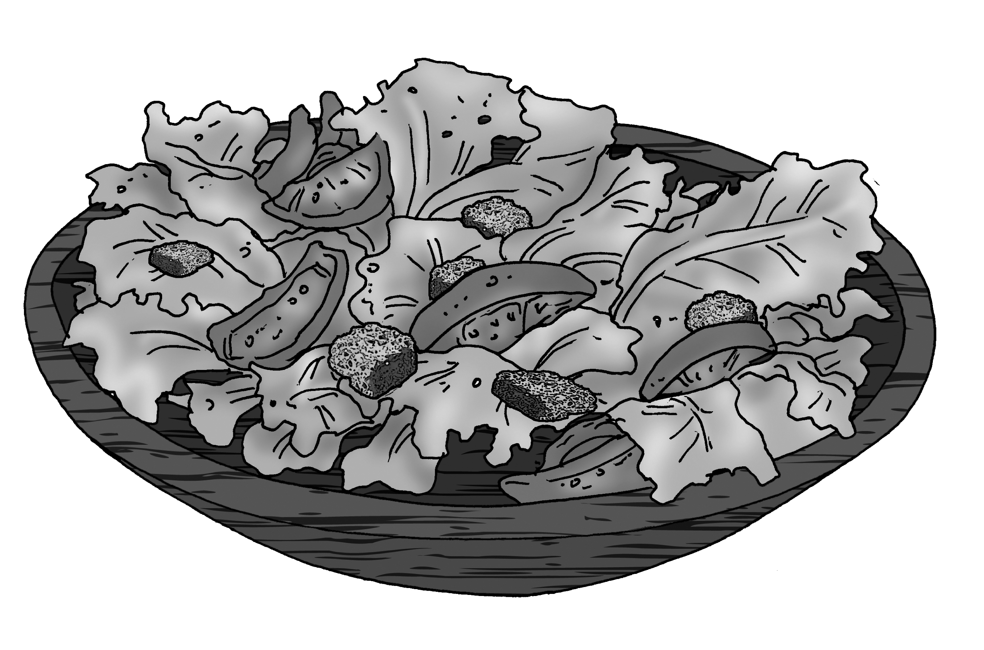 |  | It’s green and red.  It’s nice and hot! | YES NO  YES NO

4. Write questions and answers. Use this/ that, or these/ those, and the words.

What’s ______? | 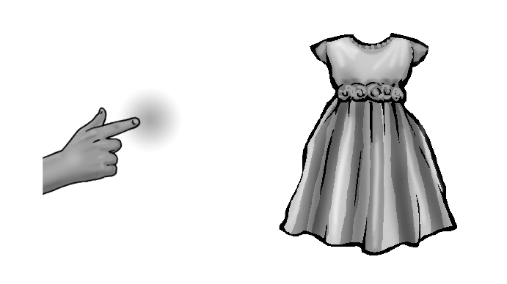 | It’s a _____.
What are_____? | 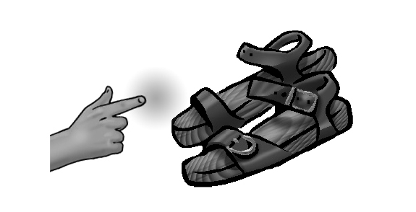 | They’re _____.
What’s _____? | 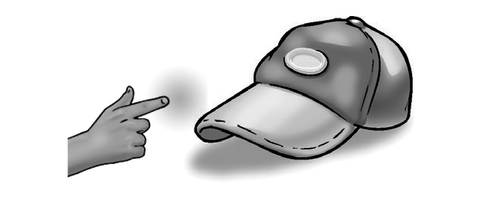 | ___________.
What are_____? | 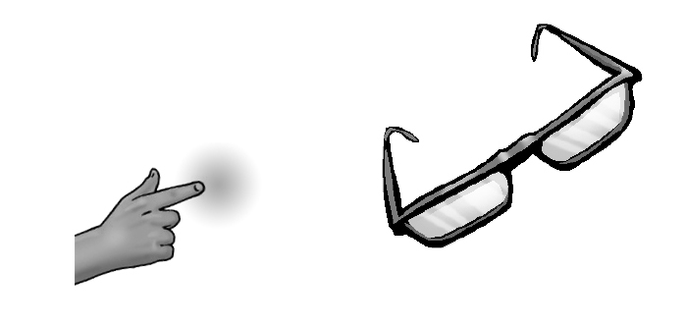 | ___________.
___________? | 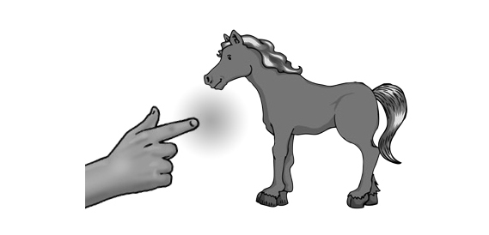 | ___________.
___________? | 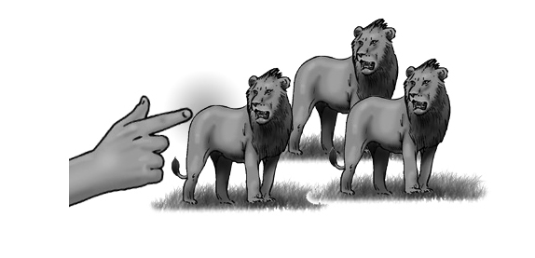 | ___________.
___________? | 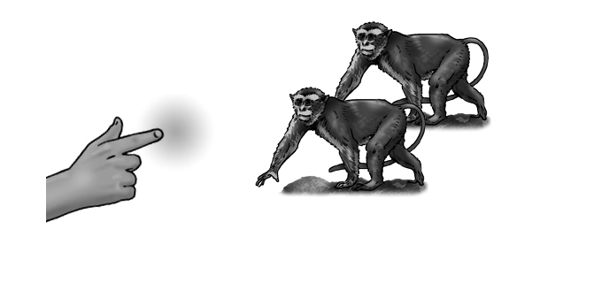 | ___________.
___________? | 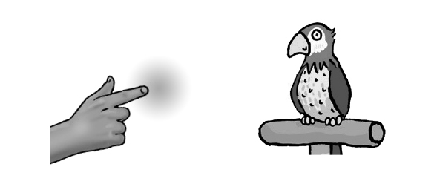 | ___________.

5. Answer the questions.
1. What are you doing now? ________________
2. Is your friend eating snacks? ________________
3. Do you like sandwiches? ________________
4. Do you have a pet? ________________

