We Can! Book 5 Unit 2: Sea Animals

1. Listen and fill in the blanks.

A: What‘s that?
B: It‘s a ___________________ .
A: What do you think about it?
B: I think it‘s ________________.
A: What are those?
B: They‘re ___________________.
A: What do you think about them?
B: I don‘t think they‘re ______________.
2. Read and match the words with the pictures. Write.
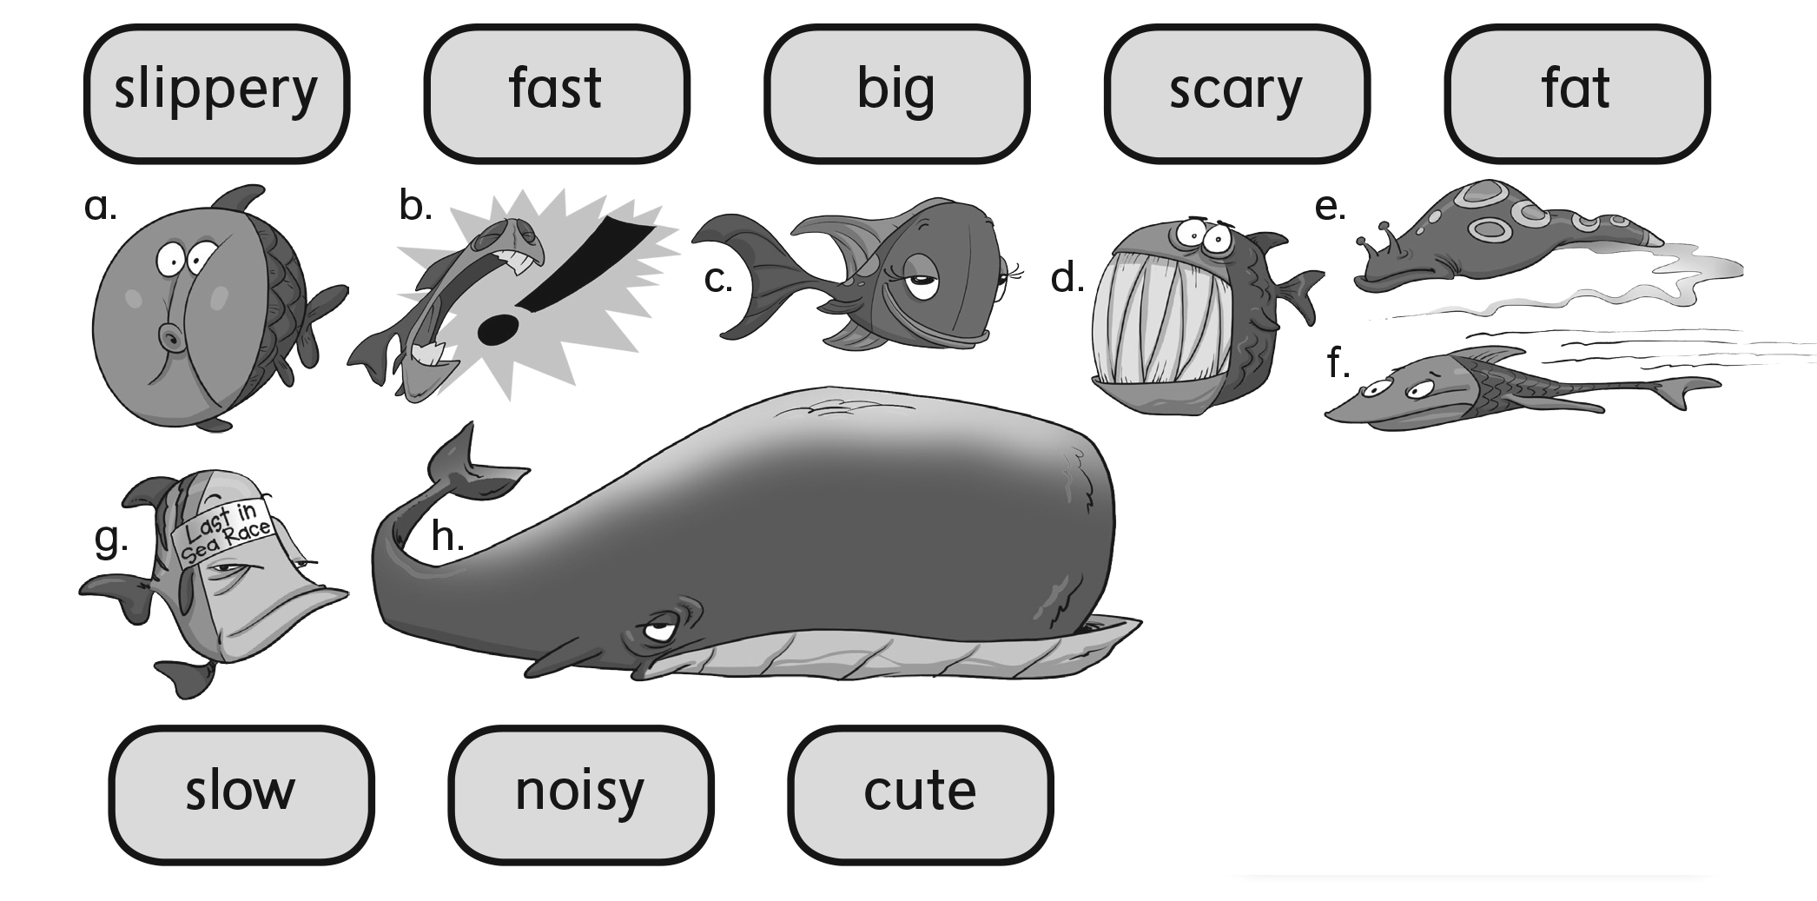
a. _______ b. _______ c. _______ d. _______
e. _______ f. _______ g. _______ h. _______

3. Listen and fill in the words.

eel walrus whale dolphin shark seal seahorse seagull

As slippery as an ______.  As fat as a _______.  As big as a _______.  As fast as a _______.  As scary as a _______.  As cute as a baby _____.  As slow as a _______.  As noisy as a _______. | 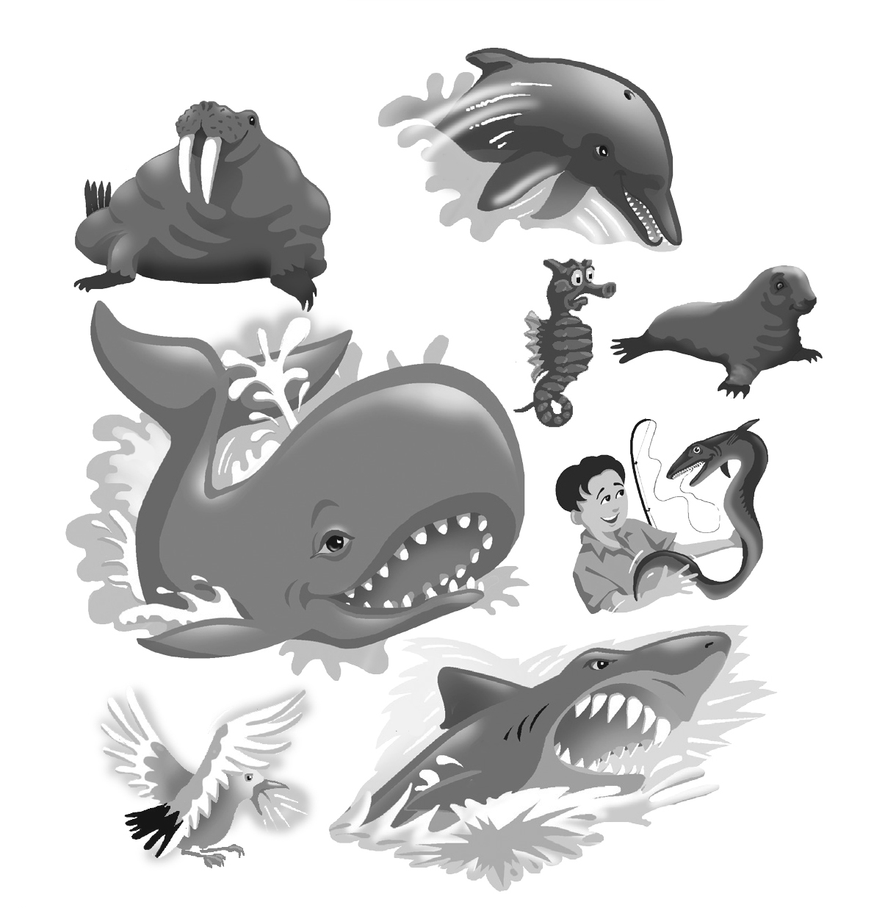
4. Listen and fill in the words.

cute cuter cutest fast faster fastest

I think …
a dolphin is _______.
a seahorse is _______ than a dolphin.
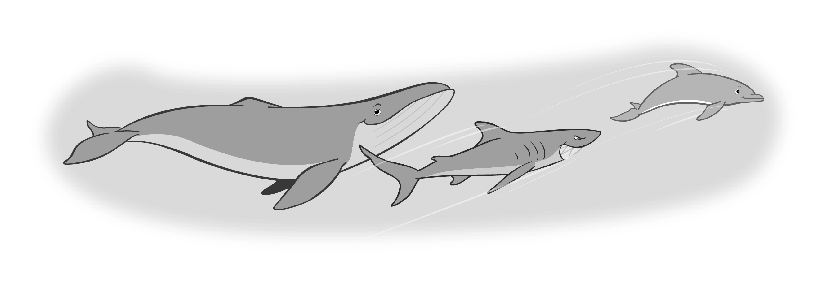
a baby seal is the _______.

I think …
whales are _______.
sharks are _______ than whales.
dolphins are the _______.

