We Can! Book 1: Revision

1. Listen and color 5 words. Then trace and write.

Red and yellow and pink and blue,
Purple and orange and green.

I can see a rainbow,
See a rainbow,
_See_ a __rainbow__ now.

2. Listen and circle the number. Then read and underline the right word.
1 5 2• | two one five
3 7 2•• | three seven two
4 8 3••• | eight four three
8 6 4•••• | eight four six
2 5 7••••• | seven five two
9 8 6•••••• | eight nine six
9 7 3••••••• | seven nine three
6 9 8•••••••• | eight six nine
5 9 6••••••••• | five nine six
10 2 9••••••••  •• | two ten nine
3. Write.

My name is _______________________.

I’m _____________ years old.
4. Listen and circle.

5 | a b c  d e f | 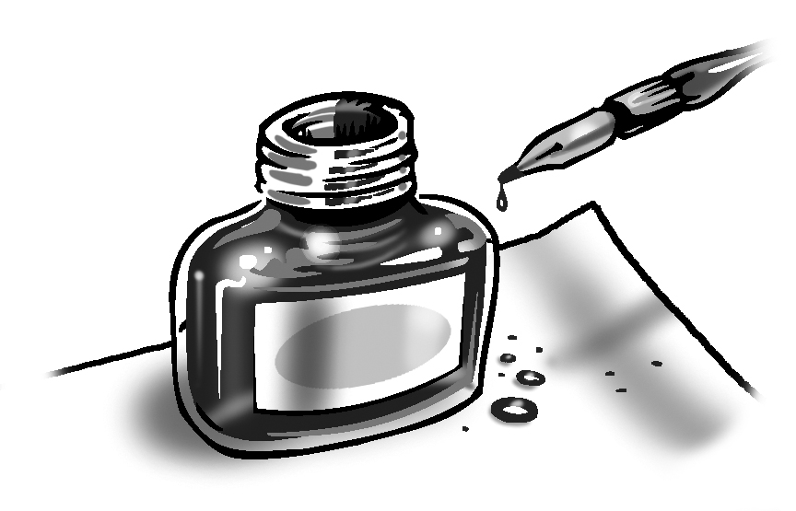 | g h i j k l
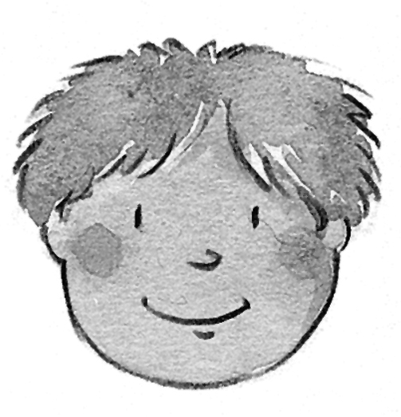 | c d e f g h | 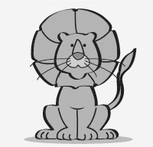 | g h i j k l
8 | a b c  d e f | 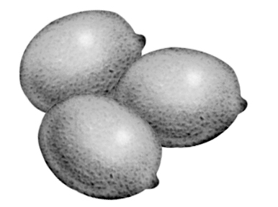 | j k l  m n o
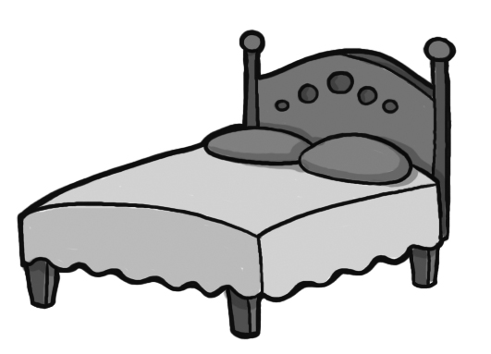 | a b c  d e f | 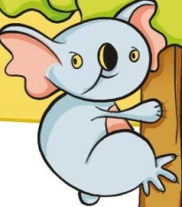 | j k l  m n o
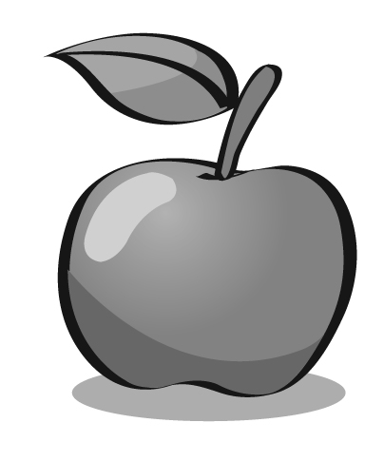 | a b c  d e f | 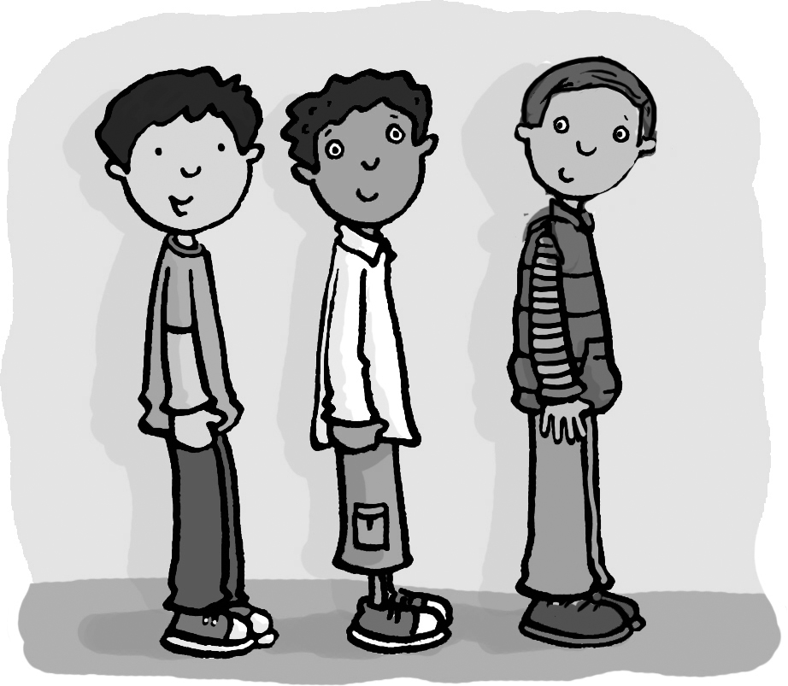 | j k l  m n o
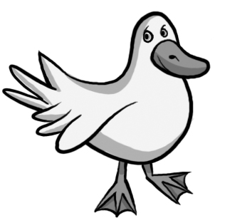 | a b c  d e f | 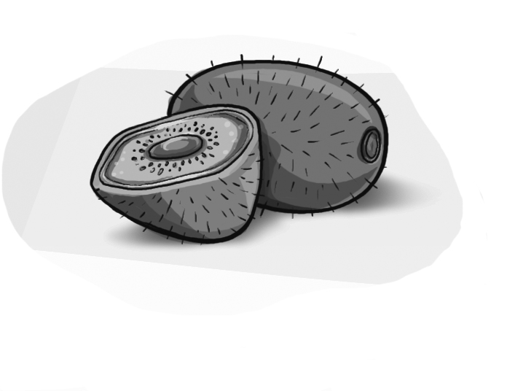 | g h i j k l
 | c d e f g h | 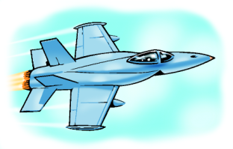 | g h i j k l
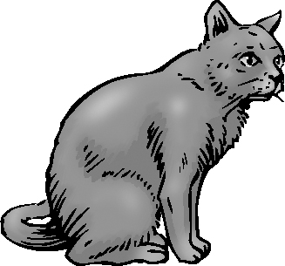 | a b c  d e f

5. Listen and circle.

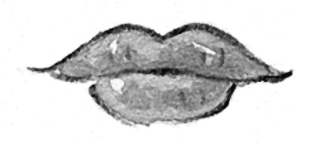 | m n o p q r | 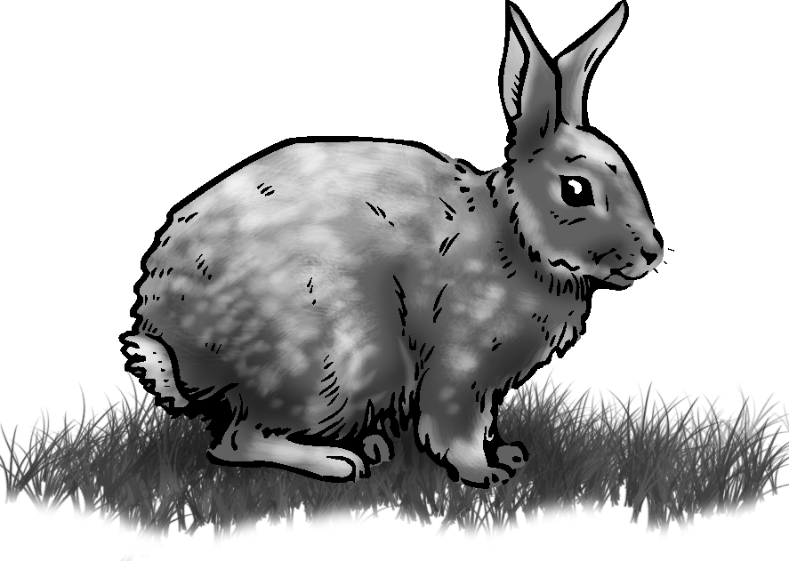 | n o p  q r s
9 | m n o p q r | 6 | n o p  q r s
 | m n o p q r |  | n o p  q r s
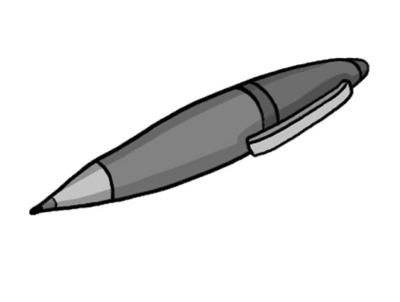 | m n o p q r | 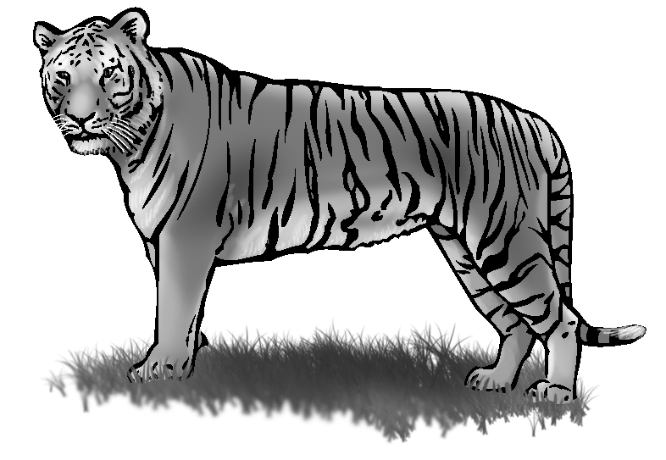 | o p q  r s t
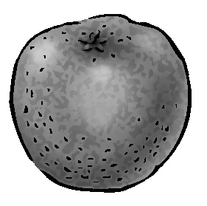 | m n o p q r | 7 | o p q  r s t
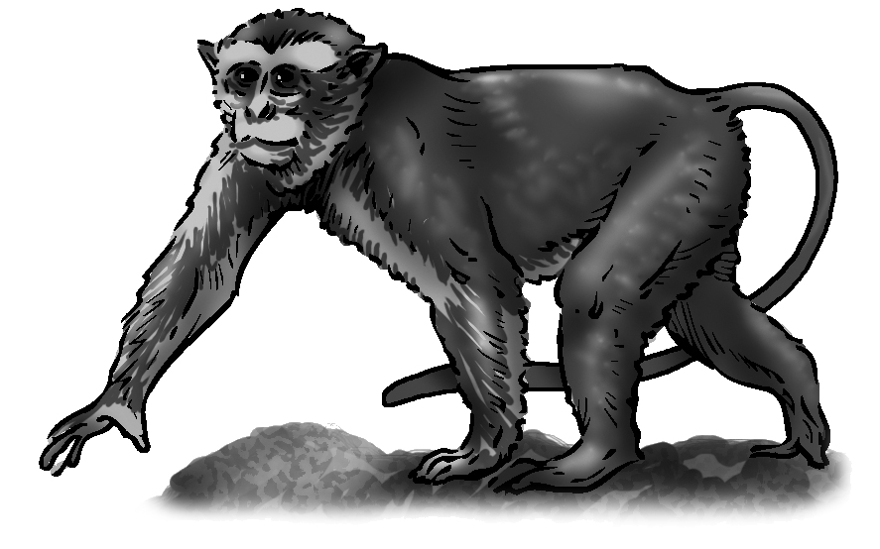 | m n o p q r |  | o p q  r s t
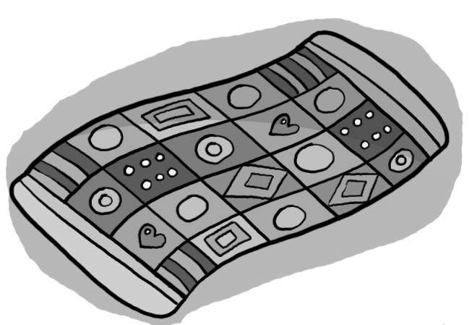 | n o p  q r s | 10 | o p q  r s t

