We Can! Book 5 Unit 6: Jobs

1. Match the words with the pictures

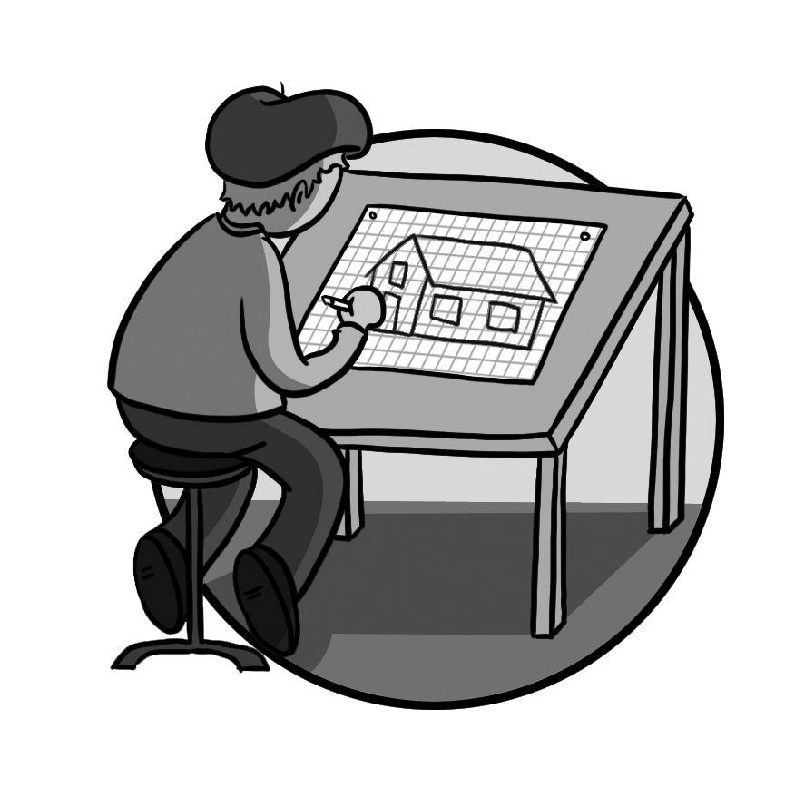__ | 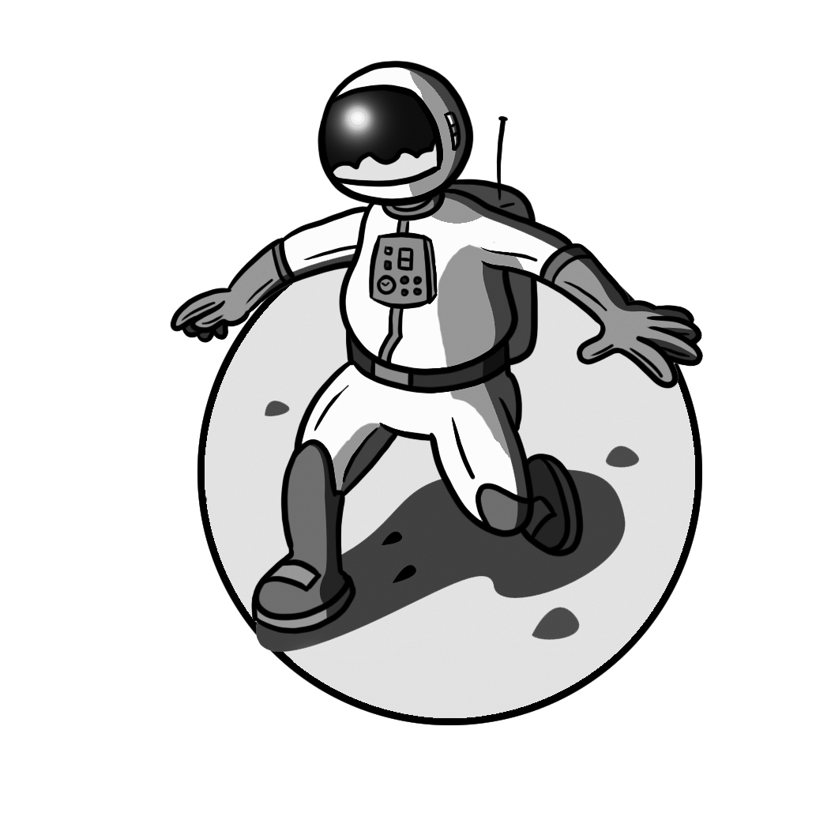__ | __ | __
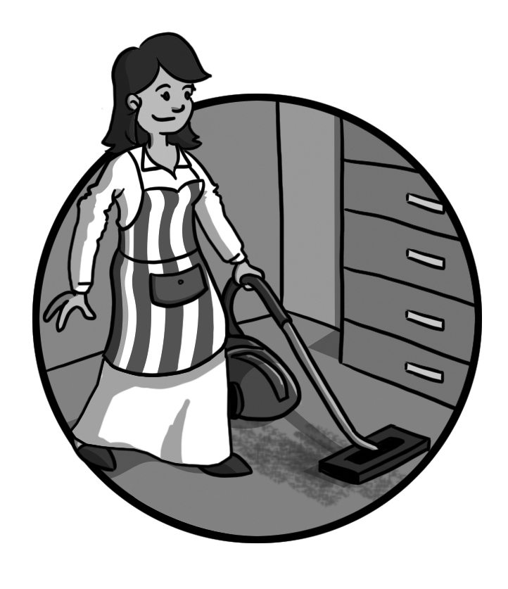__ | 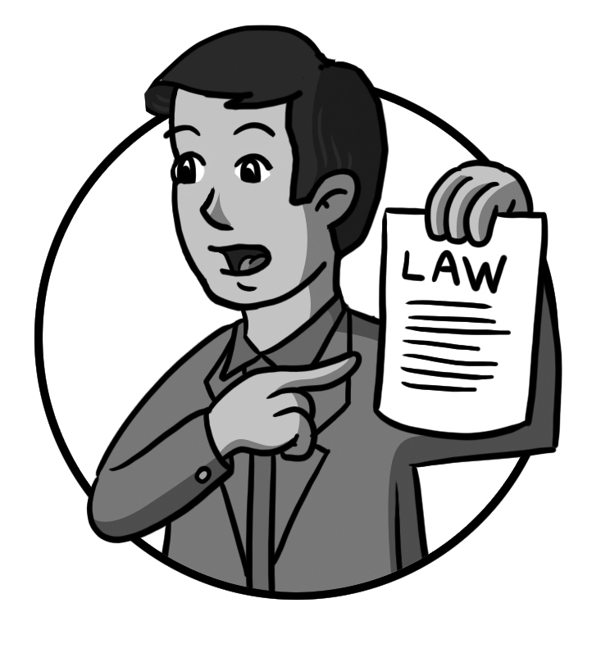__ | __ | 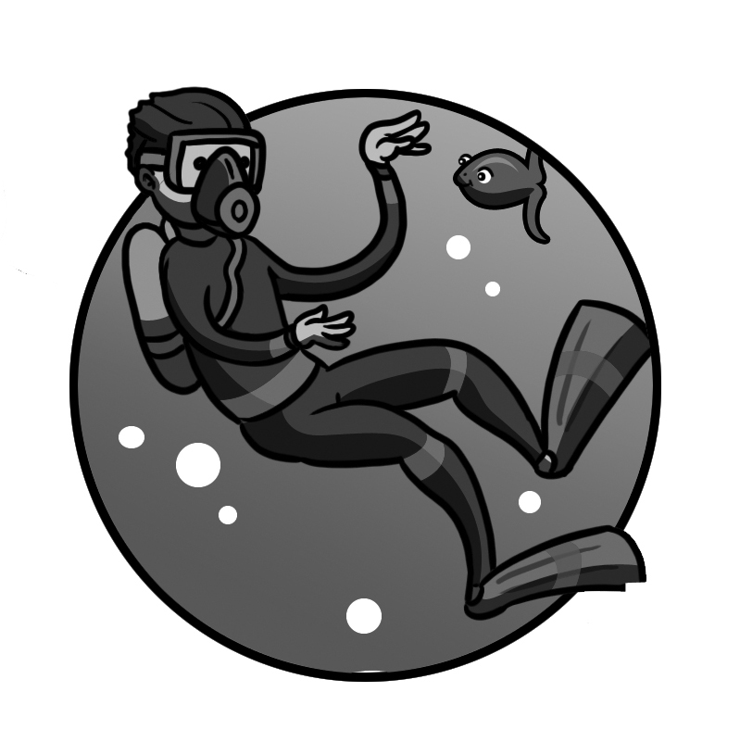__
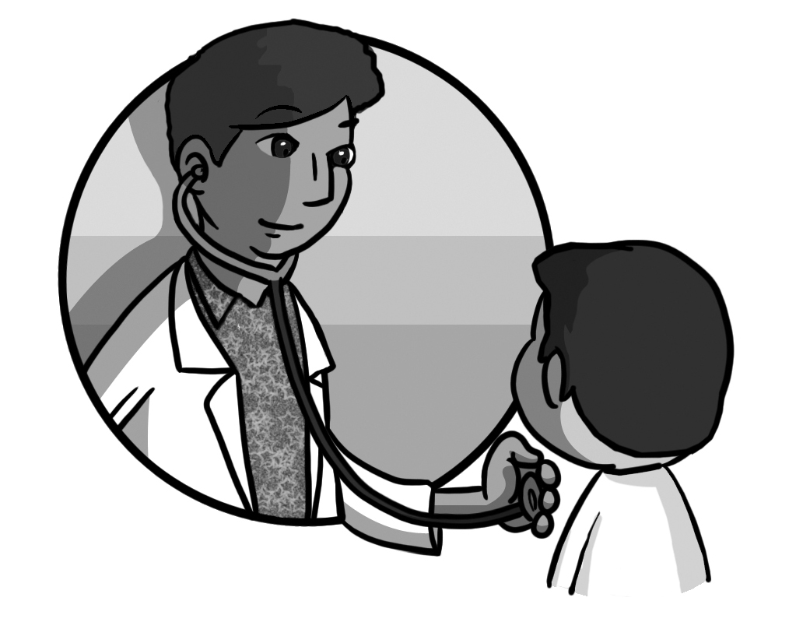__ | 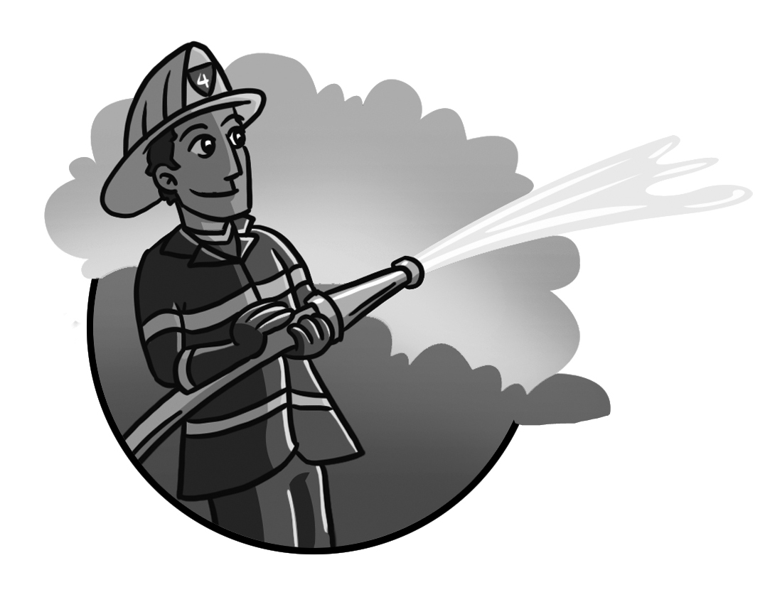__ | 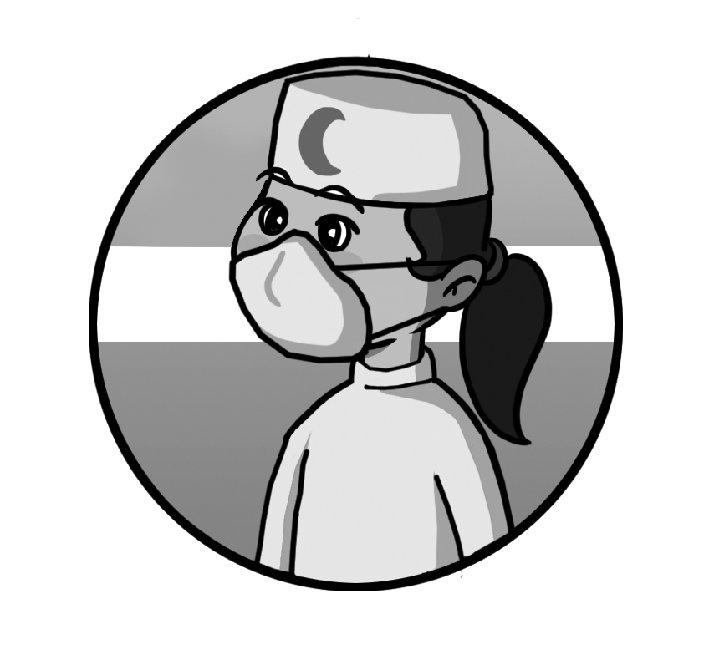__ | 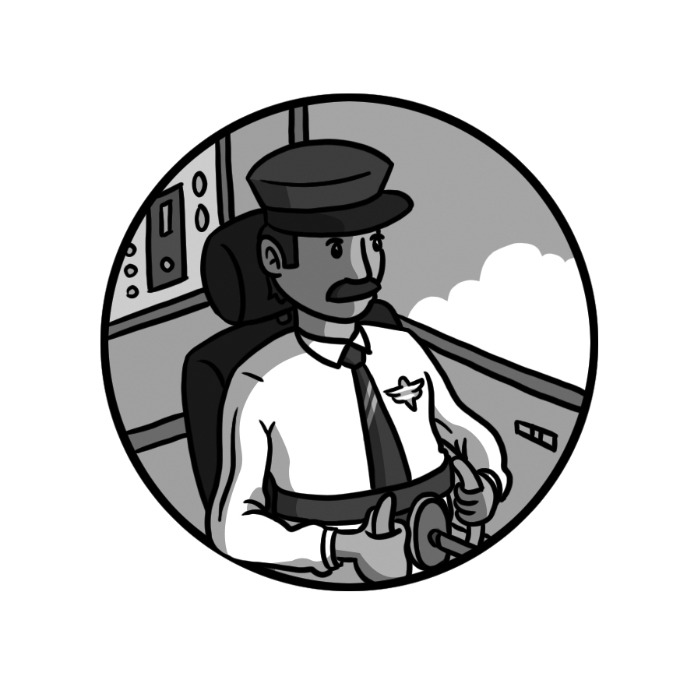__
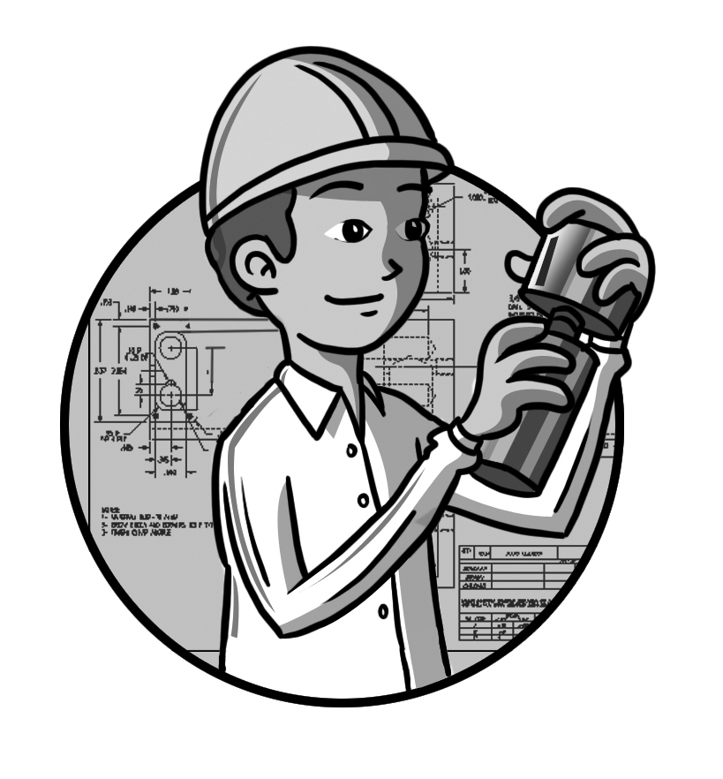__ | 1. astronaut  4. firefighter  7. housewife | 2. pilot  5. cook  8.nurse | 3. lawyer  6. engineer  9. reporter
__ | 10. diver  12. architect | 11. doctor  13. computer technician  14. businessman

2. Answer the questions.

1. What does your dad do? ____________________

2. What does your mom do? ____________________

3. Listen and fill in the missing words and phrases.

does he work What does he do fast-food
space station city hospital restaurant
Where do they work pilot cooks

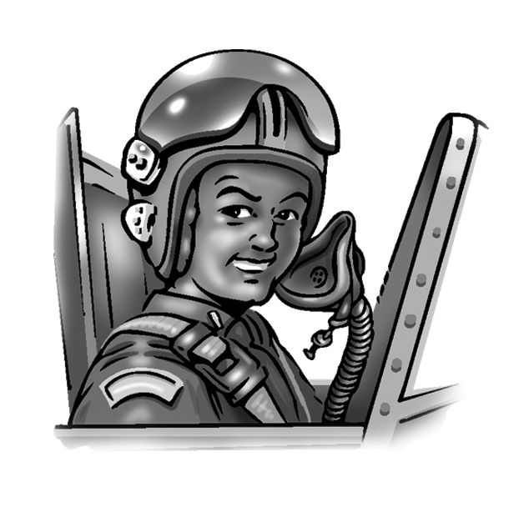
Who’s He? He’s Abdullah.
What does he do? He’s the _______
Where ___________? In a station.
In the train station?
No, in the __________ !

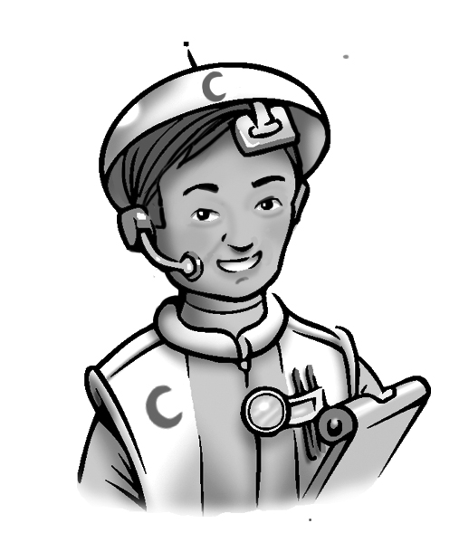
Who’s he? He’s Faisal.
______________? He’s a doctor.
Where does he work? In a hospital.
In the ___________?
No, in the space hospital.

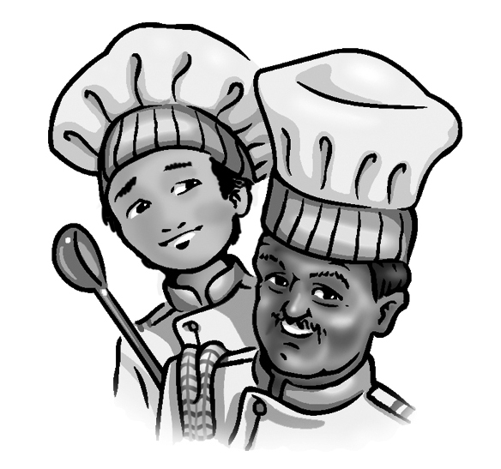
Who are they? They’re Ali and Omar.
What do they do? They’re ________.
________________?In a ________.
In the __________ restaurant?
No, in the space restaurant.

4. Read and circle T or F.

1. Faisal works in the space restaurant. T F
2. Omar is a cook. T F
3. Ali and Omar work in a fast-food restaurant. T F
4. Abdullah works in the space station. T F
5. Omar works in the space hospital. T F

