We Can! Book 2 Unit 3: Things We Do

1. Read, listen and number in the correct order.

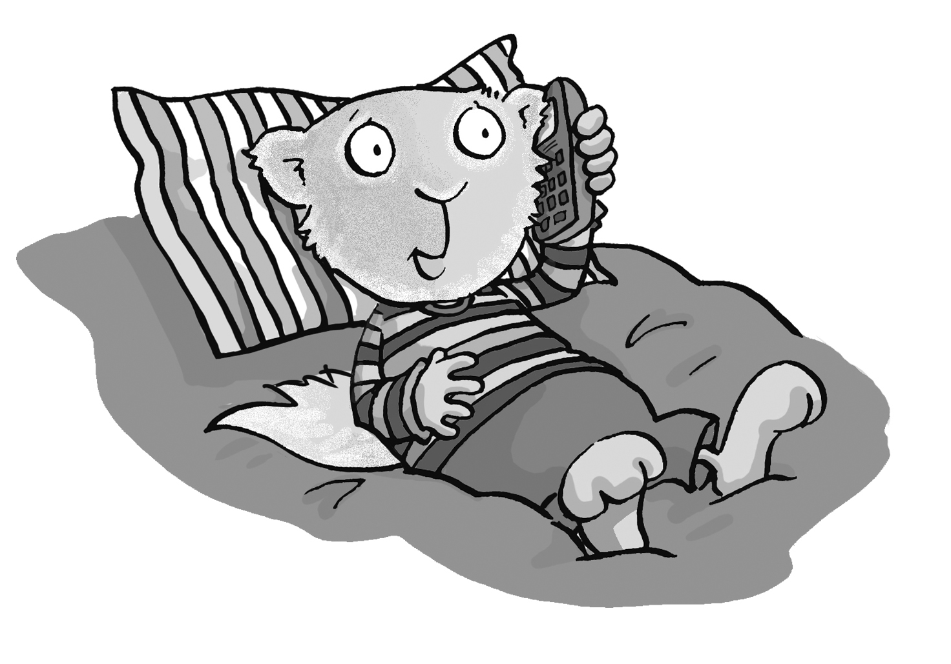 | __ What’s your dad doing?  __ Speaking.  __ What are you doing?  __ Hello. Can I speak to Joe?  __ I’m doing my homework.  __ He’s watching TV. | 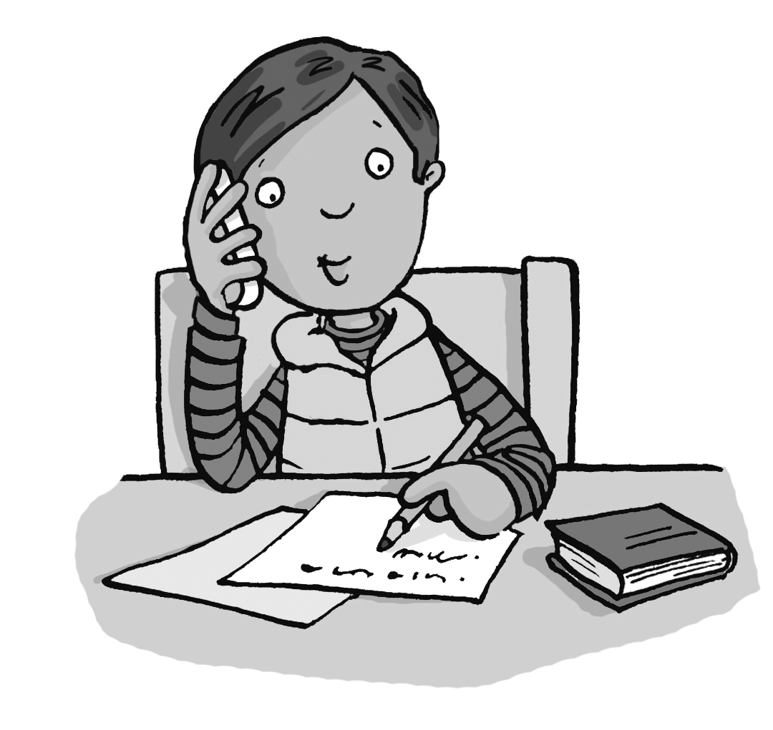  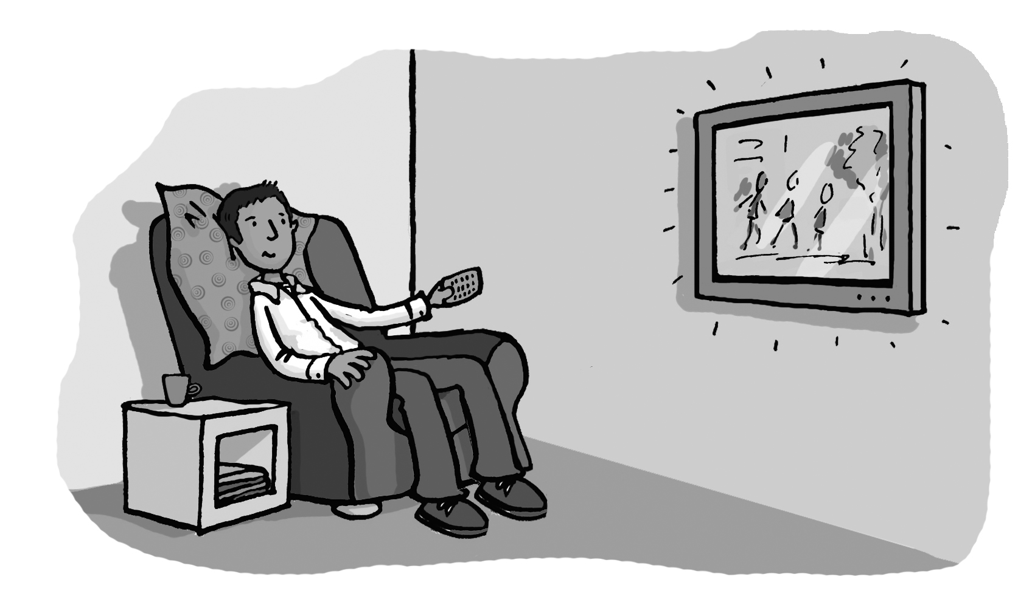
2. Match pictures and words. Write.

dress tiger truck tape wing ring bus duck doll

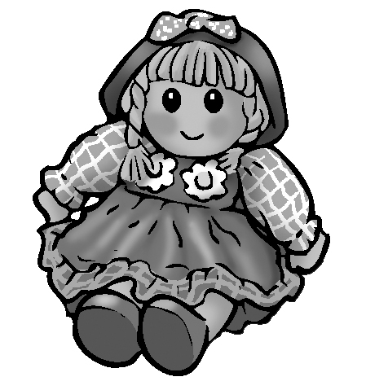  ______ | 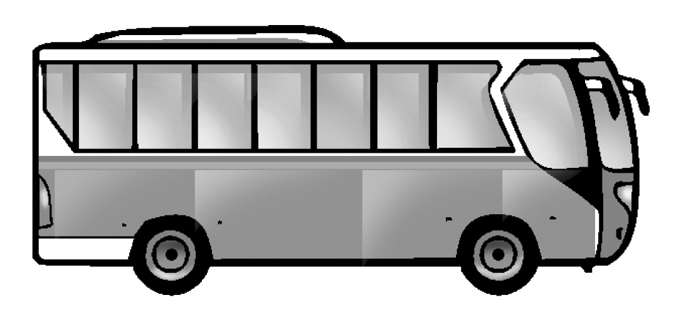  ______ | 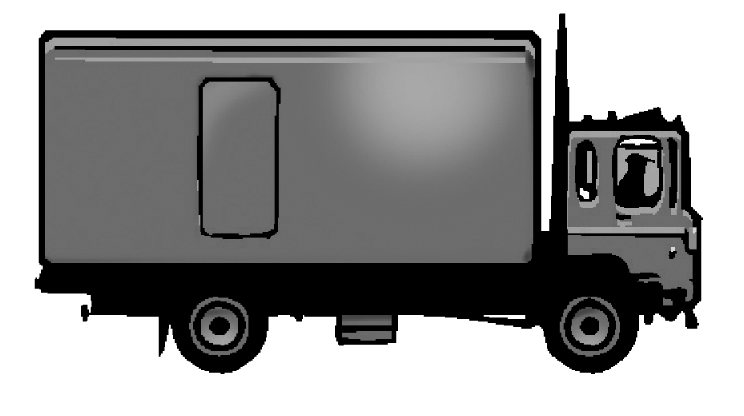  ______
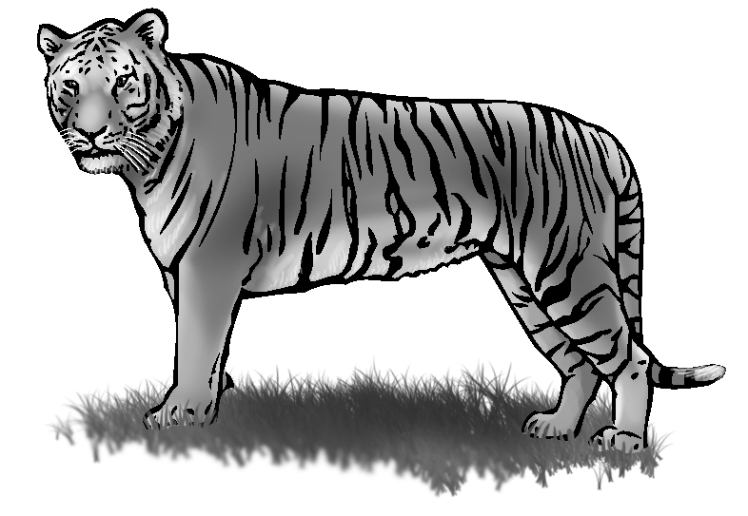  ______ | 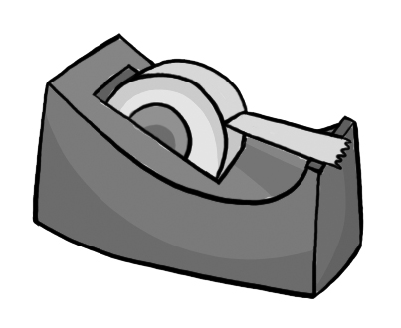  ______ | 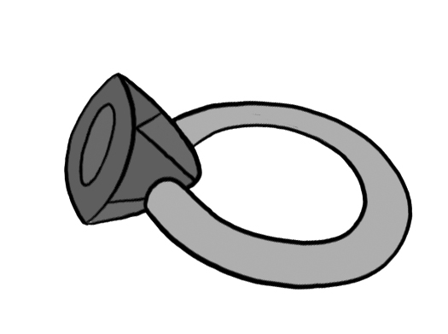  ______
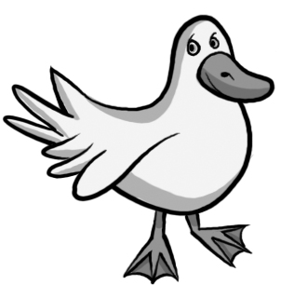  ______ | 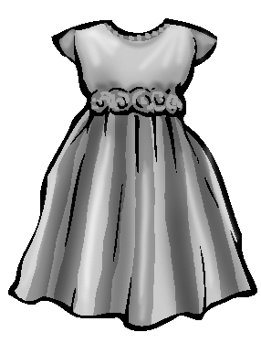  ______ | ______
3. Listen and match pictures and sentences. Number the sentences.

1 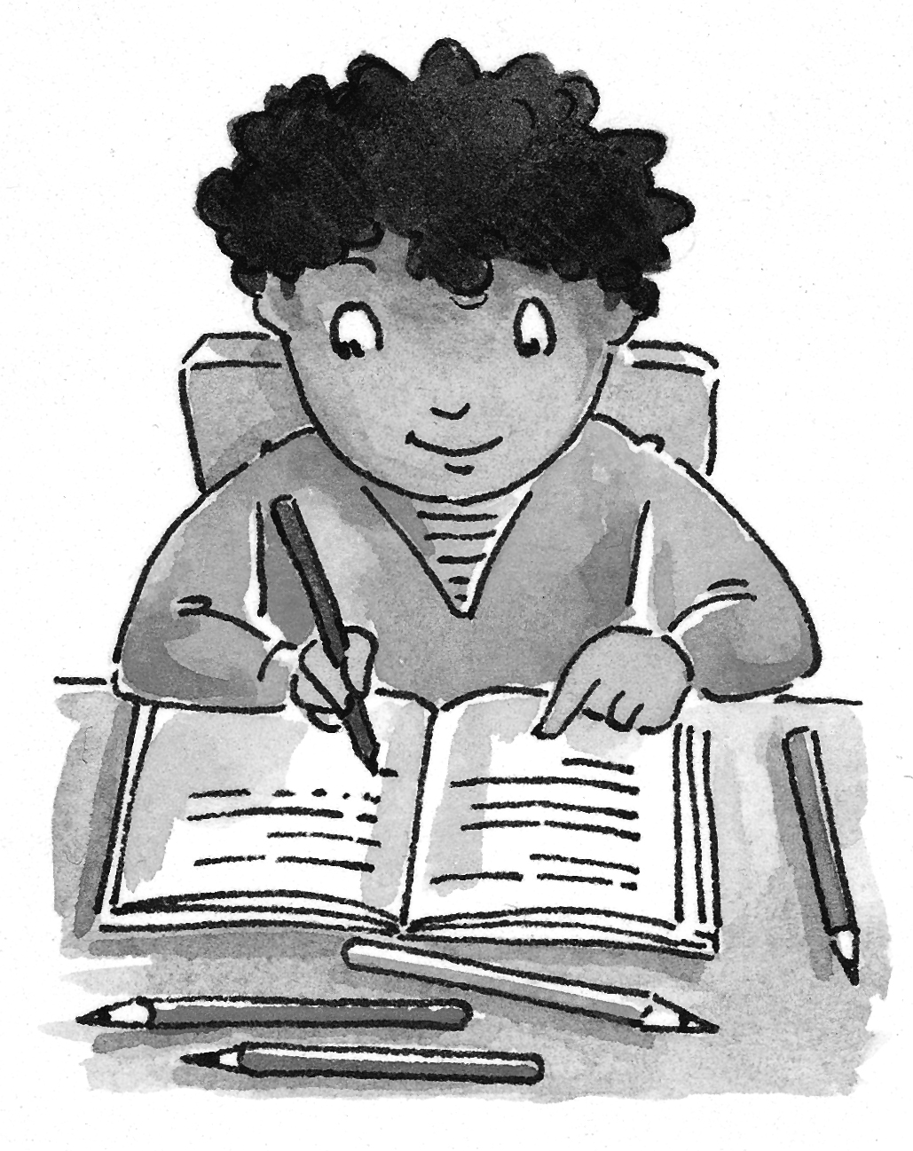 | 2 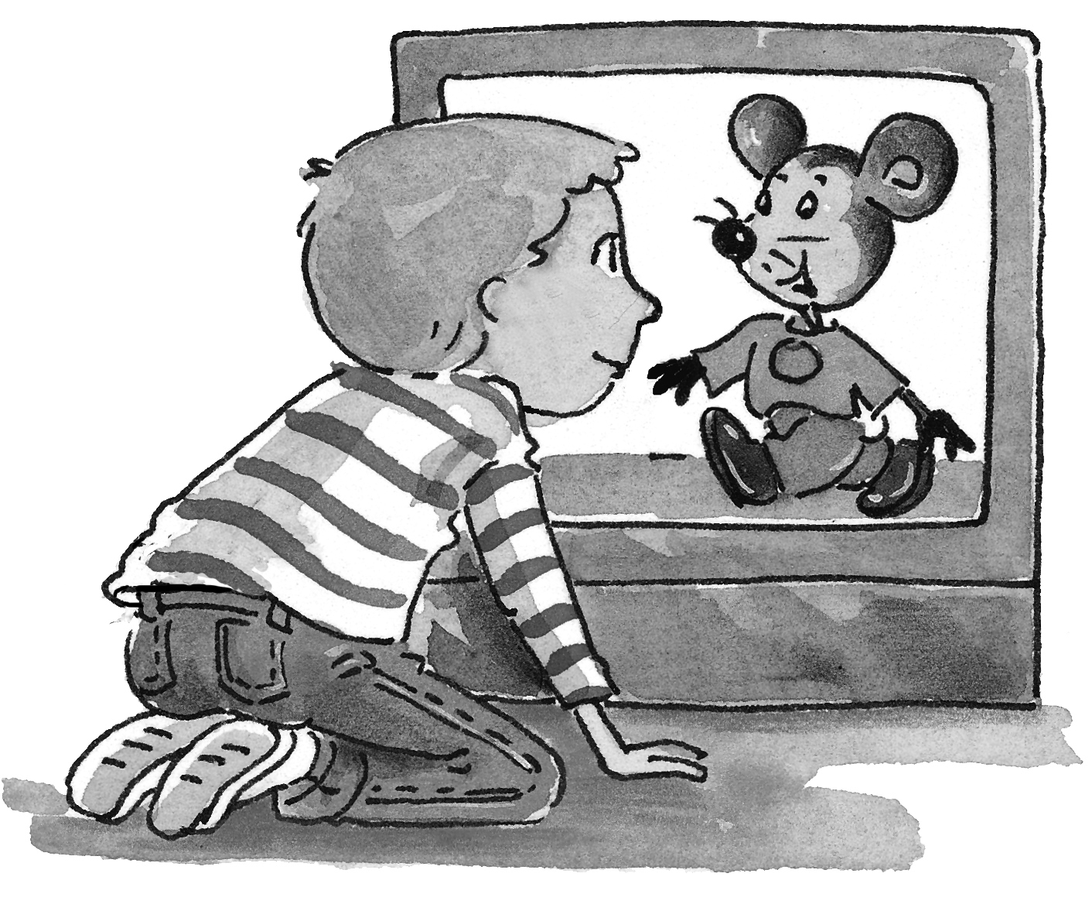 | 3 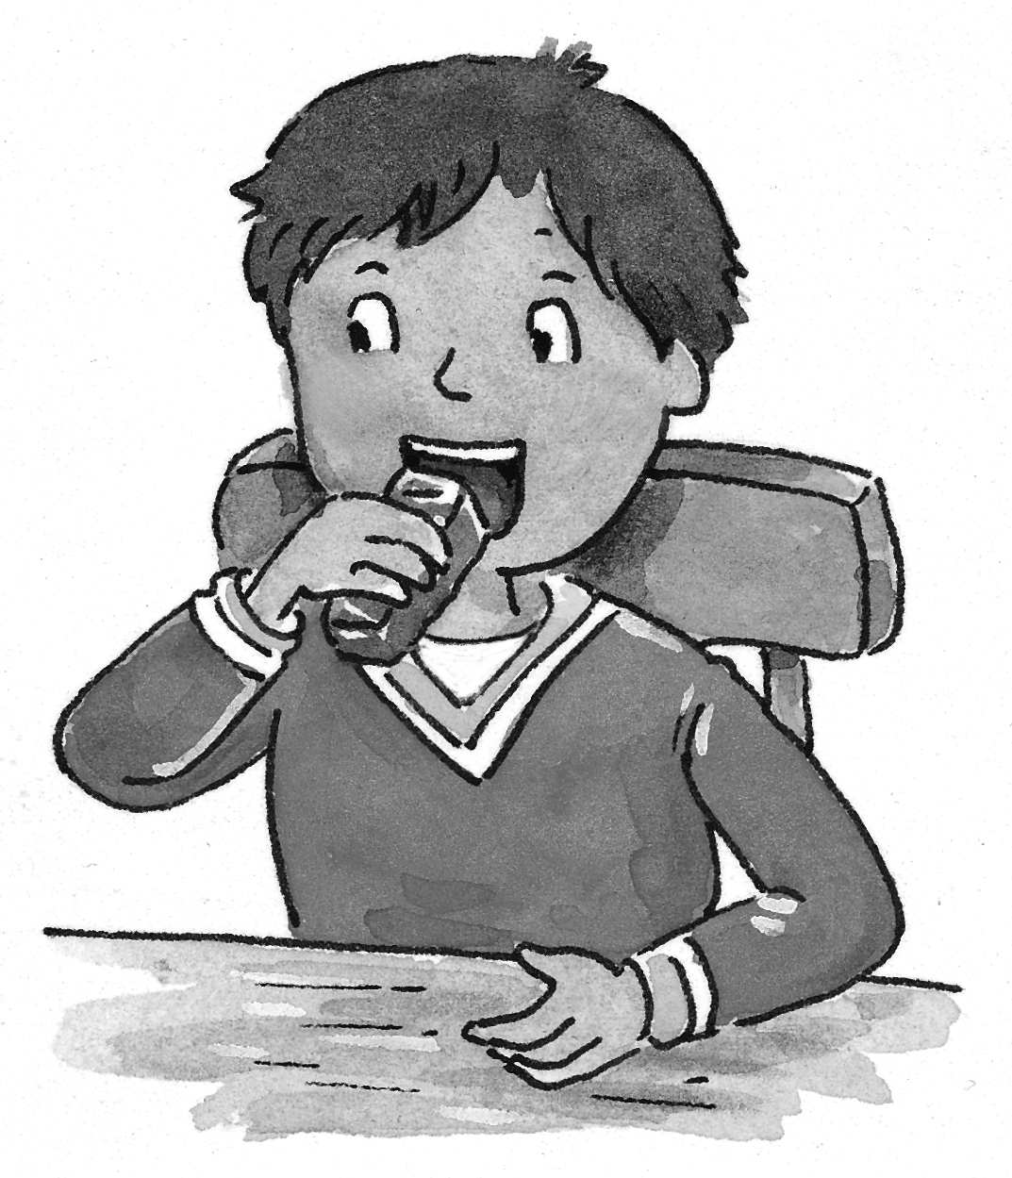
4 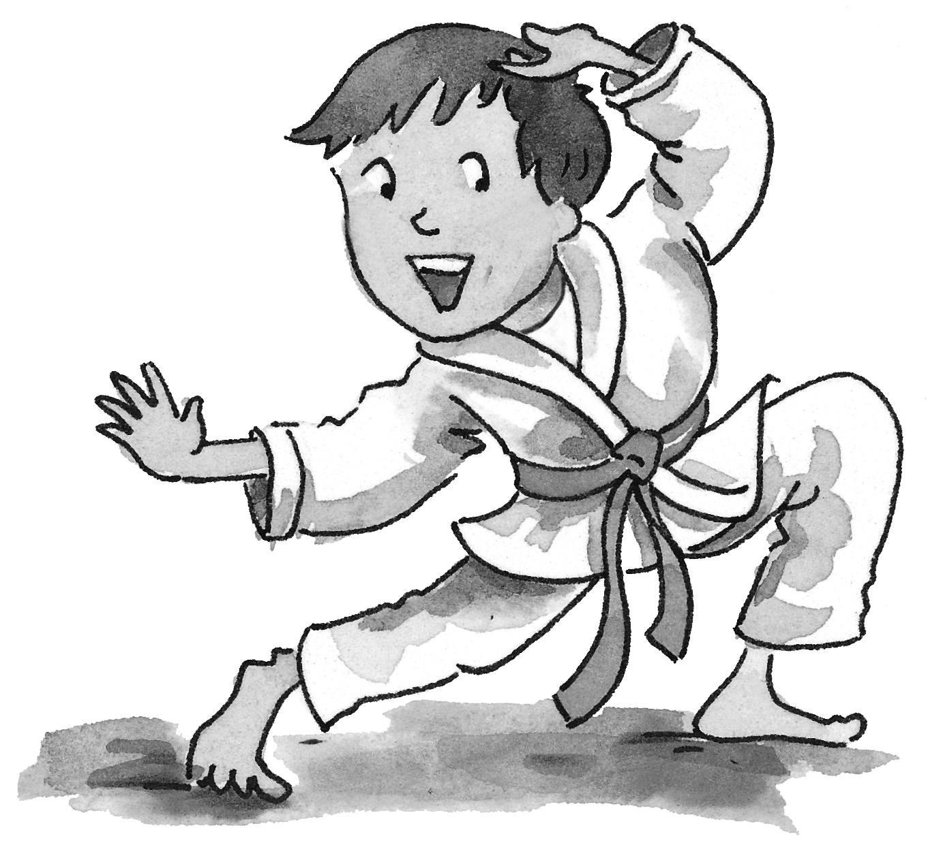 | 5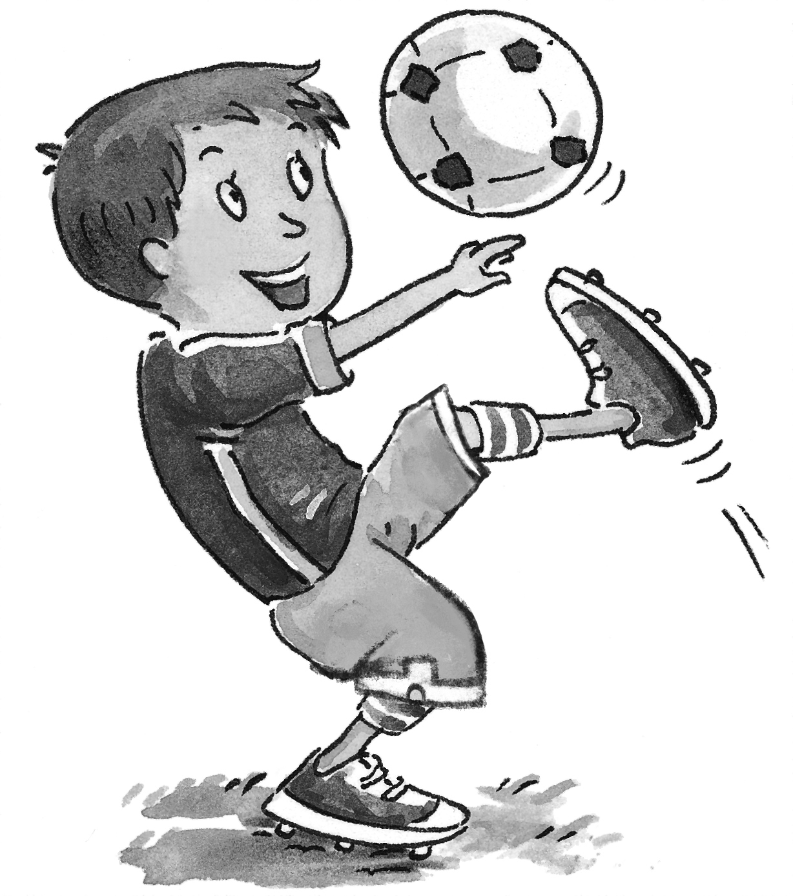 | 6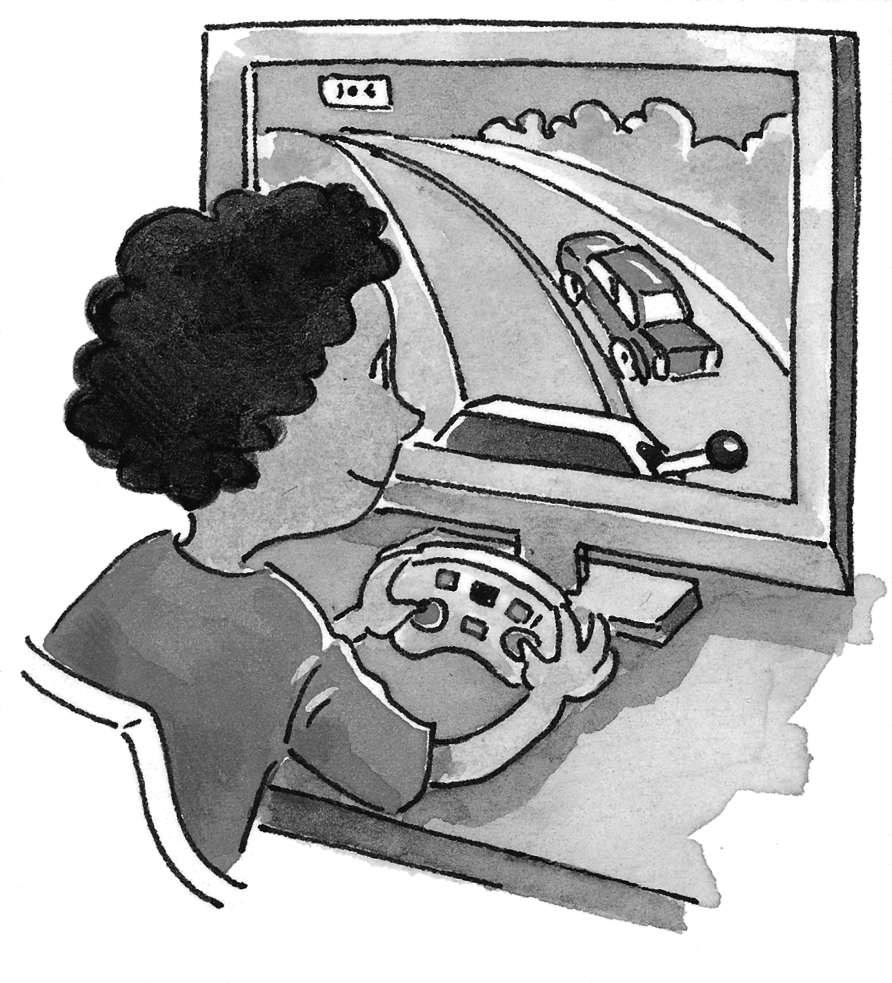
__ He’s watching TV.
__ He’s playing football.
__ He’s doing his homework.
__ He’s doing karate.
__ He’s playing computer games.
__ He’s eating snacks.
3. Check √ bl or pl. Then write.

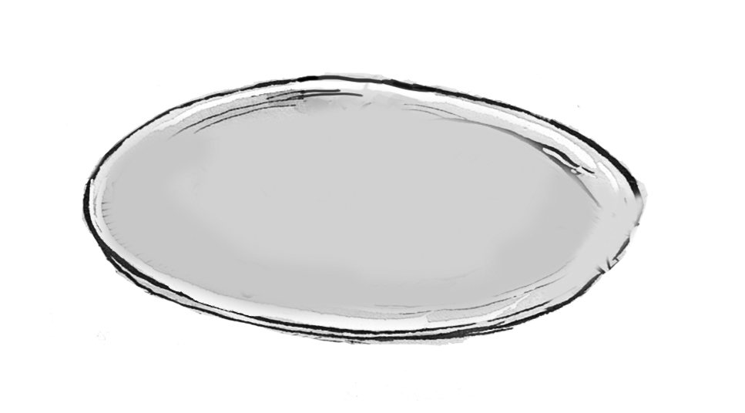 | bl pl | 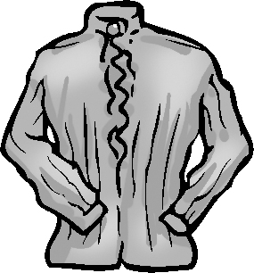 | bl pl
__ ate |  | __ ouse
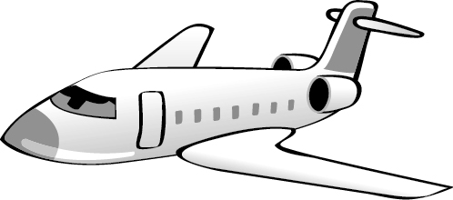 | bl pl |  | bl pl
__ane |  | __ ack

