We Can! Book 1 Unit 5: What’s This? What’s That?

1. Listen and number.

____  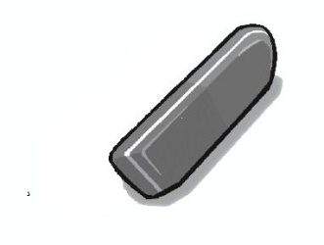 | ____  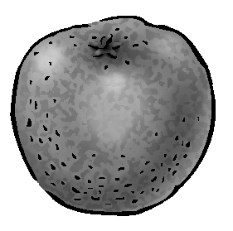 | __1__  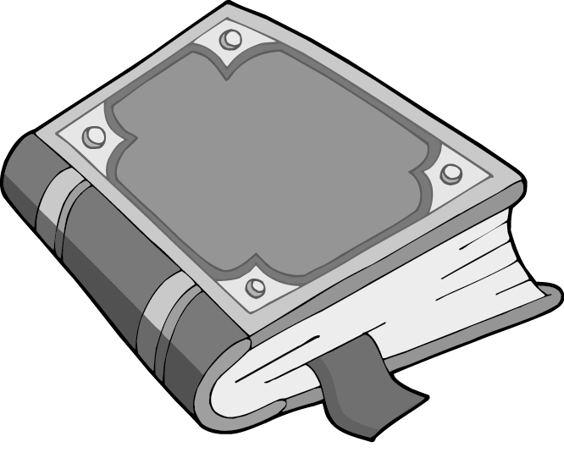
____  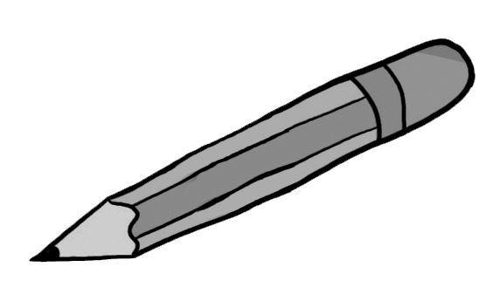 | ____   | ____  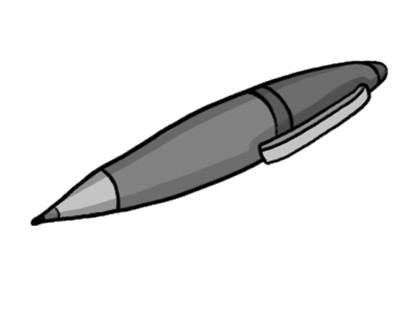

2. Write He, She, We, They.
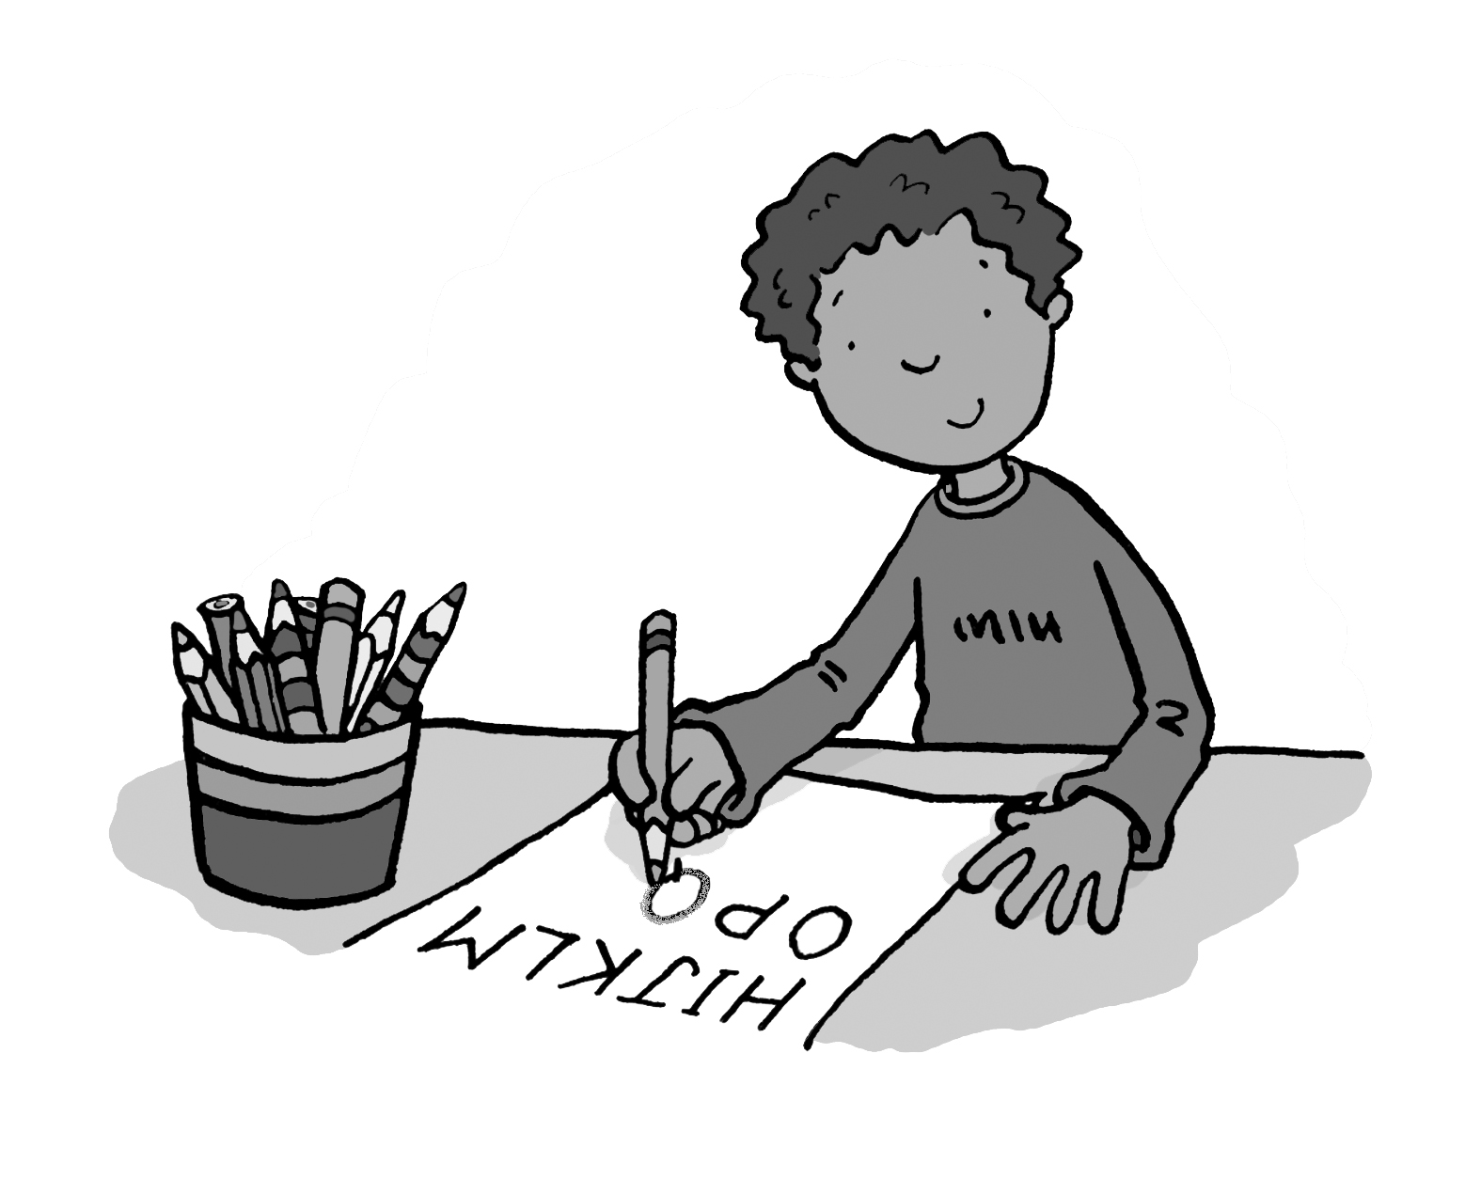 | 1. How old is Joe? ____’s nine.
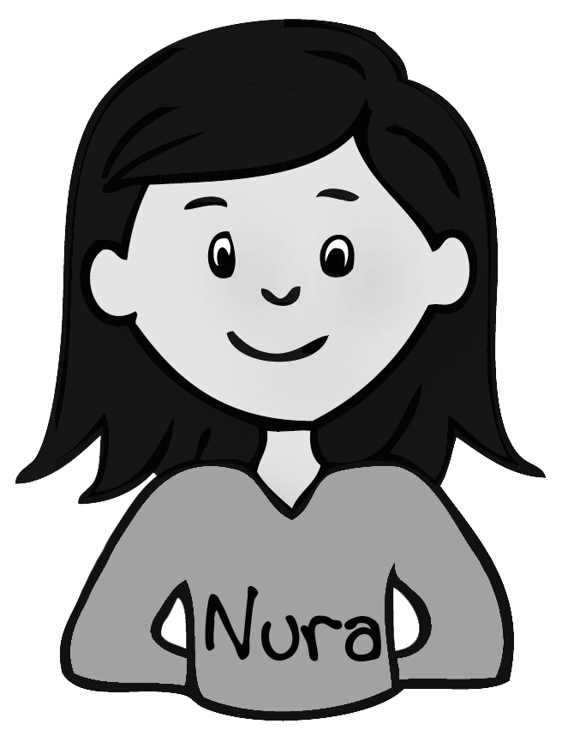 | 2. How old is Nura? ______’s nine.
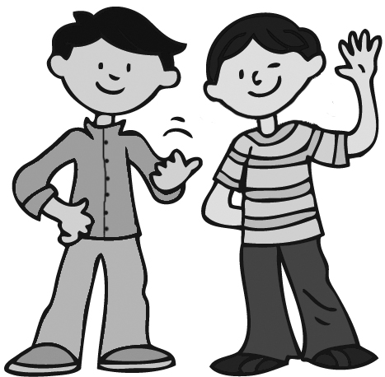 | 3. How old are you? _______’re ten.
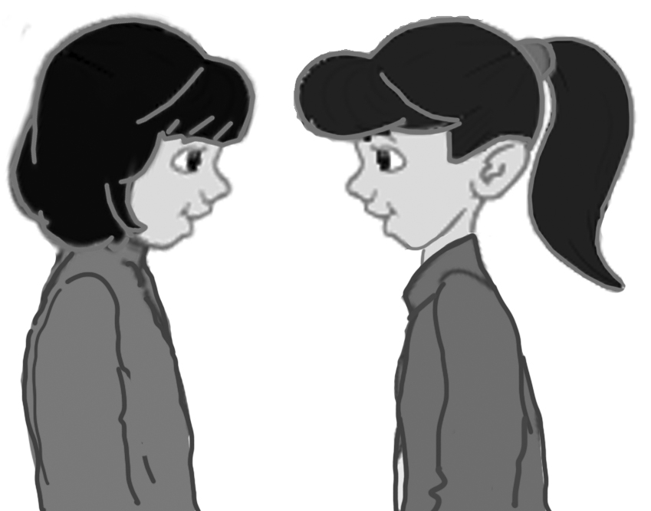 | 4. How old are Rana and Amina? ______’re ten.
3. Listen and circle the correct letter. Then write.

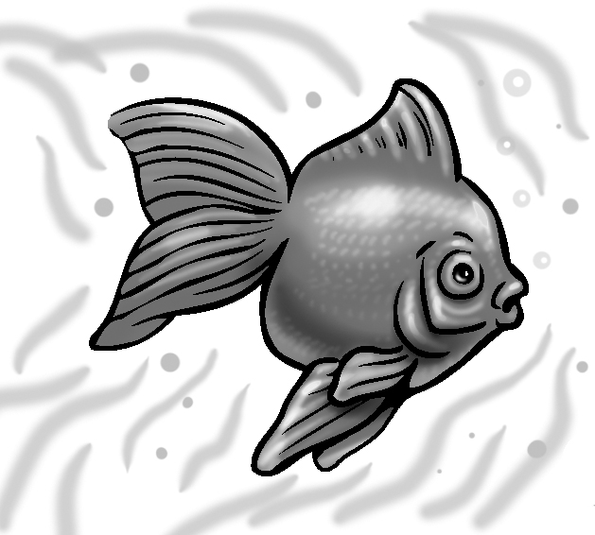 | 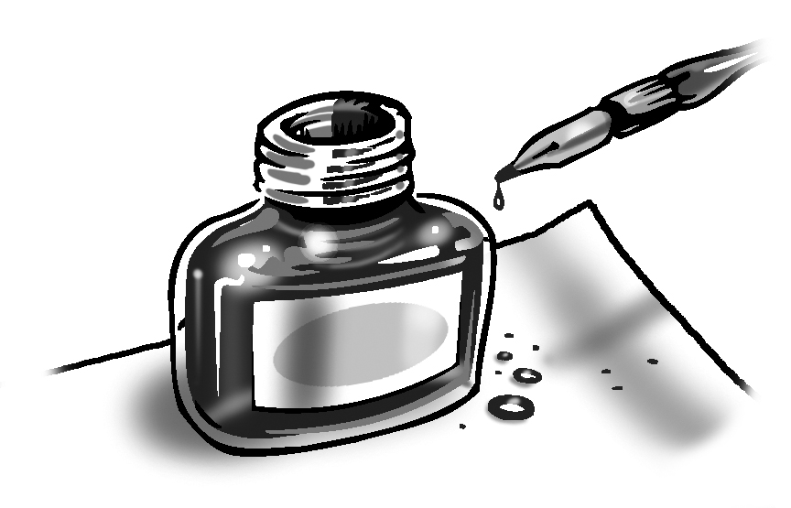 | 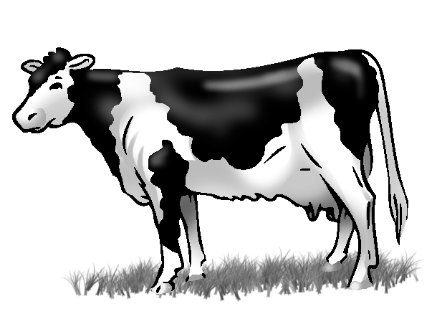
A B C D E  F G H I J  1. __ ISH | A B C D E  F G H I J  2. __ NK | A B C D E  F G H I J  3. __ OW
 | 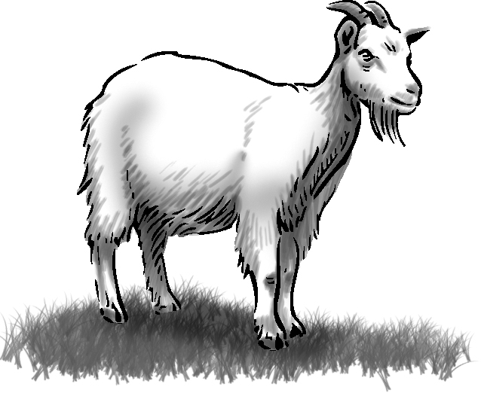
A B C D E  F G H I J  4. __ AT | A B C D E  F G H I J  5. __ OAT | A B C D E  F G H I J  6. __ PPLE
 | 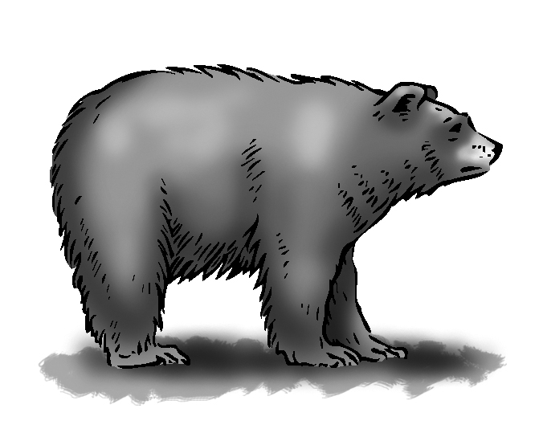 | 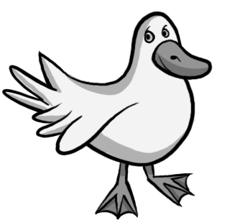
A B C D E  F G H I J  7. __ ET | A B C D E  F G H I J  8. __ EAR | A B C D E  F G H I J  9. __ UCK
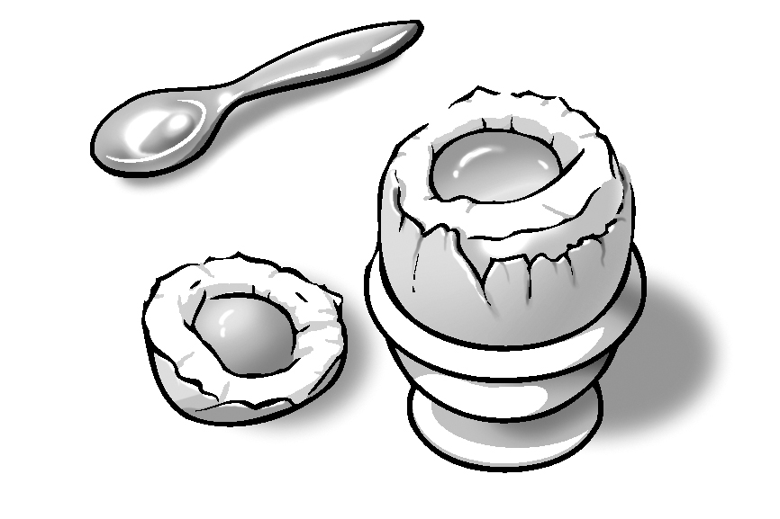 | A B C D E  F G H I J  10. __ GG

