We Can! Book 5 Unit 5: Yesterday and Today

1. Listen, choose 6 clocks and write the time.
1 2 3
4 5 6
7 8 9

( ) _______________ ( ) _______________
( ) _______________ ( ) _______________ ( ) _______________ ( ) _______________
2. Read and answer the questions.
1. What time do you go to school in the morning?
I usually go ___________________________________
2. What time did you go to school yesterday?
Yesterday, I ___________________________________
3. What time do you eat lunch?
I ___________________________________
3. Listen and write the missing form.

 | every day | yesterday
1.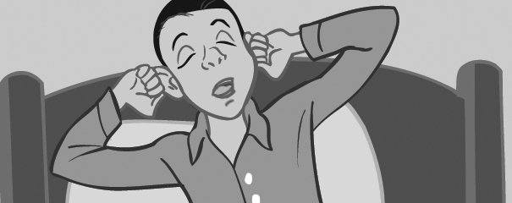 | get up | _____
2. 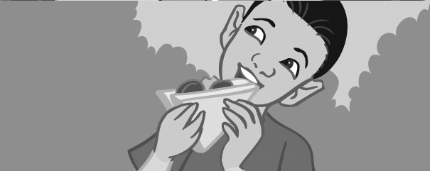 | eat lunch | _____lunch
3. 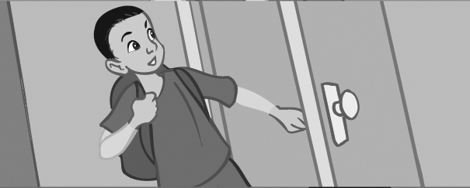 | come home | _____home
4. 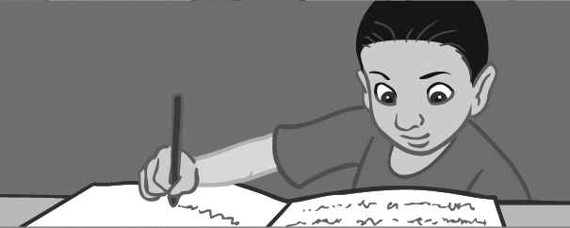 | do my homework | ___my homework
5. | take a bath | _____a bath
6. 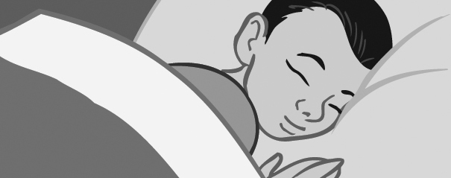 | go to bed | _____to bed

4. Complete the words with ck, k, g, or ng.

bu __ | bla __ | ro __ | 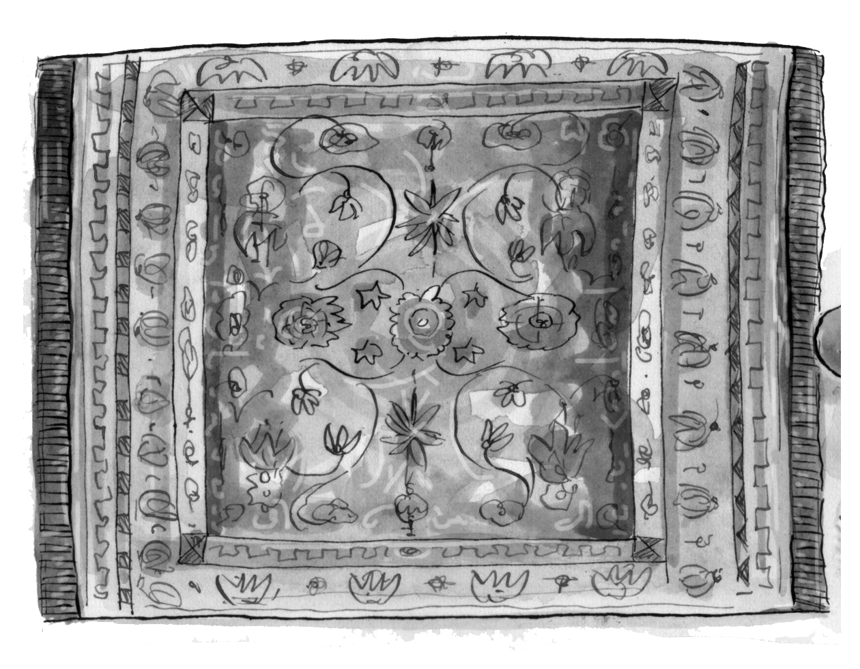  ru __
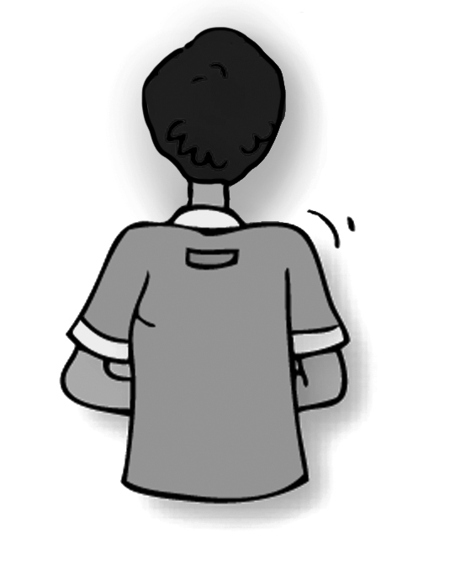  ba __ | ba __ | 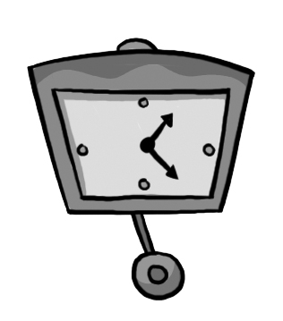  clo __ | coo __
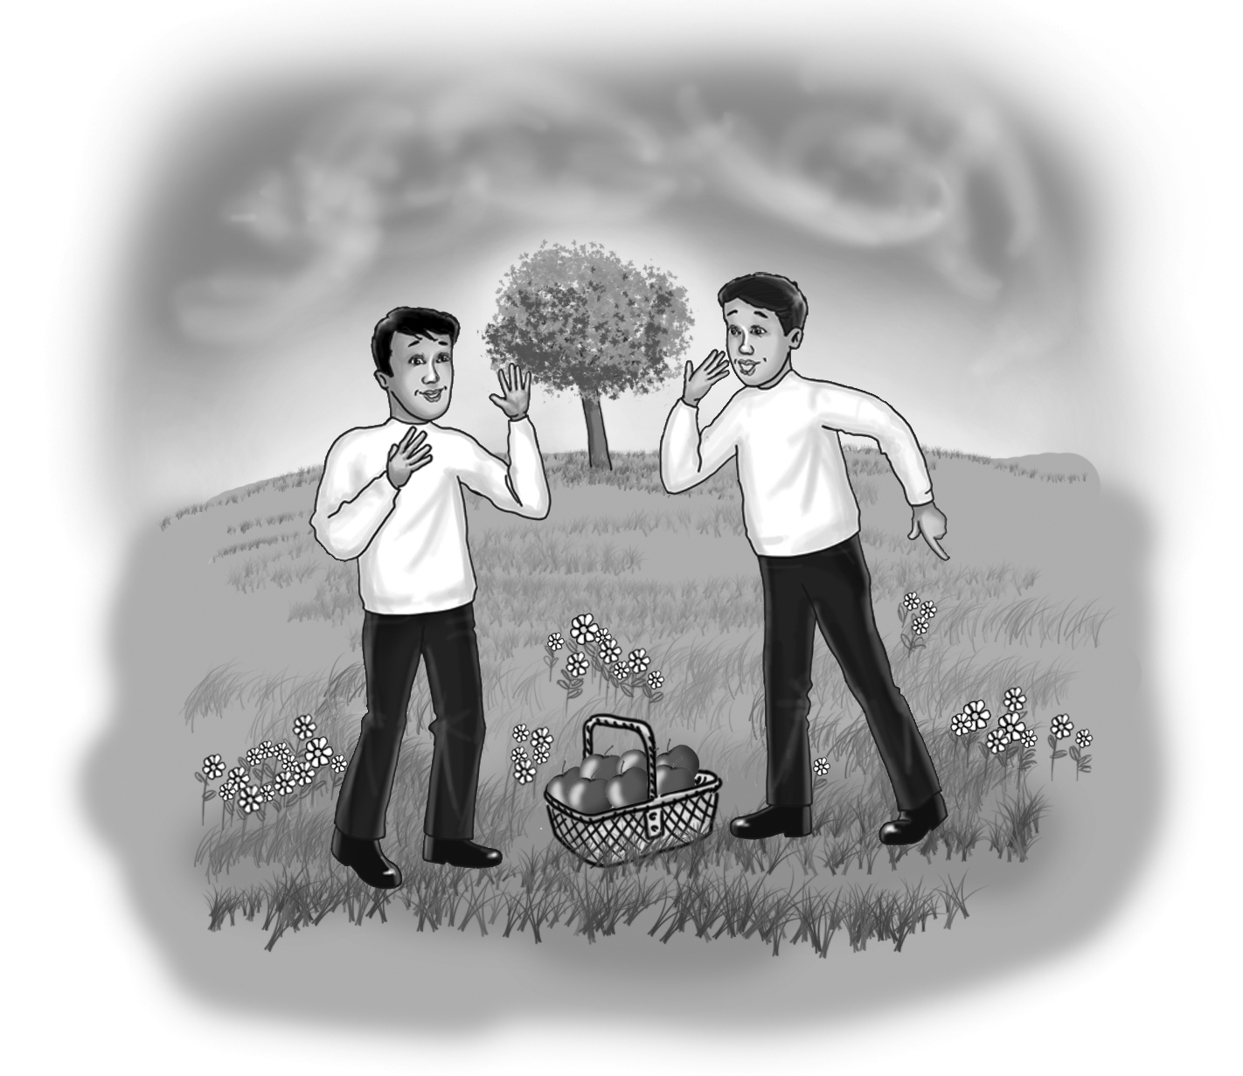  spri __ | 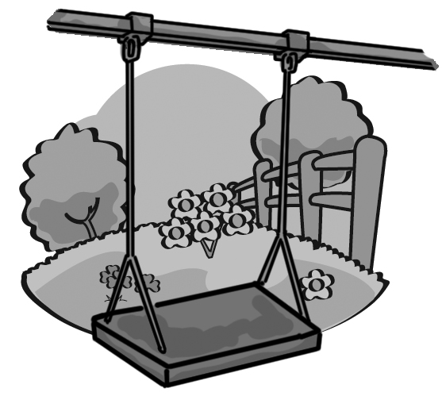  swi __ | 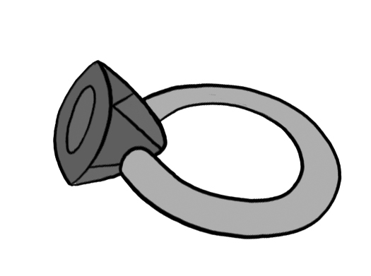  ri __ | 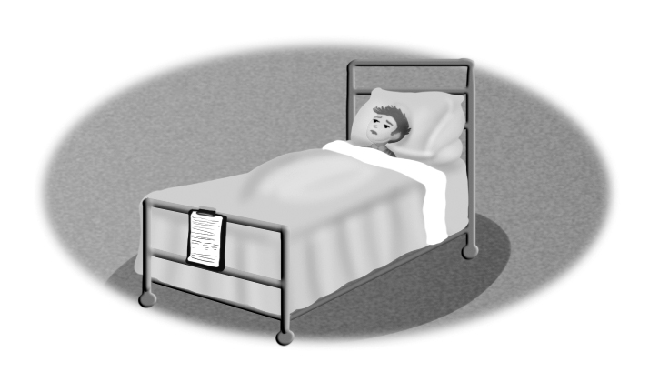  si __
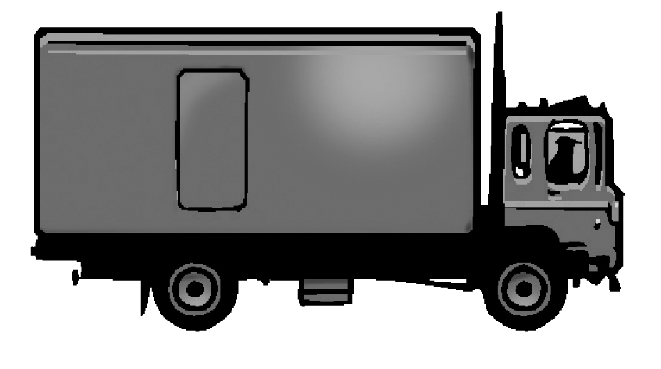  tru __ | 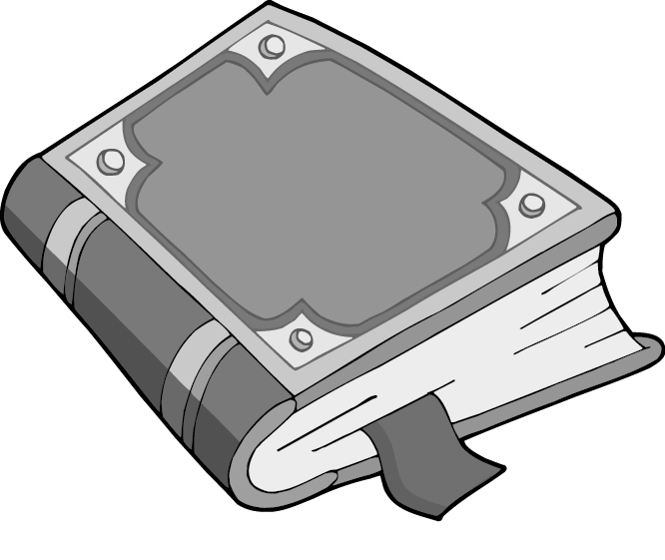  boo __ | fla __ | 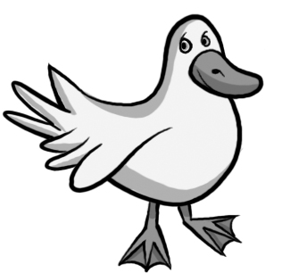  du __
5. Listen, look at the pictures and write the missing words.

eat my lunch finish school ride the bus jump out of bed brush my teeth dream
jump into bed ten meet
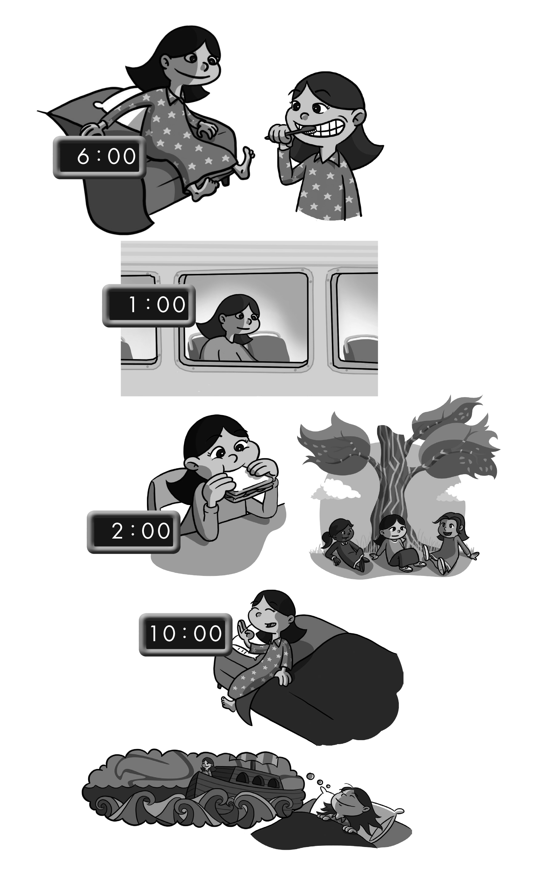
What Time Do you Do It?
At ____ o’clock,
I ________________
And ________________.
At one o’ clock,
I ________________
And ________________ home,
At two o’clock,
I ________________
And ______ my friends.
At ______ o’clock,
I ________________
And ______ a lot!
6. Write a chant about your day.
________________________________________
________________________________________

