We Can! Book 3 Unit 5: Friends, Actions, Things

1. Listen, number and write.

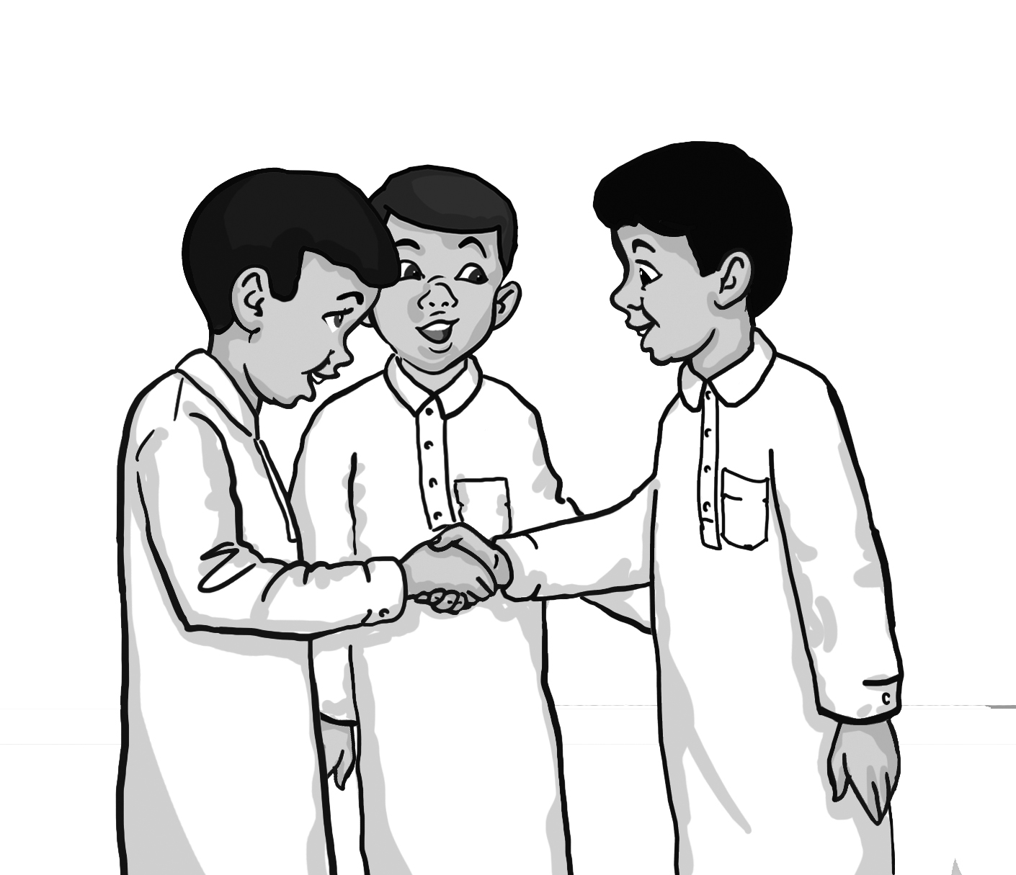 | ___to meet ____Let’s go  ____Nice ____you, too  ____This is
(1) ________ my friend, Omar.
Nice (2) ________ you Omar.
(3) ______ to meet (4) ______ !
Ready? (5) ________ to the new computer store!

2. Match time and greeting. Write.

A. Good evening B. Good morning C. Goodnight
D. Good afternoon

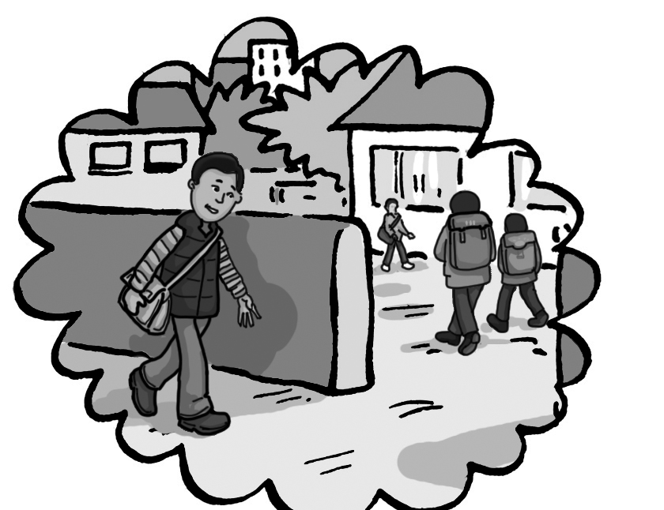 | 1. __________________!  Let’s go to school!
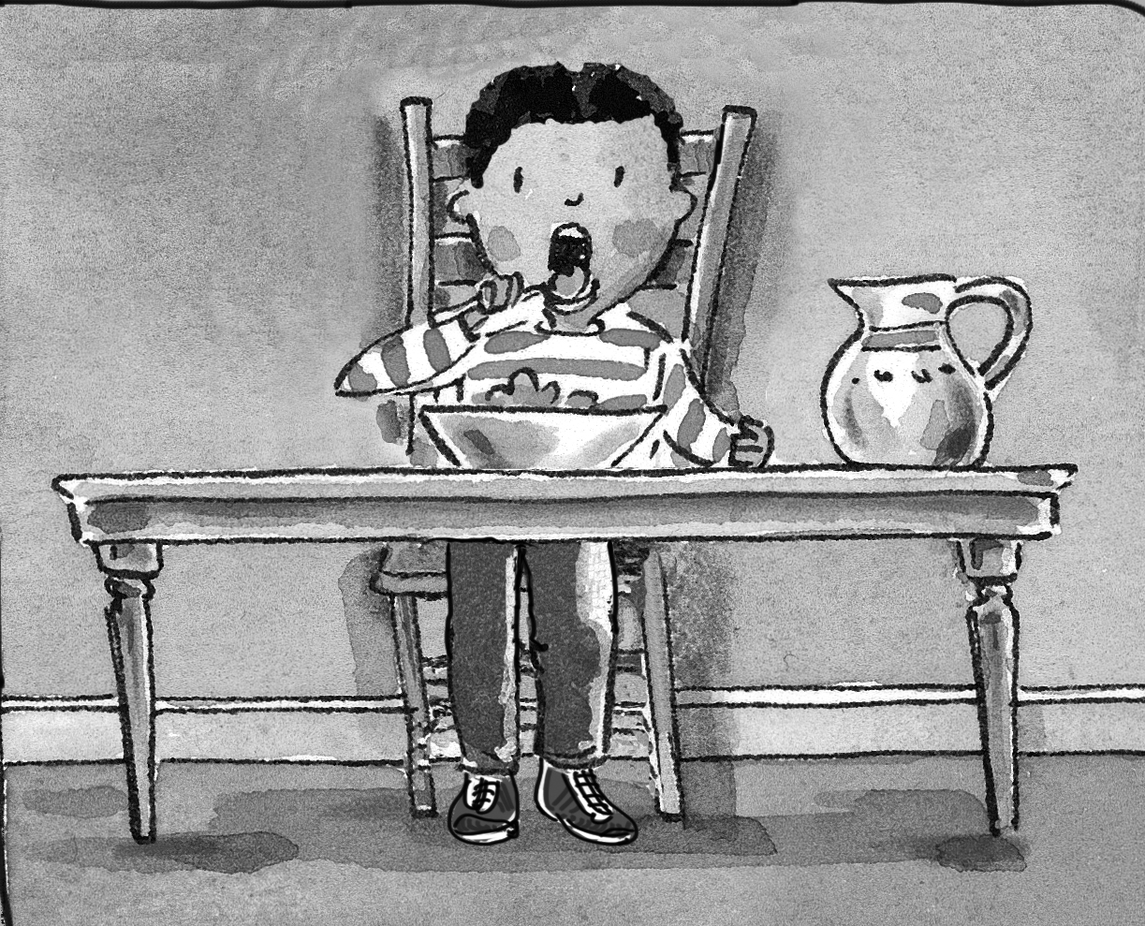 | 2. __________________!  Let’s have lunch!
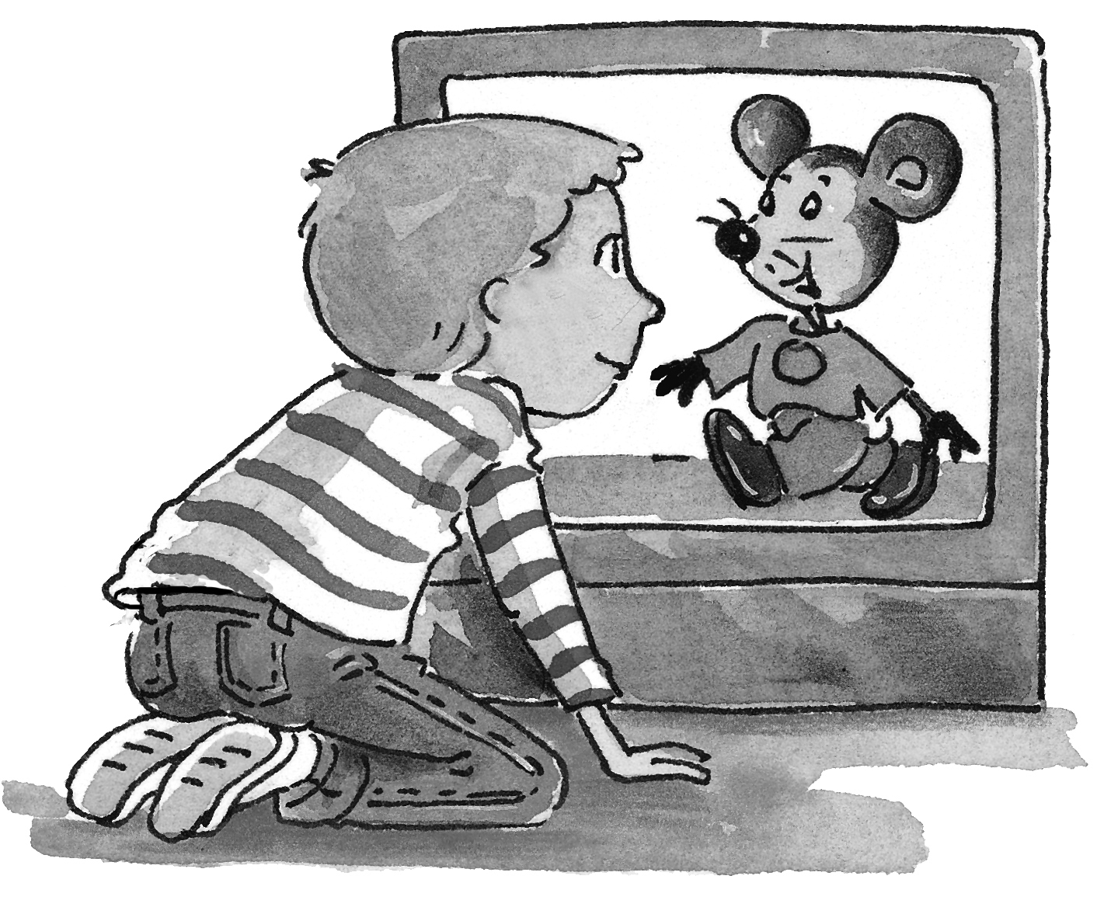 | 3. __________________!  Let’s watch TV!
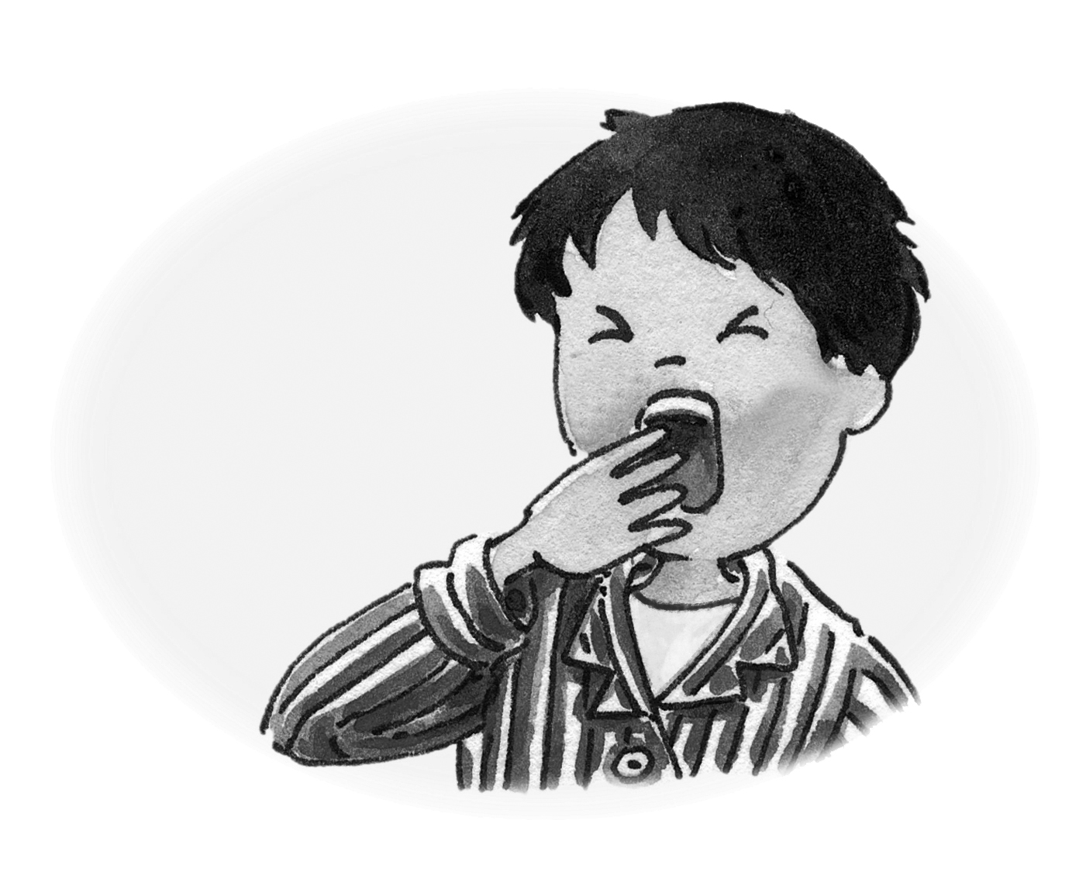 | 4. __________________!  Let’s go to bed

3. Match words with pictures and write.

talking sitting walking cycling jumping

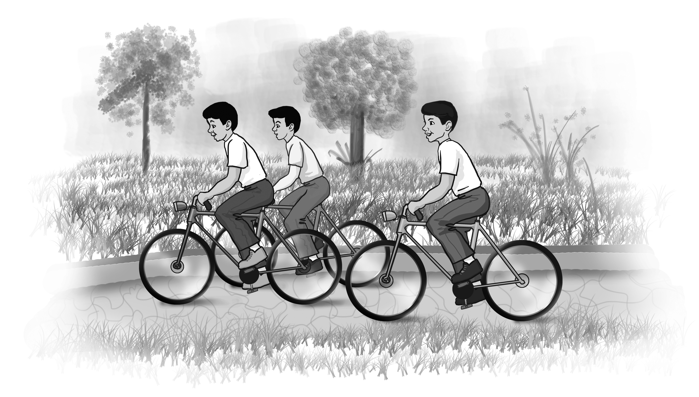 | 1  2 | They’re _____________  They’re not ____________  _______________
 | 3  4 | They __________________  ______ not _____________  _______________
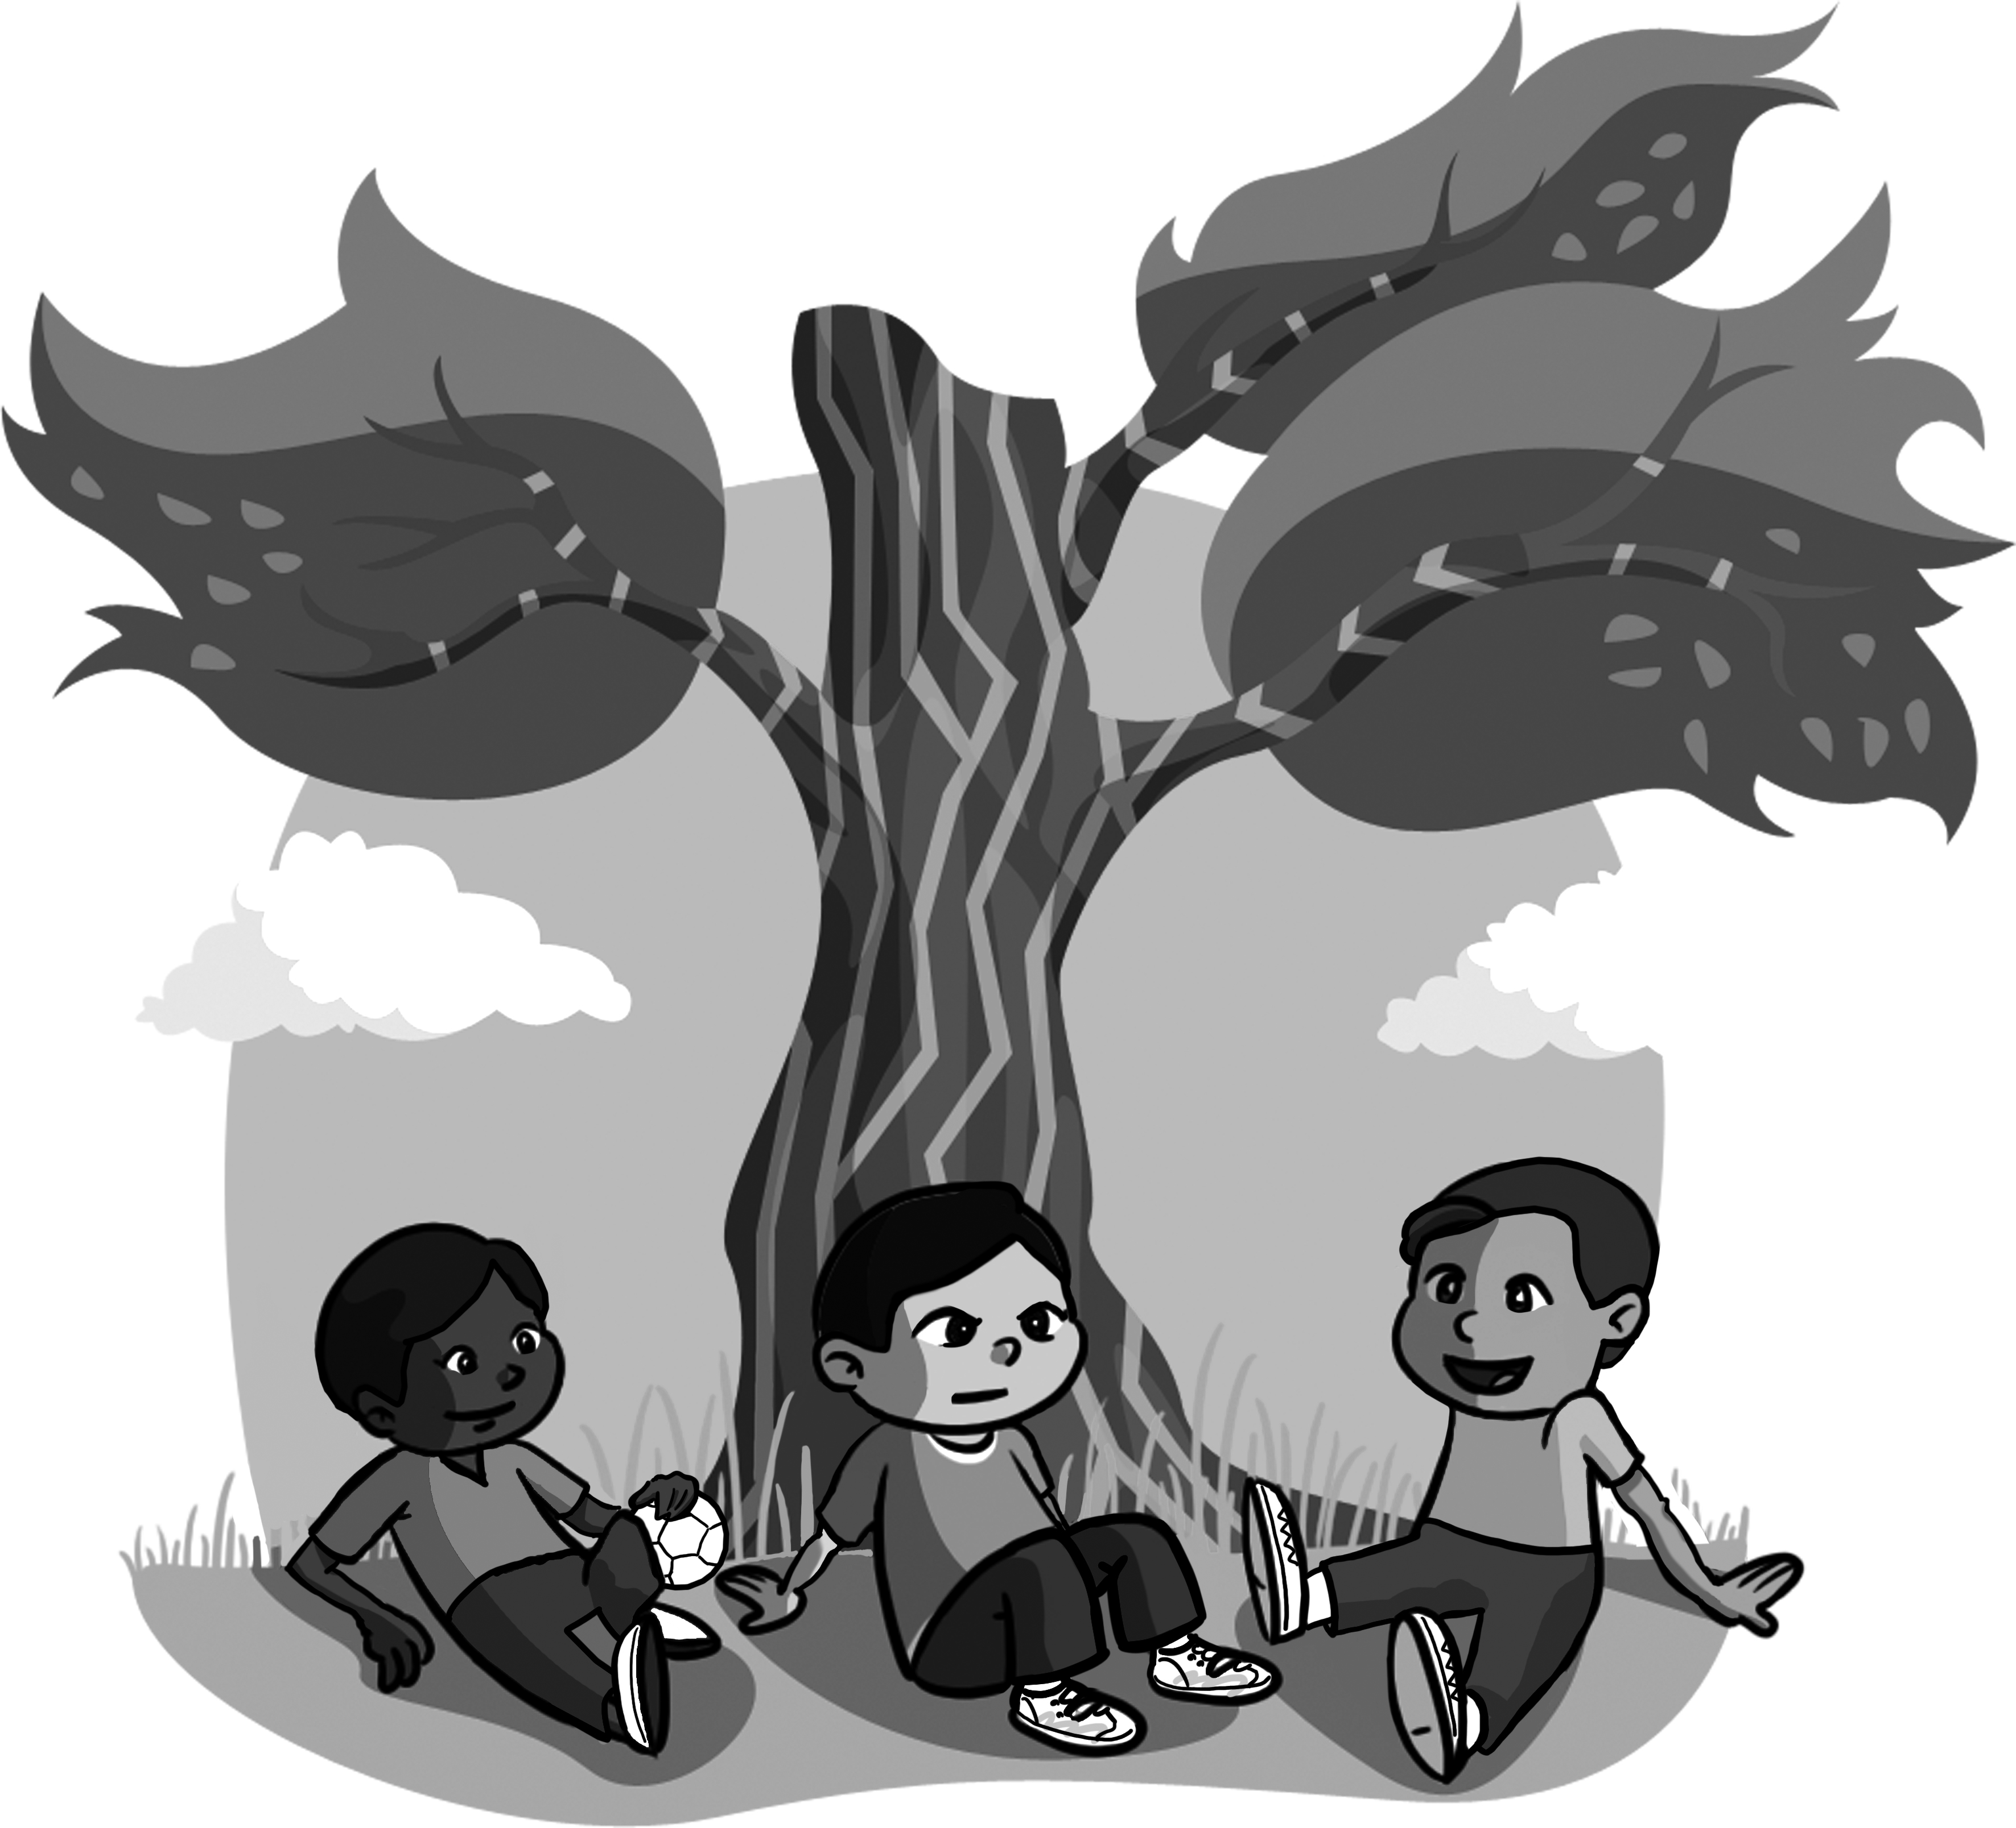 | 5  6 | ______________________  ______ not _____________  _______________

4. Listen and circle. Then write

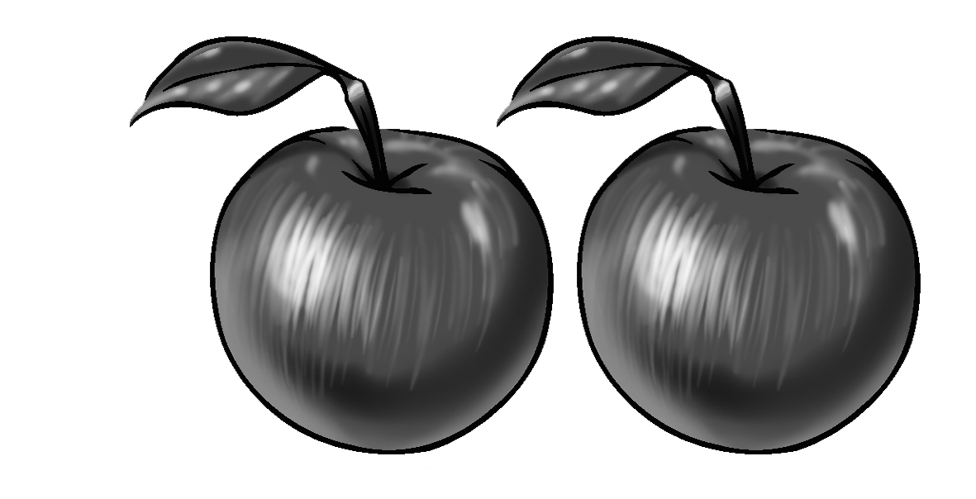 | Apples are __________! | sweet sour
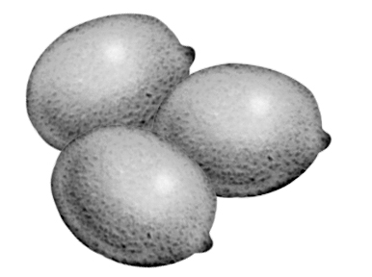 | Lemons are _________, | sweet sour
 | Cherries are_________! | sweet sour
 | They’re not __________, | sweet sour
 | My soup is__________! | cold
 | Ice-cream is_________. | hot cold
 | Rice is __________, | hot cold
 | It’s not __________. | hot cold
 | Chips are __________, | salty sweet
 | And they’re ________! | salty tasty
 | Let’s eat!

