We Can! Book 4 Unit 3: My House

1. Listen, unscramble the letters, and write the words.

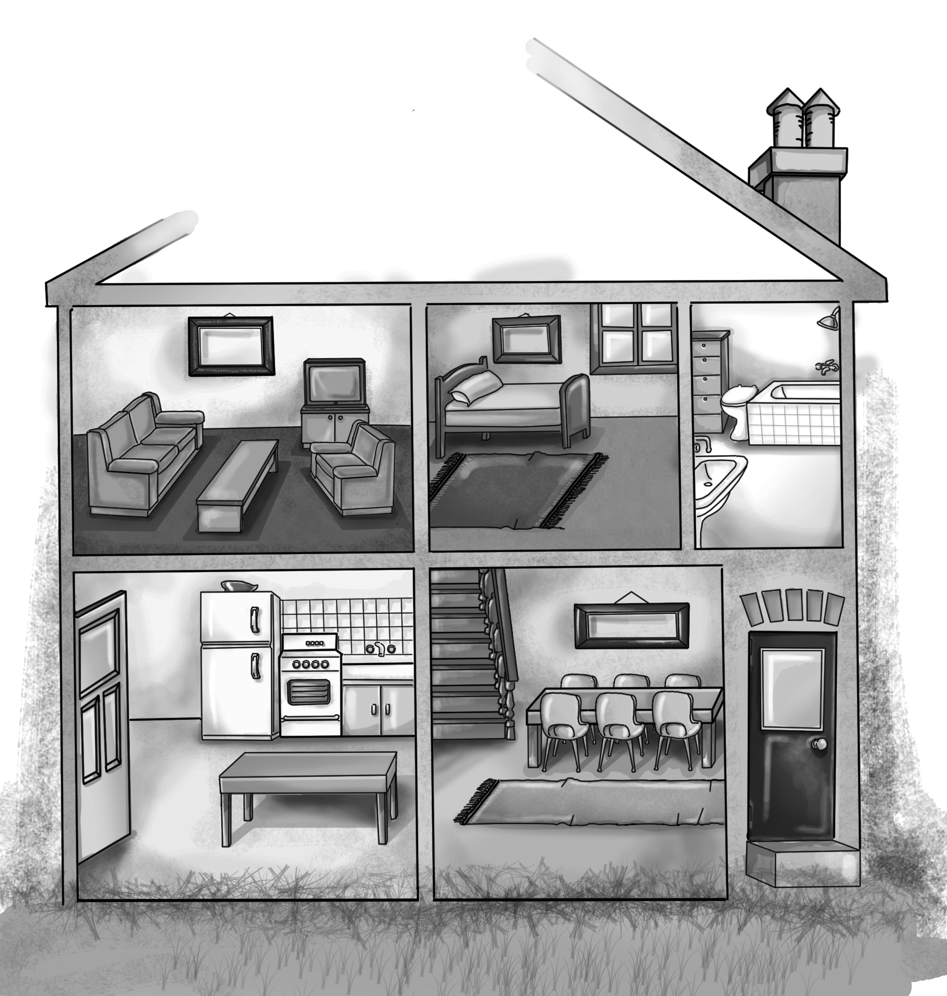 | 1.trofn rodo  ___________  2. nindig mroo  ___________  3. ntiheck  ___________  4. rbohotam  ___________  5. erobdom  ___________  6. ngviil moro  ___________
3. Read and circle Y(Yes) or N(No) for each sentence.
1. There is a TV under the armchair. T F
2. There is an armchair behind the sofa. T F
3. There is a rug in front of the bed. T F
4. There is a table in the kitchen. T F
5. There is a cup on the table. T F
3. Listen and number the pictures. Then write.

Mom | Ali | the boy | Ali
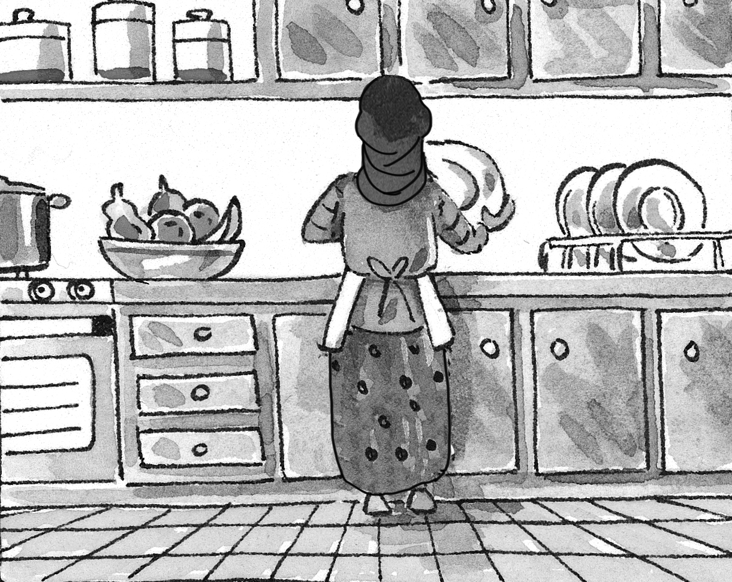 | 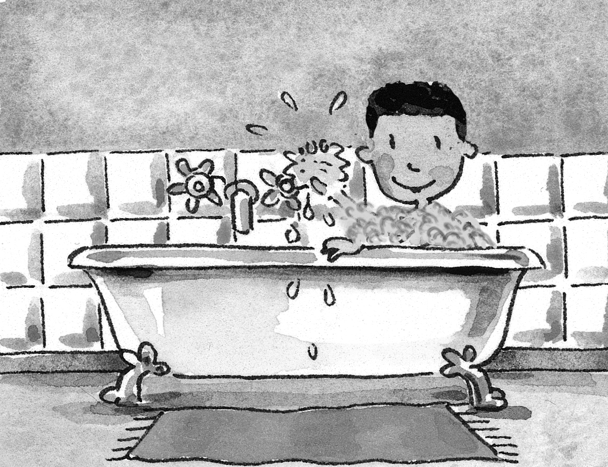 | 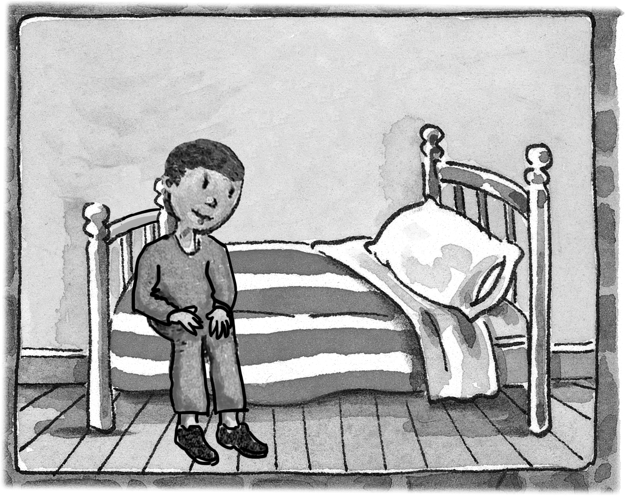 | 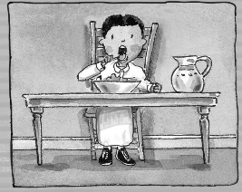
___ | ___ | ___ | ___
1. Where’s Ali? He’s in the_______________.
2. Where’s Mom? She ____________________.
3. Where’s Ali? ____________________ room.
4. Where’s the boy? _______________________.
4. Match pictures and sentences.

1 | 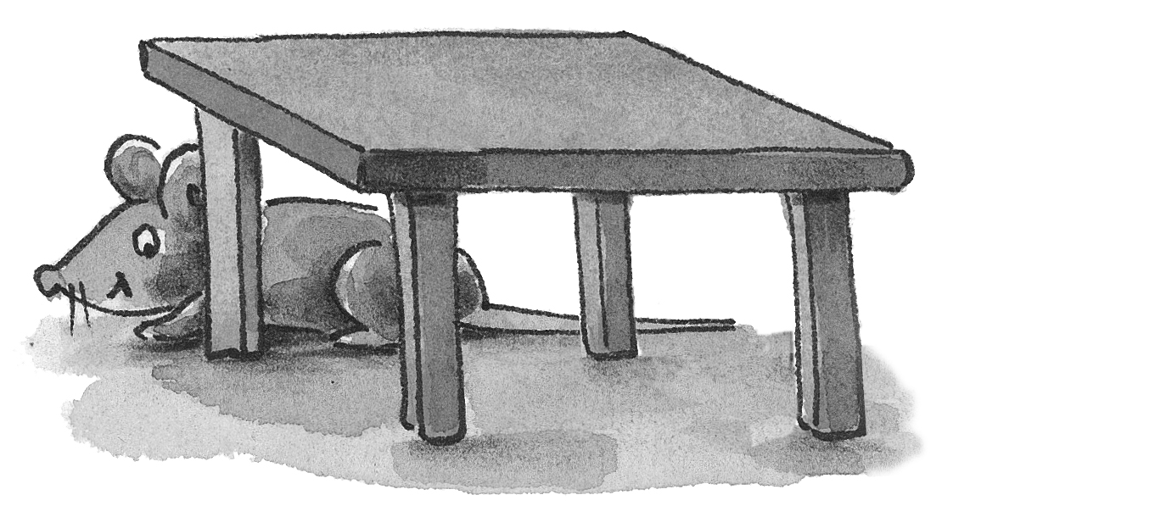 | _4_ The mouse is under the bed.
2 | 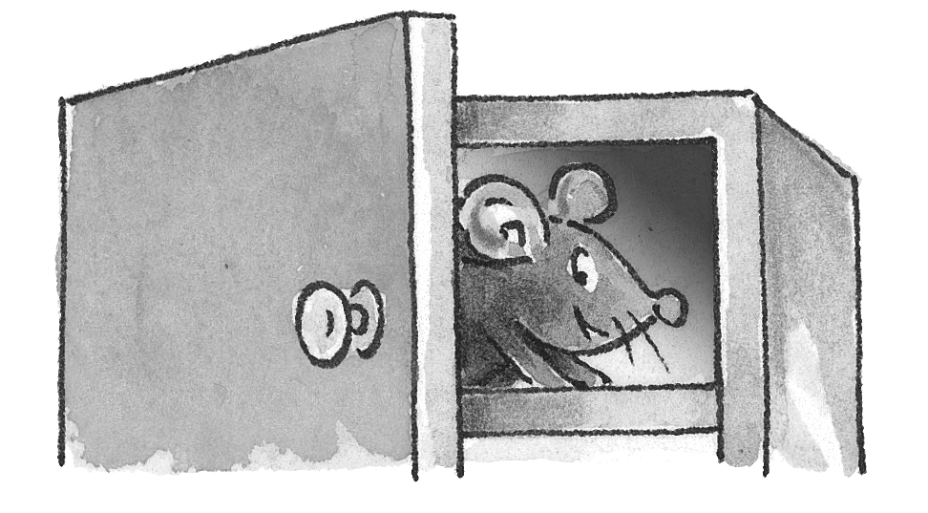 | ___ The mouse is next to the fridge.
3 | 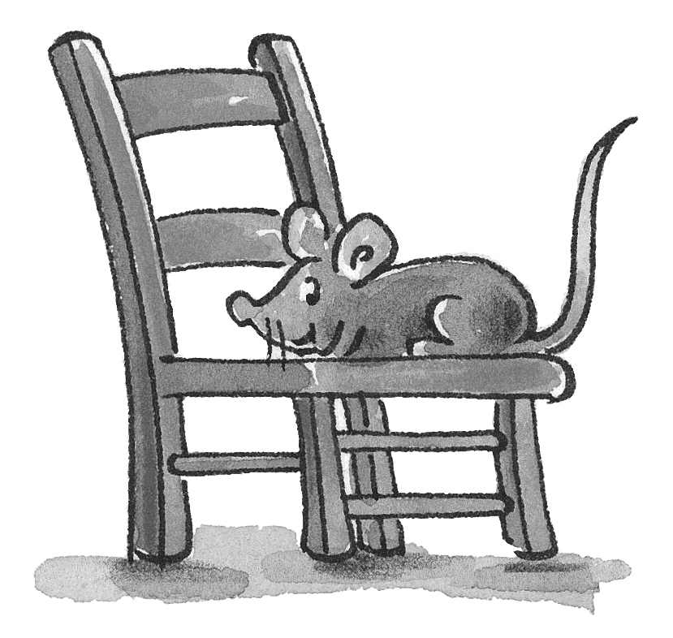 | ___ The mouse is behind the table.
4 | 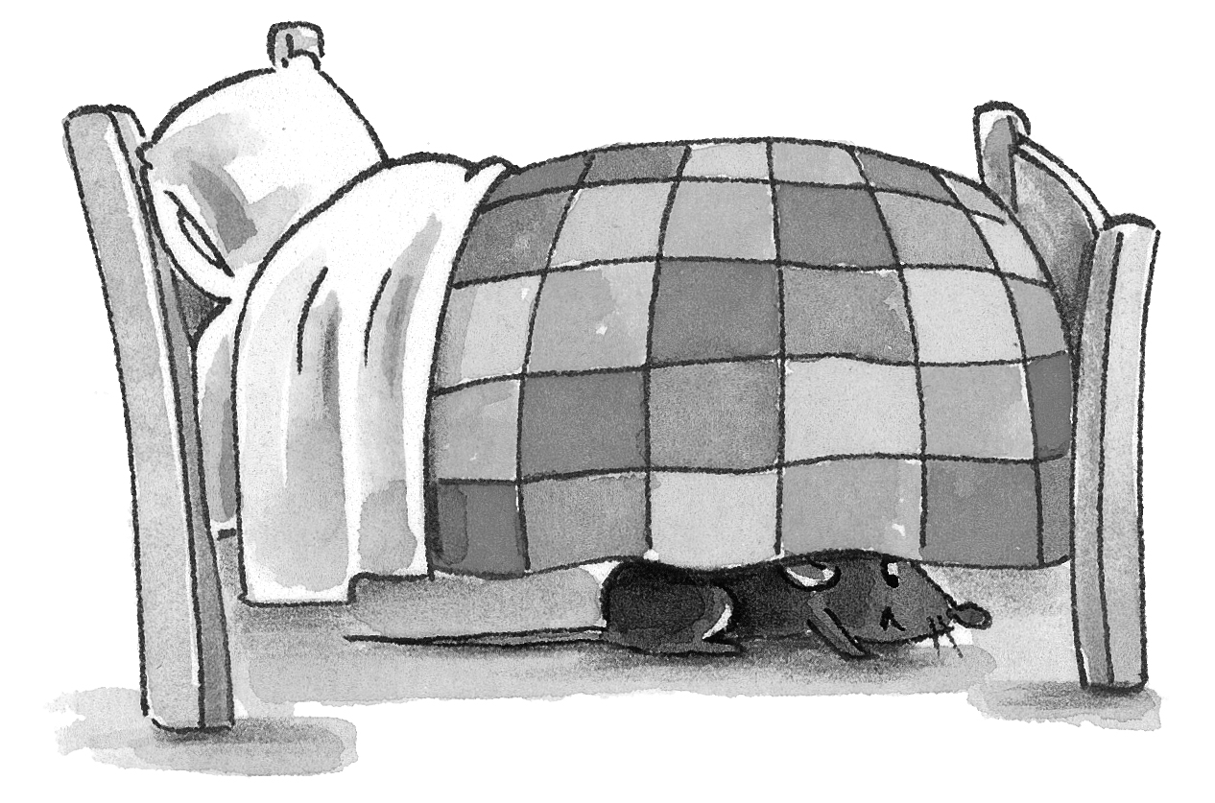 | ___ The mouse is in the cupboard.
5 | 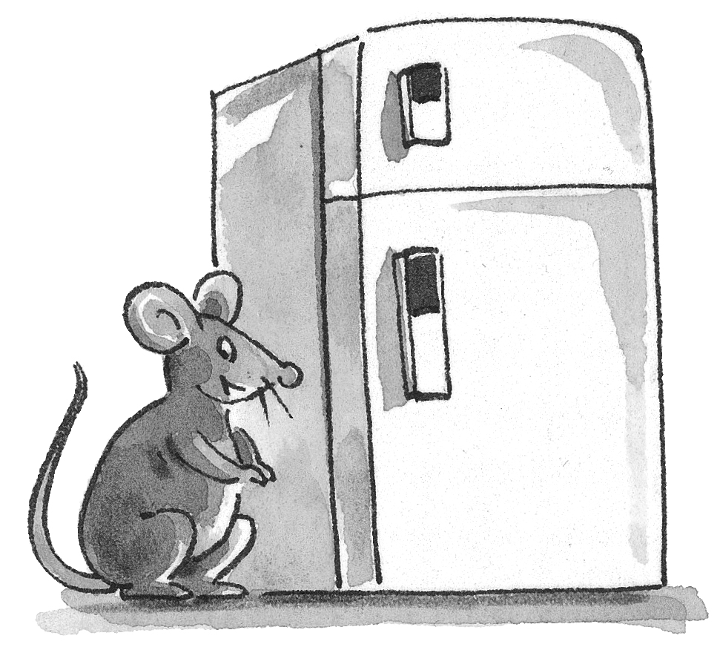 | ___ The mouse is on the chair.

