We Can! Book 6 Unit 4: A Healthy Life

1. Match the words with the pictures. Then write 2 sentences with should and 2 with shouldn’t.

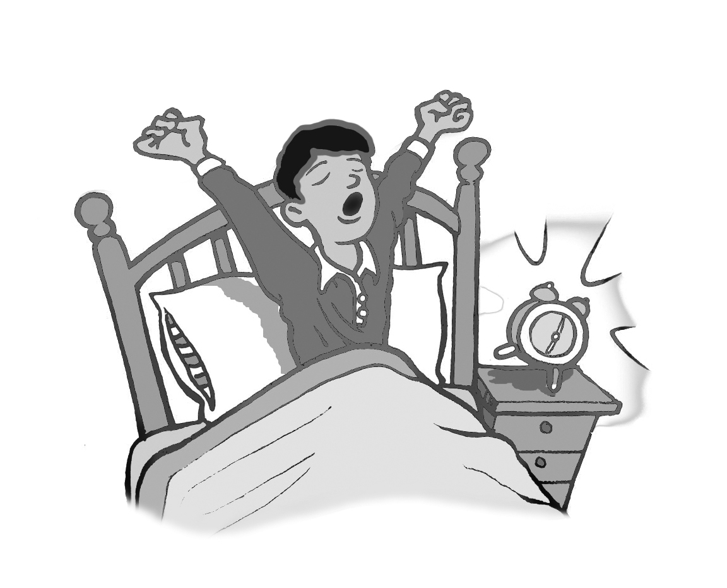  __ | 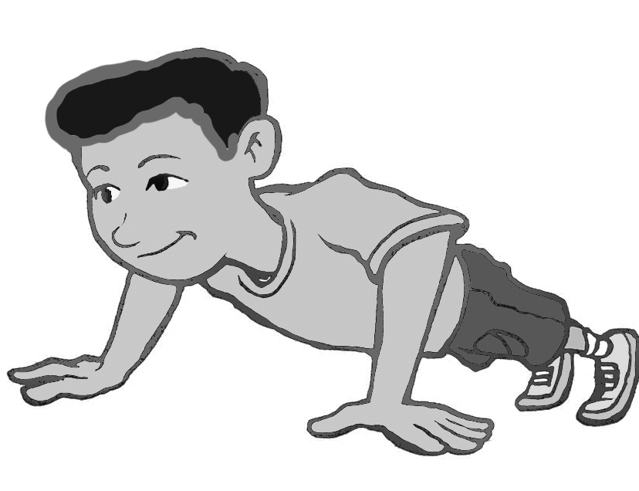  __ | 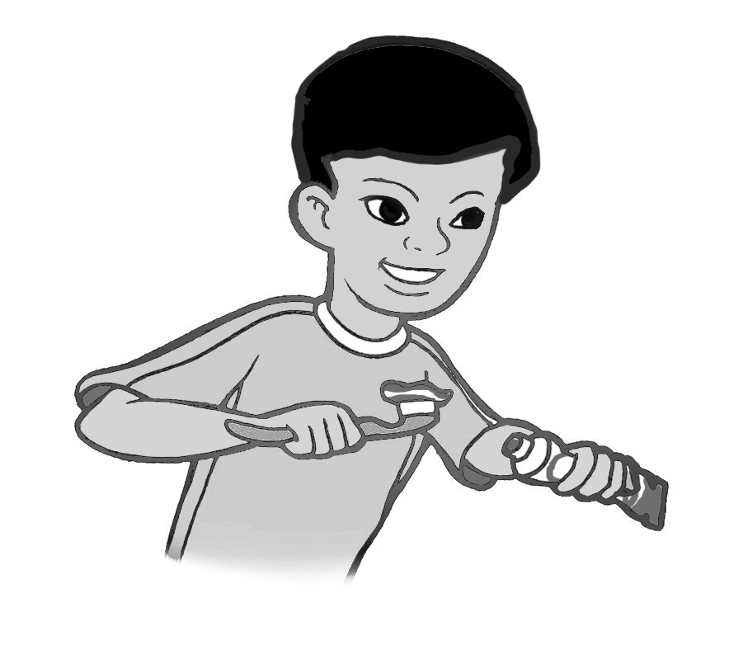  __ | 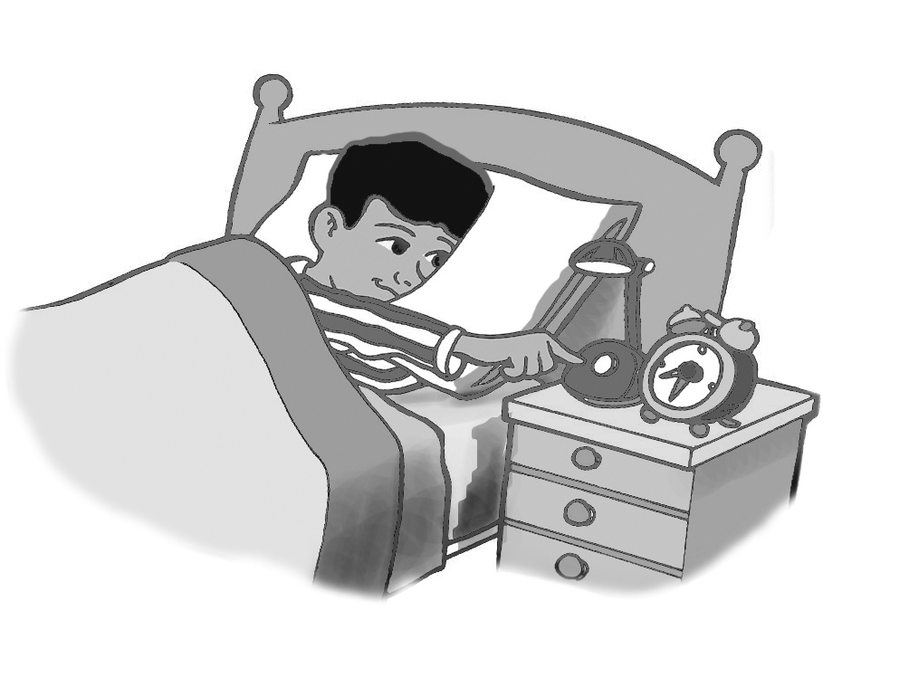  __
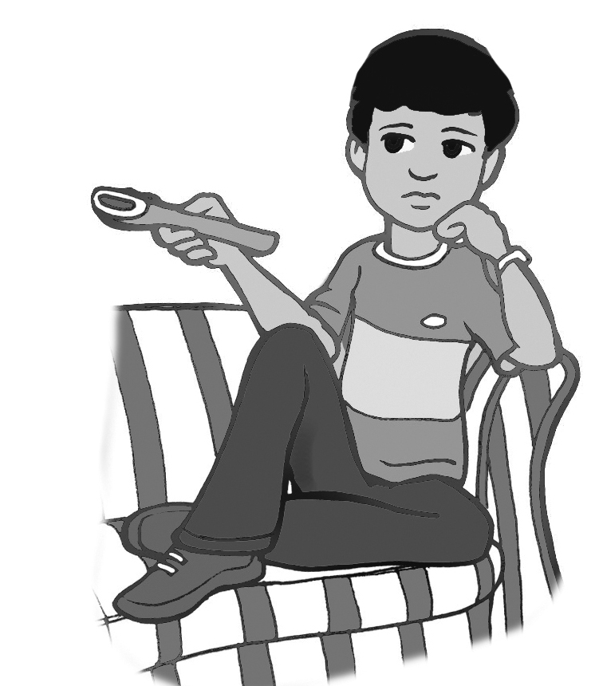  __ | 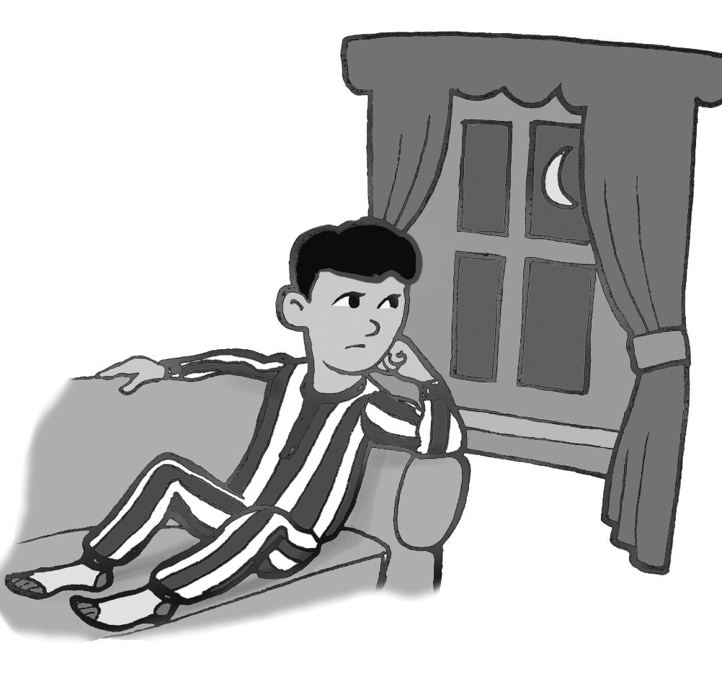  __ | 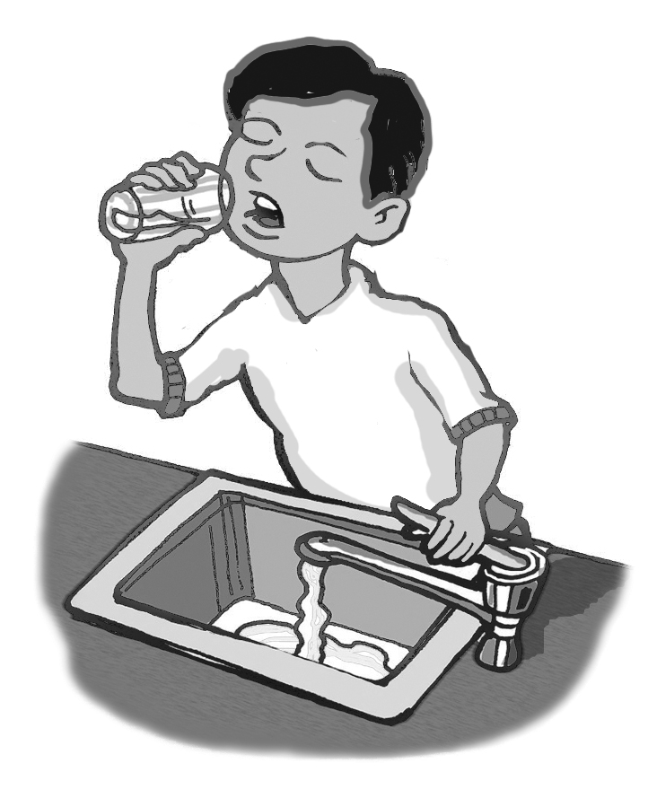  __ | 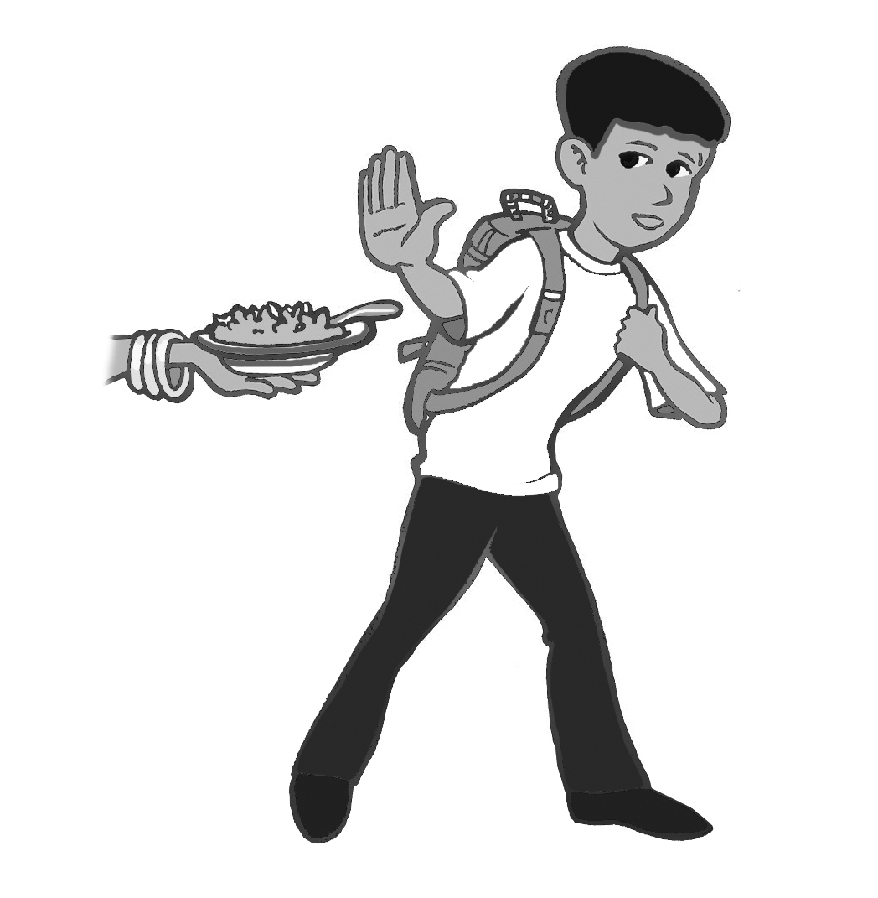  __
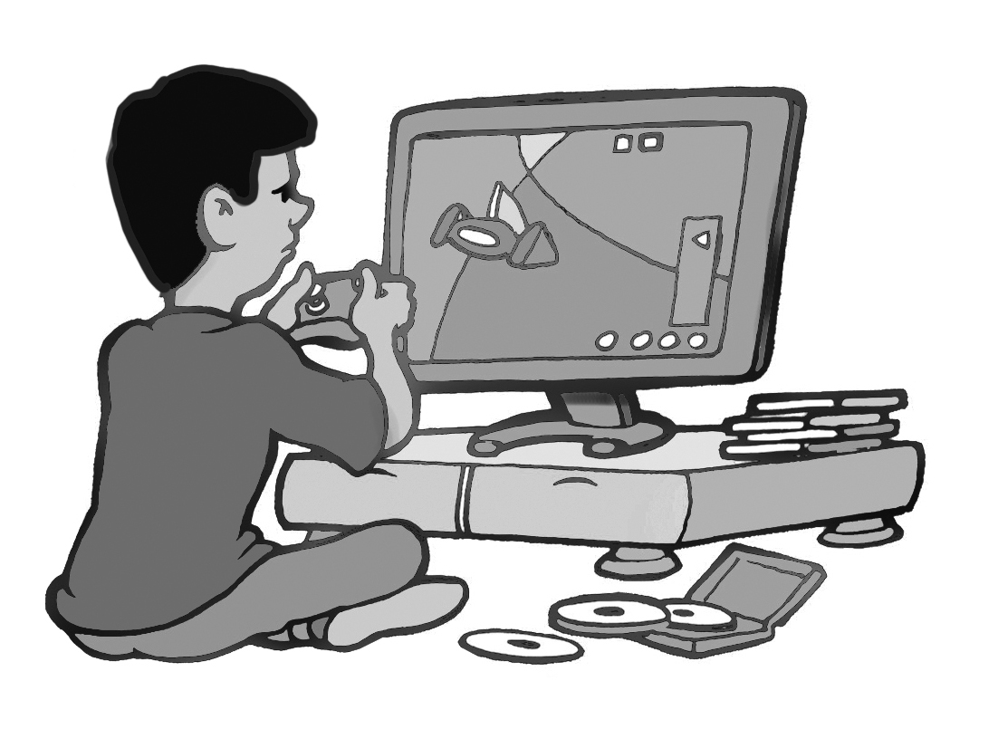  __ | 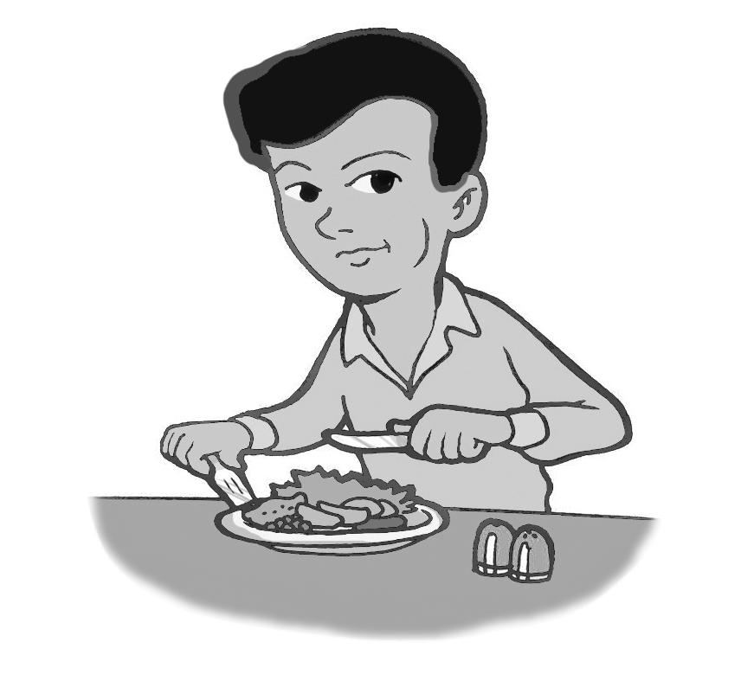  __ | 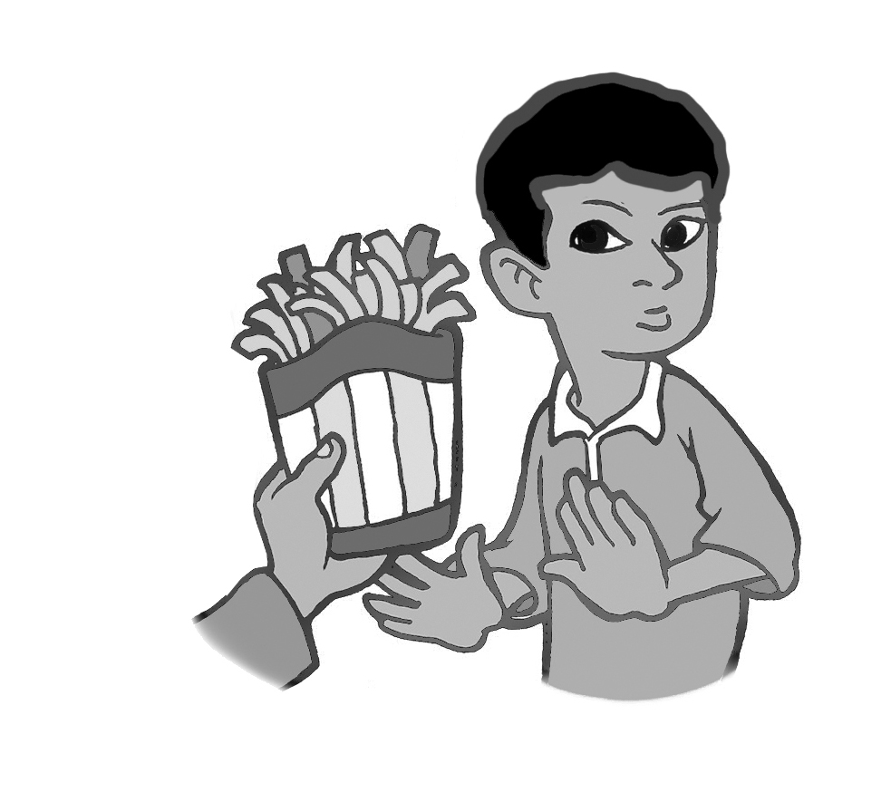  __ | 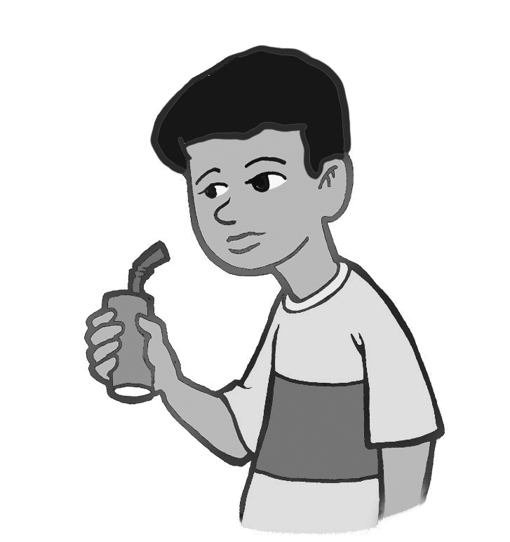  __

1. do some exercise  2. drink too much soda  3. skip breakfast  4. brush my teeth  5. watch too much TV  6. play too many computer  games | 7. eat too much junk food  8. drink a lot of water  9. get up early  10. stay up late  11. go to bed early  12. eat three meals a day
1. _______________________________________

2. _______________________________________

3. _______________________________________

4. _______________________________________

2. Fill in the blanks with the correct verb form.

drink / drank eat / ate brush / brushed

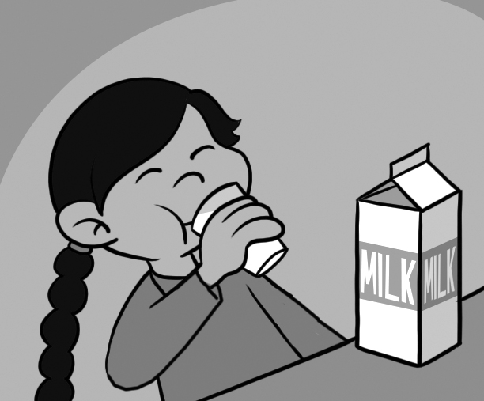 | Did you _______ milk this morning?  Yes, I _______ milk this morning.
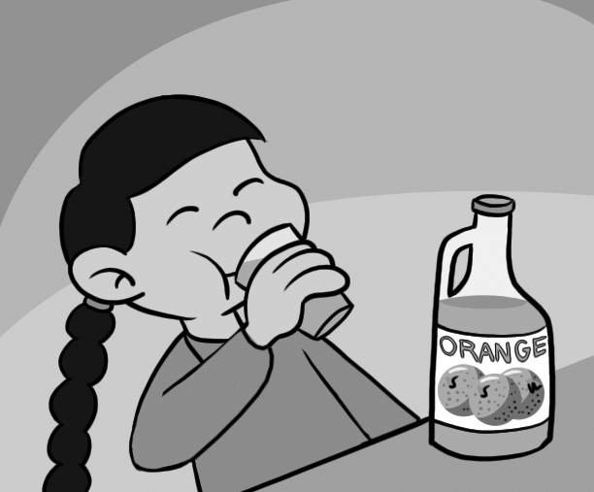 | She didn’t _______ milk this morning.
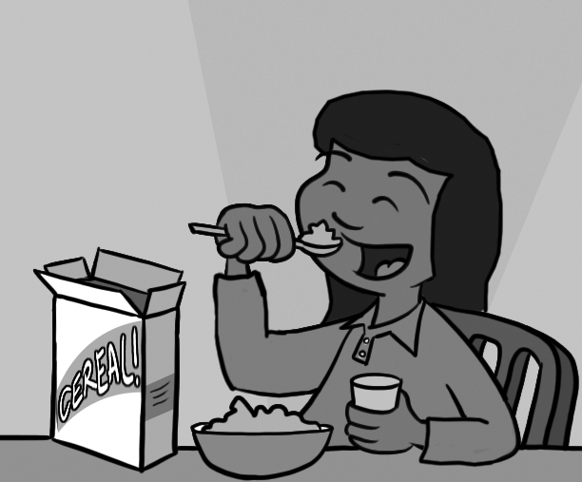 | Did she ______ breakfast this morning?  Yes, she ______ breakfast this morning.
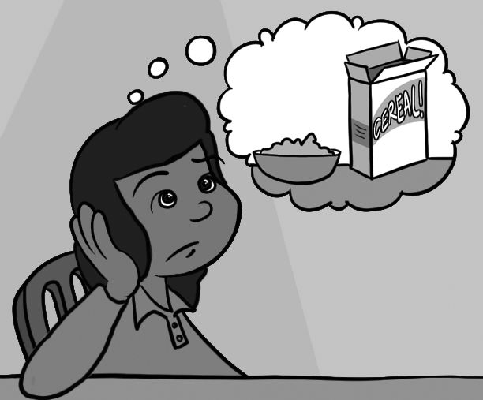 | She didn’t _____breakfast this morning
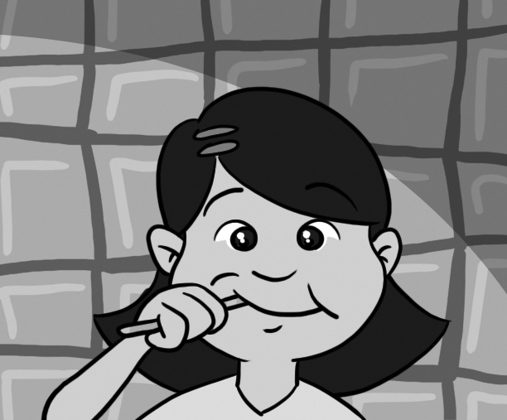 | Did she _____her teeth this morning?  Yes, she _____her teeth this morning.
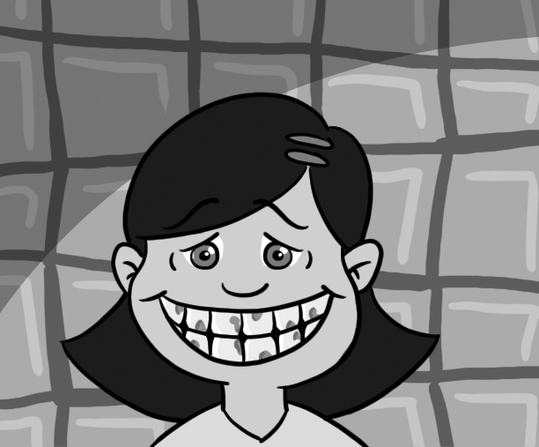 | She didn’t _____her teeth this morning.

3. Fill in the chart with the correct forms.

(Present: always, sometimes, usually, never, every day, every morning, every afternoon, every evening, every night …etc.

Past: this morning, yesterday, last weekend, last week, last night, last year, last month …etc.)

Present | Past | Present | Past
1. ______ | played | 2. get up | ______
3. watch | ______ | 4. ______ | ate
5. drink | ______ | 6. cook | ______
7. ______ | brushed | 8. ______ | went to bed
9. talk | ______ | 10. do | ______

