We Can! Book 6 Unit 2: Life’s Ups and Downs

1. Look at the pictures and fill in the missing words.

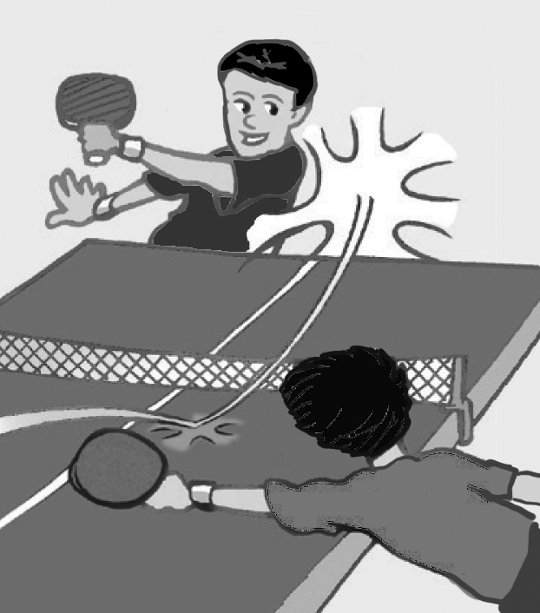  1 | 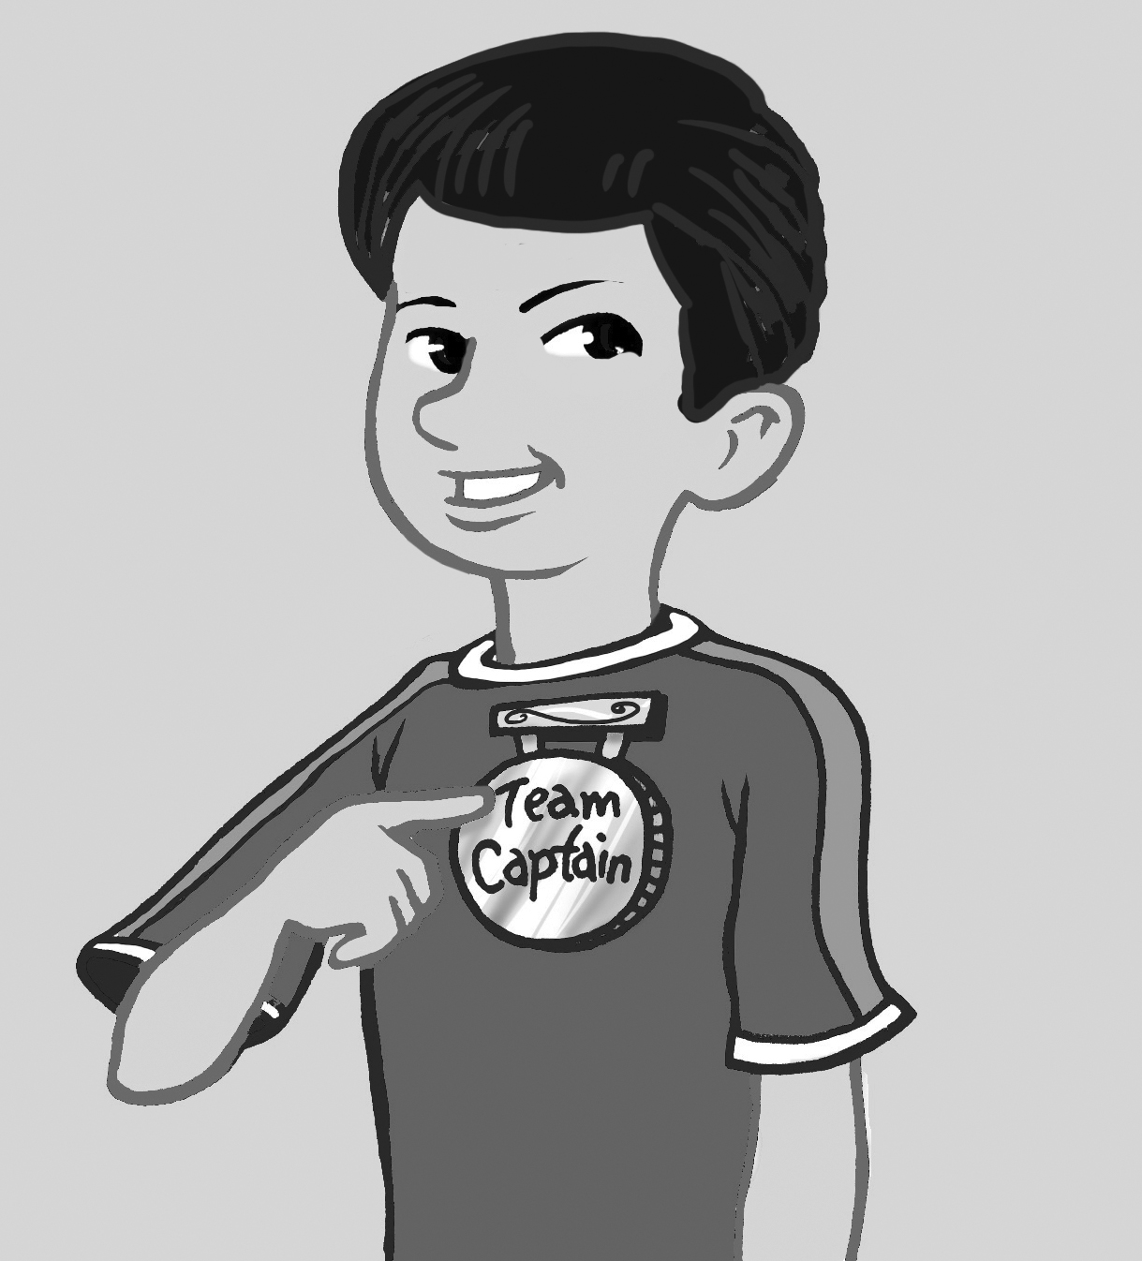  2 | 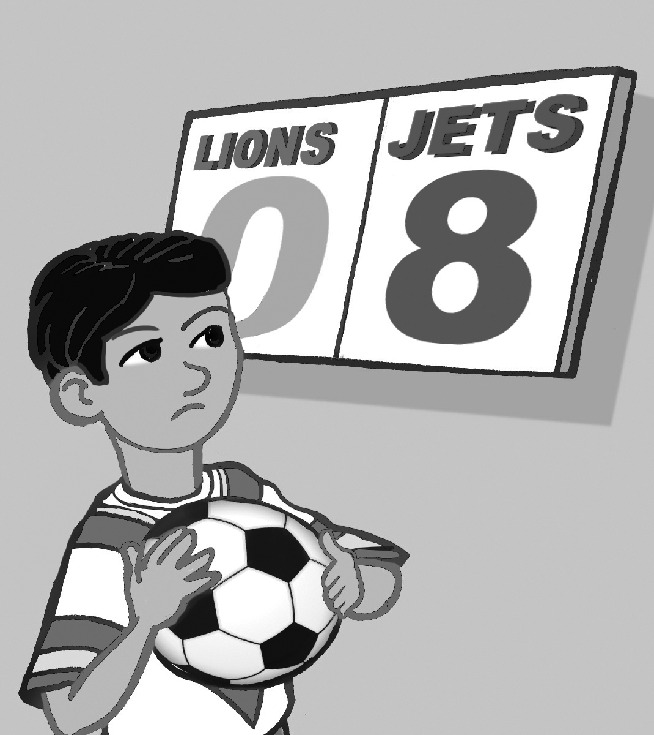  3 | 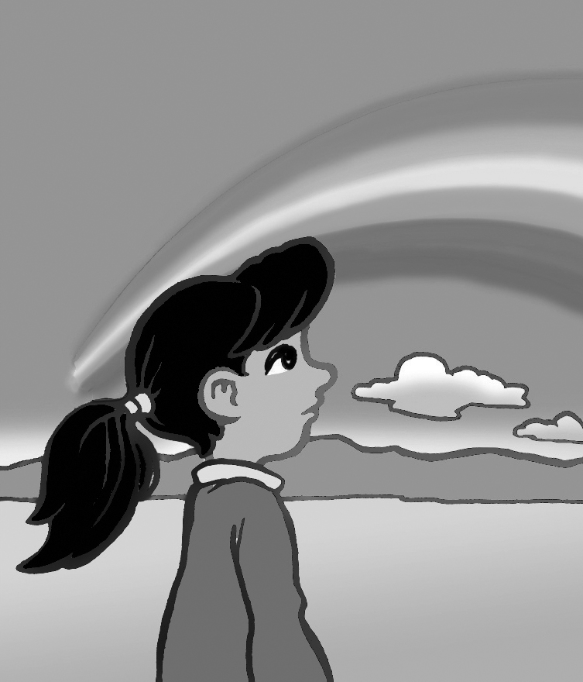  4
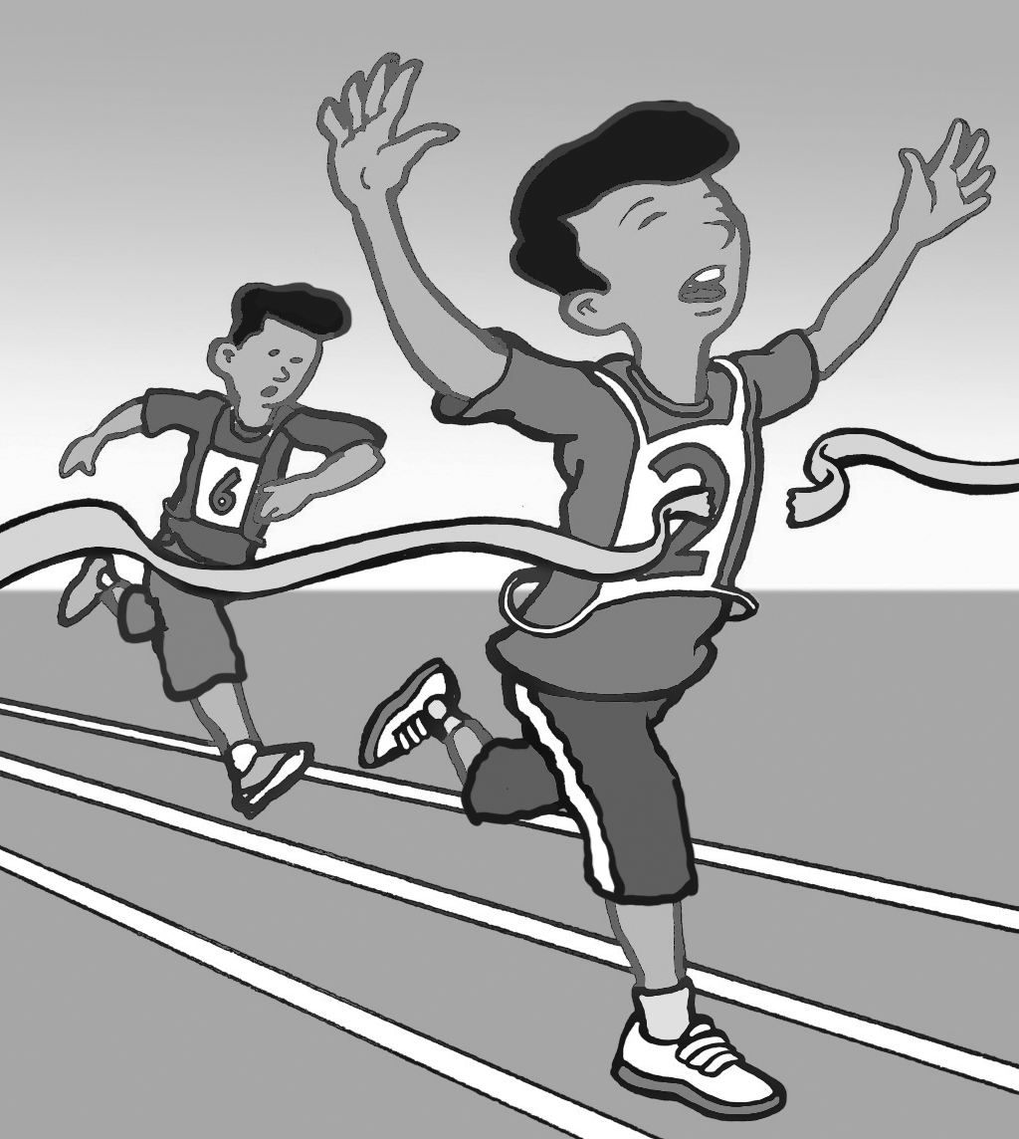  5 | 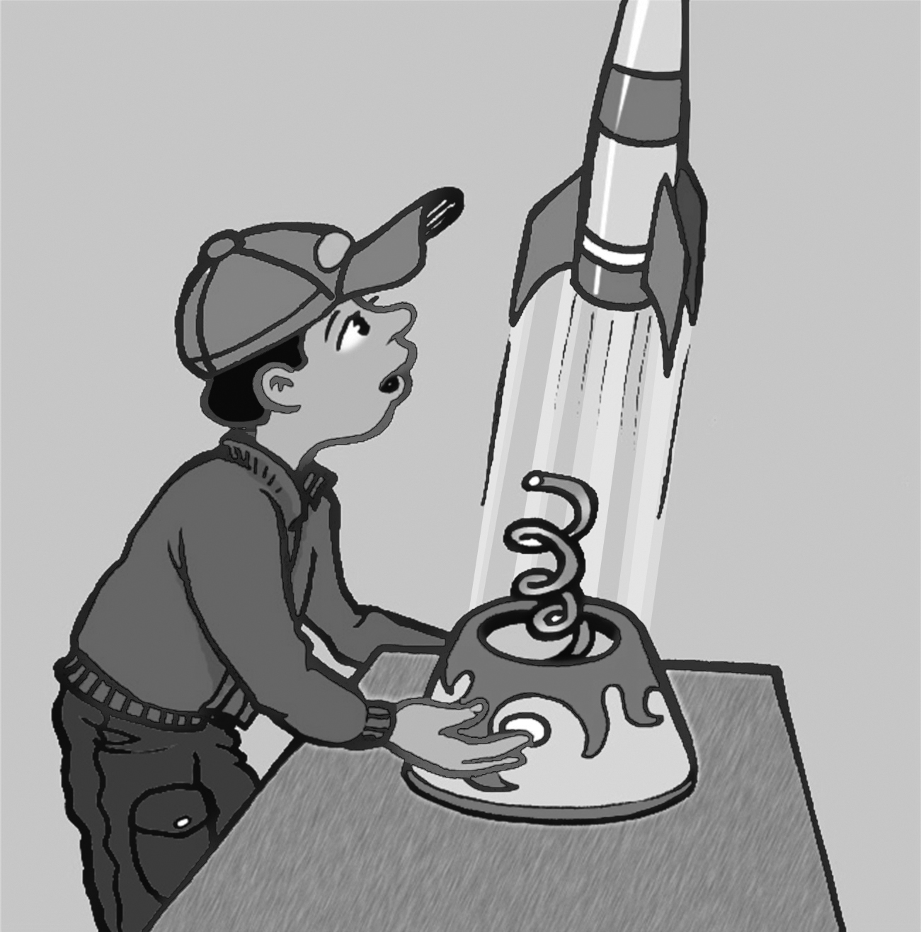  6 | 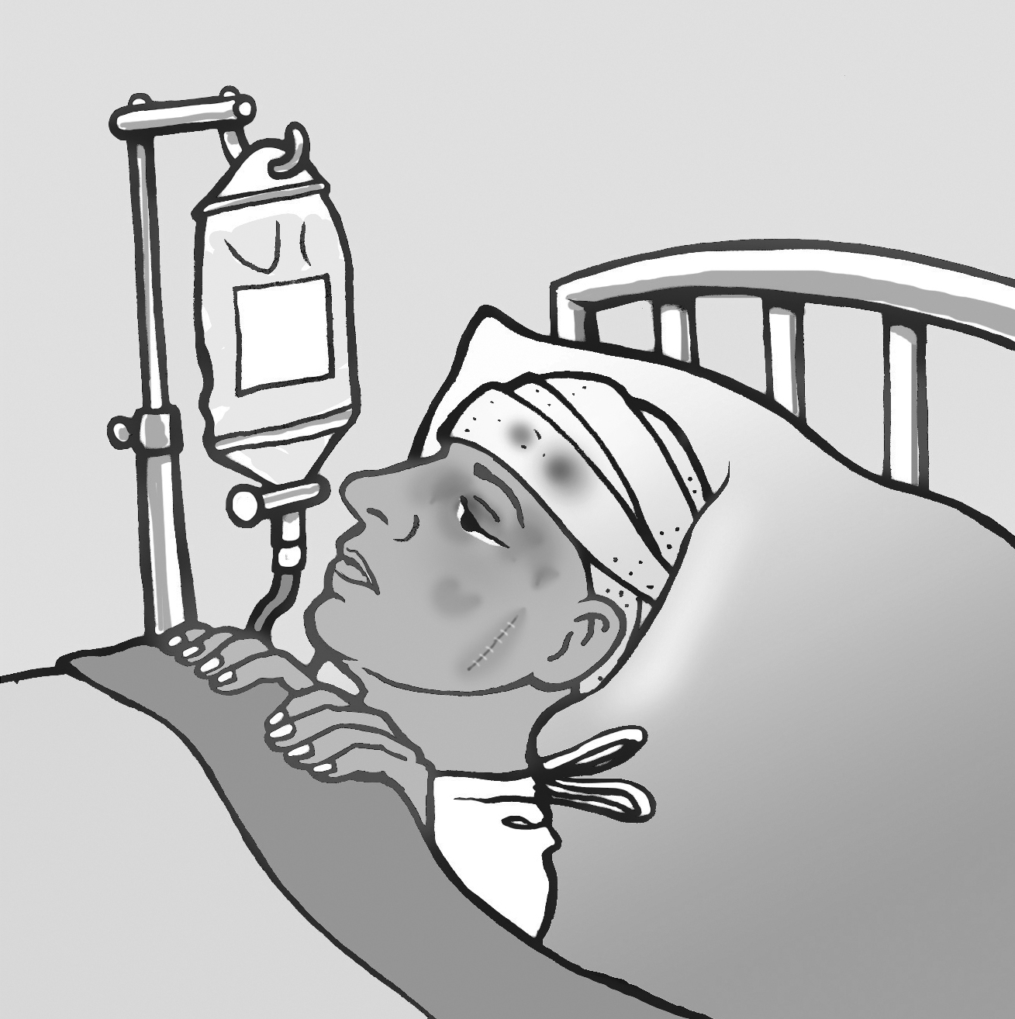  7 | 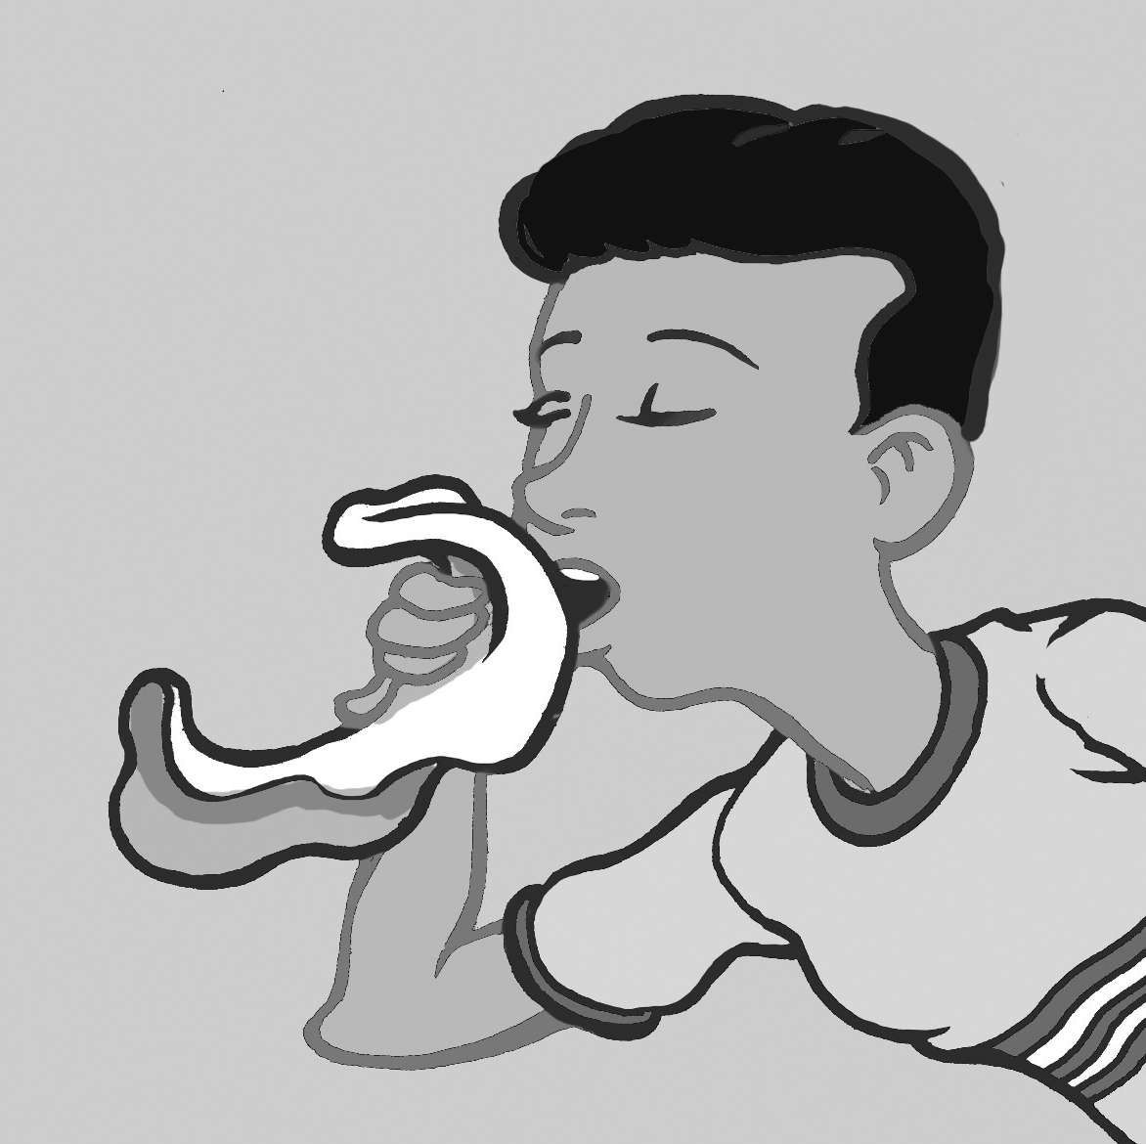  8
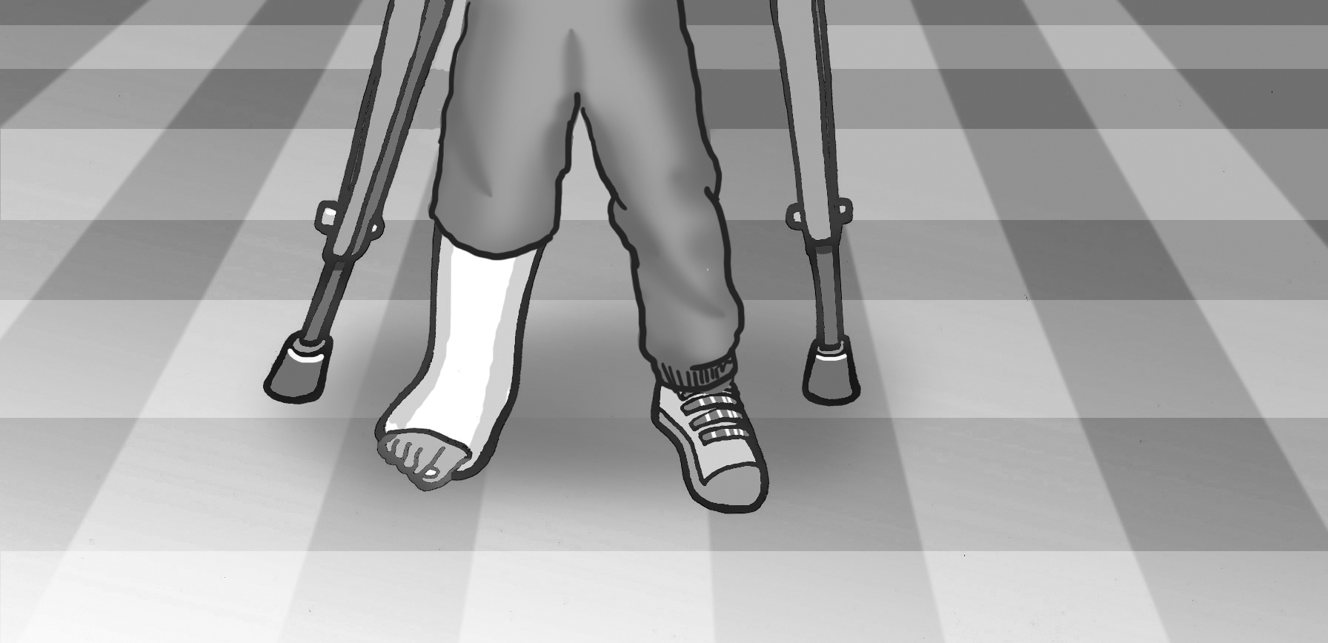  9 |  | 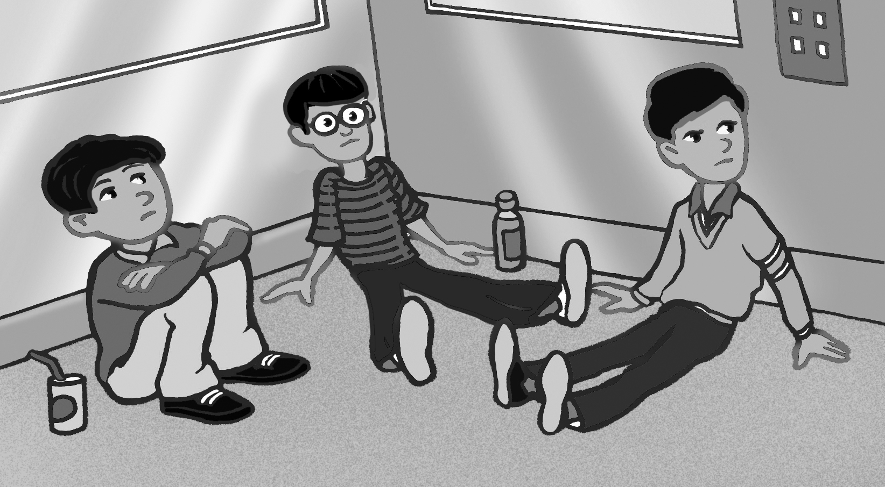  10

saw were broke had got lost was won made caught

1. I ____ a table tennis game.
2. I ____ team captain.
3. We ____ a football game.
4. I ____ a rainbow.
5. I ____ first place in the race.
6. I ____ a rocket.
7. My dad ____ an operation.
8. I ____ a cold.
9. I ____ my leg.
10. We ____ stuck in an elevator.
2. Read and match comments with pictures.

1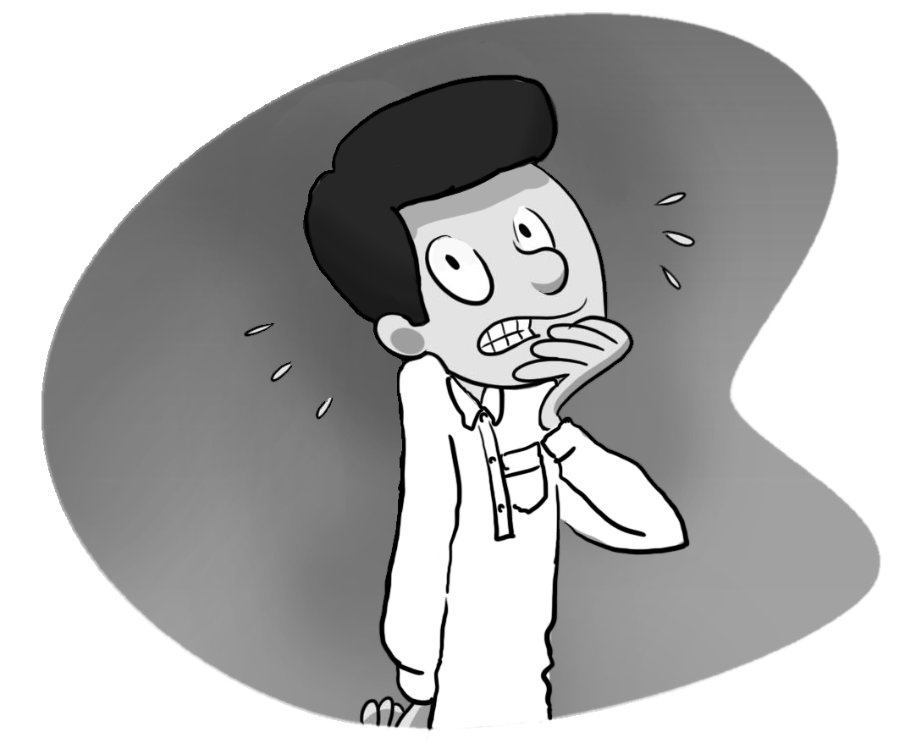 | 2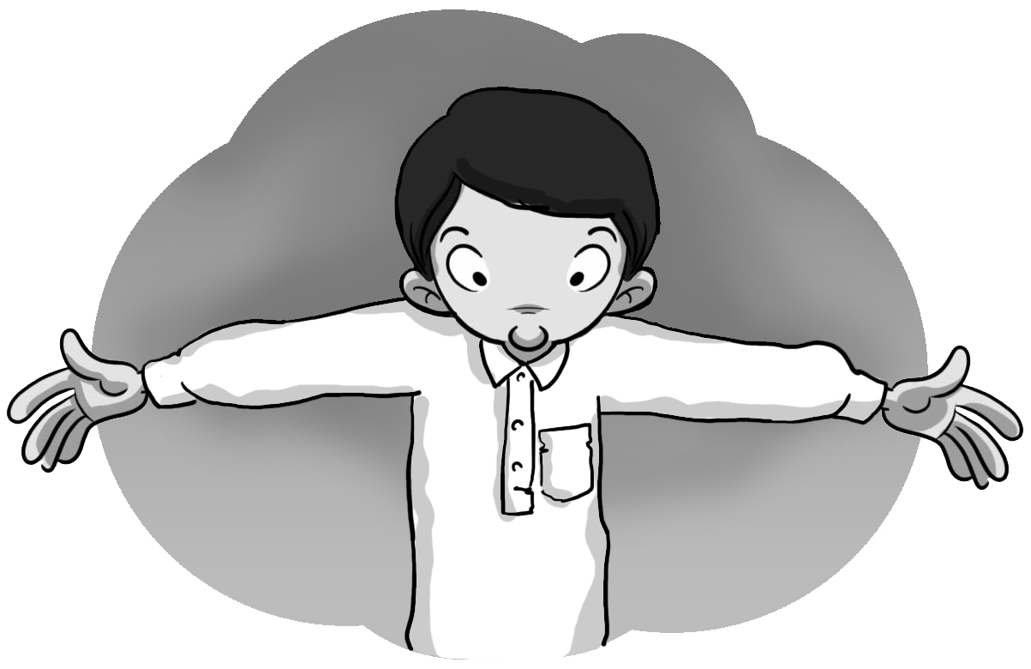 |  | 3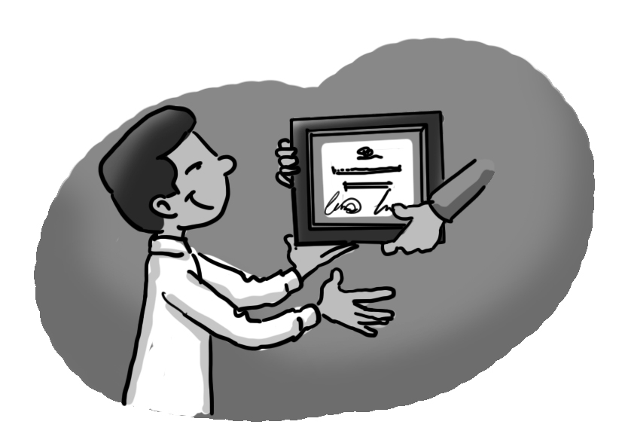
4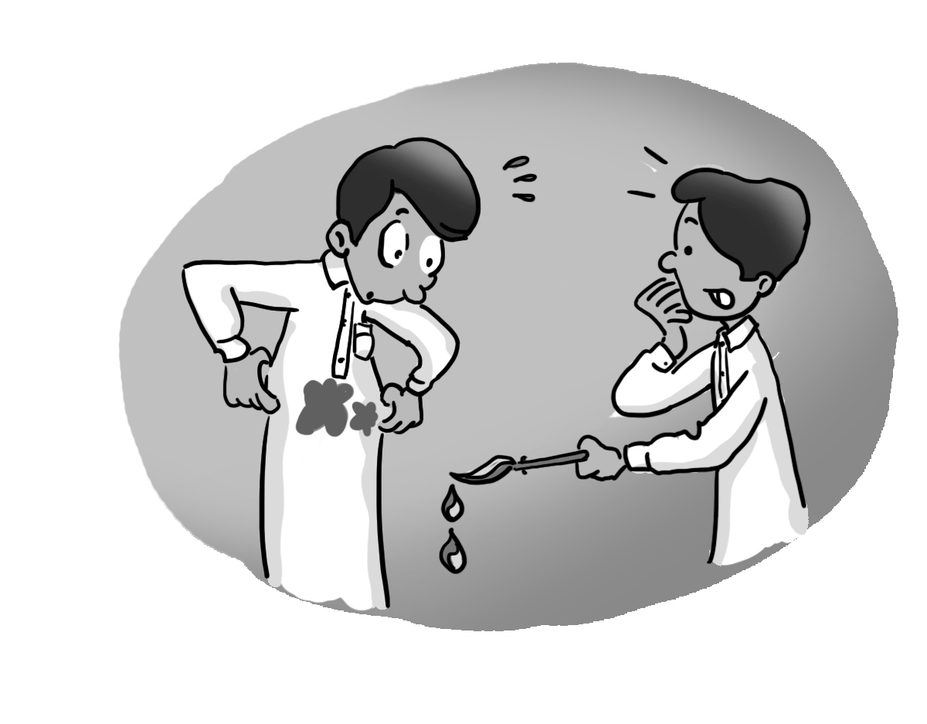 | 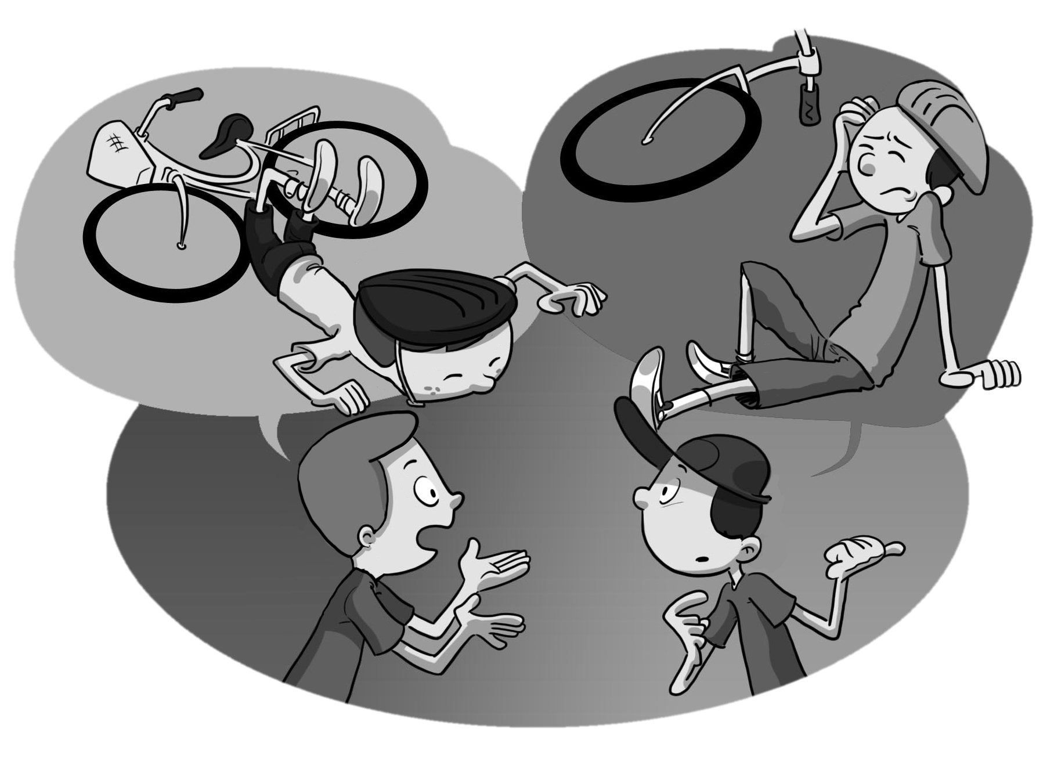  5
Congratulations ____ |  | How scary! ____
How strange! ____ |  | So did I. ____
Sorry about that. ____
3. Read and write your comment.

1. I saw a beautiful parrot in the garden.

___________________________________
2. I broke my leg in the race.

___________________________________
4. Listen and fill in the missing words.

had got went came was

My Brother Khaled

My brother Khaled
____ to the cupboard,
To find something to eat.
But when he ____ there,
The cupboard ____ bare,
And so he ____ nothing to eat.
He ____ to the grocer’s,
To buy some fruit and milk.
But when he ____ back,
He ____ holding and empty brown bag.
Poor Khaled!

5. Write about a good event and a bad event, that happened to you last week, last month, last weekend, or last year.
_________________________________________
_________________________________________
_________________________________________
_________________________________________
_________________________________________
_________________________________________

