We Can! Book 4 Unit 1: Wild Animals

1. Listen and match pictures and words. Number the words.
__chimpanzee | __koala | __ostrich | __lion
__elephant | __hippo | __snake | __giraffe
__kangaroo | __ zebra | __iguana | __polar bear
__hyena | __tiger | __rhinoceros

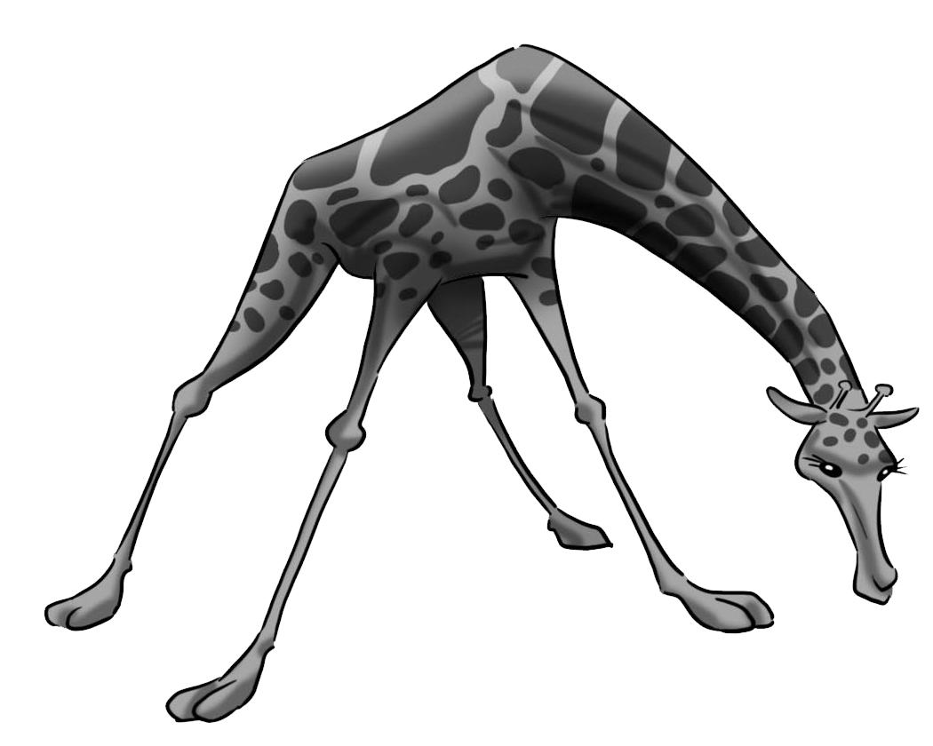  1. | 2. 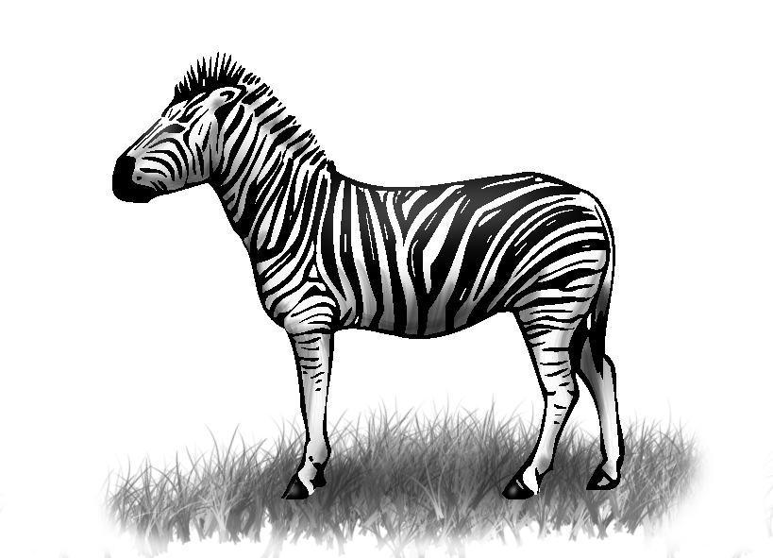 | 3. 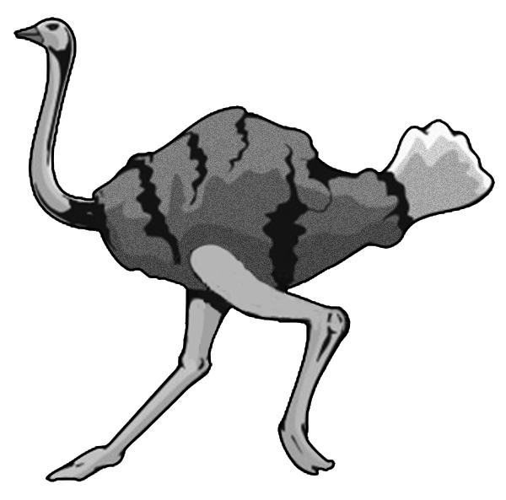
4. 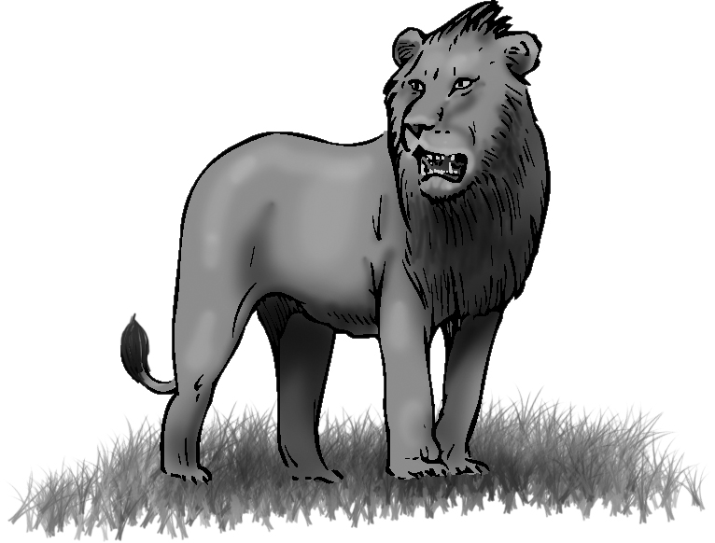 | 5. 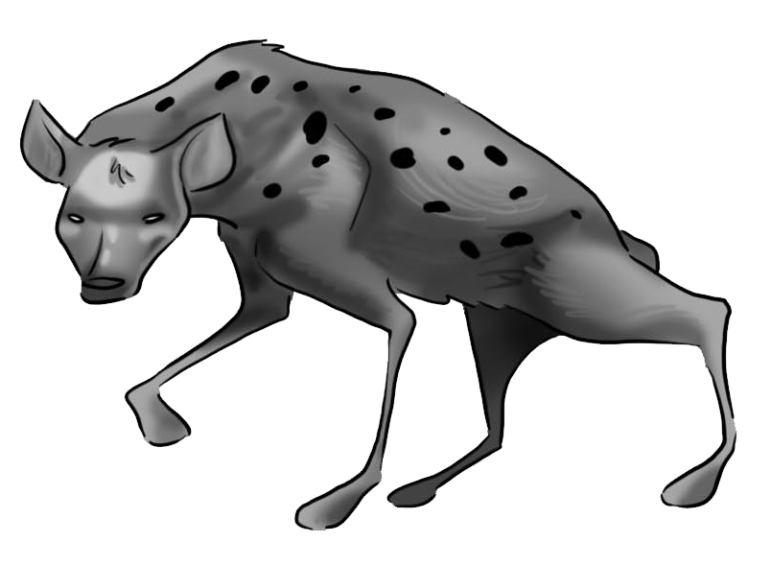 | 6. 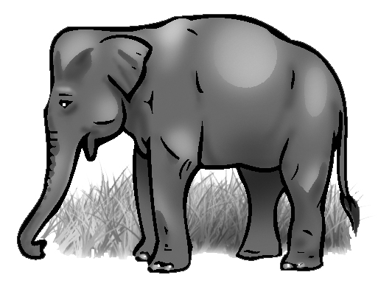
7. 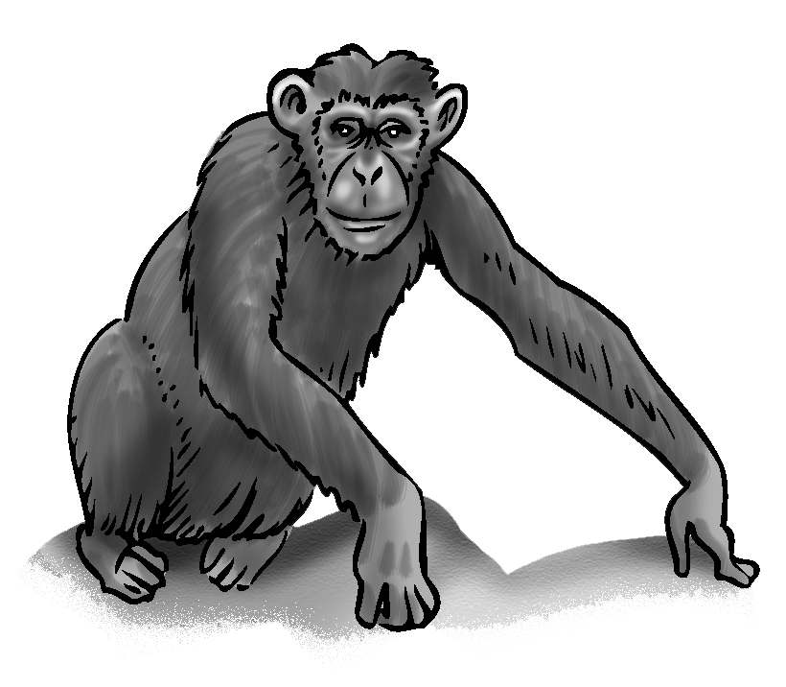 | 8. 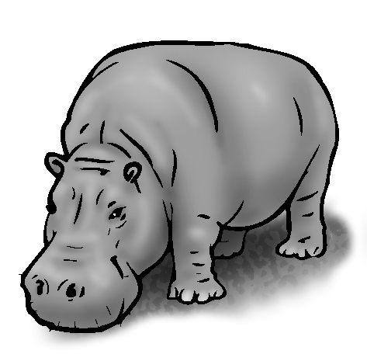 | 9. 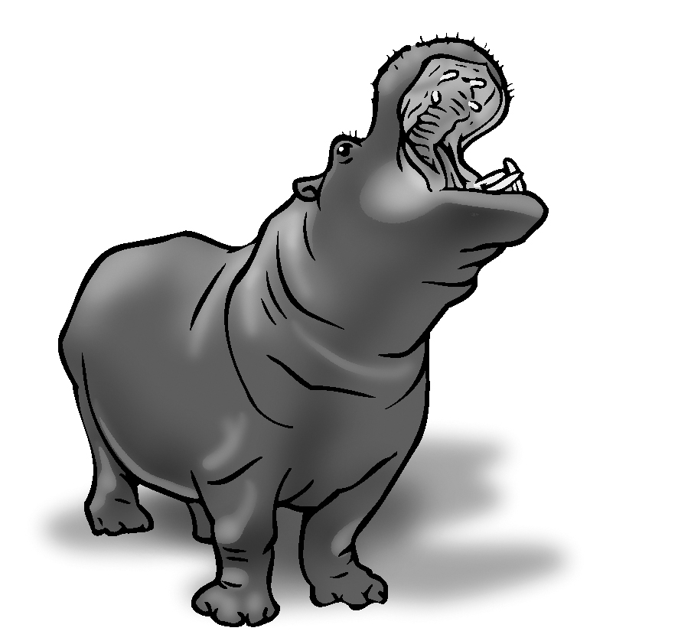
10. 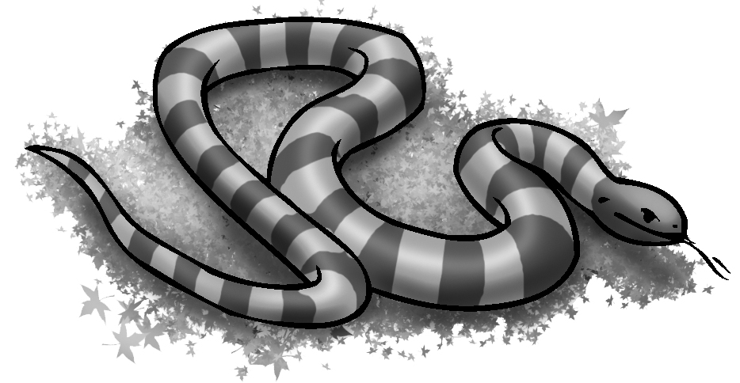 | 11. 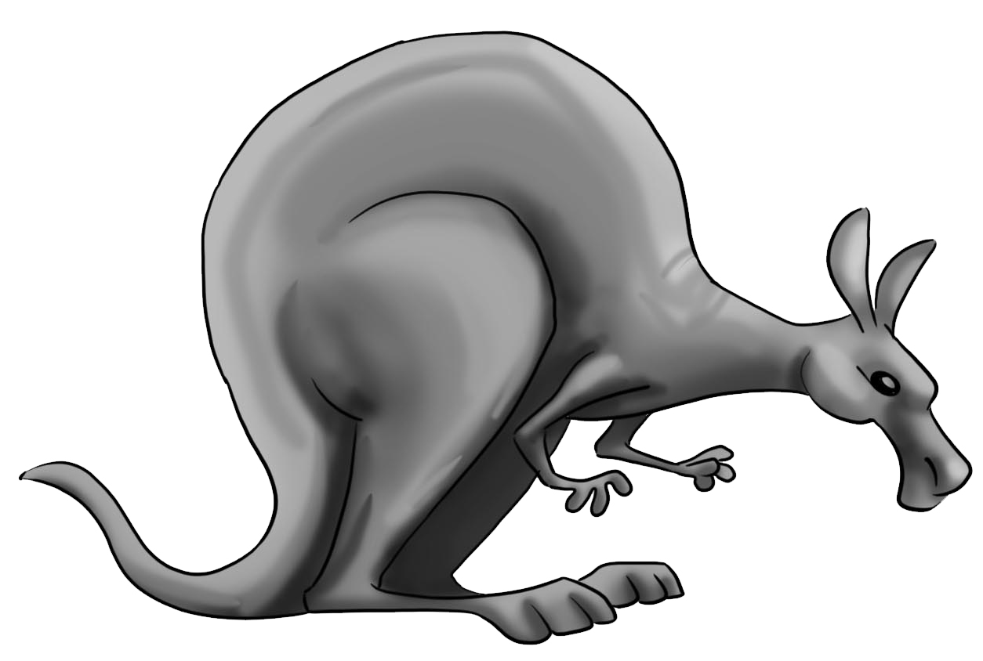 | 12. 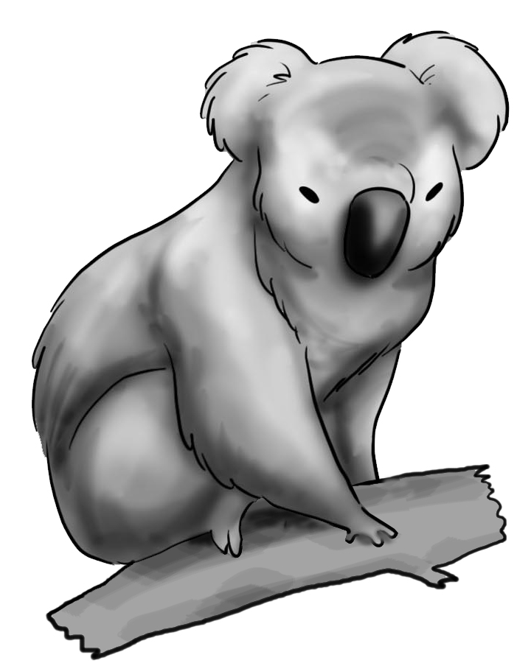
13. 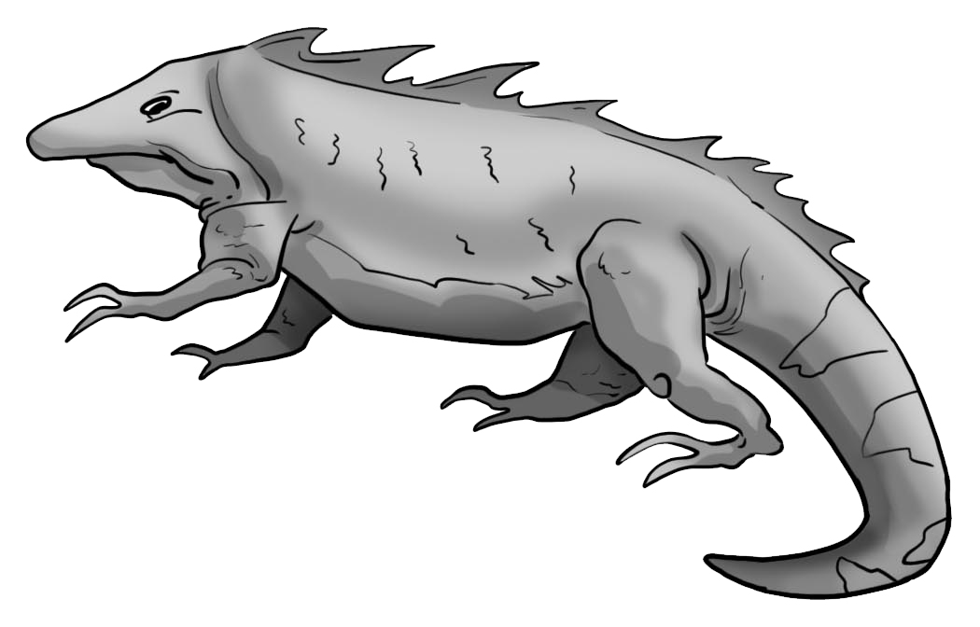 | 14. 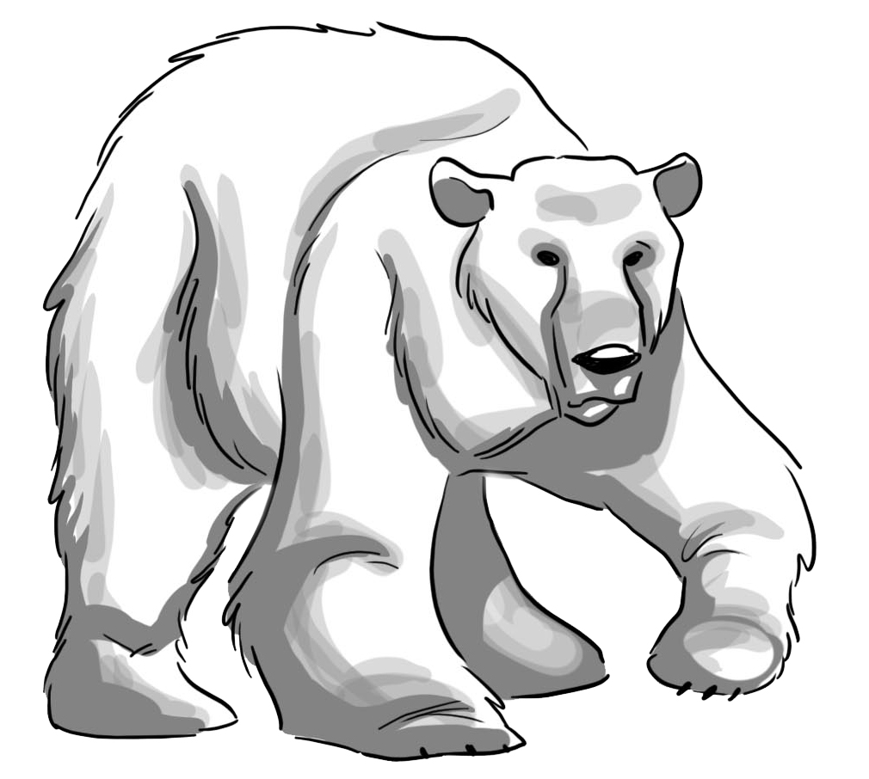 | 15. 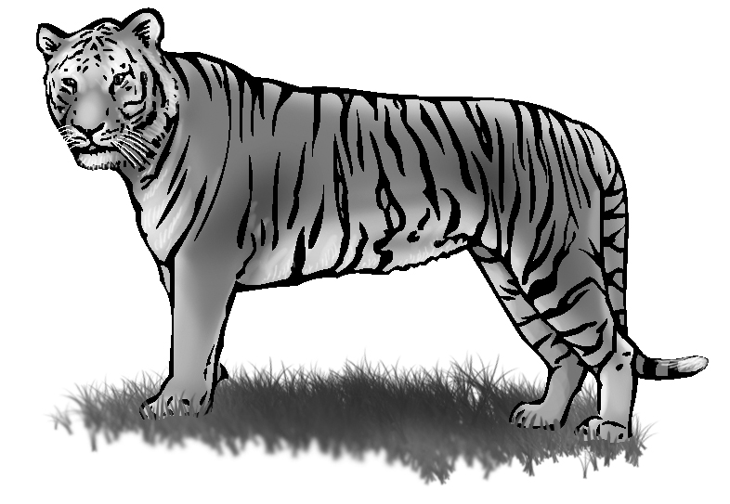

2. Listen and write about the animals. Use these words.

big / trunks black and white/ stripes scary/ big teeth

smart/ long arms long/ no arms or legs fat/ big mouths.

1. Elephants are________.  They have big________. | 2. Zebras __________.  They have ________.
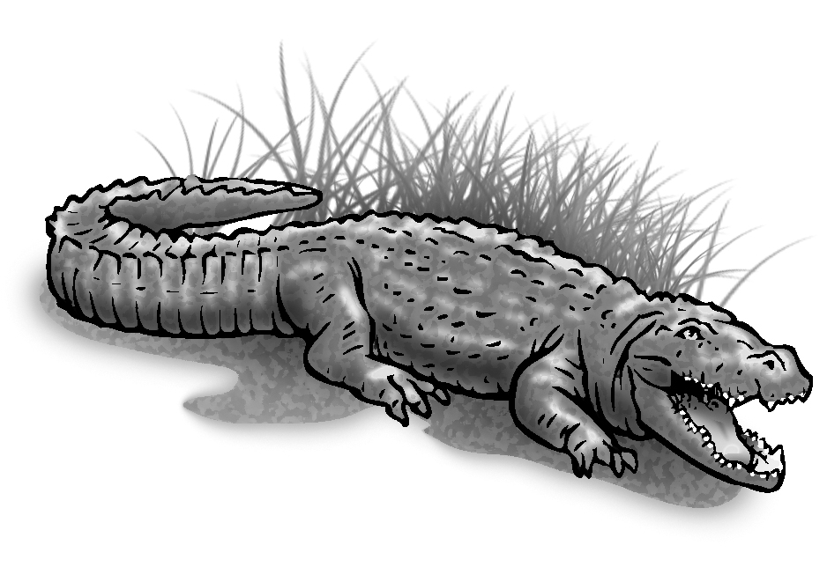  3. Crocodiles are ________.  They have ________. | 4. Chimpanzees are ________. They have __________.
5. Snakes are ________.  They have ____________. | 6. Hippos ________.  They ______________.

3. Circle the right word for each picture.

 | 1 | cup  cub  cube | 2 | beach  peach  pitch | 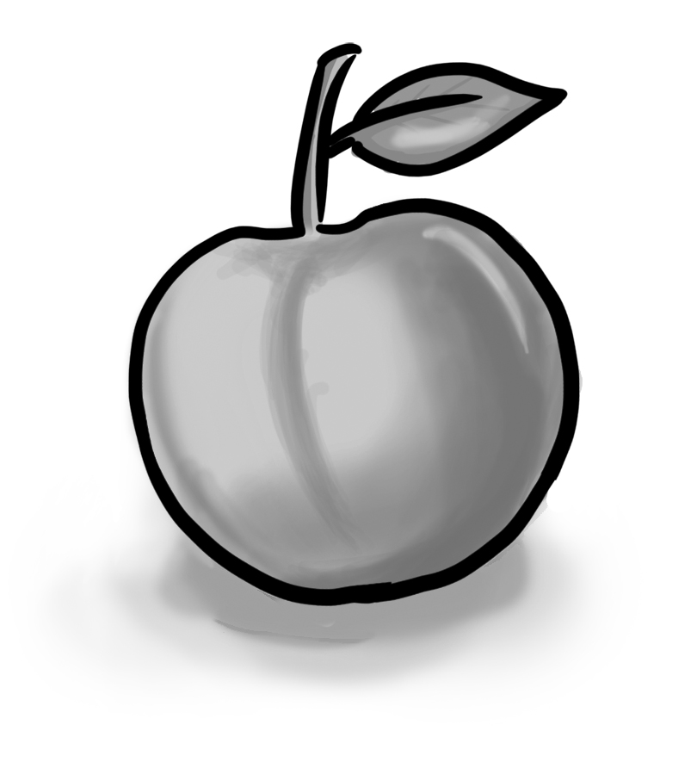
 | 3 | tube  cub  cube | 4 | man  one  moon | 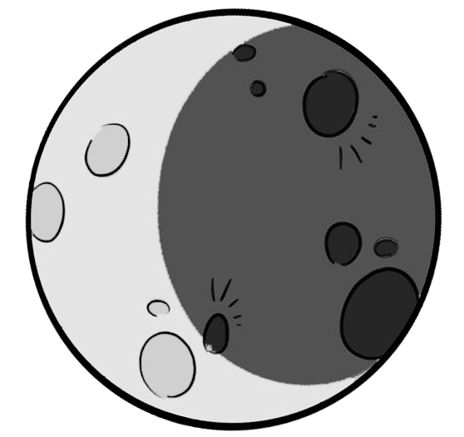
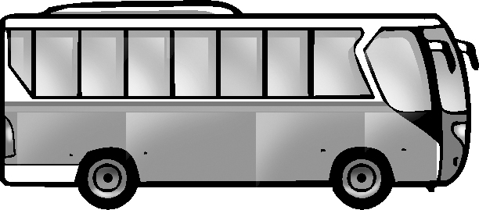 | 5 | cub  bus  tube | 6 | tube  tub  but | 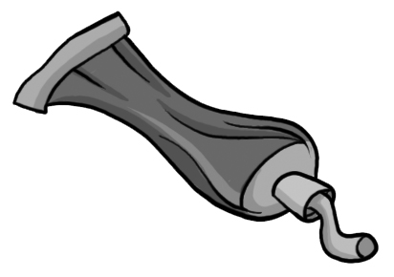
 | 7 | cook  look  cub | 8 | pack  duck  back | 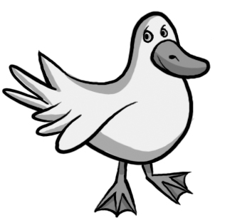
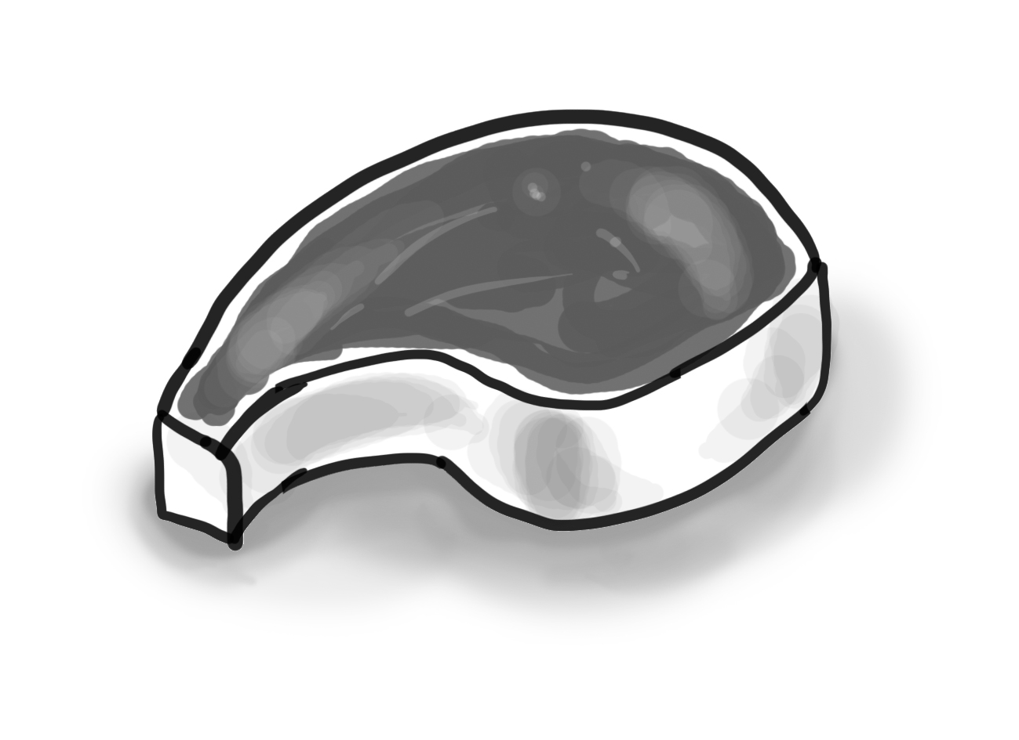 | 9 | meat  meet  team | 10 | cook  look  book
 | 11 | bead  bread  brick | 12 | school  cool  look | 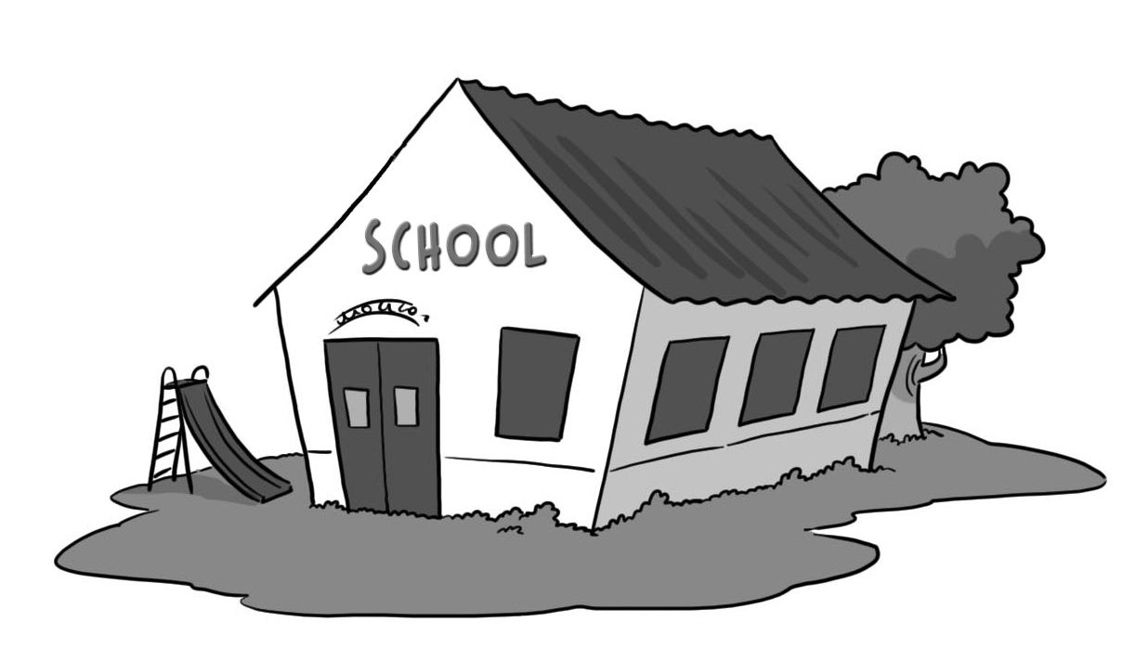
 | 13 | feather  weather  summer | 14 | food  boot  book | 