Revision Mega Goal 3
مراجعة ميغا قول 3

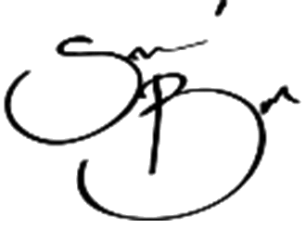
إعداد وتنظيم الأستاذ : بدر الشهري

Unit 1: Connected by Technology

Vocabulary
Match each definition in Column 1 with a word or phrase in Column 2.

Column 1 |  | Column 2
1. Someone who likes to be alone is a | E | A. funny
2. Someone who does not get upset easily is | C | B. adventurous
3. Someone who makes other people laugh is | A | C. laid back
4. Someone who doesn’t like to plan things is | F | D. straightforward
5. Someone who is not afraid to tell the truth is | D | E. loner
6. Someone who is practical and realistic is | G | F. spontaneous
7. Someone who likes to do exciting things is | B | G. down-to-earth

Grammar
Fill in the blank with the correct form of " do, have, be "

1. Do you still go to the gym every day?
2. Jenna has been studying in the library since this morning.
3. Fahd doesn't like talking on the phone. He would rather send text messages.
4. Jack was using my computer yesterday. Now, it’s not working properly.
5. We have been chatting online for two hours.

Change each sentence to a yes/no question.

1. I sent her a message yesterday.
Did you send her a message yesterday ?

2. Matt has turned off the computer.
Has Matt turned off the computer ?

3. We are driving to school today.
Are we driving to school today ?

Choose the best answer to fill in the blank in each question.

1. Using translation technology is ___________ way of communicating than using a common language.
A. a less popular
B. the most popular
C. the least popular
D. a popular

2. The Khalifa Tower in Dubai is 830 meters tall. It is _____________ man-made building in the world.
A. the most
B. taller than
C. the tallest
D. tall

Reading
Read the text and answer the questions. Choose the best answer to each question.

Is Email Good for Social Relationships?

Most people think email is a helpful invention. It allows friends and family who are far apart to keep in touch with each other easily. Before email, it was more difficult to stay in touch with friends who lived far away. Long distance telephone calls were expensive. And letters took so long to send and receive that they didn't let people talk" to each other. Most people agree that email has been very helpful in allowing people to remain friends with people they do not see very often. However, some people think that email is changing people's social networks. In the past, a person's friends usually lived nearby. Often your best friend was your next-door neighbor. This is because you could see and talk to this person quickly and easily. When you needed help, it was easy to walk next door. This is not the case anymore. Now, when you need help, it is just as easy to email a friend about a problem. Some people are afraid that this is harmful to local communities. People who live near each other do not know each other as well as they used to. In the U.S., there are groups who are trying to change this trend. These groups are trying to organize community events to get people together and make life in neighborhoods more like it used to be. These people don't think email is a bad thing. They just want to make sure that people interact with each other in real life, too.

1. Email helps people _____.
A. call people who are far away
B. keep in touch with people who live far away
C. meet their neighbors
D. do their shopping

2. Email does not help people _____.
A. learn to do new things
B. shop online
C. stay in touch with old friends
D. become friends with their neighbors

3. In the past, people’s best friends usually _____.
A. had fewer problems
B. had more problems
C. lived nearby
D. lived far away

4. Which sentence does the writer probably agree with?
A. People should use email to keep in touch with old friends but still try to make new friends in their community.
B. People should email only people who live nearby and write letters to people who live far away.
C. People should only have close friends who live nearby.
D. People should only have close friends who live far away.

5. Some groups are trying to _____.
A. stop people from using email
B. stop people from talking to people on the street
C. help people get to know their neighbors
D. help people learn to write letters

Unit 2: Crime Doesn’t Pay

Vocabulary
Complete each sentence with a word from the box.

abandon | hijack | misdemeanor
declined | inmate | unauthorized

1. A man tried to hijack my car today! He told me to get out of the car, but I locked the door and sped away.

2. The crime was a misdemeanor so he will probably not go to jail.

3. The criminals had to abandon the car because it was too small to hold all of the money they had stolen!

4. He has been an inmate at that prison for ten years.

5. When I tried to use my credit card today, it was declined I guess I’ve spent too much money this month.

6. The sign on the beach says “No unauthorized vehicles.” That means we can’t drive on the beach without permission

Grammar
Complete each sentence with the correct passive form of the verb in parentheses.

1. Yesterday, the stolen jewels were found in a child’s backpack. (find)

2. Tomorrow, the thief will be sent to prison. (send)

3. The painting was stolen from the museum two years ago. (steal)

4. In the future, this crime will be remembered as an amazing robbery. (remember)

5. The driver was given a warning by the police officer. (give)

Complete each sentence with the past perfect or past perfect progressive form of the verb in parentheses.

1. I had been eating lunch when I heard a strange noise. (eat)

2. She had been sleeping when she was woken by the telephone. (sleep)

3. We had forgotten to study for the test, and we failed it. (forget)

4. He had sent the letter, but it never arrived. (send)

Choose the best answer to fill in the blank in each question.

1. When she was younger, she ________ afraid of the dark.
A. used to be
B. would be
C used to
D. use to be

2. What were you doing_______ you were living in Riyadh?
A. when
B. where
C. while
D. which

Reading
Read the text and answer the questions. Choose the best answer to each question.

A Silly Criminal

A man had driven to the local grocery store, parked his car, and gone into the store to do some shopping. When he came out of the store, carrying his bags, he saw that his car was missing from the parking lot. He called the police and reported that his car had been stolen. He told the police that he had left his cell phone in the car. The police thought hard about how to use the cell phone to find the stolen car. Finally, one of the police officers had a brilliant idea. A police officer called the man’s cell phone, and the thief answered the phone.
The officer explained that he had seen the ad in the newspaper about the car for sale and that he was interested in buying the car. The officer asked a few information questions about the car and arranged a meeting for him to take a look at the care later that day. A few hours later, the thief drove the car to the meeting place, expecting to be paid for the car that he had just stolen. He was arrested on the spot and the car was returned to its owner. What a silly criminal.

1. Which sentence is correct?
A. The car was stolen from the woman’s home.
B. The car was stolen from a friend’s house.
C. The car was stolen from the police station.
D. The car was stolen from a grocery store parking lot.

2. The woman had left _____ in the car.
A. her cell phone
B. her groceries
C. her appointment book
D. a newspaper ad

3. The police officer pretended that _____.
A. he knew the car was stolen
B. he wanted to buy the car
C. his car had been stolen
D. he had an appointment with the woman

4. Which sentence is true? ____
A. The police were arrested when they called the thief.
B. The thief arrested the police while stealing the car.
C. The thief was arrested while he was trying to sell the stolen car.
D. The thief was arrested at the grocery store.

5. The phrase “on the spot” probably means _____.
A. immediately
B. at a later date
C. on the hand
D. in a circle

Unit 3: Far and Away

Vocabulary
Complete each sentence with a word from the box.

alternative | ecosystem | surface | unique
commercial | relatively | undisturbed | widespread

1. There has been a decrease in the amount of green space in the city because of widespread development.

2. Too many tourists can harm the rainforest’s natural ecosystem

3. That treetop hotel is totally unique There is not another hotel like it.

4. Ecotourism is an alternative to traditional tourism.

5. The goal of ecotourism is to experience nature while leaving it undisturbed

6. The underwater hotel is located six meters below the surface

7. Hotels in this city are relatively inexpensive. They cost a lot more in other large cities.

8. Ecotourism is important to commercial development in Brazil.

Grammar
Choose the sentence that has the same meaning as the underlined sentence in each question.

1. Traveler: I’d like to book a hotel room for the night.
Clerk: Unfortunately, we do not have any rooms available tonight.
A. We’re very happy that you are staying with us at the Fairmont Hotel.
B. It is lucky that we do not have a hotel room for you.
C. We’re sorry, but we do not have a hotel room for you.
D. It is obvious that we have many rooms for you.

2. John: Where are you going on vacation?
Sam: Presumably, we’ll go to the beach.
A. It is most likely that we’ll go to the beach.
B. It is unlikely that we’ll go to the beach.
C. It is possible that we’ll go to the beach.
D. We never go to the beach.

3. Adel: Where is our taxi? I called for it over an hour ago.
Liam: Evidently, it is not coming. Let’s walk home.
A. It is unlucky that the taxi is not here yet.
B. It is clear that the taxi is not going to come.
C. It is surprising that the taxi is not here yet.
D. The taxi might not come.

4. Jack: I can’t believe this hotel costs $300 a night!
Ray: It is undoubtedly the most expensive hotel in town.
A. It is unlucky that we are paying a lot of money for this hotel.
B. It is surprising that we are paying a lot of money for this hotel.
C. I think it might be the most expensive hotel.
D. I am completely sure that it is the most expensive hotel.

Choose the sentence that has the same meaning as the statement in each question.

1. Whew! We nearly missed our flight!
A. It is clear that we are going to miss our flight.
B. I’m glad we didn’t miss our flight!
C. It’s too bad we missed our flight.
D. I can’t believe our flight left without us!

2. The northern part of the country is scarcely populated.
A. Not many people live in the northern part of the country.
B. More and more people are going to live in the northern part of the country.
C. The northern part of the country is very crowded with people.
D. People only live in the northern part of the country in summer.

3. This hotel room is rather small.
A. This hotel room is too big for us.
B. This hotel room is extremely large.
C. This hotel room is very small.
D. This hotel room is a little bit small.

Choose the best answer to fill in the blank in each question.

1. ____ are you going to travel?
We are going to go by train.
A. When
B. Why
C. How long
D. How

2. Where are you staying?
_____ stay at a hotel in the central square. I have to call and make a room reservation.
A. We are going to
B. Maybe we’ll
C. Probably we won’t
D. We are

Reading
Read the text and answer the questions. Choose the best answer to each question.

A Unique Hotel

There is a unique hotel that is located in Ottensheim, Austria, on the banks of the Danube River. It is called the Daspark hotel. This hotel was created for travelers on a low budget. Travelers who stay at the Daspark hotel are not looking for luxury and convenience. They are just looking for an interesting and inexpensive place to spend the night. The hotel has three “suites.” What is unique about the suites is that they are actually old sewer pipes. Naturally, the sewer pipes have been completely cleaned. Each pipe has also been furnished with a bed, a light, an electrical outlet, and a window. The pipes are 6 feet (2 meters) across and 8 feet (2.5 meters) long. However, there are no toilets or showers at the Daspark hotel. Guests must use public showers and restrooms in town.
The sewer pipes are located in a park, and they are available from spring through autumn. Interestingly, there is no set nightly fee at the Daspark hotel. It was created for people who travel on a budget, and guests may decide what they want to pay for their night's accommodations. How much money do you think you would pay to spend the night in an old sewer pipe?

1. The Daspark hotel is located in ______
A. Germany
B. Austria
C. Hungary
D. Slovakia

2. The hotel has _____ “suites.”
A. three
B. six
C. eight
D. twelve
3. The hotel is unique because _____
A. it is located in a park
B. it is not very expensive
C. it is located near sewer pipes
D. the rooms are in old sewer pipes

4. The Daspark hotel does not have _____.
A. lights
B. beds
C. electricity
D. toilets

5. Which sentence is true?
A. The hotel charges each guest the same fee.
B. There is a rather expensive fee to stay at the hotel.
C. There is no set fee to stay at the hotel.
D. There is a very small fee to stay at the hotel.

Unit 4: TV Around the World

Vocabulary
Match each word in Column 1 with a definition in Column 2.

Column 1 |  | Column 2
1. broadcast | E | A. to make a secret plan
2. contestants | D | B. having or making a lot of money
3. fictional | G | C. hard to understand
4. plot | A | D. people who are in a contest
5. prosperous | B | E. to transmit to an audience by radio or TV
6. puzzling | C | F. a variation
7. version | F | G. not real

Grammar
Fill in the blank in each question with " to - for "

1. Imad: Can I listen to that joke again on your smartphone?
Ryan: I downloaded it for you. Here you go.

2. Imad: Can I use your laptop again? Mine is broken.
Ryan: I fixed it for you. Here you go.

3. Please give that book to me.

4. Could you buy some fruit for me at the store?

5. I promise that I’ll write an email to you every day that I’m away.

Write ( C ) for correct or ( I ) for incorrect at the end of each sentence.

1. Please translate me what they are saying ( I )

2. Please pronounce me this word ( I )

3. Please open the door for me ( C )

Choose the best answer to fill in the blank in each question.

1. The global language _________ around the world today, is English.
A. is used
B. that is used
C. which used
D. use

2. He is someone ______ can easily persuade others.
A. who
B. which
C. whom
D. he

Reading
Read the text and answer the questions. Choose the best answer to each question.

Entertainment

What do you like to do for entertainment? A research company recently asked this question to thousands of people in different cities and towns. The top four answers in order were: " watch TV; use the Internet; watch films; and read books. "
Many people were surprised by these results. They thought that more people liked to go out to restaurants and parks or spend time in the mall. But an increasing number of people prefer to stay home and watch TV and films in their own living room. “Going out with friends is too expensive,” one respondent said. “And it is more comfortable to be at home on your own couch, watching TV. Also there are many films available on TV now so we don’t have to go out and rent a DVD from a video store.”
Many restaurants and video stores offer all kind of small gifts and discounts to attract customers, but the amount of people who prefer to stay at home rather than go out continues to increase. As the internet takes over and viewers have access to more channels and programs, even more people will be staying home for their entertainment!

1. Research showed that people’s entertainment preferences, in order, are
A. Internet, TV, books, films
B. Internet, TV, films, books
C. TV, Internet, books, films
D. TV, Internet, films, books

2. Restaurants and video stores want to _______
A. reward customers
B. to rent films
C. to attract more people
D. give people gifts

3. Now, more people ______
A. connect their TVs to the Internet
B. have more DVDs
C. rent DVDs
D. read books on TV
4. One reason that people stay at home and watch TV is ___
A. it is more expensive
B. it is more comfortable
C. there are better games on TV
D. you can also read while watching TV

Unit 5: Working 9 to 5
Vocabulary
Complete each sentence with a word from the box.

appreciate | entails | respectful
cooperate | income | satisfaction

1. You should always be respectful when you are talking to people who are older than you.

2. Many jobs require you to work on a team and cooperate with other people well.

3. A high income is important to many people.

4. If you like your job, then you will have more job satisfaction

5. I’m a doctor and I know that my patients appreciate me because they always thank me when they feel better.

6. My job entails keeping detailed records of patients’ progress and advising less experienced doctors.

Match each definition in Column 1 with a word or phrase in Column 2.

Column 1 |  | Column 2
1. It is necessary that I wear a helmet and protective clothing when I am at work. | B | A. engineer
2. It is essential that my patients are comfortable and still while I work. | C | B. race car driver
3. It is important that I stay alert and watch my screen and instruments at all times to help pilots. | D | C. surgeon
4. I ask that visitors stay away from young animals to protect them from diseases. | E | D. air traffic controller
5. I specialize in constructions that utilize alternative sources of energy. | A | E. zoologist

Grammar
Choose the best answer to fill in the blank in each question.

1. I’d like you _____ your room after school today.
A. clean up
B. cleaning up
C. to clean up
D. would clean up

2. I want you _____ at 5 o’clock sharp.
A. to pick me up
B. pick me up
C. picking me up
D. would pick me up

2. My boss _____ this project today.
A. had like me to finish
B. likes me to finish
C. would like me to finish
D. would like me finish

Choose the best answer to fill in the blank in each question.

1. You will apply for that job today , _____ ?
A. will you
B. will I
C. won’t I
D. won’t you

2. Excuse me, could you tell me _____ ?
A. where the nearest supermarket is
B. where is the nearest supermarket
C. where the nearest supermarket
D. where the nearest

Reading
Read the text and answer the questions. Choose the best answer to each question.
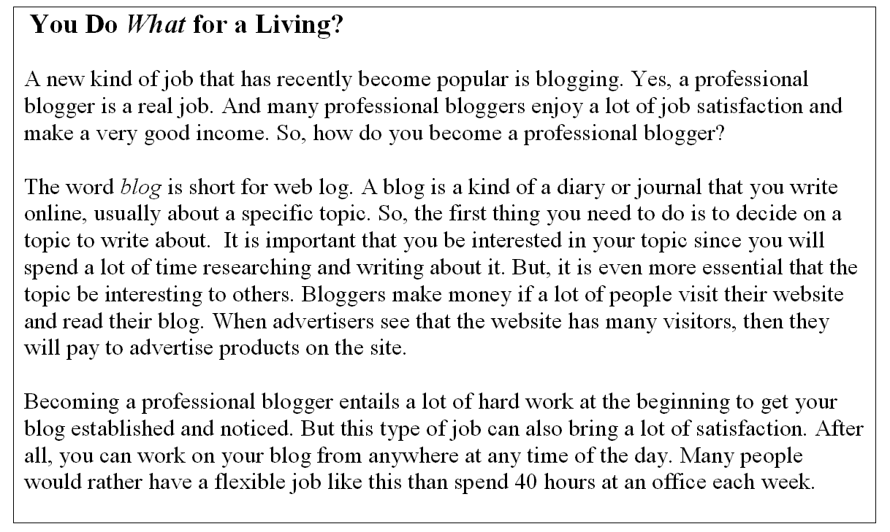

1. The word blog is short for _____.
A. website
B. journal
C. blogger
D. web log

2. To be successful, it is essential that your blog be _____.
A. interesting to yourself
B. interesting to others
C. a real job
D. written from an office

3. To make money, it is necessary that _____.
A. you have advertisements on your site
B. a lot of people work on your site
C. you write about a lot of different topics
D. you have income from another job

4. Many professional bloggers get a lot of _____ from their work.
A. cooperation
B. appreciation
C. satisfaction
D. respect

5. To be successful, it is important that you _____.
A. have a lot of job interviews
B. make a lot of money
C. work hard at the beginning
D. work at an office

Unit 6: Going Green

Vocabulary
Match each word in Column 1 with a definition in Column 2.

Column 1 |  | Column 2
1. conserve | E | A. the origin or beginning point
2. consumption | D | B. a chemical used to kill bugs
3. crank up | G | C. a device to control temperature
4. organic | F | D. to use up or eat up
5. pesticide | B | E. to use wisely and sparingly
6. source | A | F. natural
7. thermostat | C | G. to turn up high

Grammar
Fill in each blank with the infinitive or gerund of the verb in parentheses.

1. We really like living in the country. It is very quiet and peaceful. (live)
2. For a healthier diet, I recommend eating more fruits and vegetables. (eat)
3. I prefer to eat vegetables from my garden than vegetables from the store. (eat)
4. Can I borrow your car? I promise to drive slowly. (drive)
5. Please remember to lock the door when you leave. (lock)
6. Sara, you keep forgetting to turn off the lights when you leave! (forget)
7. Did you decide to go to the party tonight? (go)
8. Michael, please stop making that noise. It’s annoying me. (make)

Choose the best answer to fill in the blank in each question.

1. Overfishing is depleting our oceans of fish. In other words, people ____ far more fish out of the ocean than can be replaced by those remaining.
A. taking
B. are taking
C. will take
D. taken

2. If measures are not taken to stop overfishing, there __________ no more fish in the ocean.
A. will be
B. will
C. can’t be
D. going to

Reading
Read the text and answer the questions. Write T or F at the end of each statement.

Shop At Your Local Farmer's Market!

A farmer's market is a place where local farmers sell their produce. It is usually held outdoors and often on scheduled days of the week. Produce usually means fruits and vegetables. But at some farmers' markets, farmers also sell meats, eggs, and dairy products, such as milk, cheese, and butter. Food that is sold at farmers' markets is known for being fresh and is often organic. Buyers assume that the food has been just picked or prepared at a local farm. There are a lot of reasons to buy your food at a farmer's market rather than at a grocery store. The following are just a few of them: When you buy food from a farmer's market, you are supporting local farms. This allows the farms to stay in business, which in turn, preserves the farmland from development. Farms can usually sell their food at a much lower price than grocery stores. This is because they don't have to pay as many employees or pay for the food to travel. The food you buy will be fresher and possibly healthier than food bought at the grocery store because chemicals have not been added to it. Since the food does not have to be packed and shipped to a far-away grocery store, it does not contain any additives or preservatives to keep it fresh. Buying food at your local farmer's market also helps the environment because it means your food did not have to be shipped from far away.

1. Farmers’ markets only sell fruits and vegetables. ( F )
2. Produce at farmers’ markets is often organic. ( T )
3. Buying food from farmers’ markets can be less expensive. ( T )
4. Food at farmers’ markets is often shipped from far away. ( F )
5. Produce at farmers’ markets usually contain preservatives
to make them last longer ( F )

