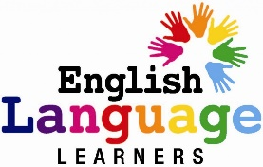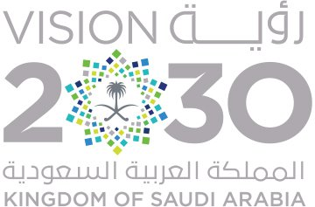

بسم الله الرحمن الرحيم



المملكة العربية السعودية

وزارة التعليم

إدارة التعليم بــ ..............................

مكتب التعليم بــ ............................

ابتدائية .......................................



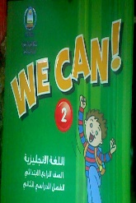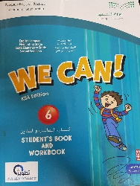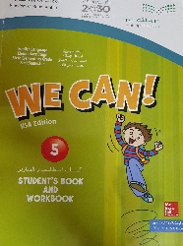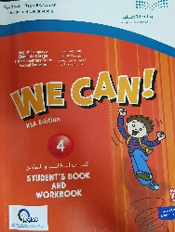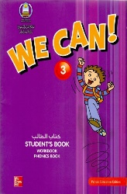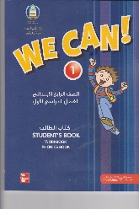

English Preparation Book

دفتر تحضير اللغة الانجليزية

للفصل الدراسي _________

للعام الدراسي - هـ

قائد/ة المدرسة :

...........................

معلمـ/ة المادة :

...............................

Objectives of Teaching English in the Kingdom:

* To enable pupils to survive in the real world using English.
* To give them a foundation for secondary English course.
* To teach them about 1500 of the most useful English words.
* To give them a clear understanding of the basic tenses for the past, present and future.
* To teach them the basic grammatical structures of English.
* To enable them to understand what they hear on a variety of topics.
* To enable them to speak (ask and answer questions, give descriptions, etc.) on the same variety of topics.
* To prepare them to read simple text by themselves without depending on the teacher for explanations or translation.
* To enable them to write a simple guided paragraph of linked sentences.

Objectives of Teaching English in Elementary Stage:

* To greet someone, ask and answer basic questions dealing with personal information.
* Ask and answer basic questions about home, school, occupations, shopping, time, numbers and measurements.
* Describe people and their activities and talk about routine actions and current actions.
* Understanding and using the grammar and vocabulary taught during the year.
* Listen to short conversation, descriptions, etc… to extract the information they need.
* Begin to read letters, puzzles and short stories.
* Say the alphabet, know the order of the alphabet, and spell the words they have learned.
* Form and connect letters correctly, punctuate and capitalize properly.
* Write paragraphs by copying and choosing words or forming sentences in answer to questions

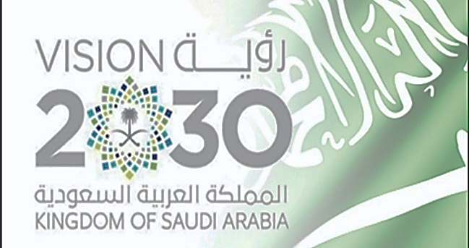Education and 2030 Vision

Ways of educational development :

* Developing philosophy, policy and goals of curricula, means of development, mechanism activation and connecting all these means with the programs of teacher preparation and his professional  development .
* Developing such teaching methods, that focus on learner not on teacher, and concentrate on inculcating skills, personality development, improving confidence, and promoting spirit of creativeness.
* Developing attractive, preferred, and simulant school environment, connecting it with supportive and integrated services systems.
* Comprehensive education for persons with disabilities, and providing appropriate  support to all its  categories.
* Providing pre-primary education opportunities and expanding it, providing kindergartens, and activating its link with education  system.

Ways of administrative development :

* Redefine school as an educational institution, that hones talent, inculcates skills, and nurtures generation of ambitious future adults who have the spirit of facing challenges, competitiveness, and loves work, and production.
* Assuring discipline in the educational system, seriousness in educational practice, starting activities and attending conferences and events.
* Restructuring education sector, modernization of systems, instructions, and bylaws to  control curricula development, staffing teachers in educational services, organizing the process  of educational supervision, and continuously raise the competence of development and vocational training.
* Raising efficiency of  operational performance, reducing the waste cost, maximizing use of human potential, resources, equipment, and buildings.

Changing trends :

* Improving and developing the administrative environment in the Ministry and its Education departments, approving decentralization of the administration, delegating powers to departments and schools to serve the education system.
* Developing rules and procedures  to ensure work seriousness, and discipline in education system, promote justice, and reward excellent performance.
* Raising the efficiency of performance, employing modern support technologies in education system.

The General goals of the Saudi Vision 2030 in Education :

* Provide education opportunities for all the students in a suitable educational environment in light of the educational policy of the Kingdom .
* Raising the quality of education outputs .
* Increase the effectiveness of scientific research .
* Encourage creativity and innovation .
* Develop community partnership .
* Upgrade the abilities and skills of all the Ministry of Education staff .
* Bridging the gap between higher education outputs and labor market requirements .
* Develop general education and guide students towards appropriate career options .
* Provide the students with all the opportunities to rehabilitate the flexibility to move between different educational tracks .

Teacher : …………………………………………………..

School Leader : ………………………………………

Supervisor : ……………………………………………..



Distribution of the Syllabus - the 5th Elementary Stage

**توزيع منهج اللغة الانجليزية للصف الخامس الابتدائي**

|  |  |  |  |  |  |  |
| --- | --- | --- | --- | --- | --- | --- |
| **6th week** | **5th week** | **4th week** | | **3rd week** | **2nd week** | **1st week** |
| Revision  Test | -Words  - Phonics  ( Phonic Practice page 44 – 45 ) | Unit 2  - Talk time  - Rhythms & sound | | -Words  - Phonics  ( Phonic Practice page 42 – 43 ) | Unit 1  - Talk time  - Rhythms & sound | introduction |
| **12th week** | **11th week** | **10th week** | | **9th week** | **8th week** | **7th week** |
| Unit 5  - Talk time  - Rhythms & sound | Revision  Test | -Words  - Phonics  ( Phonic Practice page 51 – 52 ) | | Unit 4  - Talk time  - Rhythms & sound  ( Phonic Practice page 49 – 50 ) | -Words  - Phonics  ( Phonic Practice page 47 – 48 ) | Unit 3  - Talk time  - Rhythms & sound  ( Phonic Practice page 46 ) |
| **18th week** | **17th week** | **16th week** | | **15th week** | **14th week** | **13th week** |
| Final Evaluation &  Correction Programs | | | Test | Phonics Practice | Revision | -Words  - Phonics |



Timetable

Tr**.** Name:

Class:

|  |  |  |  |  |  |  |  |  |
| --- | --- | --- | --- | --- | --- | --- | --- | --- |
|  |  | 1 | 2 | 3 | 4 | 5 | 6 | 7 |
|  | Sunday |  |  |  |  |  |  |  |
|  | Monday |  |  |  |  |  |  |  |
|  | Tuesday |  |  |  |  |  |  |  |
|  | Wednesday |  |  |  |  |  |  |  |
|  | Thursday |  |  |  |  |  |  |  |

Headmaster

Name : ………………………………

Signature : …………………………

Kingdom of Saudi Arabia

Ministry of Education

English preparation QR Code

We Can 4

Unit 1 : Wild Animals

|  |  |  |  |  |
| --- | --- | --- | --- | --- |
| Date | lesson | Content | Objectives | Strategies |
| / / 1441 AH | 1 | QR Code | Tell the names of some wild animals  Write the names of some wild animals  Talk about animals | Role playing  Brainstorming |
| / / 1441 AH | 2 | QR Code | Chant the " Animal Chant " chant  Name the body parts of the animal  Sort letters according to their sounds | Role playing  Cooperative learning |
| / / 1441 AH | 3 | QR Code | Describe animals  Write the words correctly  Classify a variety of animals and their habitats | Role playing  Think , pair , share |
| / / 1441 AH | 4 | QR Code | Spell some words correctly  Comprehend the sounds represented by the letters of the alphabet  Pronounce the final S correctly | Identifying similarities and differences  Concept mapping |



Kingdom of Saudi Arabia

Ministry of Education

English preparation QR Code

We Can 4

Unit 2 : From Here to There

|  |  |  |  |  |
| --- | --- | --- | --- | --- |
| Date | lesson | Content | Objectives | Strategies |
| / / 1441 AH | 1 | QR Code | Give direction  Pronounce " st " sound correctly  Read a map using cardinal directions | Reciprocal teaching  Cooperative learning |
| / / 1441 AH | 2 | QR Code | Pronounce letters sounds correctly  Chant " When You See a Red Light " chant  Tell the road signs meaning | Think , pair , share  Explicit instructions |
| / / 1441 AH | 3 | QR Code | Use " a – an " in a sentence correctly  Use imperatives to give instructions correctly  Talk about different modes of transportation | Role playing  Cooperative learning  Concept mapping |
| / / 1441 AH | 4 | QR Code | Guess the meaning of the words  Differentiate between the sounds of the letters  Spell the words correctly | Reciprocal teaching  Think , pair , share |



Kingdom of Saudi Arabia

Ministry of Education

English preparation QR Code

We Can 4

Unit 3 : My House

|  |  |  |  |  |
| --- | --- | --- | --- | --- |
| Date | lesson | Content | Objectives | Strategies |
| / / 1441 AH | 1 | QR Code | Match words with pictures  Practice new vocabulary related to house  Spell the words correctly | Reciprocal teaching  Cooperative learning |
| / / 1441 AH | 2 | QR Code | Pronounce the letters correctly  Use short forms of " he is – she is "  Ask questions using " Where " | Explicit instructions  Think , pair , share |
| / / 1441 AH | 3 | QR Code | Use vocabulary about pieces of furniture  Use prepositions in context  Pronounce the letters correctly | Cooperative learning  Jigsaw  Concept mapping |
| / / 1441 AH | 4 | QR Code | Spell three-letter words correctly  Pronounce sounds correctly  Read the three-letter words  " speed reading " | Explicit instructions  Brainstorming |



Kingdom of Saudi Arabia

Ministry of Education

English preparation QR Code

We Can 4

Unit 4 : My Things

|  |  |  |  |  |
| --- | --- | --- | --- | --- |
| Date | lesson | Content | Objectives | Strategies |
| / / 1441 AH | 1 | QR Code | Complete the numbers in a chart from 1 to 30  Count from 1 to 100 | Reciprocal teaching  Cooperative learning  Think , pair , share |
| / / 1441 AH | 2 | QR Code | Practice the new words  Identify consonant blends  Use can to ask for permission | Role playing  Cooperative learning |
| / / 1441 AH | 3 | QR Code | Use plural nouns in sentences  Ask about things using demonstrative pronouns  Match new vocabulary to pictures | Role playing  Concept mapping |
| / / 1441 AH | 4 | QR Code | Identify vowel letters  Pronounce sounds correctly  Count from 40 to 100 | Explicit instructions  Cooperative learning  Think , pair , share |



Kingdom of Saudi Arabia

Ministry of Education

English preparation QR Code

We Can 4

Unit 5 : My Day , Animals , Places

|  |  |  |  |  |
| --- | --- | --- | --- | --- |
| Date | lesson | Content | Objectives | Strategies |
| / / 1441 AH | 1 | QR Code | Tell the time  Talk about their routines  Build up questions and answers about daily activities | Role playing  Cooperative learning |
| / / 1441 AH | 2 | QR Code | Use can to talk about abilities  Describe the weather of each season | Cooperative learning  Explicit instructions |
| / / 1441 AH | 3 | QR Code | Talk about jibs  Describe people appearances using  " have and has "  Answer questions correctly | Reciprocal teaching  Cooperative learning |
| / / 1441 AH | 4 | QR Code | Pronounce sounds correctly  Use demonstrative pronouns  Use prepositions of place correctly  Read the new words correctly | Think , pair , share  Cooperative learning |



Kingdom of Saudi Arabia

Ministry of Education

English preparation QR Code

We Can 4

Unit 5 : Phonics Practice

|  |  |  |  |  |
| --- | --- | --- | --- | --- |
| Date | lesson | Content | Objectives | Strategies |
| / / 1441 AH | 1 | QR Code | Make plurals  Pronounce words with " s " ending correctly | Concept mapping  Explicit instructions |
| / / 1441 AH | 2 | QR Code | Produce the sounds of short and long vowels  Match words with pictures | Reciprocal teaching  Think , pair , share |
| / / 1441 AH | 3 | QR Code | Produce words with  " bl – pl – gl – gr – cl – cr – fl – fr – dr – tr – br – pr – wh – ph – sm – sn – sl – st "  Use consonant blends to make words  Make words with initial consonant blends | Think , pair , share  Explicit instructions |

