Kingdom Of Saudi Arabia
Ministry Of Education
General Management-Taif
The Speaking Final Exam for 3rd grade secondary –2nd Term-1443H
Model 1

1- What are you good at ?

2- How long have you been good in that ?

3- How can you be successful in your life without depending on others ?

T: Huda AL-Thagafi
----------------------------------------------------------------------------------------------------------------------------------

Kingdom Of Saudi Arabia
Ministry Of Education
General Management-Taif
The Speaking Final Exam for 3rd grade secondary – 2nd Term-1443H
Model 2
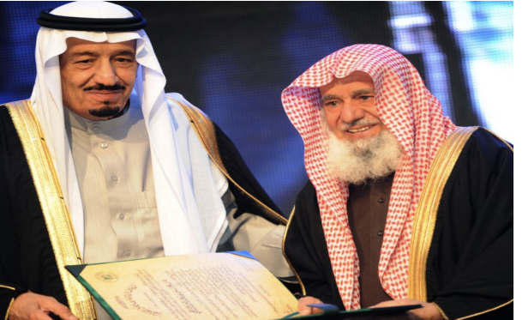
1- Who is the man on the right ?

2- What is he famous of ?

3- Talk about his remarkable projects in Saudi Arabia ?

T: Huda AL-Thagafi

Kingdom Of Saudi Arabia
Ministry Of Education
General Management-Taif
The Speaking Final Exam for 3rd grade secondary –2nd Term-1443H
Model 3
1- Name some genres of films ?

2- What is the best kind for you ? Why ?

3- Name some famous films ?

T: Huda AL-Thagafi
----------------------------------------------------------------------------------------------------------------------------------

Kingdom Of Saudi Arabia
Ministry Of Education
General Management-Taif
The Speaking Final Exam for 3rd grade secondary – 2nd Term-1443H
Model 4

1- Do you think you are influenced by advertisement ? Explain ?

2- Describe an advertisement that you think is memorable or effective ?

3- Where can you see advertisements ?

T: Huda AL-Thagafi

