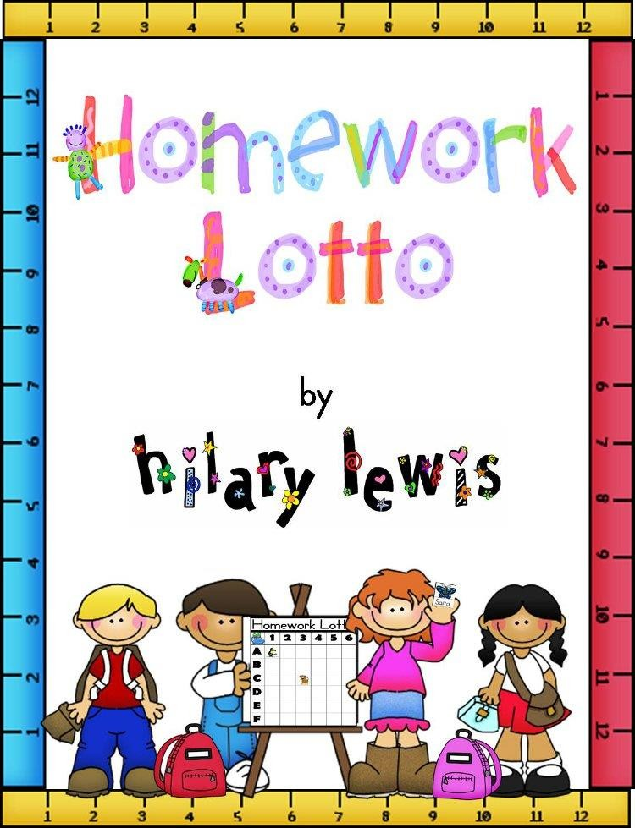

Prepared by: Khadija Almuayizri

***Ministry of Education***

***Al- Asema Education Area***

***Al Doha Pr. School***

*للمعلمه حنان الظفيري*

Name:

…………………

Class:

……………….



|  |  |  |
| --- | --- | --- |
| **No** | **Vocabulary** | **Meaning** |
| **1** | **bakery** | **مخبز** |
| **2** | **Go shopping** | **الذهاب للتسوق** |
| **3** | **cake** | **كعكه** |
| **4** | **pie** | **فطٍيره** |
| **5** | **cupcake** | **كعك صغٍير** |
| **6** | **buy** | **يشتري** |
| **7** | **bookshop** | **محل كتب** |
| **8** | **supermarket** | **محل تجاري** |
| **9** | **small** | **صغير** |
| **10** | **big** | **كبير** |
| **11** | **jam** | **مربى** |

Ask and Answer:

**Have we got cake? Yes we have No, we have**

Read the text and answer the questions:

Tom has got two pets. He has a dog and a cat. The dog's name is Snoopy. The cat's name is

Bossy. Snoopy always plays in the garden. Bossy always sleeps in Tom's bed.



tick ( √ ) or ( ×)

1. Tom has four pets. ( )
2. Snoopy always plays in the garden. ( )
3. The dog's name is Snoopy.( )
4. Snoopy always sleeps in Tom's bed.

*Group rhyming words or words with the same sounds



**cook – white – book –– wheel**

*1- …………………………*

*2- …………………………*

*1- …………………………*

*2- …………………………*

**Fill in the spaces with the suitable words from the list :**

small - pie - bookshop - bakery



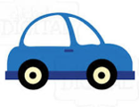1- I buy books from the …………….

2- The car is ………………..

3-I like apple ……………

**A) Choose the correct answer from a, b and c :**

1- Have we ………….. jam?

1. got b)get c) gets

2-let's ………… shopping.

1. going b) go c) gos

3-Haya …………. A pie.

1. want b) wanted c) wants

## Write the missing word:

## I want to go to the …………….. I want to buy a

## 

## http://www.spicycaribbee.com/images/Mango_Jam_cartoon.jpg

## ………………..

## 

## My mom wants to buy ………….. from the ………………

**Re Order the words to form sentences with proper punctuation:**



it's

bakery

a

1- -------------------------------------------------------------

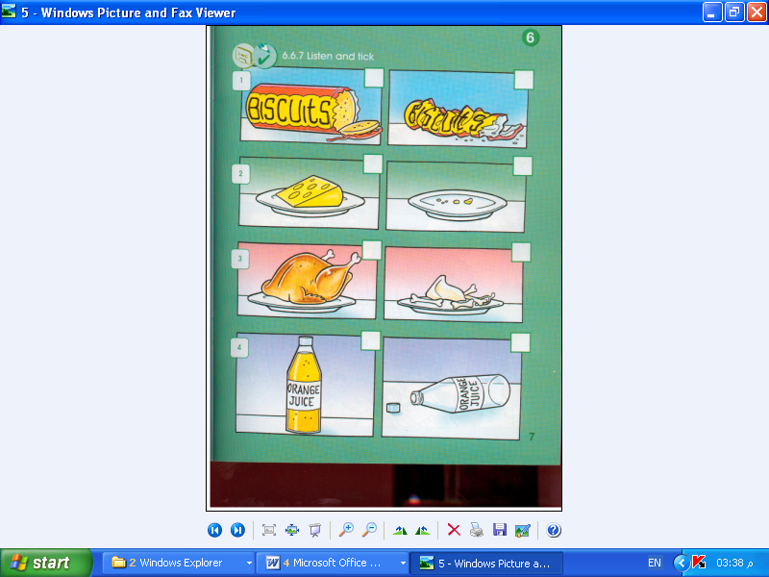

we

have

cheese

got

2- -------------------------------------------------------------



have

we

jam

got

3- -------------------------------------------------------------

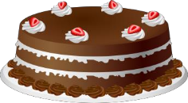

a

It's

cake.

3- -----------------------------------------------------------

bakery cake pie cupcake

Copy the sentence.

buy go shopping supermarket

Copy the sentence.

bookshop small big jam

Copy the sentence.



|  |  |  |  |  |  |
| --- | --- | --- | --- | --- | --- |
| **No** | **Vocabulary** | **Meaning** | **No** | **Vocabulary** | **Meaning** |
| **1** | **science** | **علوم** | **9** | **thirty** | **ثلاثون** |
| **2** | **math** | **رياضيات** | **10** | **fourty** | **اربعون** |
| **3** | **gym** | **نادي رياضي** | **11** | **fifty** | **خمسون** |
| **4** | **brown** | **بني** | **12** | **sixty** | **ستون** |
| **5** | **book** | **كتاب** | **13** | **seventy** | **سبعون** |
| **6** | **PE class** | **حصة البدنيه** | **14** | **eighty** | **ثمانون** |
| **7** | **ten** | **عشره** | **15** | **ninety** | **تسعون** |
| **8** | **twenty** | **عشرون** | **16** | **one hundred** | **مئه** |

Ask and Answer:

**What class do you**

**like ? I like Math class.**

**I like art clas**

*Read the text and answer the questions

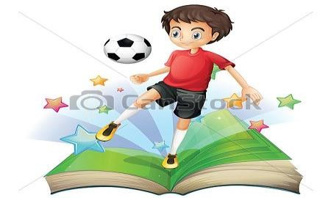

# Ahmed likes reading books. He has big books and small books. He buys his books from the bookshop. He likes reading books about football. He reads every day before he goes to sleep.

*tick ( √ ) or ( ×)

1. Ahmed likes reading books. ( )
2. He buys his books from the supermarket.( )
3. He likes reading books about football.( )
4. He reads every day in the school.( ).

*Group rhyming words or words with the same sounds



**brown – blue – blossom – brother**

*1- …………………………*

*2- …………………………*

*1- …………………………*

*2- …………………………*

**Fill in the spaces with the suitable words from the list :**

gym - brown - science - math - book

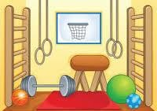

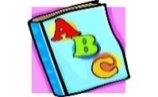1- I play basketball in the …………….

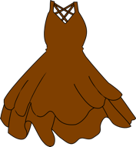2-I like to read a small ………………..

1. My dress is ……………
2. I want my ……….. book

**A) Choose the correct answer from a, b and c :**

1- Ali ………… tennis every Monday.

1. plays b)play c) playing

2- They ……….. math.

1. Like b) likes c) liking

3- Yesterday, I ……………. A butterfly

1. see b) seeing c) saw

## Write the missing word:

## 

## I have a ………….…. Book and a ……………..book in

## my school bag.

## I read a ……………….. about ……………….

Order the words to form sentences with proper punctuation:



school.

to

goes

haya

1- -------------------------------------------------------------



this

school

my

is

1. -------------------------------------------------------------

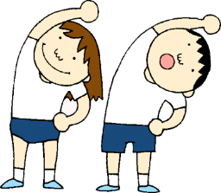

do

you

P.E class

like

1. -------------------------------------------------------------

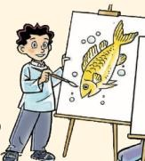

painted

fish

salem

a

1. ------------------------------------------------------------

science math gym book

Copy the sentence.

brown P.E class 10 20

Copy the sentence.

30 40 50 60 70 80 90 100

Copy the sentence.

|  |  |  |  |  |  |
| --- | --- | --- | --- | --- | --- |
| **No** | **Vocabulary** | **Meaning** | **No** | **Vocabulary** | **Meaning** |
| **1** | **fly** | **يطير** | **9** | **giraffe** | **زرافه** |
| **2** | **sing** | **يغني** | **10** | **camel** | **جمل** |
| **3** | **monkey** | **قرد** | **11** | **lion** | **أسد** |
| **4** | **horse** | **حصان** | **12** | **tiger** | **نمر** |
| **5** | **bird** | **طير** | **13** | **climb** | **يتسلق** |
| **6** | **zebra** | **حمار وحشي** | **14** | **zoo** | **حديقة حيوان** |
| **7** | **elephant** | **فيل** | **15** | **falcon** | **صقر** |
| **8** | **rabbit** | **أرنب** |  |  |  |



Ask and Answer:

**What do birds do?**



**They fly.**

**They sing**

*Read the text and answer the questions

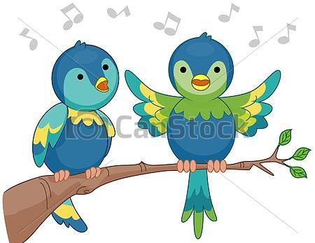

# Yesterday Ali went to the garden with his sister. They saw lots of birds. The birds were blue and white. Birds can fly. They can sing too. Birds are beautiful.

*tick ( √ ) or ( ×)

1. Ali went to the zoo. ( )
2. Ali went with his mom.( )
3. Birds were blue and white. ( )
4. Birds can't sing ( )

------------------------------------------------------------------------------------------------------------------

*Group rhyming words or words with the same sounds

*1- …………………………*

*2- …………………………*

*1- …………………………*

*2- …………………………*



**car– girl – bird – far**

**Fill in the spaces with the suitable words from the list :**

Fly – climb – zoo – elephant – rabbit

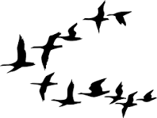

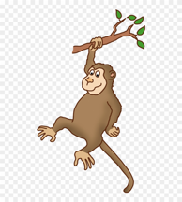1- Birds can …………….

2-Monkeys can ………………..

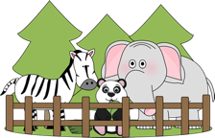3-The …………… is big.

4-I saw a lion in the ………….

**A) Choose the correct answer from a, b and c :(2X½=1m)**

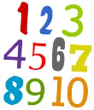

1- I like ………..

1. sings b)sing c) singing

2- I can ……….. lots of animals in the zoo.

1. see b) saw c) sawing

3- Monkeys …………. bananas

1. eat b) eats c) eating

## Write the missing word:

## My favorite animals are ………….…..and ……………….

## The ………………… can …………… and jump.

**Re Order the words to form sentences with proper punctiuation:**

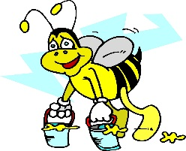

make

bees

honey

1- -------------------------------------------------------------

honey

do

eat

camels

2- -------------------------------------------------------------

drink

horses

water

3- -------------------------------------------------------------

what

rabbits

do

do

4- -------------------------------------------------------------

fly sing monkey horse

Copy the sentence.

bird zebra elephant rabbit

Copy the sentence.

giraffe camel lion

Copy the sentence.

tiger climb zoo falcon

Copy the sentence.



|  |  |  |
| --- | --- | --- |
| **No** | **Vocabulary** | **Meaning** |
| **1** | **friendly** | **ودود** |
| **2** | **neighbourhood** | **جيران** |
| **3** | **park** | **حديقه** |
| **4** | **next to** | **بالقرب من** |
| **5** | **street** | **شارع** |

Ask and Answer:

**Where do you live?**

**I live in Ardhiya**

**I live in Ferdous**

*Read the text and answer the questions:

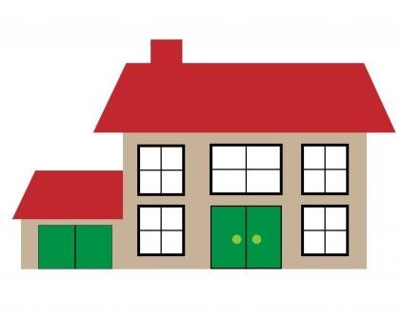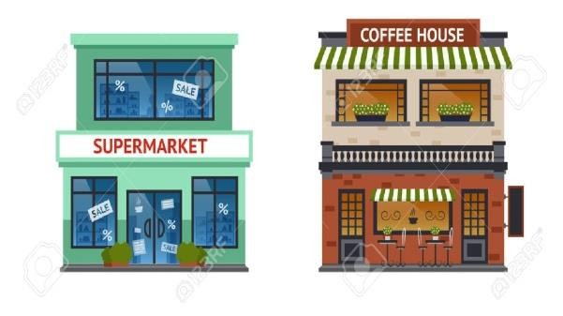

# My name is Waleed. I am 7 years old. I live in Doha. My house is big. It is next to the supermarket. Every day I go with my big brother to buy chocolate from the super market.

*tick ( √ ) or ( ×)

1. Waleed is 10 years old. ( )
2. Waleed lives in Jahra . ( )
3. His house is small. ( )
4. Waleed buys juice from the supermarket( ).

------------------------------------------------------------------------------------------------------------------

*Group rhyming words or words with the same sounds



**sun– clock – fun – dock**

*1- …………………………*

*2- …………………………*

*1- …………………………*

*2- …………………………*

**Fill in the spaces with the suitable words from the list :**

Friendly – street – neighborhood – next to - park

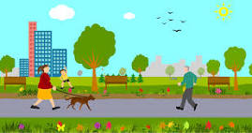

1- There is flowers in the …………….

1. 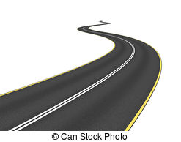My teacher is ………………..
2. 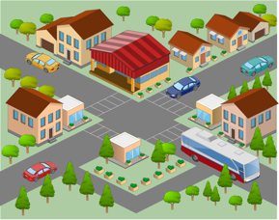Don’t play in the ……………...
3. My …………. is big.

**A) Choose the correct answer from a, b and c:**

1- Sara …………in Kuwait

1. lives b)live c) living

2- I ………….. bread from the bakery

1. buys b) buy c) buying

3- My house is next ……… the supermarket

1. to b) on c) in

## 

## Write the missing word:

## The ………… is next to the ……………

## 

## The people in my ……………………. Are ………………….

**Re Order the words to form sentences with proper punctuation:**

in

doha

live

I

1- -------------------------------------------------------------

where

they

are

2- -------------------------------------------------------------



The park

play

in

they

3- -------------------------------------------------------------



kuwait

come

from

I

1. -------------------------------------------------------------

friendly neighbourhood park

Copy the sentence.

next to street

Copy the sentence.



|  |  |  |
| --- | --- | --- |
| **No** | **Vocabulary** | **Meaning** |
| **1** | **fish** | **يصيد السمك** |
| **2** | **well** | **بئر** |
| **3** | **women** | **نساء** |
| **4** | **dhow** | **سفينه شراعيه** |
| **5** | **telephone** | **تلفون** |
| **6** | **children** | **اطفال** |

Ask and Answer:

**What did you see**

**today? I saw a dhow.**

**I saw a bird.**

*Read the text and answer the questions

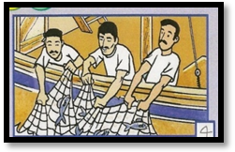

# My grandfather was a fisherman. He used to fish with his friends on the dhow. He fished lots of fish some of them were big and some of the were small. I love my grandfather.

*tick ( √ ) or ( ×)

1. The grandfather was a teacher. ( )
2. He fished lots of fish. ( )
3. He used to fish with his friends ( )

-----------------------------------------------------------------------------------------------------------------

*Group rhyming words or words with the same sounds



**sport – phone – fort –– photo**

*1- …………………………*

*2- …………………………*

*1- …………………………*

*2- …………………………*

**Fill in the spaces with the suitable words from the list :**

Fish – telephone – children –dhow - well



1. 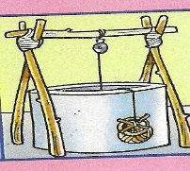I like to …………… with my dad
2. 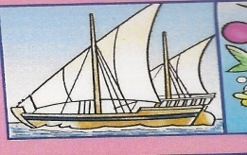There is water in the ……………..
3. [](http://www.google.com.kw/imgres?imgurl=http://www.kidsportchaptersontario.com/Images/Timiskaming/Cartoon%20Pics/telephone_cartoon.png&imgrefurl=http://www.kidsportchaptersontario.com/Content/Timiskaming/Contact.asp&h=264&w=270&sz=37&tbnid=8sTVCGh5uzf1gM:&tbnh=110&tbnw=113&prev=/images?q=picture+of+a+cartoon+phone&hl=ar&usg=__oW7UH5EdTblLn3MX6HUT2fPX2lE=&ei=YbbUSpnkIo-B4Qb5hp3LDA&sa=X&oi=image_result&resnum=3&ct=image&ved=0CAsQ9Q)It is a big …………………
4. The …………..is on the table

**A) Choose the correct answer from a, b and c :**

1- Yesterday, Sara …………a cat in the park

1. see b)sees c) saw

2- Mom ………… eggs in the cake

1. used b) uses c) use

3- What did you ……….. today?

1. see b)sees c) saw

## Write the missing word:

## In the past, …………………. Used to get water from

## 

## 

## the ………….

## In the past, men ……..…. on the ………………….

**Re Order the words to form sentences with proper punctuation:**



monday

fished

on

I

[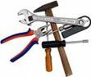](http://www.google.com.kw/imgres?imgurl=http://socialmediabuildingblocks.files.wordpress.com/2009/04/tools.jpg&imgrefurl=http://socialmediabuildingblocks.wordpress.com/&h=403&w=480&sz=33&tbnid=hCDYbaFPhzF7MM:&tbnh=108&tbnw=129&prev=/images?q=picture+of+tools)&hl=ar&usg=__NDFud3AsZCAb5HfYn6EKpCHlQ4k=&ei=lX7cSr_2D5WI4Qawz5XwCA&sa=X&oi=image_result&resnum=3&ct=image&ved=0CA4Q9Q)1- -------------------------------------------------------------

tools

they

are

2- -------------------------------------------------------------

they

did

what

do

3- -------------------------------------------------------------

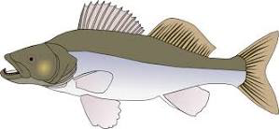

a big

saw

fish

I

4--------------------------------------------------------------

fish well women

Copy the sentence.

dhow telephone children

Copy the sentence.

