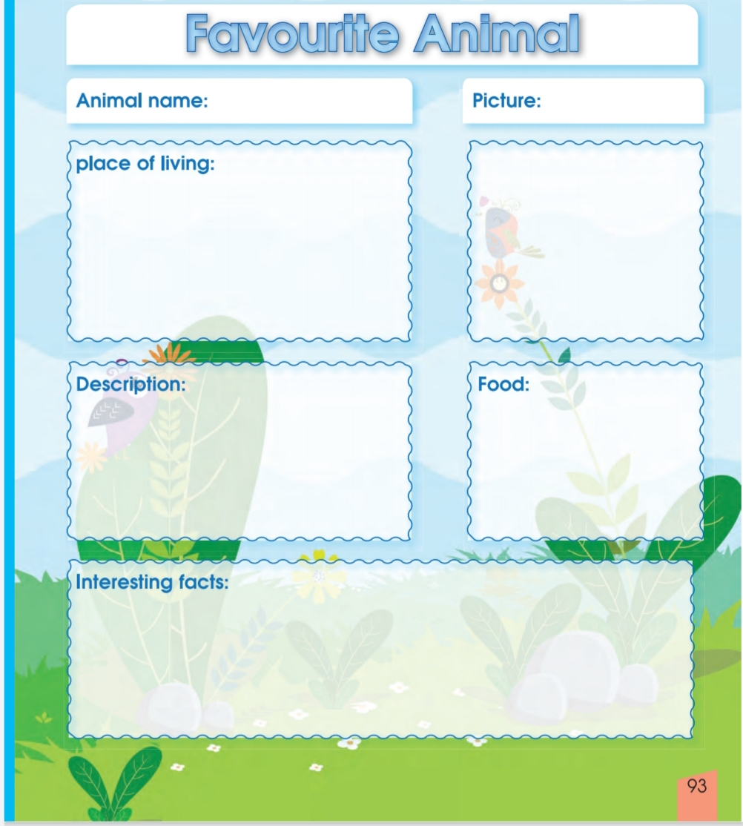
Falcon
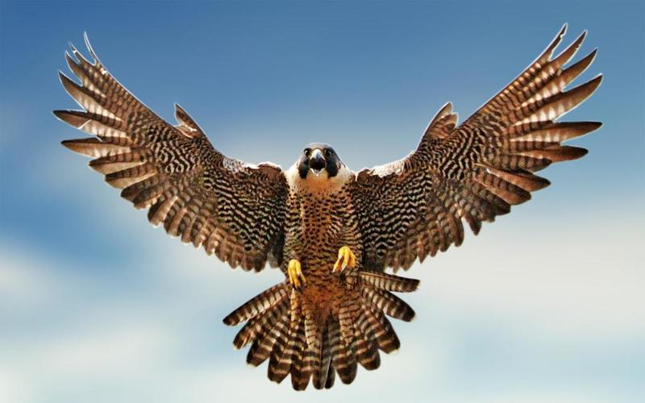
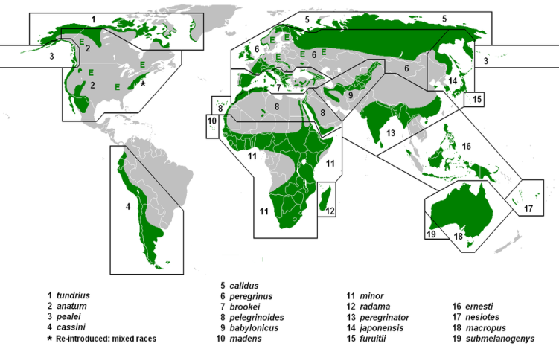

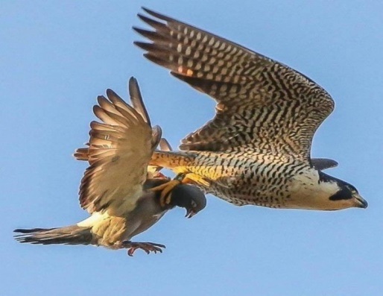
Falcons are small birds of prey and are
related to hawks and eagles. They usually
have pointed wings. Most falcons have
dark gray or brown backs and wings,
with white undersides and long tails.

Falcons are birds of prey, meaning that they hunt and eat animals for food. They are related to hawks and eagles. Falcons are swift, powerful fliers. A sport called falconry dates back to ancient times. It involves training falcons to hunt animals in cooperation with humans. Some common kinds of falcons include the peregrine falcon, the merlin, and several types of kestrels. Falcons are found nearly all over the world. They live in many habitat …

Eissa AL-Obaid 4/1

