The Baby Celebration

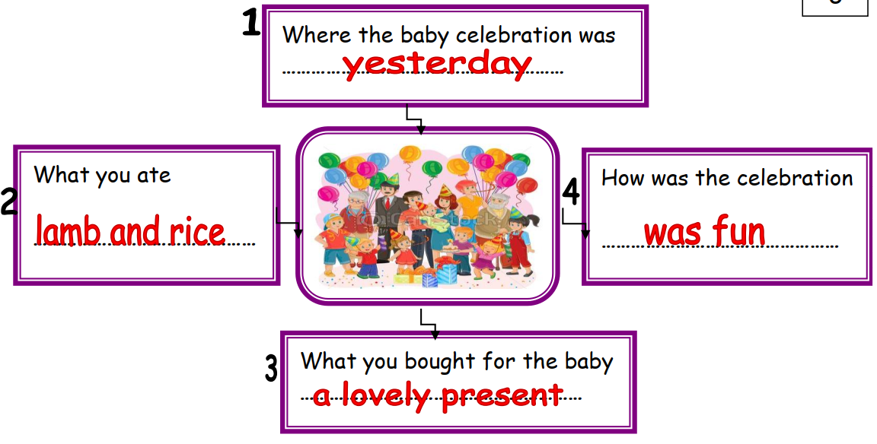

The baby celebration was yesterday. I ate lamb and rice. I bought a lovely present for the baby. The celebration was
fun.

