My Free time

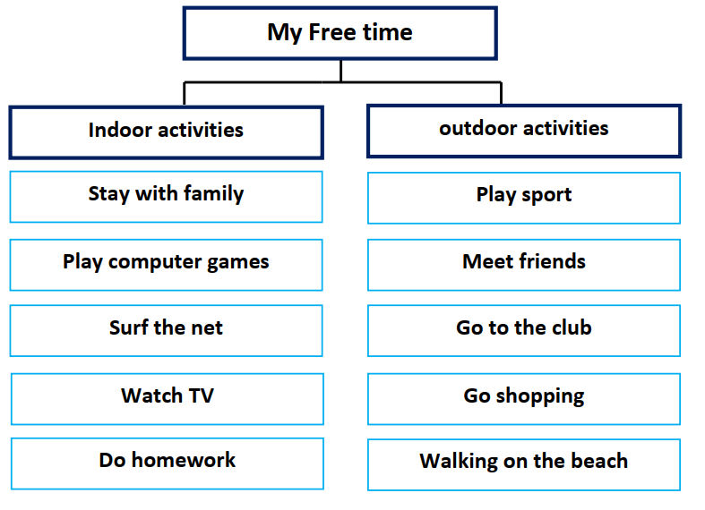

I enjoy my free time very much. There are different indoor and
outdoor activities in free time. In my home, I like surfing the Internet to
get information. I prefer staying with my family and talking to each
other. I enjoy playing computer games with my brother. At night, I watch
TV. I do my homework and pack my school bag.
There are different outdoor activities in my free time. I play sport
with my friends. We meet together and go to the club. We go shopping
and eat at the restaurants. At the weekend, I’m keen on walking on the
beach

