Healthy Lifestyle

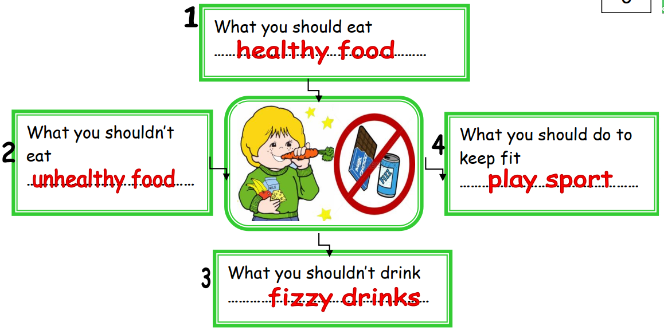

I should eat healthy food. I shouldn’t eat unhealthy food. I shouldn’t drink fizzy drinks. I should play sport to keep fit

