Museums

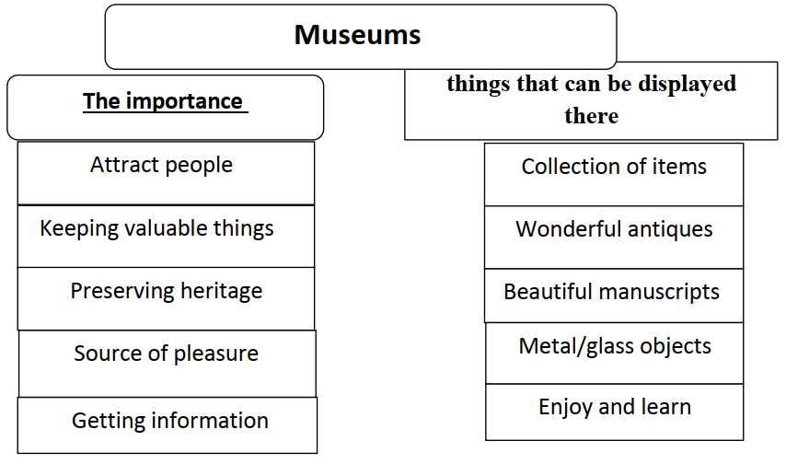

A museum is one of the most interesting places that attracts people of different ages. It is a place for keeping the most valuable things. The heritage of the country is preserved in the museums. Also, the museum is a source of pleasure and information for its visitors.
The museum has a collection of items. It includes wonderful
antiques. Also, it has beautiful manuscripts. There are also metal and
glass objects. When you visit the museum, you will enjoy and learn.

