Houses

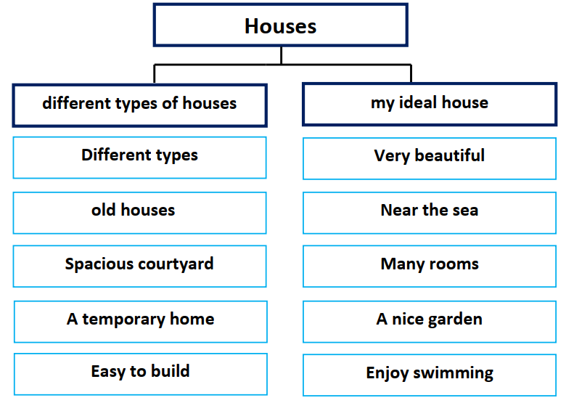

There are different types of houses. Old houses were made of
mud. They had a spacious courtyard. An igloo is a temporary home in
the Arctic. The wooden houses are easy to build, warm in winter and
cool in summer.
My ideal house is very beautiful and large. It is near the sea.
It has got many rooms, a kitchen, and a balcony. It has got a nice garden.
I enjoy sitting in the garden and swimming in the sea.

