Expeditions

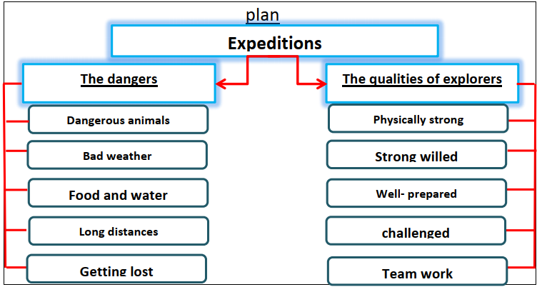

An expedition is a special journey with a particular purpose.
Although expeditions are interesting, there are many dangers. First, there are many dangerous animals that prey on humans. Second, the bad weather causes many problems. Third, the explorers have to walk for long distances. They may suffer from food and water lack. Finally,, they may get lost or injured.
Expeditions are mental and physical challenges. There are some qualities of explorers. They have to be physically strong. They should have determination and strong will. They have to be well prepared and know how to work as a team. All in all expedition is a great way to see the world

