Girgaian

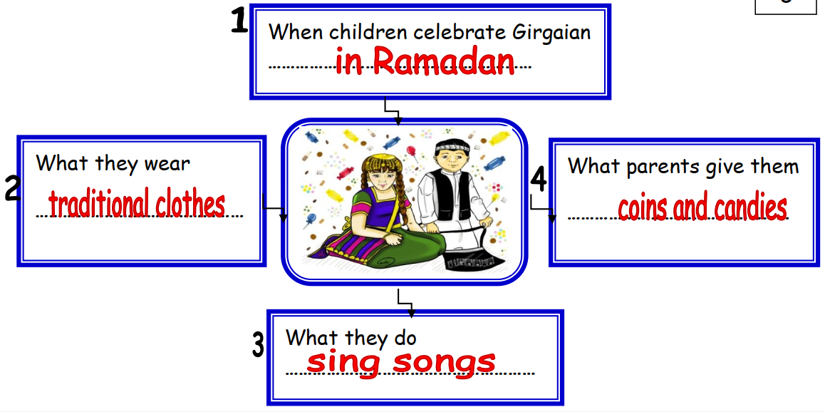

Children celebrate Girgaian in Ramadan. They wear traditional clothes. They sing songs. Parents give them coins and candies.

