Authors

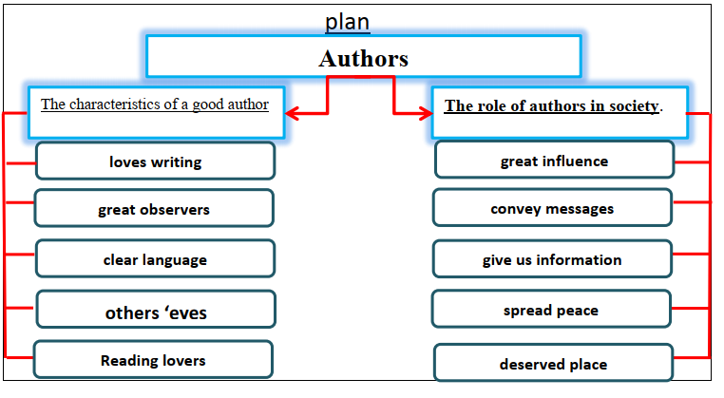

An author is someone who loves writing. There are some characteristics of a good author. Good authors should be great observers. They have to use simple and clear language. They can see their works through the others ‘eyes. Good
authors are reading lovers.
Good authors have a great influence on people. They convey messages and keep their era alive. They give us information about the past. Their great role is to spread peace in society. Finally good authors should get their deserved place in society.

