The science lab rules

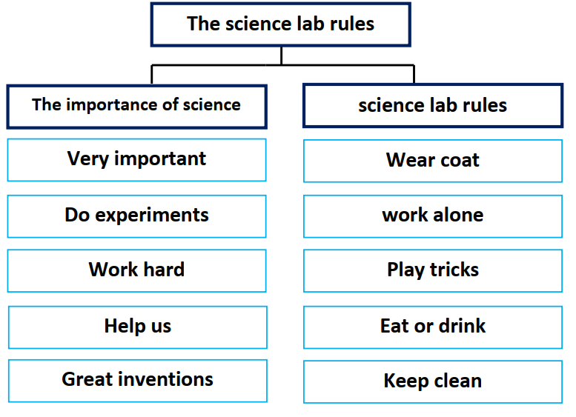

Science is very important for our life. Scientists do
experiments in the lab. They work hard. They help us too much.
They make great inventions to make our life easier.
There are some rules for the science lab. You should wear
a lab coat and goggles. You shouldn’t work alone in the lab.
Don’t play games or tricks there and be careful. Don’t eat or
drink. Always keep the lab clean.

