My favourite sport

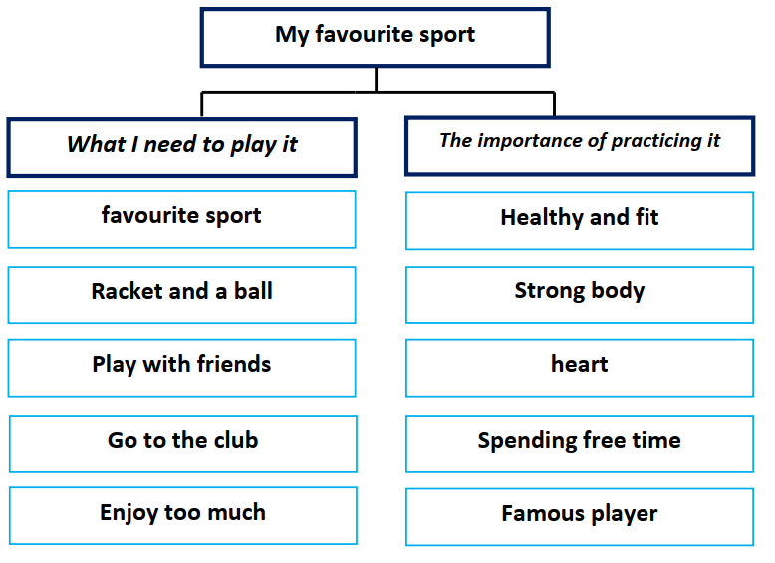

My favorite sport is tennis. You need a racket, ball and a
net to play tennis. Every weekend, I go to the club. I go with my
friends. we play tennis and we enjoy too much.
Practicing sport is of great importance. It helps me to be
healthy and fit. Sport keeps my body strong. It is good for heart
and building muscles. I like spending my free time I a good way.
I’d like to be a famous tennis player.

