Camping

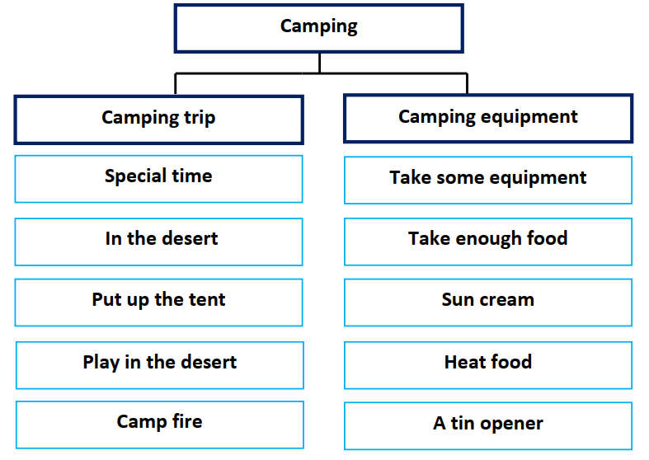

Winter is a special time for people to go camping. I like camping
very much. I go camping in the desert. I help my brothers to put up the
tent. Children are happy; they enjoy playing in the desert and flying
Kites. At night, we sit around the campfire telling stories.
When we go camping, we have to take some equipment.
We have to take a tent, food and enough water. We should take insect
repellent and a torch. Sun cream is important to protect our skin from
the sun. We need a tin opener and a stove to heat food.

