Life in space

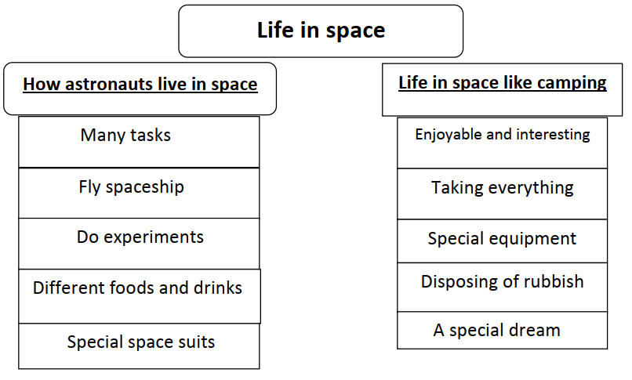

Life in space is enjoyable, but it is very tiring. It is like camping for three reasons. First, you must take everything you need. Second, you use special equipment. Third, you must dispose of your rubbish.

In space astronauts do many tasks. They fly the spaceship. They do experiments and explore planets. They eat tinned food and drink through a straw. They wear special suits, which have parachutes, oxygen, and water. I dream of being an astronaut travelling into space.

