Cycling

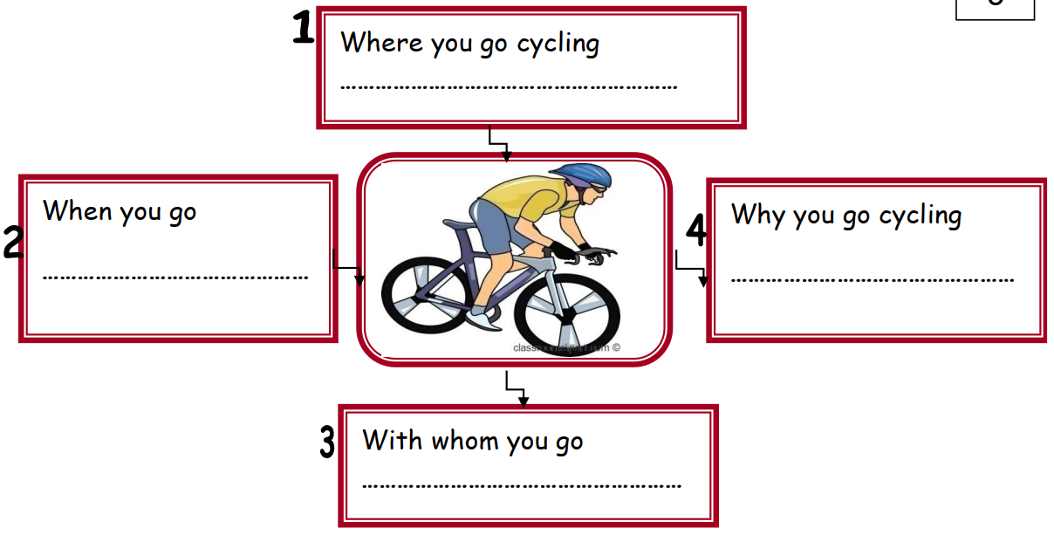
In the park
On Fridays
With my Friends
To keep fit and healthy

I go cycling in the park. I go on Fridays. I go with my friends. I go cycling to keep fit and healthy.

