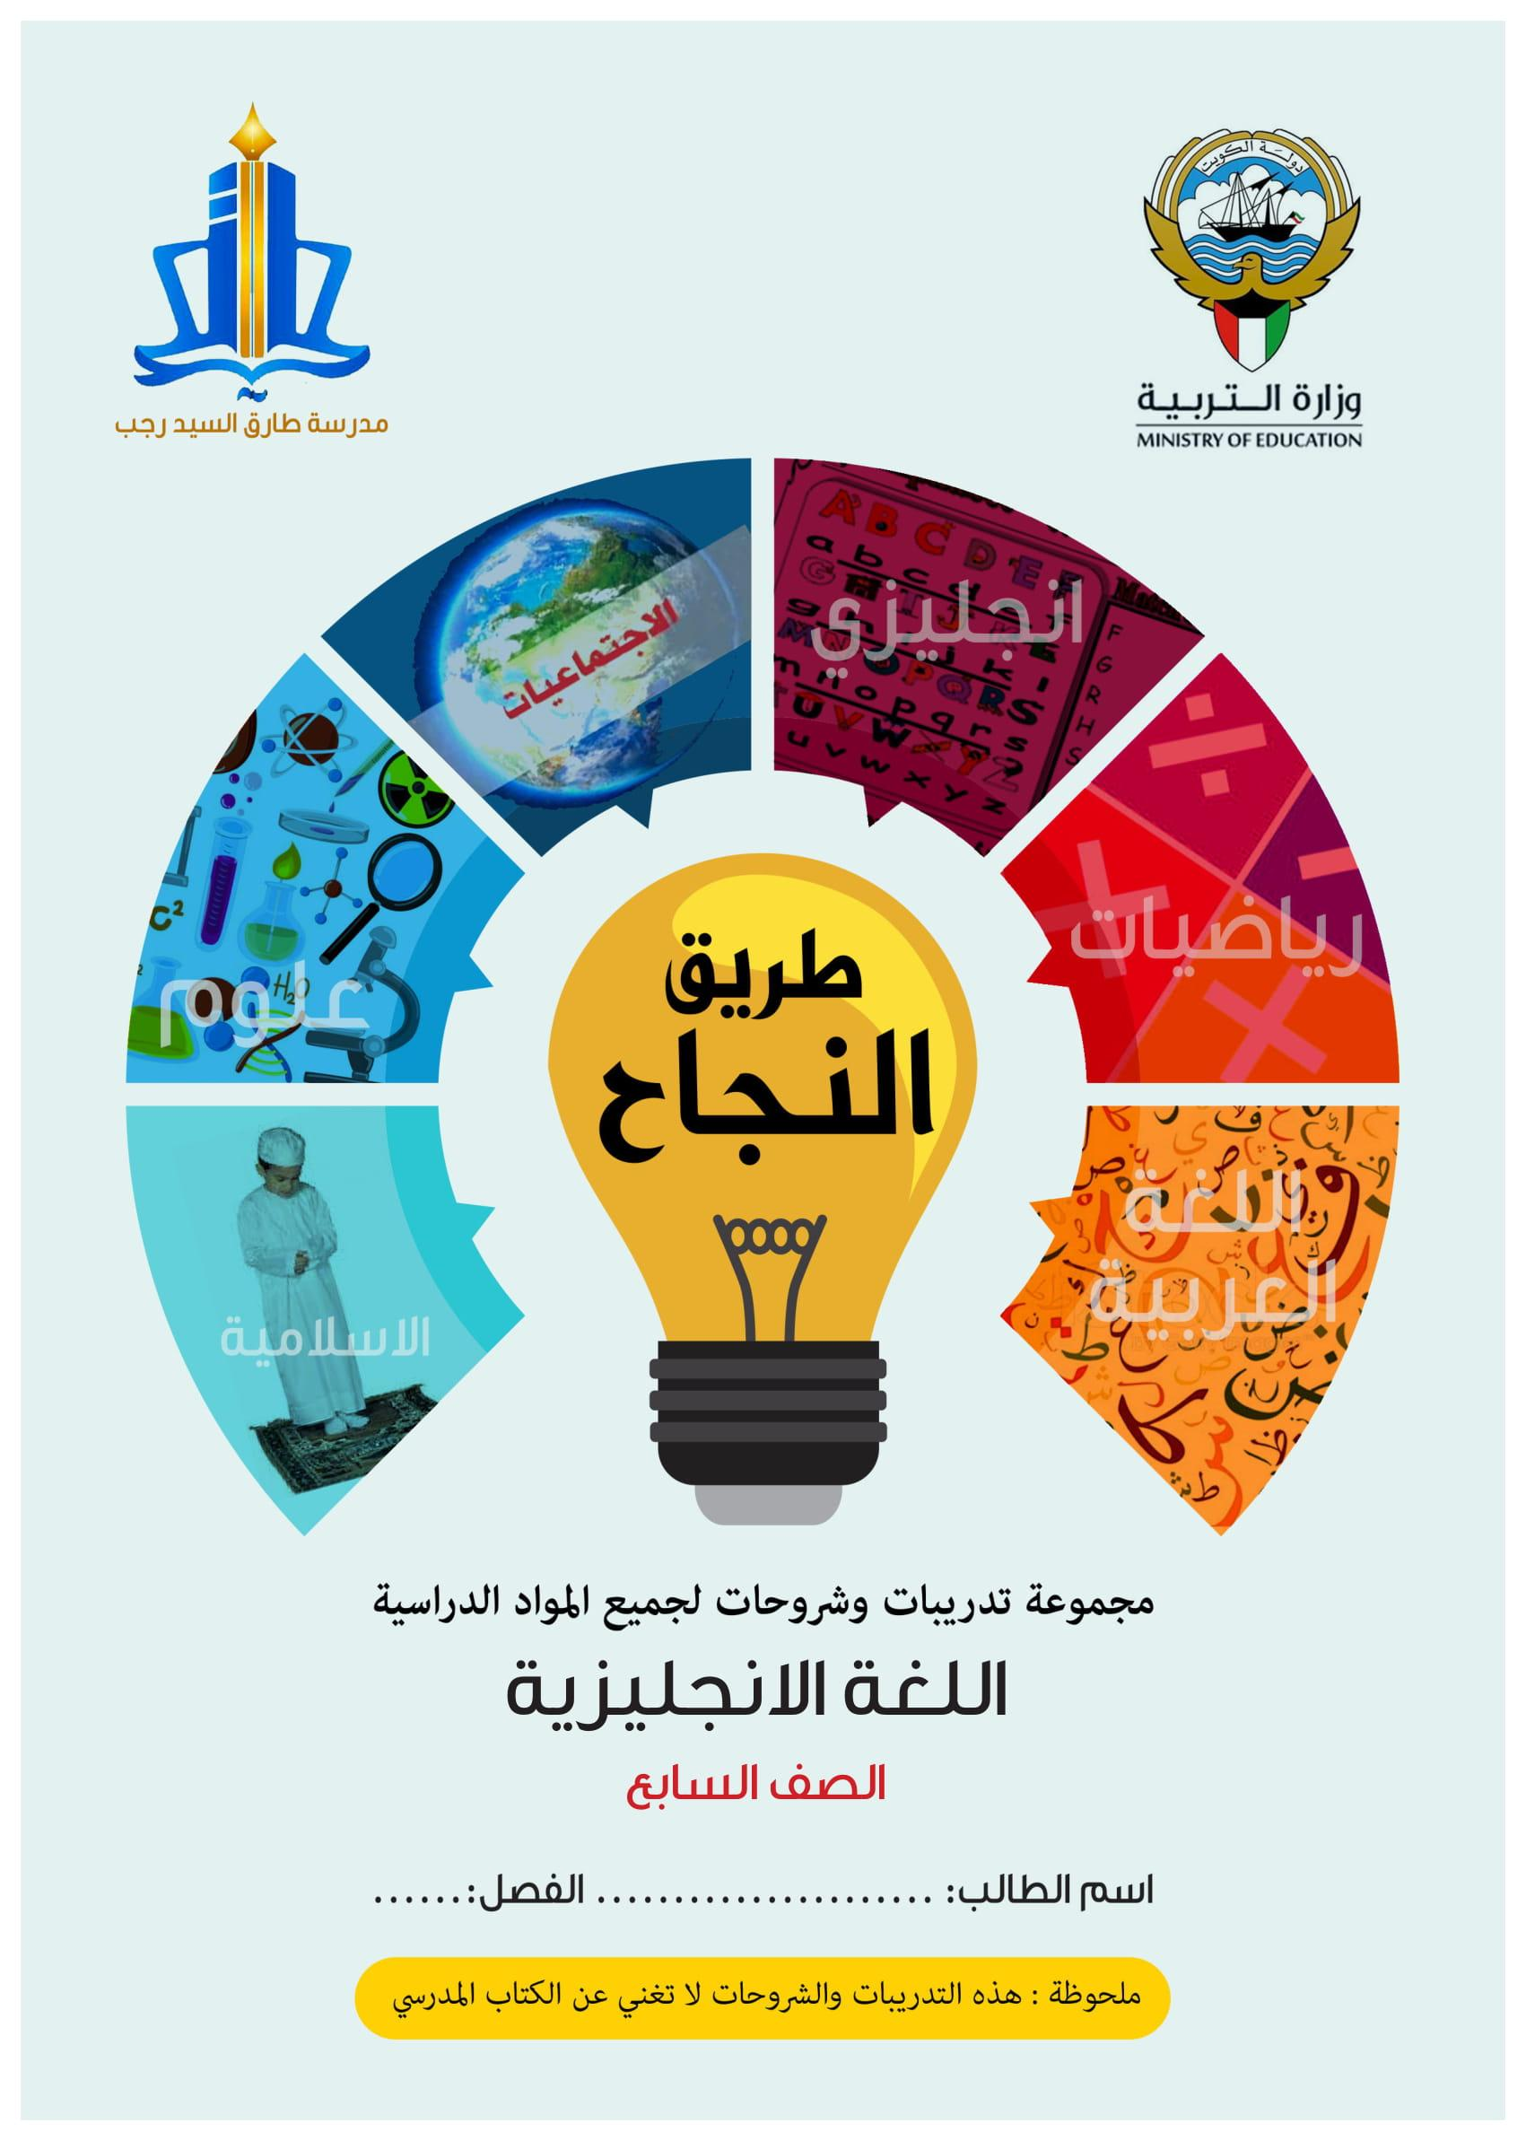

دولة الكويت
وزارة التربيةالعام الدراسي: 2018/2019
الإدارة العامة لمنطقة العاصمة التعليمية المجال: اللغة الإنجليزية
التوجيه الفني للغة الإنجليزيةالصف السابع
الزمن: ساعتان الامتحان في (6صفحات)

(امتحان نهاية الفترة الدراسيةالأولى للصف السابع 2018/2019(
Total Marks ( 60 )
1. Reading (30Marks)
A) Vocabulary ( 14 Marks )
a) Choose the correct answer from a, b, c and d: (4×2=8 marks)

- He doesn’t like eating meat. He is a .......................person

d. vegetarian c. numerous b. survival a. tasteless

- Kuwait’s Opera House is .................... decorated with amazing designs.

d. gently c.magnificently b. altogether a. officially

- I like to ……………………. Some sugar on cookies to make them so sweet.

d. recite c. snorkel b.sprinkle a. limit

- When you go camping, you need a ………………… to cook your food.

d. equipment c. chat room b. envelope a. stove

b) Fill in the spaces with the most suitable word from the list below:(4×1½=6 marks)

{luxury – stove – posted – leisure – cuisine }
5 – I Phones, I Pads and other Apple’s are considered …………… products.
6 – I .................... reply message to my friend on Instagram.
7 – Biryani is a very famous meal from the Indian ……………………
8 – You don’t have to ………………… so much on other people.

امتحان نهاية الفترة الدراسية الاولى الصف السابع الصفحة الثانية
B: Reading Comprehension (16Marks)
Read the following text carefully then answer the question below:
Sushi originates in a Southeast Asian dish, known today as "salted fish". It is stored in rice for possibly months at a time. It is a very well- known dish all over the world. fermentation of the rice prevented the fish from spoiling; the rice would be discarded before consumption of the fish. This early type of sushi became an important source of protein for its Japanese consumers. The term sushi comes from an old grammatical form no longer used in other contexts, and literally means "sour-tasting"; the overall dish has a sour taste.
Vinegar began to be added to the preparation of sushi for the sake of enhancing both taste and preservation. In addition to increasing the sourness of the rice, the vinegar significantly increased the dish's long preservation, causing the fermentation process to be shortened and eventually abandoned. The early types of sushi were developed in Osaka, the seafood and rice were pressed into a shape with wooden (typically bamboo) shape.
The common ingredient in all types of sushi is vinegar sushi rice. Fillings, toppings, and preparation vary. Sauce can be added and it’s called wasabi. It‘s added as a topping. This dish is now one the most famous meals and it is served all over the world.
a) Choose the correct answer from a, b, c and d: (6x2=12 marks)
9. The main idea of the 2nd the paragraph is:
a. Adding vinegar to sushi b. Foods taste is the most important thing.

c. Adding wasabi sauce to sushi . d. Sea food has a bad taste.

10.What is the meaning of the underlined word ‘prevented’ in the 2nd paragraph ?
d. made c. stopped b. started a. caught

11.The underlined pronoun “it “ in the 3rd paragraph refers to:

d . Japan b.vinegar c. Curry spices d. wasabi
12. Which of the following statements is TRUE?

a. Sushi originates in South East Asia b. Italian sushi was made first.

c. Sauce can’t beaded to sushi. d. You can’t find sushi except in Japan

13. What is the writer’s purpose of writing this text :

a- to warn people of dangers of sea food. b. to introduce an English dish
c- Explain how to prepare pizza. d. Inform us about sushi facts

14. Sushi is stored in …………………… for possibly months at a time
a. wasabi b. rice c. vegetables d. sauced
امتحان نهاية الفترة الدراسية الاولى الصف السابع الصفحة الثالثة

b) With reference to the passage, answer the following questions: (2x2=4 marks )
15. Where does the term sushi come from?
…………………………………………………………………………………………………

16. What is the benefit of fermenting fish?
…………………………………………………………………………………………………

II. Writing (30Marks)
A) Grammar (11Marks)
a) Read the following paragraph and choose the correct answer between
brackets :(4×2=8 marks)
A boy [ has got -had–have got ] a Cannon digital camera. He [ bought -buying -buys] it last year. There [ are-is-was] different kinds of cameras .
If you are interested in photography, you [ getting -get –can get ] a drone camera,
it ‘s very professional one .

b)Do as required between brackets:(2×1½=3marks)
21. she sleeps early every night .(Make negative )

………………………………………………………………………………………………………………………………………

22.Yes, I can play the guitar .(Ask a question )

………………………………………………………………………………………………………………………………………

امتحان نهاية الفترة الدراسية الاولى الصف السابع الصفحة الرابعة

B: Writing
Write a report (of 8 sentences) about “ Para – sports”
The following guide words may help you:
(include – skiing – cycling – wheelchair basketball – athletes – Kuwait –medals)

(Plan)
The plan ( 1 mark)

امتحان نهاية الفترة الدراسية الاولى الصف السابع الصفحة الخامسة
(The Topic 14 marks(
……………………………………………
……………………………………………………………………………………………………………………………………………………………………………………………………………………………………………………………………………………………………………………………………………………………………………………………………………………………………………………………………………………………………………………………………………………………………………………………………………………………………………………………………………………………………………………………………………………………………………………………………………………………………………………………………………………………………………………………………………………………………………………………………………………………………………………………………………………………………………………………………………………………………………………………………………………………………………………………………………………………………………………………………………………………………………………………………………………………………………………………………………………………………………………………………………………………………………………………………………………………………………………………………………………………………………………………………………………………………………………………………………………………………………………………………………………………………………………………………………………………………………………………………………………………………………………
Rubrics |  |  |  |  |  |  | Total
Planning (graphic organizers / mind mapping ) | Exposition of ideas and coherence | Paragraphing and number of sentences | Grammar | Spelling | Handwriting | Punctuation | 15
1 | 8 | 2 | 1 | 1 | 1 | 1

امتحان نهاية الفترة الدراسية الاولى الصف السابع الصفحة السادسة

C: Spelling (4Marks)
Re-write the following words correctly: ( 4X1= 4 marks)
23My friend is going to joinKuwait equsetiarnCenter to learn horse riding.
…………………….
24. They will perform the play on school thaeter .
…………………….
25. Yon need a teacher and good equipment to sanorkle
…………………….
26Some animals have the ability to sarvife in the desert.
…………………….

انتهت الأسئلة
مع تمنياتنا لكم بالنجاح

Grammar
The possessive ('S)

We use apostrophe before and after S ending of nouns
's : 1. This is Ali's car. ( Ali is singular)
2. I met the boy's father. (One boy)
S' : I met the boys' fathers.( many boys )

Verb to be
I am a doctor. = I'm a doctor.
He is a teacher. = He's a teacher.
She is my sister. = She's my sister.
It is a nice cat. = It's a nice cat.
They are nice friends. = They're nice friends.
You are a pupil. = You're a pupil.
We are good at English. = We're good at English.

Grammar
He ………..
I ………. She ………..has got
We ………. have got It ………..
They ……….
You ……….
A: I have got a mobile phone. B: So have I .
A: I haven't got a mobile phone. B: Neither have I .

Grammar

Present simple

Affirmative Negative
We / they / you / I 🡪 play don’t play
He / she / it 🡪 plays doesn’t play

Key words
always/ usually/often / sometimes/ never / every

We make negative with(never) for both singular and plural
We use( don’t) to make negative for plural
We use( doesn’t ) to make negative for singular

Grammar
Talking about ability : can + inf.
I can play football.
My brother can’t ride a horse.

Grammar
Present Continuous

I 🡪 am
He / she / it 🡪 is + verb + ing
We / they / you / 🡪 are
Key words
Now / at the moment / Look / Listen
I am doing my homework now.
Look! Simon is drawing a nice picture.
They are playing volleyball at the moment.

Grammar
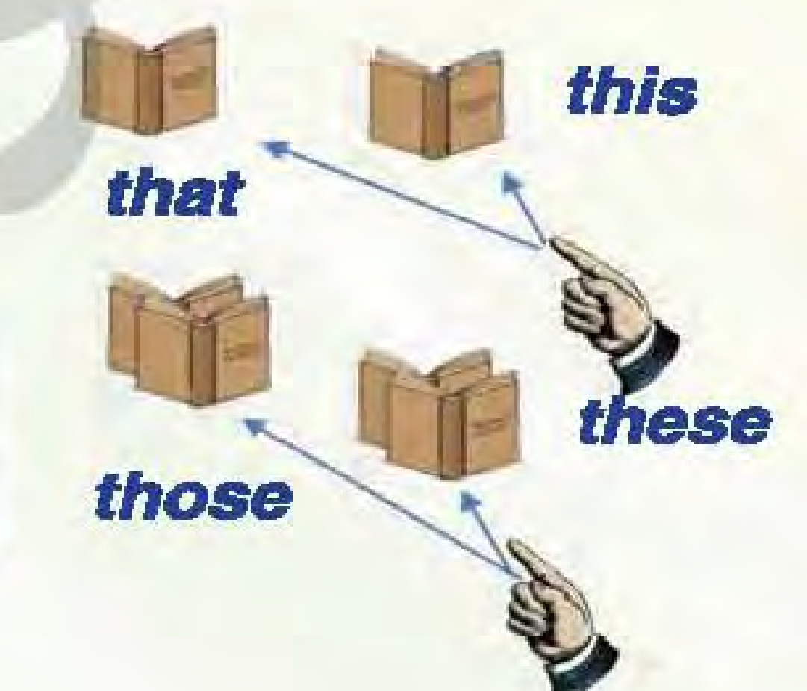

this / that / these / those

this :one thing close to the speaker
that :one thing far from the speaker
these :two or more things close to the speaker
those :two or more things far from the speaker

Grammar

Adverbs

We form adverbs by adding ( ly ) to adjectives
Slow 🡪 slowly quick🡪 quickly
Adjectives ending in [ p / t / s ] + –y 🡪ily
Happy🡪 happily noisy🡪 noisily
Irregular adjectives
good🡪 well hard 🡪hard fast 🡪fast
- He was running quickly to catch the bus.

Grammar

There is / there are ( present )

- There is … singular. There is a car over there.
- There are … plural . There are some books on the table.
There was / there were ( past )

There was … singular. There was a car accident yesterday..
There were some students in the class on the table.

Grammar

Some / any / a / an
- There is some milk in the fridge. ( affirmative )
- There isn’tany sugar in my tea. ( Negative )
- Are there any pupils in the classroom? ( question)
- I have gota car. ( singular beginning with a consonant)
- I have eaten an apple. ( singular beginning with a vowel[ a/e/i/o/u] )

Grammar
Question Tag
- They are from Kuwait, aren’t they?
- Salem isn’t at school, is he?

Grammar
Pronouns
I | Me | My book | Mine
He | Him | His book | His
She | Her | Her book | Hers
It | It | Its colour | -
We | Us | Our class | Ours
They | Them | Their class | Theirs
you | You | Your house | Yours

Grammar
First Conditional

If `🡪 present simple 🡪 will / won't + inf.
If I have time , I will help you.
If you don’t study, you won't pass the test.

Second Conditional

If 🡪 past simple 🡪 would + inf.
If I hadmoney , I would buy a car.
If they didn’t study, they wouldn’t pass the test.

Grammar

Asking about countable and uncountable nouns
How many : for countable nouns
Example: There are three eggs in the box.
Q. How many eggs are in the box?
How much: for uncountable nouns.
Example: I drink a lot of water in the morning.
Q. How much water do you drink in the morning?

Unit 1
الورك | Hip (n)
عملية | Operation (n)
كرسي متحرك | Wheelchair (n)
يحد من – يقيد | Limit (v)
متحدي الإعاقه | Physically challenged(adj)
لذيذ | Delicious (adj)
مغامرة | Adventure (n)
علية المنزل | Attic (n)
واسع | Spacious (adj)
مؤقت | Temporary (adj)
سكان الاسكيمو | Inuit (n)
خصوصا | Especially (adv)
ضد | Against (preposition)
صديق البيئة | Eco-friendly (adj)
مصدر | Source (n)

Unit 2
معدات - أدوات | Equipment (n)
تماما - إلى حد كبير | Quite (adv)
أرض الملعب | Pitch (n)
يحرز – يسجل | Score (v)
حكم مباراة | Referee (n)
التزلج على الماء | Water ski (v)
رمي الرمح | Javelin (n)
دراجة رباعية | Quad bike (n)
الغوص بإستخدام أنبوب التنفس | Snorkel (v)
الجنسية | Nationality (n)
الكثير من - متعدد | Numerous (adj)
إمكانيات - القدرة | Potential (n)
بداية | Initially (adv)
يتفوق – يبرز | Excel (v)
منافس | Rival (n)
رياضة المعاقين | Para- sport (n)

Unit 3
مقصف | Canteen (n)
محلي -وطني | Local (adj)
يعتمد على | Depend on (ph v)
فراغ | Leisure (n)
شخصي | Personally (adv)
مرفق | Facility (n)
يرسل | Post (v)
غرفة دردشة | Chat room (n)
ينظم | Run=( organize)
نجاة- انقاذ | Survival (adj)
محتمل | Probably (adv)
يتلو | Recite (v)
مناسب -ملائم | Convenient (adj)
فروسي | Equestrian (adj)
تسجيل | Registration (n)
نشيط وحيوي | Lively (adj)

Unit 4
تعليمات - إرشادات | Instruction (n)
نظامي | Regular (ad j)
يطوي | Fold (v)
ظرف | Envelop ( n)
أصلي | Original ( adj)
ينثر - يرش | Sprinkle (v)
بذور | Seeds (n)
تربة | Soil ( n)
إناء فخاري - وعاء | Pot (n)
امين مكتبة | Librarian (n)
معا | Altogether (adv)
تحرير | Liberation (n)
طريق | Route (n)
المقصد - الوجهة | Destination (n)
خدعة | Trick (n)
غطاء | Lid (n)
يحكم الغلق - يسد | Seal (v)
يمتص | Suck (v)
ملاحظة | Observation (n)
ممر | Corridor (n)

Unit 5
يتطلب | Require (v)
جهاز -أداة | Appliance (n)
متاح | Available (adj)
يزود | Supply (v)
موقد طبخ | Stove (n)
الكرة الارضية | Globe(n)
عطشان | Thirsty (adj)
بوصلة | Compass (n)
مبيد حشري | Insect repellent (n)
ينجو | Survive (v)
بالتأكيد | Definitely (adv)
بشكل رسمي | Officially (adv)
تعكس | Reflect(v)
رفاهية - فخامة | Luxury(n)
مسرح | Theater (n)
بارز- مشهور | Iconic (adj)
حضارة | Civilization(n)
بلوفر - بلوزة | Sweater(n)
يجذب | Attract (v)

Unit 6
يسكب | Pour(v)
يقطع | Chop (v)
يمزج - يقلب | Stir (v)
مكونات | Ingredients (n)
شريحة | Slice (n)
بهدوء - بلطف | Gently (adv)
يدهن | Grease (v)
يلصق | Stick (v)
بلا طعم | Tasteless (adj)
اسلوب وطريقة طهي | Cuisine (n)
نباتي | Vegetarian (adj)
منضده | Counter (n)
استبيان | Questionnaire (n)
ديني | Religious (adj)
جدال | Argument (n)
الاستقلال | Independence (n)
بشكل رائع | Magnificently (adv)
زي - لباس خاص | Costume (n)
مناسبة | Occasion (n)

