My Daily Routine

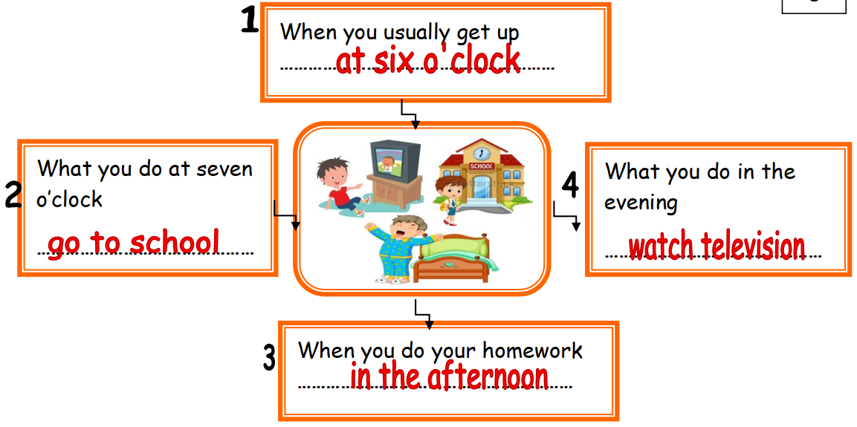

I usually get up at six o’clock. I go to school at seven o’clock. I do my homework in the afternoon. I watch television in the
evening.

