The disabled

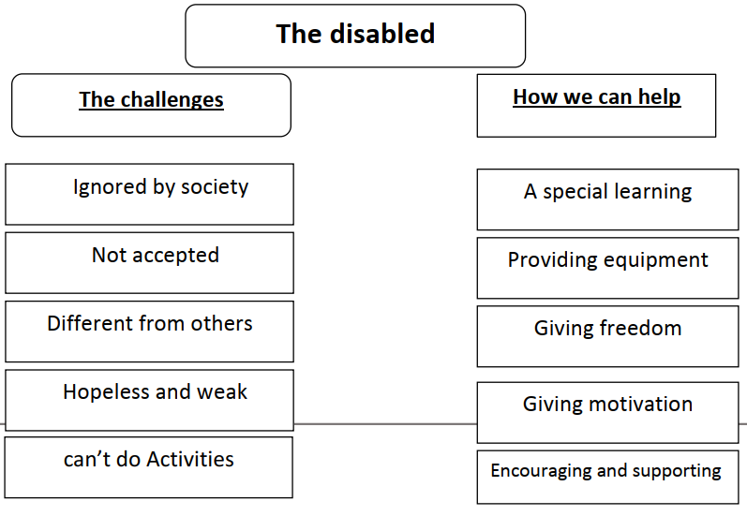

The physically challenged can do miracles inspite of their disabilities. They may face many challenges. Some Societies usually ignore them. Some Societies don’t accept them because they think that the disabled are different from others. They think that the disabled are hopeless, and they can’t do any activities.
To help the disabled we should provide them with special learning.
We should provide them with special equipment to learn and play. It is important to give them freedom to practice activities. Looking at them in appositive way can help them to overcome their disabilities. The disabled area part of any society when we encourage and help them, they will be effective and successful members.

