Kuwait’s impressive building

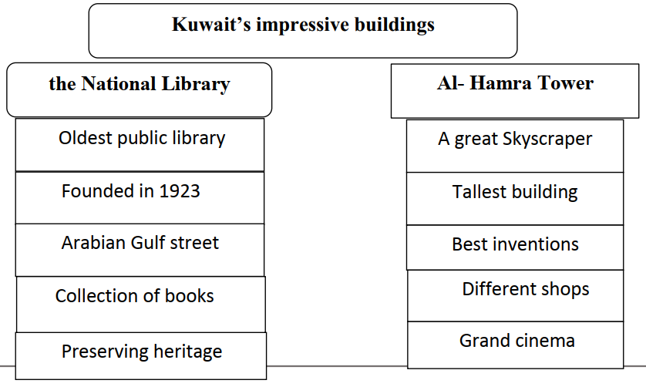

Kuwait has many impressive modern places. The national library is the oldest public library in Kuwait. It was founded in 1923. It is located in the Arabian Gulf Street. The library has a collection of thousands of books and manuscripts. The library preserving the national heritage of
Kuwait.
Al –Hamra Tower is a great skyscraper. It is the tallest building in Kuwait. It was included in the list of the best inventions of 2011. There are many exciting luxury shops. Also, the eight-screen grand cinema is
found there. Impressive buildings prove the economic power of the country.

