Football

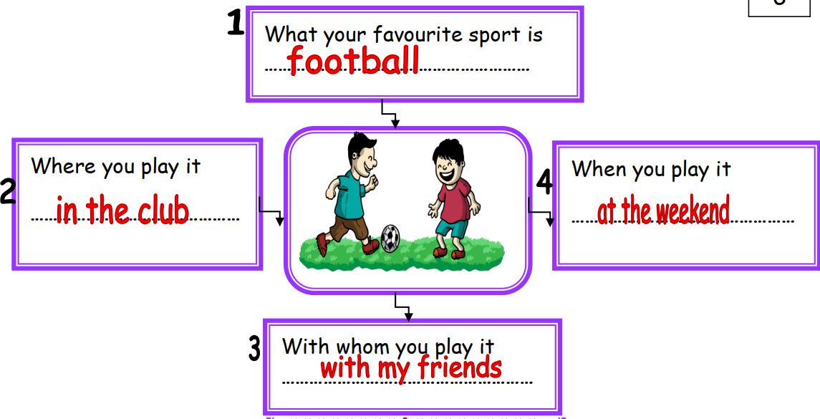

My favourite sport is football. I play it in the club. I play it with my friends. I play it at the weekend.

