Pollution

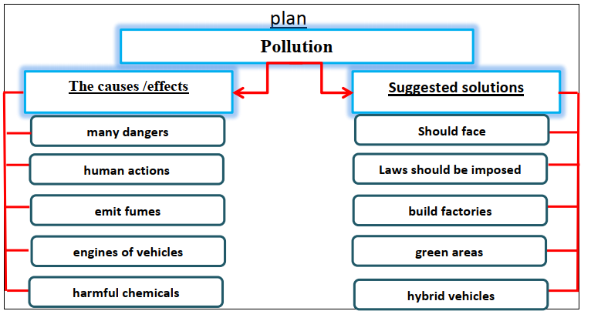

There are many dangers that face our planet. Pollution is one of the most serious problems. Air pollution is caused by human actions. First, factories emit fumes and smoke. Second, emissions from engines of vehicles contain pollutants.
Pesticides and fertilizers release harmful chemicals into air.
Pollution is an environmental problem that we should face. There are some suggested solutions for this problem. Laws should be imposed on using pesticides. Also, it is important to build factories away cities. We should increase the green areas. We can use electric and hybrid vehicles.

