My birthday

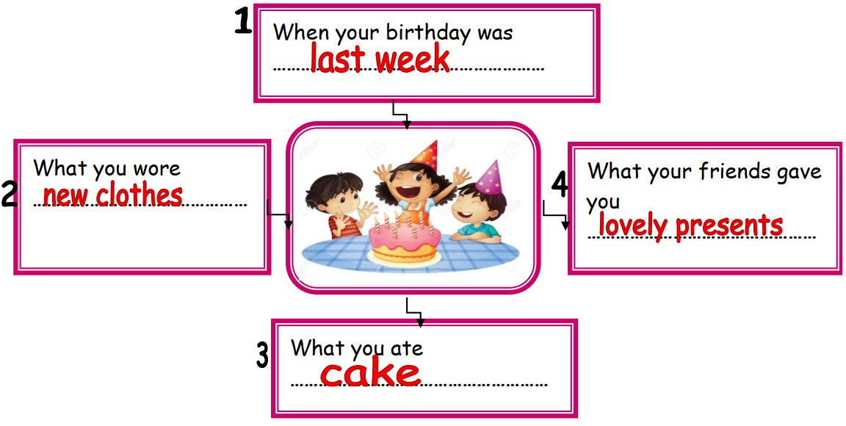

My birthday was last week. I wore new clothes. I ate cake. My friends gave me lovely presents.

