A healthy lifestyle

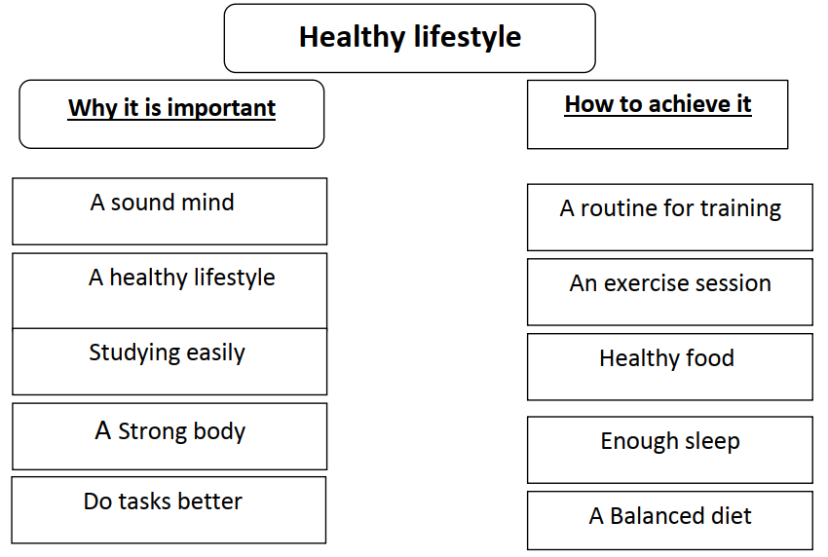

A sound mind is in a sound body. It is very important to have a healthy lifestyle. When you are fit, studying becomes easier. You will have a strong body. You can do tasks easily.
There are many ways to achieve the healthy lifestyle. It is important to have routine of training. You should have a good exercise session. Eating healthy food and having enough sleep help to keep fit. Finally, a balanced diet and daily exercise will help you to keep fit and healthy.

