Voluntary Work

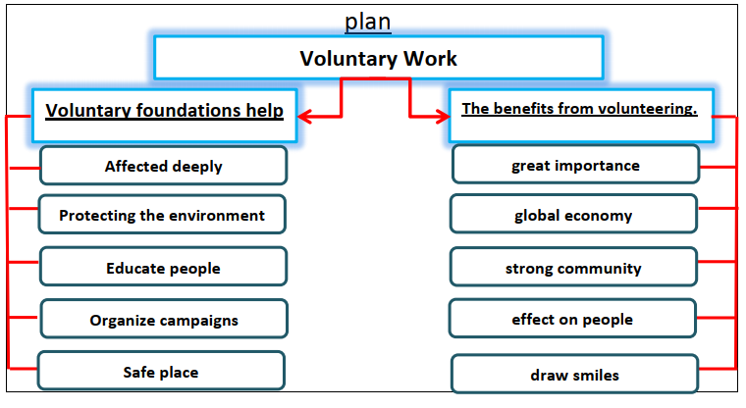

Volunteering is serving by your choice for free. Voluntary environmental foundations affect the society deeply. They aim at protecting the environment. They educate people about the importance of the environment. They organize campaigns to keep the environment clean. Their main goal is to keep the
community a safe place.

Volunteering is very importance. It contributes to the global economy. Volunteering helps building a strong community. It encourages more people to work in the public section. Also, volunteering has a positive effect on people. It makes them sharing others on their hardships. It draws smiles on faces.

