Life in the past and nowadays

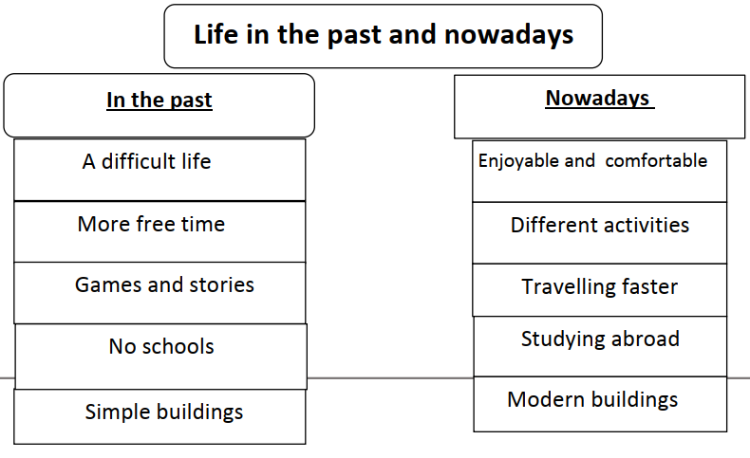

Life in the past Was different from life nowadays. In the past life was difficult. People had more free time than we have nowadays. They used to play simple games and tell stories to each other. There were no schools. Buildings were simple and homes were made of mud.

Nowadays, it is completely different. Life is easier, enjoyable, and more comfortable. People can do many activities, play online games, and surf the internet. They can travel faster, and they can study abroad. Also, buildings are modern. Although some people think that life in the past was hard, I think it was not as difficult as today.

